Review - First DRAFT SECTION III, FAO Voluntary Guidelines on National Forest Monitoring.
H. Gyde Lund
Forest Information Services
6238 Settlers Trail Place
Gainesville, VA 20155 USA
gyde@comcast.net
19 October 2015

Thank you for the opportunity to review the First DRAFT SECTION III, FAO Voluntary Guidelines on National Forest Monitoring. This is an excellent and very useful document – A job well–done!
Here are some observations that may be of interest.
Page 10 - Information Needs Assessment.
Start with laws, regulations that govern your organization. Next identify criteria and indicators. From these, determine the measurements or observations to be made on various parameters (see figure 1).
You should be able to trace any data element you collect or measure in the field back to a required report or law. If such a link cannot be made, there probably is no need to collect that data.
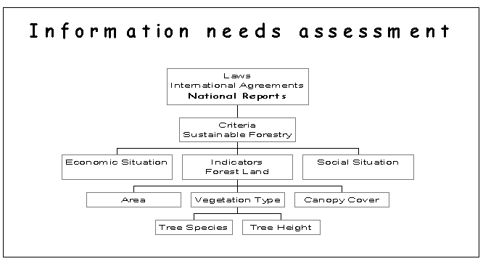
Figure 1 – An information needs assessment flowchart.
Getting more specific, a basic question to ask is "what data should be collected?" The answer is simply answered by the following equation: (What do you NEED to know) – (What you already know) = Information you must gather. There are certain key questions that must be answered to help you decide what you truly need.
- First and foremost "Why do you need a forest inventory?" Possible answers – the inventory is needed for national strategic planning, you need to meet international commitments, or your boss says so. Table 1 lists typical information needs by various decision levels.
Table 1. Typical Decision Level Characteristics (Lund 1985)
Level | Characteristics
International | Goal: To develop international assistance programs or action plans to reverse the depletion of resources and degradation of the environment; foreign trade agreements to shift surplus to meet demands; or cooperative agreements to control Pests and diseases or to address other catastrophic occurrences. Information sought Includes the present state of the resources and the rate and pattern of change. Data are usually assembled by an international group.
National | Goal: To develop long range Federal policies and programs for public and private land-administrating organizations within a given country. National assessments often provide basic and relevant data on renewable resources held by all types of Owners within a nation, appraising changes in supplies of resources and demands for them, the outlooks for future, and possible alterations in these outlooks by changes in national program end policies. National assessments include descriptions of the present situation and estimated changes due to management, cultural influences, and natural or secondary factors  The data are usually assembled and compiled by a Federal agency or an association dealing with a specific resource product. The primary users of the information are the executive branch, Congress, and regulatory agencies. Private industries also use long-range estimates of production and trends to develop their own strategies.
Agency | Goal: To develop an overall strategy for the management of resources within the agency's jurisdiction; define a policy; to express that policy as a set of regulations; and to carry out and execute the policy through agency's program. The information required usually reflects current values end or and rates of change. Inventories conducted at this level may be considered as a prelude to the development of the resource. Inventories focus on the resource stock and the land's capability to produce on a sustained yield basis. The inventory units used in planning are usually based upon political or administrative boundaries. Broad management goals and objectives and financial plans for the organization are the eventual products
Region, Forest, District | Goal: To develop long-term direction for each management or administrative unit (e.g. Region, Forest, District) within an organization. The resources and their condition and potential are described only in sufficient detail to direct the manager’s attention to specific portions of the management unit for more intensive planning. Area, volume, and production estimates are usually tied to each unit. For timber planning, information sought includes areas by land class, soil-vegetation types, estimates of growing stock within the classes, and accessibility. The product is a management plan.
Compartment and Stand | Goal: To determine what, where, and when specific treatments are to take place. Decisions regarding timber sale locations and prescriptions for specific stands are examples. Inventories to assist the decision maker often include maps of vegetation conditions by compartments and stands, description of vegetation and terrain within the units, and accessibility and relevant classification of the units with respect to the alternatives selected under the land use planning process.  Data observed include vegetation factors, potential productivity, accessibility, and economic factors in order to determine specific management actions to take place within the treatment unit.  The inventories are usually conducted by the District. The output is a functional action plan showing the treatment areas and indicating what is to be done when, where, and how. The plan is used for the day-to-day operations of the lowest level field office.
Many nations need a national level inventory for strategic planning and to meet international obligations especially those resulting from the United Nations Conference on Environment and Development in 1992. Documents arising from UNCED include Agenda 21, the Forestry Principles, the Conference on Biological Diversity, the Framework Convention on Climate Change, and the Convention on Desertification. If your last national inventory was carried out before UNCED chances are that you do need a new inventory, as there are new information requirements as a result of these agreements.
- Who wants to know and when? People requiring the inventory may be the government, NGOs, the public, industry or academia. As to when, the answer is usually as soon as possible. How soon the information is actually required helps dictate the method used to gather the data.
- What do ‘they' (those wanting the information) need to know? Start with the rules, regulations, and laws that apply to your organization. Examine them for data requirements. Next look at any international obligations you may have. In all probability "they" will want to know the amount, condition, production and location of the ____ resources on ____ lands. (The blanks to be filled in later).
We do know that we have to manage our forest resources on a sustainable basis. Since 1992, the concept of sustainable forest management has changed. The old concept was essentially the use and management of forestland by producing more timber than is harvested. The new concept is the stewardship and use of forests and forestland in a way and at a rate, that maintains their biodiversity, productivity, regeneration capacity, vitality and their potential to fulfill now and in the future, relevant ecological, economic and social functions, at local, regional, national, and global levels and does not cause damage to other ecosystems.
Tables 2 list the types of areas to be monitored for agreements arising from UNCED.
Tabel 2 - Areas to be monitored according to documents arising from UNCED (Anonymous 1992, 1993).
Area | Agenda 21 | Forestry principles | Convention on Biodiversity conservation | Convention on climate change | Convention on Certification
Low-lying coastal |  |  | Yes | Yes
Arid and semi-arid |  |  | Yes | Yes | Yes
Suitable for reforestation |  | Yes
Suitable for afforestation | Yes | Yes
Prone to natural disasters | Yes |  |  | Yes
Liable to drought & desertification |  |  |  | Yes | Yes
High urban atmospheric pollution | Yes |  |  | Yes
Fragile ecosystems |  |  | Yes | Yes
Forested | Yes | Yes | Yes | Yes

Tables 3 lists the types of indicators to be monitored for agreements arising from UNCED. Note that many of the indicators involve observing things other than trees and nearly all require the measurement of change. This new direction means new information. To protect and create more natural biological diversity for example, one needs information not only on the trees but on other flora, fauna, soils, site, and habitat as well. These kinds of things should be built into new inventories. Once the information requirements are known, the next task is to break the requirements down into data to be measured.

Table 3 - Indicators to be monitored according to documents arising from UNCED (Anonymous 1992, 1993).
Area | Agenda 21 | Forestry principles | Convention on Biodiversity  conservation | Convention on  climate change | Convention on  Certification
Biomass | Yes |  |  | Yes
Climate | Yes |  |  | Yes
Ecosystems & habitat |  | Yes | Yes
Emission sources and removals |  | Yes |  | Yes
Employment |  | Yes
Energy | Yes
Fodder |  | Yes
Food | Yes | Yes
Fuel |  | Yes
Land Cover | Yes
Land degradation | Yes |  |  |  | Yes
Land Productivity | Yes
Land use | Yes |  |  | Yes
Landscape diversity |  | Yes
Minerals | Yes
Medicine |  | Yes
Plants & animals | Yes | Yes | Yes
Recreation |  | Yes
Shelter |  | Yes
Soils | Yes
Water and water use | Yes | Yes
Wildlife | Yes | Yes
Woodstocks |  | Yes
- How often will ‘they' need the information? The answer to this question has a huge bearing on the inventory infrastructure one sets up and on the inventory design employed. Given the requirements for tracking change, one may wish to consider establishing a continuous forest inventory system using permanent sample plots.
- What would happen if ‘they’ do not have an inventory? / How good do the answers have to be? (What is the desired sampling error and confidence level?) The answers depend on what is the impact on the resources, what is the impact on the decisions, and what is the impact on the decision-maker if there is no inventory or if the data are weak.
- Is this a one-shot deal or will subsequent observations need to be made over time?
- The big question - How much are ‘they' willing to pay or what are they willing to contribute to the effort? In my opinion, those that are requesting the information should pay for it be it timber data, biological diversity, etc. ‘Payment’ may be in the form of in-kind contributions, money, personnel, equipment, office space, computer support, etc. What contributions are likely to be available also impacts the inventory design and how ‘good' the information will be.
- Which lands shall you include? International agreements tend to promote the increase of forest area. That implies that you will need data on areas that currently do not have trees but should have. Do you wish to include these current non-forested areas in your assessment?
- What do you need in the way of maps? Why? Who will use them? How?
Page 16 - Definition of the population of interest and sampling frame
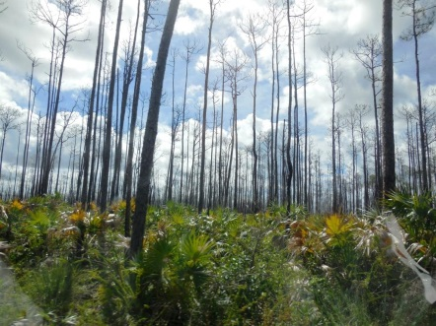
Determine if you are inventorying or monitoring the population as it exists, as it was in the past, or what you think it will be in the future. For example, here is an image of an area of dead trees in the Bahamas that were killed due to storm surges of salt water. In the past this would have qualified as forest land. Would you include this area as part of the forest population today?

Below is an image of a pine plantation in Manassas, Virginia. As it exists at the time the photo was taken, the area would not have met the definition of forest as the crown closure was not dense enough and the trees not large enough to qualify. In ten years hence, the area would qualify as forest. So, would you include this area as forest in your inventory. Four years after this image was taken, the area was paved over to make a parking lot for a local hospital.
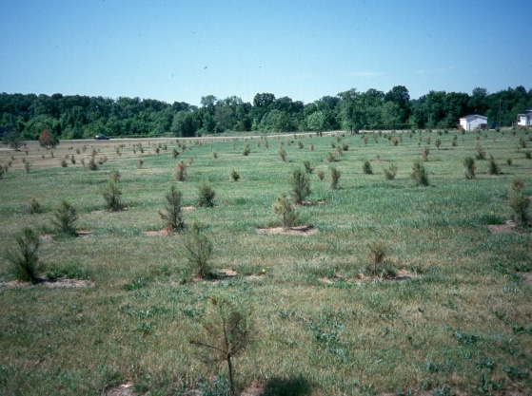
Page 17 - Identification and specification of variables to be recorded
- What do you need in the way of tables? What are the column and row headings? Why? Who will use them? How?
- What does one have to measure/observe to fill in the columns and rows?
Page 36 – Field Work Planning
- What will the inventory cost be and do you have enough funding? The costs depend on several things, including existing available resources. Some general resource requirements include:
- Forest survey and inventory officers
- Remote Sensing, Remote sensing/GIS officers
- Database management system and manager
- Appropriate equipment, hardware, software
  - Per person
    - Hard hat
    - Clinometer
    - Compass
    - Bark scribe
    - Vest
    - Increment hammer
    - Ruler
    - Aluminum tags for numbering trees
    - Stakes for marking plot center
    - Diameter tape
    - Pencils
    - Canteen
    - Hatchet
    - Insect repellent
  - Per crew
    - Radio/telephone
    - Data Recorder or Tatum
    - GPS
    - Loggers tape
    - First aid kit
    - Truck
- Financial resources for training, field data collection
- Appropriate sampling methodology for ground data collection
- Standardized metadata, projections and work flow processes
- Administrative infrastructure for the implementation of demarcation and description of forest areas
  - Cost of Field Work - A formula to determine the cost of a field plot: F = CW{[L + (M) + D} Where
    - F = The field cost in dollars for a single plot
    - C = The size of the field crew
    - W = Hourly wage per person in dollars
    - M = The time per crew to measure each sampling unit (plot) in hours
    - L = The travel time between sampling units (plots) in hours
    - D = The daily travel time to and from the inventory unit in hours.
  - To determine field cost to measure all plots within an inventory unit Multiply F X N to get the total cost of field work minus equipment, subsistence, travel and transportation expenses where:
    - N = Number of sampling units to be measure
      - The formula for determining the number of plots needed to meet a desired sampling error and a desired confidence level is as follows:
      - N = (t²CV) / E² where n = number of plots, CV = coefficient of variation, E = sampling error (%), and t = student’s ‘t’ statistic.
      - For the Bahamas – Assuming a desired accuracy of +/- 15% at 2 standard deviations (t = 4) and a coefficient of variation of 43% (largest cv reported) –
      - N = 4(43²)/15² = -7396/225 = 32.9 or 33 plots required for the resulting true value of the estimate to be within +/- 15%, 95% of the time.
      - Here is formula to estimate what the sampling error would be given n number of plots.
      - E² = (t²CV)/n. Using the 43% coefficient of variation, a ‘t’ of two; Here the estimated sampling errors for 30 and 200 plots.
      - For 30 plots
      - E² = 2²(43²)/30 = 4 x1849/30 = 7396/30 = 247 ; √E = 16%
      - Thus if you establish 30 plots you can expect to be within +/- 16% of the true value 95% of the time.
      - For 200 plots
      - E² = 2²(43²)/200 = 4 x1849/200 = 7396/200 = 247 ; √E = 6%
      - Thus if you establish 200 plots you can expect to be within +/- 6% of the true value 95% of the time.
Page 38 – Data management, data analysis and reporting
Be sure you have the needed programs and software tested, up and running before you start collecting field data. This will help double check that you are collecting the needed data and ensure you can produce results in a timely manner. In one of the timber inventories that I helped with it was two years after the field work was completed that we were finally able to process the data.
References
Anonymous. 1992. Earth Summit Agenda 21 The United Nations Programme of Action from Rio. New York, NY: United Nations. 294 p.
Anonymous. 1993. Documents of the Earth Summit (Diskette). Rectors of the Costa Rican Public Universities.
Lund, H. Gyde. 1985. Designing inventories to support multiple decisions. Prepared for: Proceedings; Gli inventari delle risorse forestali: strumenti conoscitivi per i processi decisionali; 26 April 1985; Venice, Italy. 11 p.
Lund, H. Gyde. 2002. The Information Needs Assessment (INA). ETFRN News No. 36:8-15. European Tropical Forest Research Network, Wageningen, The Netherlands.

Thank you once again for the opportunity to review this document.
Cheers, Gyde.

