Pulses for the Health of the Planet
Pulses are nutrient-dense crops that improve human diets, while their unique ability to fix nitrogen in the soil is valuable in crop rotations and for sustainable natural resource management. Several pulses are also resilient to adverse climate such as drought and heat, and grow in the dryland regions of the world. This makes them important food crops that adapt easily to the rising temperatures and increasingly frequent droughts under the changing climate of the planet.
Pulses are rich in protein, oil, and micronutrients including iron and zinc. They supply amino acids that are deficient in cereals, sharply improving protein quality when eaten together. The high iron and zinc content is especially beneficial for women and children at risk of anemia. Pulses also contain bioactive compounds that show some evidence of helping to combat cancer, diabetes and heart disease. The exceptional palatability of pulses is important. For example, as severely malnourished children lose their appetites, chickpea paste is used as a base ingredient in emergency famine relief foods.
Pulses can biologically fix nitrogen from the atmosphere, thus meeting their own nitrogen fertilizer need. This reduces both the costs and the environmental impacts of chemical fertilizer use. Inclusion of pulses in farming systems increases the effective capture, productive use and recycling of water and nutrients such as the end-of-season residual soil moisture in maize, rice and wheat fallows.
Pulses thus have important roles in human diet, on the farm and for the sustainability of agriculture.
Some of the planet’s most commonly consumed pulses are Chickpea, Common Bean, Cowpea, Faba bean, Lentil and Pigeon Pea.
Chickpea is the world’s second-largest cultivated food legume, with developing countries accounting for over 95% of its production and consumption. Chickpea grain is an excellent source of high-quality protein, with a wide range of essential amino acids, and the crop has a high ability to fix atmospheric nitrogen.
Common bean is the most important grain legume for direct human consumption with 23 million hectares grown worldwide, and approximately 12 million metric tons produced annually, of which 8 million tons are from Latin America and Africa. In the developing world beans are smallholder crops, and in Africa these are cultivated largely by women. Annual consumption is as high as 66 kg per person, and in many areas common bean is the second most important source of calories as maize.
Cowpea is the most important grain legume crop grown in sub-Saharan Africa, where it is mostly grown in the hot drought-prone savannas and very arid Sahelian agro-ecologies. Cowpea is a protein-rich grain that complements staple cereal and starchy tuber crops, and is highly drought tolerant.
Faba bean is one of the oldest crops domesticated in the Fertile Crescent of the Near East, expanding around the world during the Neolithic period. It is consumed as boiled grains and as vegetable green seeds/pods, dried or canned. It has a protein content of 24-30 per cent, more than three times that of cereals. Faba bean is a staple breakfast food in the Middle East, Mediterranean region, China and Ethiopia.
Lentil is one of the world’s oldest cultivated plants, originating in the Middle East, and spreading through Western Asia into the Indian subcontinent. The crop has great significance in cereal-based cropping systems because of its nitrogen fixing ability, its high-protein grain, and its straw for animal feed. Protein content ranges from 22-35 per cent.
Pigeon pea is a staple grain legume in South Asian diets and is also widely grown and consumed in household gardens of Africa. With protein content ranging above 20 per cent, pigeon pea plays an important role in nutrient-balancing the cereal-heavy diets of the poor. Pigeon pea is also important in some Caribbean islands and some areas of South America where populations of Asian and African heritage have settled.
The CGIAR Research Program on Grain Legumes is a global partnership invested in agricultural research on pulses from the lab to the field to the farm to increase their productivity, and to further enhance their climate adaptability and soil-nitrogen-fixing capacity. The partnership includes four CGIAR Centers (International Center for Tropical Agriculture [CIAT], International Center for Agricultural Research in the Dry Areas [ICARDA], International Crop Research Institute for the Semi-Arid Tropics [ICRISAT], and, International Institute of Tropical Agriculture [IITA]) working hand-in-hand with National Agricultural Research Systems and other strategic partners to deliver improved pulse varieties to the small-holder farmers of Africa, Asia and Latin America. The program aims to improve food and nutrition security, income and sustainable natural resource management of smallholder farmers that grow chickpea, common bean, cowpea, faba bean, groundnut, lentil, pigeon pea and soybean.
Early-Maturing Chickpea in Myanmar and India
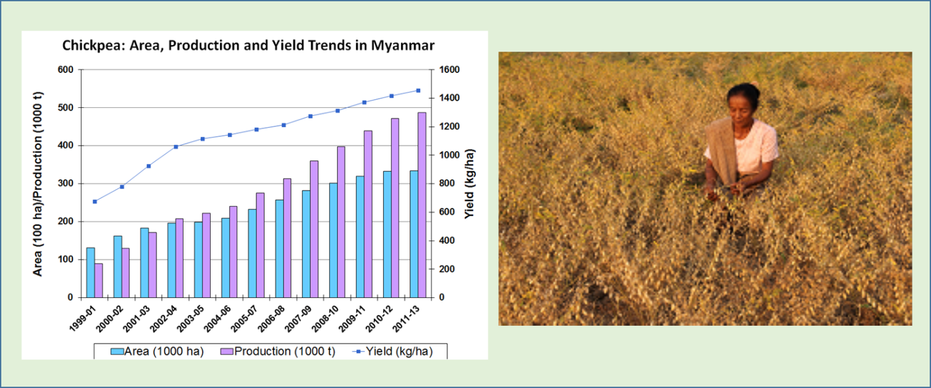
Over 95% of the chickpea area in Myanmar and Andhra Pradesh is now under early-maturing varieties. During a period of 15 years from 1999 to 2013, the chickpea production has increased 7.2-fold in Myanmar and 5.8-fold in Andhra Pradesh. This is the result of a 3.3-fold increase in area (101,000 to 335,000 ha) coupled with a doubling of productivity (670 to 1460 kg/ha) in Myanmar, and a 4.7-fold increase in area (146,000 to 680,000 ha) together with 25% increase in productivity (890 to 1115 kg/ha) in Andhra Pradesh. Myanmar restarted export of chickpea in 2001 after almost no export for over two decades. The country has exported on average 50,000 tons of chickpea (valued at US$ 24.0 MM) every year since 2001. Andhra Pradesh is helping India meet its domestic demand that continues to remain higher than the domestic production. The chickpea varieties developed and released for early maturity, high yield, and resistance to Fusarium wilt by ICRISAT and national partners in India and Myanmar directly contributed to this changing trend.
Wilt-Resistant Pigeon Pea in Eastern and Southern Africa
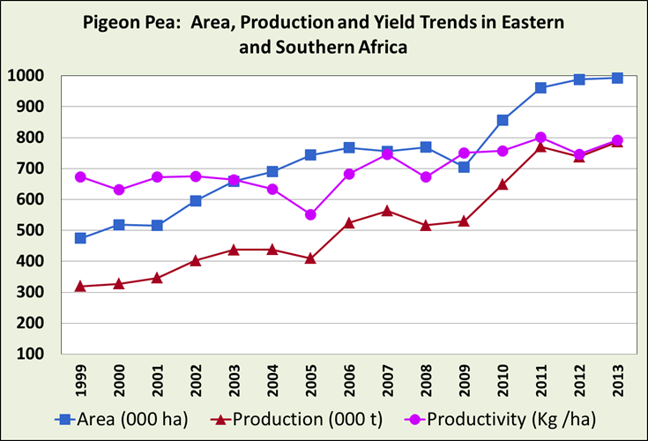
During the last fifteen years, the area and production of pigeon pea in Eastern and Southern Africa have increased by 109% and 146%, respectively. Countries in the region export about 200,000 t of grain/year valued at $ 140 MM. Traditional pigeon pea varieties in Eastern and Southern Africa that have been low-yielding and late-maturing, with susceptibility to pests and diseases, are now replaced with 32 improved varieties that are high-yielding, early maturing and resistant to Fusarium wilt. These varieties, developed and released by ICRISAT and national partners, have had rapid adoption in Kenya, Malawi, Mozambique, Tanzania and Uganda, increasing the incomes of smallholder farmers.
Extra-Short-Duration Lentil for Rice-Based Cropping Systems in Bangladesh
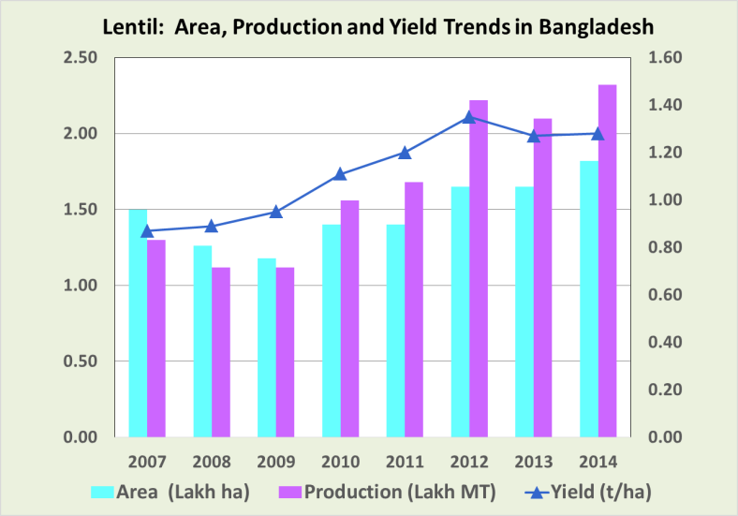
Lentil (Lens culinaris Medik. ssp. culinaris) has been an integral part of the rice-based cropping systems of the Indo-Gangetic plain of South Asia, mainly because of its ability to thrive comparatively well under water-limiting environments. The rice-rice system provides a short-season window of 100-110 days in which an extra-short-duration lentil variety (90-100 days) can successfully be grown. Similar opportunity also exists in the fallows of the rain-fed rice-growing areas that are dominated by medium to long-duration rice varieties. The top-soil layer generally dries completely at the time of the rice harvest reducing the feasibility of a post-rainy season crop. Under such limitations, extra-short-duration lentil varieties provide an excellent opportunity to increase lentil production and sustain productivity of the rice-based systems by converting the mono-cropped rice areas into double-cropped areas. The increased adaptability of these varieties to marginal soil conditions helps to increase overall system productivity, sustainability and profitability. ICARDA, together with national partners in South Asia, has combined extra-early maturity of lentil with agronomic traits by pre-breeding to identify extra-early segregates and their utilization within the mainstream breeding program. Adoption of these varieties (BARI M4, BARI M5, BARI M6 and BARI M7) by Bangladeshi farmers has led to an increase in lentil production from 119,639 tons in 2011 to 173,886 tons in 2015, the annual growth rate being 10.9%.
Heat-Tolerant Beans
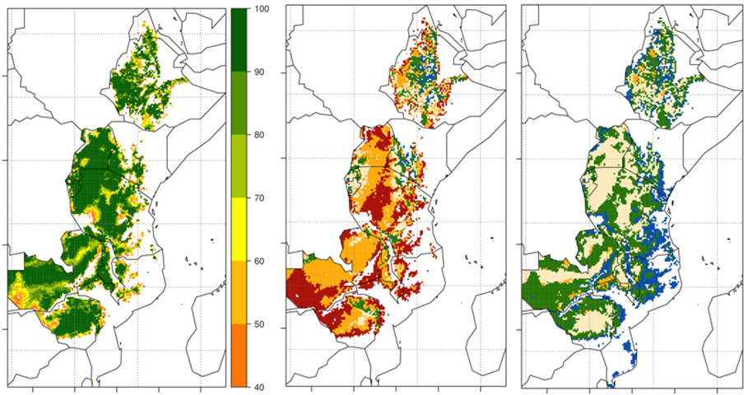
Major effects of high temperatures on common bean (Phaseolus vulgaris L.) are expressed as inhibition of pollen fertility. Modelling of the adaptability of current common bean cultivars suggests that rising temperatures will likely disrupt bean production in Nicaragua, Haiti, Brazil, and Honduras, while in Africa, Malawi and the Democratic Republic of the Congo would be the most vulnerable, followed by Tanzania, Uganda, and Kenya. A field evaluation of more than 1000 materials under high temperatures by CIAT in Colombia identified about 30 experimental breeding lines with superior production. Most of these lines were derived from interspecific crosses of common bean with a sister species, the tepary bean (P. acutifolius), a little known crop from the deserts of Mexico and southwest USA. Some of these breeding lines maintain pollen viability with up to 5ºC higher night temperatures than those normally considered to be limiting (18ºC at night). A modelling exercise to estimate the benefits of this heat tolerance was undertaken using the EcoCrop model, assuming a more conservative genetic gain of adaptation to 3ºC higher temperatures. The analysis indicates that heat tolerant bean varieties would counter most (if not all) of the negative impacts of climate change (Figure 1). While currently cultivated bean varieties are projected to suffer a 20-50 % loss in suitable area by 2050s, heat tolerant breeding lines are projected to suffer little (< 5%) or no suitability loss by the same period. Even by the end of the century, improved lines show < 10 % area loss. Thus, enhancing the capacity of common bean to resist high temperatures through interspecific crosses is a very promising adaptation strategy globally. EcoCrop, however, is a very simple model of climatic suitability that does not account for daily extremes and does not provide any indication of potential impacts on crop productivity. Therefore, further work is required to determine the extent to which daily extremes can limit the potential benefits shown here; and also to quantify potential productivity gains associated with heat tolerance improvement.
Historical and future (2050s) common bean suitability simulations for East Africa Left: suitability of currently cultivated common bean for historical climate; middle: projected impact of climate change for control (no-adaptation) simulations; and right: projected impact of climate change for adapted common beans. For middle and bottom panels: red=areas that become unsuitable, orange=areas that remain suitable but reduce their climatic suitability, beige=areas that stay suitable with equal suitability to historical, green=areas that stay suitable but increase their climatic suitability, and blue=new areas.
Combining Bio-Pesticides for Cowpea Pest Management
The bio-pesticide, neem oil, is usually sprayed as a bio-pesticide either as pure oil or mixed with lighter oils to facilitate its application by spin-disk sprayers. This method is not suited for crops with lower growth habit such as cowpea, because of the high losses due to drift, neither can neem oil alone keep under control the various insect pests attacking cowpea. Over the last few years IITA and partners have developed the application of neem oil in emulsifiable form which can be mixed with other compatible bio-pesticides. The mixture of emulsifiable neem oil and the pod-borer specific Maruca vitrata Multiple Nucleopolyhedrovirus (MaviMNPV) from the World Vegetable Center (AVRDC) was first tested in the lab, with encouraging results, and subsequently in the field. The combined effect of the neem oil on aphids and thrips, and that of the virus on the pod borer, sometimes exceeded the control achieved by a standard chemical pesticide. These results have been confirmed by large field trials by national partners in Burkina Faso and Niger.

