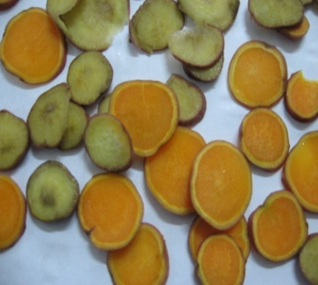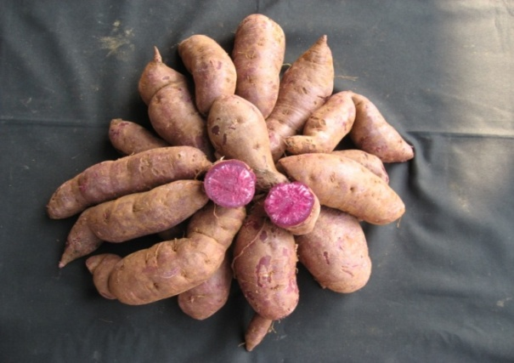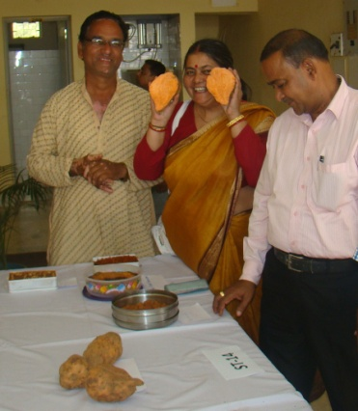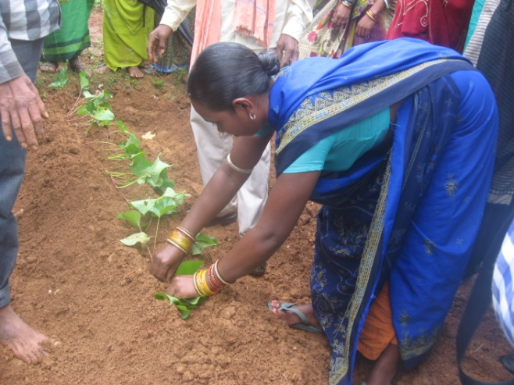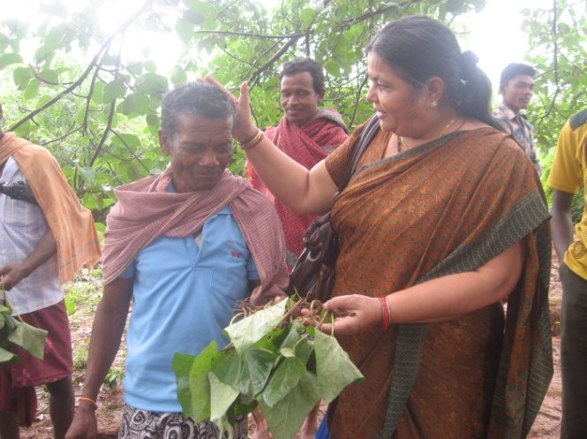

**Fig.5. High starch, anthocyanin rich ST-13 sweet potato is spreading across the country for food and nutrition**

**Fig.4. Training imparted by Dr. Archana Mukherjee to SHGs on white and orange flesh chips of sweet potato for household food, nutrition and livelihood through Ram Krishna Mission, Ranchi, Jharkhand**

**5**

**4**

**3**

**2**

**1**

**Fig.3. Interactions on sweet potato variety ST-14, its products, on 27th December 2013 during tuber crops based livelihood improvement training programme**

**Figs. 1-2. Training on ‘ST-14 beta carotene rich orange flesh sweet potato based livelihood programme’ in Koraput, Odisha, India**

**Interactions on sweet potato variety ST-14, its products, on 27th December 2013 during tuber crops based livelihood improvement training programme**