Call for lessons and good practices on investments for healthy food systems

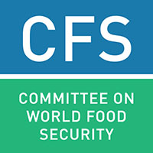
Template for submissions
(Approximately 1000 words in total)
Please use this submission form to share your examples and experiences on investments promoting healthy food systems for improved nutrition. For the necessary background and guidance, please refer to the topic note: www.fao.org/fsnforum/activities/open-calls/investments_healthy_food_systems
You can upload the completed form to the FSN Fourm www.fao.org/fsnforum or send it via email to fsn-moderator@fao.org.

Proponent
Christoph Lindinger
e-mail: ch.lindinger@gmail.com
phone: +260 962 653100
Date/Timeframe and location
23/04/2014 up to date
Choma District, Southern Province , Zambia

Main responsible entity
Yumi Milling Ltd
PO Box 630683, Choma, Zambia
yumimilling@outlook.com

Nutrition context
Yumi Milling Ltd aims to develop an agricultural cluster in a rural community in Southern Zambia. Built around the milling of maize, we aim to integrate as many local farmers and their families into our value chains. We promote crop diversification and we aim to increase the availability and affordability of nutritious food products to schools and private persons.
We aim to help small scale farmer to venture in more profitable agricultural value chains, such as poultry and dairy, which will also help to ensure food security and the nutritional standard of the surrounding community.

Key characteristics of the food system(s) considered
The core of our food system is the integration of smallholder farmers into our value chains, therefore increasing their income and their nutrition.
The by-products of the processing of maize and oil seeds will ensure affordable feed and short distances will ensure optimum efficiency.
We plan to implement a community feedlot which will work similar to a warehouse receipt system. Farmers will be given the opportunity to access short term loans for farming inputs.
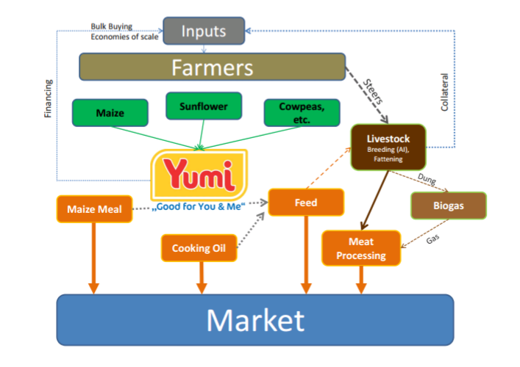

Key characteristics of the investment made
Our efforts are so far financed solely privately. We haven´t received any support form NGO´s or other institutions.
We are currently in the process of applying for a grant from Innovations Against Poverty (IAP) since we reached a stage where we would need support to grow YUMI and serve even more farmers in the community.

Key actors and stakeholders involved (including through south-south/triangular exchanges, if any)
Christoph Lindinger (German) – Founding Director
Nickson Ndawa (Zambian) – Director and Administrator
Enock Siankwilimba (Zambian) – Advisor, MUSIKA

Key changes (intended and unintended) as a result of the investment/s
Dairy farmers can access affordable local feed and increase their milk output. Poultry businesses are thriving in the surrounding.

Challenges faced
Working capital is very expensive in Zambia. We are competing with some big milling companies and we do not have the financial muscle to stock up enough maize during the marketing season. In order to grow sustainably and reach more farmers we will need to come up with solutions to buy enough maize between June and November in order to work throughout the rainy season.

Lessons/Key messages
Private investments can start development initiatives in the food sector, but any company faces a point where it needs external sources in order to exploit given growth opportunities. Food processing is capital intense and it needs to be supported.

