Public-Private Partnership for addressing the challenges faced by rural youth aged 15 to 17 in preparing for and accessing decent work

The present document is intended to share the knowledge produced throughout programs development and implementation by the Extension and Education Services at the Lebanese Ministry of Agriculture which are targeting the youth, thereby sharing lesssons learned and the challenges to be still addressed. For this a brief description of the releant lebanese context will be described.

The Lebanese population is young, with 44 per cent of residents below 24 years old (Yaacoub and Badre, 2012). Around 85 per cent of residents live in cities. The male/female sex ratio at birth is 1.05 and for the working age population of 15-64 is 0.95 . Rural urban migration rate stands at around 84 migrant per 1000 population , where 76.3% of migrating population are male and 23.7% are females .
At present, the overall unemployment rate in Lebanon stands at 24 percent with youth unemployment exceeding 35 percent. Young Lebanese are ‘discouraged’ from working and aspire for out-migration. Inactivity rates of the youth in Lebanon are high, registering 70 per cent in 2013 compared to a global average of 52.6% . This is aggravated for female youth.

The Lebanese economy is being profoundly affected by the crisis in Syria. While slowing output and employment growth and declining worker productivity and per capita GDP were pre-existing trends, the disruption of trade routes and tourism, the influx of refugees and greater political instability caused by the crisis have created added burdens. Lebanon is currently facing a critical unemployment situation, compounded by political instability both at the regional and national levels, and made worse by the influx of approximately 1.5 million refugees from Syria (equivalent of nearly more than 25% of the Lebanese population). They are mostly concentrated in rural agricultural districts or locations.
As FAO reports reveals, the increased stress on resources, water and food, with a decline in income and economic activity is adding tremendous strain on neighbouring countries at the national, local and household levels. The report estimated that It is estimated that there are some 30 000 poor smallholder Lebanese returnees who have been farming inside Syria for generations. These highly vulnerable returnees are now hosted in some 136 villages of all districts bordering Syria, most of which represent the poorest areas of the country that were already the target of the Government of Lebanon‟s social safety-net programmes prior to the Syria crisis
Despite the efforts of the Lebanese authorities, generous Lebanese citizens, UN agencies, and international and national aid organizations, this overwhelming influx of refugees has created intense stresses, as refugees find themselves having to take on new roles and responsibilities that are often at odds with their traditional gendered social roles.
In agricultural rural areas labor market is essentially characterized by full-time family farm operators who rely, to a large extent, on seasonal family laborers and hired workers. The large majority of paid seasonal workers are Syrian migrant workers. These latters are of two categories to be noticed : (1) Syrian Migrant Workers – Women and men of Syrian nationality who have been working as agricultural labor in Lebanon for several years, namely in agricultural production, post-harvest handling or food processing; and (2) Syrian Refugees Both women and men Boys and girls who have been displaced from Syria due to the conflict; they are either working or available to work as agricultural laborer in Lebanon. Indeed, an estimated 10% of the refugee population has previous experience in agriculture . Around 20% of refugee families are finding employment in agriculture. The agricultural skills of refugees can enhance the agricultural sector in in the same time bring additional pressure and competition to the agricultural labor market.
In a UN report (2014) that was exploring the Lebanese youth situation as was affected by the Syrian crisis, of all Syrian refugees fleeing to Lebanon,
The distribution of surveyed youth by sex shows patterns similar to those of the general refugee population, where the number of female youth is significantly higher than that of male. The Female to male ratio reaches 2:1 in the 19-24 age group. Youth occupations are somewhat gender-segregated, with jobs of females predominantly being in agriculture (highest in the age group of 15-18 year old) as seasonal agricultural laborers, bakeries and factories, and in childcare. However, these female workers get almost 30% of their male counter parts and almost half of the rate of ther peer Lebanese female worker.
Over half of young refugees in the workforce are employees; around 45 per cent are daily and/or seasonal workers, mostly in agriculture and construction. The surveyed refugee youth turned out to be mostly in elementary occupations. Youth occupations are somewhat gender-segregated, with jobs of females predominantly being in agriculture (with the age group of 15-18 followed by the age group of 19-24), bakeries and factories, and in childcare. Overall, both males and females are employed as daily and seasonal workers in rural areas, especially close to the border with Syria.
On the other hand the Lebnese Farming is aging, the average farming age being 52 year old for male and 55 year old for femalefarmers. Neverthesless, some subsectors are found to be better attractive to the youth. They would find the incentives and motivations to pursue these farming activties as decent work or business for life (Organic farming, Farming activties linked to eco-tourisms, Beekeeping, vegetable production, ...). Young rural residents need to see agriculture-related activities as viable and attractive livelihoods that are profitable thereby match their aspirations and no more linked with poverty as was the case for their ancestors. The interest of youth need to be supported through new profitable agriculture applications and concepts, which provide solutions to the value chain and to end-users practices while as the same time providing attractive sustainable business where rural youth can engage in stay on their land and do not flee to urban areas seeking better job opportunities. As FAO is suggesting “Youth can be the drivers of agricultural and rural transformations that create more inclusive and sustainable food systems”. In Lebanon they are considered to be the power of change and as such they are to be the future of food security and poverty reduction.
In order to attract and retain youth in agriculture the sector need further to be correlated with ICT and technology revolution as it is used in other enterprises.

Lebanese youth in agriculture are, as their peers worldwide are facing challenges in accessing proper knowledge, and education; factors of production and decent work or jobs, markets access, social protection and safety nets, as well as opportunities or platforms to participate in policy dialogue and or rural organizations. On top of that the Lebanese youth in general and the rural in particular suffer inequity in job offers. Structural reforms in the public sector and new policies are needed to enforce rural youth participation allowing merit based recruitment. This frustrating fact is forcing the Lebanese youth to migrate. As such the government need to assume responsibilities and work on strengthening its vocational centers in the rural areas and link it to finance and market opportunities.

Rural youth of age less than 18 usually are at risk of transition from school to work or dropped out of schools. They can also be sometimes as weak to follow regular academic schools and face Lebanese taboo against following vocational training, especially in agriculture. When social norms considers vocational education is only for “losers”. We have a surplus of doctors, engineers and lawyers that the country can hardly absorb, but a lack of specialized skilled workers.

Unemployed youth are unaware of potential job opportunities and thus, their knowledge and skills do not correspond to the needs of the Lebanese job market. Contributing factors to these problems are: lack of provision of opportunities for life skills development for out-of-school youth and absence of a plan that identifies the skill and specialization needs of the labor market in the middle or long term. Curricula throughout the education system should be adapted to actual and future labor market needs to help achieve job creation. There is a structural gap between needs and competence. To close this gap, vocational training should be totally reviewed and restructured in close collaboration with the private sector, so as to ensure that appropriate and sufficient skilled labor is available in line with market demands. what is also essential to development is small- and medium-sized agricultural enterprises along with policy reforms that would set enabling envirnonment for such investments and niche market.
Weak representation of youth in the agriculture sector, low wages for agricultural workers in general and, unequal pay, discrimination in working conditions between boys and girls and moreover prevalence of child labour are now more prevailing. The latter is especially true when it comes to agricultural work where a significant number of Lebanese and non-Lebanese children are active in the fields. According to UNICEF, there are currently more than 300,000 out-of-school Syrian refugee children in Lebanon, with 38% are in the age group of primary schooling.

In such a humanitarian context there remain challenges facing the displaced youth and these include separation from social and community networks, including family; discontinuation of formal and non-formal education; loss of livelihood; lack of, or weakened security and protection mechanisms and networks; disruption of, or decreased access to health services; adaptation to a new environment; and increase in daily free time - all of which may pose a risk for youth in the long run.

Child labor is not new in Lebanon. At the Lebanese farm households these were considered as family labor assets. The difficult economic situation of Lebanese and Syrian refugee households and the fact that the cost of living in Lebanon is considerably higher than in Syria, have dramatically exacerbated the problem of child labour. Consequently, hundreds of refugee children were left with no choice but to work in order to contribute to their families’ basic needs. Due to economic constraints, access to free education has become more and more challenging among Lebanese and Syrian households.
A rapid assessment done by ILO (in Akkar agricultural area of Lebanon) revealed that child labor, including the worst forms of child labour, is a critical issue and cannot be overlooked, this is critically shown among the Syrian refugees. They are being exploited by key mediators (:“Shawish” in Arabic) who act between them and their employers. The Shawish sets conditions on farmers looking for workers in informal settlements in terms of cost of labor and workers to hire. In particular, they force farmers to hire children as pre-conditions to provide adult laborers. In addition, Shawishes usually deduct a certain amount from workers’ labor fees and/or collect the livelihood subsistence allowance cards from Syrian families as a compensation for their employment mediation services.

Most children are working long hours between 6 and 12 hours per day, even sometimes during the night (after midnight until dawn, in particular during hot weather at greenhouse sites) and in some cases not allowed their entitled resting hours let alone not receiving a sufficient quantity of food; jobs are mostly informal, with no written contracts and little or no protection. Very often children are exposed to various risks and hazards during their work. This includes carrying heavy weights, working with and around dangerous farm machinery (aged and homemade machinery to extremely specialized and designed to perform many different tasks) with no proper guards and shields, boarding dangerous machines (tractors and open pickups). Harsh climate conditions, excessive noise and vibration, chemicals, infectious agents, dust and other organic substances are also among the risks and hazards that children are exposed to. The same dangers that are present to hired farmworkers hold further danger to the sons and daughters of those farmers. Since the effects of child labour are not limited to children themselves (even if they bear the biggest consequences) but stretch to the whole community, there is a high need to raise awareness among various actors related to implementation of legislations, applying measures of protection and providing access to available services (where to go in case of support needed).

The MOA being in the process ofstregnthenigand revitalizing its vocational education affiliated to the Education and Extension Services (EES) of the Directorate of Studies and Coordination in the General Directorate for Agriculture. MOA inlcuded in its agricultural strategy (for the period 2015-2019) policy directives for vocational training and extension and education services that are based on public-private perntnership where Education and Advisiory services are delivered based on a pluarlistic approach and schools curricula are to be linked to labor market. MOA has been engaging in partnership with relevant partners including FAO, ILO, UNICEF, and NGO’s especially AVSI.
Efforts were to contribute to adressing the challenges faced by Rural Youth aged 15-17 |(actually inlcuded 15-24 old age group), through developing its vocational eductaion system building on extensive collaboration with private non governmental partners including donor communities and UN Agencies (AVSI, EU, UNICEF, FAO and ILO).

EES is conducting TOT training on OSH in agriculture with FAO and ILO. For this a training guide in Arabic on child Labor and OSH in agriculture was elaborated for practitioners with ILO. It has further contributed to the production of an illustrative visual guide on how to protect children from pesticides for FAO Publications.
Supported by ILO MOA has been working with Ministry of Labor for advocacy and awareness against worst forms of child labor and held regional platforms and training in collaboration with the civil society.
MOA is implementing a program aiming at revitalizing its vocational schools to efficiently preform their services in joint implementation with AVSI and above mentioned actors. MOA is now revising its schools curricula based on Educational level of the youth working in agriculture (with AVSI-UNICEF partnership) and Labor market study (AVSI partnership with the Italian cooperation funds). This is in the objective of upgrading skills and competencies of the youth in the agricultural sector while matching training packages and curriculum with the employers and agricultural industry requirement.
The main critical lesson learned thoroughout these programs in addressing the needs of youth is governent commitment and leadership role tht the government should assume along the engagment of non-governemental actor with serious competent efficient drivers for work (as AVSI) and establishing public-private efforts to acheive collective efforts, therey pooling the resources and pooling tand efficient involvemenet of stakeholders including UN agencies.

Case Study: MOA-AVSI Project (ENPI 2013/323-965)

Zeinab a young female along with four other young peers aged less than 18 were able to have job opportunities following engagement in technical agricultural and life skill vocational training program.

Project name:
Peaceful And Comprehensive Education in seven district of Lebanon – PE.A.C.E.” (ENPI 2013/323-965) funded by EU (project started in 2013 and ended in 2015)

Overall Objective:
The overall objective is to contribute to the improvement of technical and human skills of Syrians and Lebanese students by promoting a peaceful coexistence in seven agricultural technical schools in Lebanon.
Implementers involved:

MOA its central eduction and extension services and the 7 vocational schools
AVSI Foundation, is an international non-profit, Italian non-governmental organization in Italy created in 1972, and has been working in Lebanon since 1996, implementing more than 50 projects (agriculture and water, educational, humanitarian and emergencies interventions).
Partners:
BILADI, a Lebanese NGO in charge of the elaboration of a course related to the rural heritage and the conservation of the traditional knowledge through the development of training material and practical activities.
Minoprio An Italian technical school, in charge of the elaboration of the short course curriculum and training for the school teachers;
Private companies, (SEEDS, Debbane) and other 71 private employers (nurseries, agriculture shops, veterinary pharmacies, gardening/landscaping, irrigation and large scale farming) were contacted for students’ internships.
Beneficiaries: Lebanese and Syrian students aged 15-24 (280 students were trained)
Sucess Acheived:
Following the training program and after following internship agreement with the private employers, 5 work opportunities were made avilable to the program garduates.
Debbane-Agri a large company of 6 branches and 4 trial stations in Lebanon that sells seeds, fertilizers, irrigation systems, crop protection products, greenhouses, agriculture equipment, public health and pest control products and post-harvest products and has floral shops. Even more, Debbane Agri is a sister company of Exotica and Enoteca two well kown companies in the flower and wine industries. Debbaneh was able to fulfill its needs selecting 2 apprentice florists and 2 technicians for their trial stations from among these project garduate students.
Zeinab also before her enrollment, was working as an agricultural daily workers in the SEED bound agricultural private company. Providing her with opportunity helped her self motivation, perseverance and strong will to improve and develop her skills. After completing her training and obtaining the certificate of achievement and due to Zeinab got full time job. Using her new skills got a better position andwas even assgined with the task of supervising the rest of the workers. Zinab is now trongly involved in the preparation and implementation of all the exhibitions in which Seed Bound is holding.
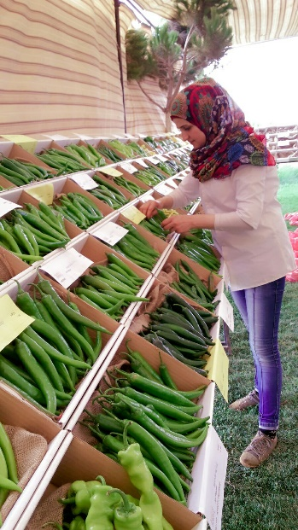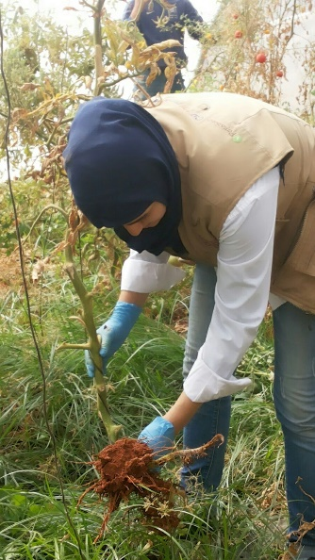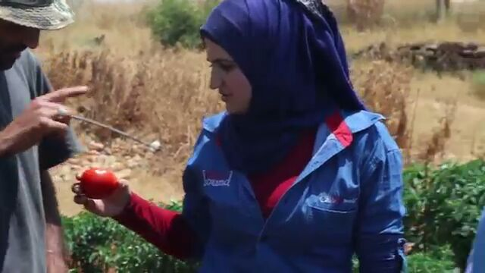
Reference PEACE Project (ENPI 2013/323-965)/MOA-AVSI: Zeinab Shokor during her work at Seed Boound Sareen - Lebanon

Abir Abul Khoudoud
EES-MOA
May 2016
Still a lot to Share!!!

OECD Development Center, 2014.
MOA, 2015. Ministry of Agriculture 2015-2019.
CAS, 2009.
Salem Ajluni and Mary Kawar, (2015) Towards Decent Work in Lebanon: Issues and Challenges in Light of the Syrian Refugee Crisis. ILO
FAO (2013), Agricultural Livelihoods and Food Security Impact Assessment and Response Plan for the Syria Crisis in the Neighbouring Countries of Egypt, Iraq, Jordan, Lebanon and Turkey
International Rescue Committee, Save the Children, Danish Refugee Council, OXFAM, and UKaid, Emergency (2013). Market Mapping and Analysis (EMMA) of the Agricultural Labor Market System in North and Bekaa, Lebanon. Recommendations for Growing Livelihood Opportunities for Refugees and Host community families (April 2013).
UNFPA , et al (2014). Situation Analysis of the Youth in Lebanon Affected by the Syrian Crisis.
ILO UNICEF, AND (2016), Concept Note for an advocacy workshop to support risk reduction of child labour within the Agriculture Sector in Akkar region.

