Call for lessons and good practices on investments for healthy food systems

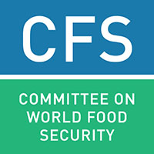
Template for submissions
(Approximately 1000 words in total)
Please use this submission form to share your examples and experiences on investments promoting healthy food systems for improved nutrition. For the necessary background and guidance, please refer to the topic note: www.fao.org/fsnforum/activities/open-calls/investments_healthy_food_systems
You can upload the completed form to the FSN Fourm www.fao.org/fsnforum or send it via email to fsn-moderator@fao.org.

Proponent

Date/Timeframe and location

Main responsible entity

Nutrition context

Key characteristics of the food system(s) considered

Key characteristics of the investment made

Key actors and stakeholders involved (including through south-south/triangular exchanges, if any)

Key changes (intended and unintended) as a result of the investment/s

Challenges faced

Lessons/Key messages

