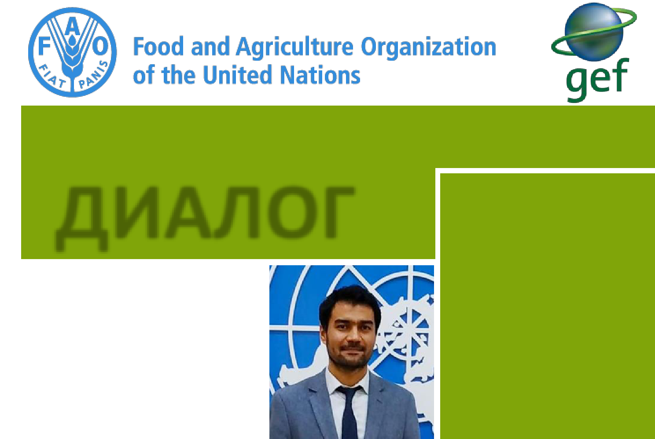

Newsletter No. 1
DIALOGUE

Dear partners, friends and colleagues,

We are happy to present the first quarterly newsletter of the CACILM-2 Project.

This newsletter aims to inform our partners and like-minded people in Kazakhstan, Kyrgyzstan, Tajikistan, Turkmenistan, Uzbekistan, and – possibly, in the near future Turkey – about the project’s activities, new practices and technologies being introduced in member countries, results achieved and how the project will affect the lives of people in the region.

We hope that the information shared will be useful and can be put into practice.

We also invite you to submit articles for publication on the sustainable use of natural resources in Central Asia and Turkey, on practices and approaches to adapt to climate change, reverse soil degradation and deforestation, and on how to promote the efficient use of water resources. I believe that together we can build a platform for discussion to find best practices and approaches to preserving the environment and improving agricultural efficiency in our countries.

FAO/GEF Project
“Integrated Natural Resources Management in Drought-prone and Salt-affected Agricultural Production Systems in Central Asia and Turkey” (CACILM-2)

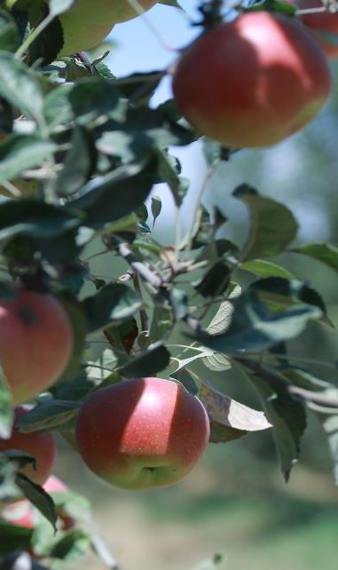

Best regards,

Makhmud Shaumarov,

Regional Project Coordinator, CACILM-2
^{Photo:FAO}

CACILM-2 May 2020

In this issue:

A targeted and individual approach to each country: An interview with Makhmud Shaumarov, Regional Project Coordinator, CACILM-2

Regional implementation of the FAO-GEF Project on Integrated Natural Resources Management

Kazakhstan is carrying out research on climate change-induced natural disaster risk management

“Adapting to change is our national objective”: An interview with Matraim Zhusupov, National Project Coordinator in Kyrgyzstan

Strengthening partnership within the framework of the Plant a Million Garden Trees campaign in Uzbekistan

Tajikistan plans to sow more drought-tolerant crops this year

Mission to Turkmenistan

Project allocates KGS 12 million to support Kyrgyz farmers affected by COVID-19

In brief

Calendar of CACILM-2 events for June-August 2020

Contacts
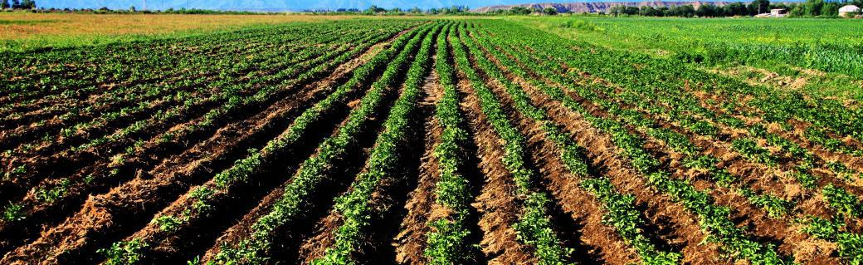

Photo: FAO Copyright

May 2020
CACILM-2
20

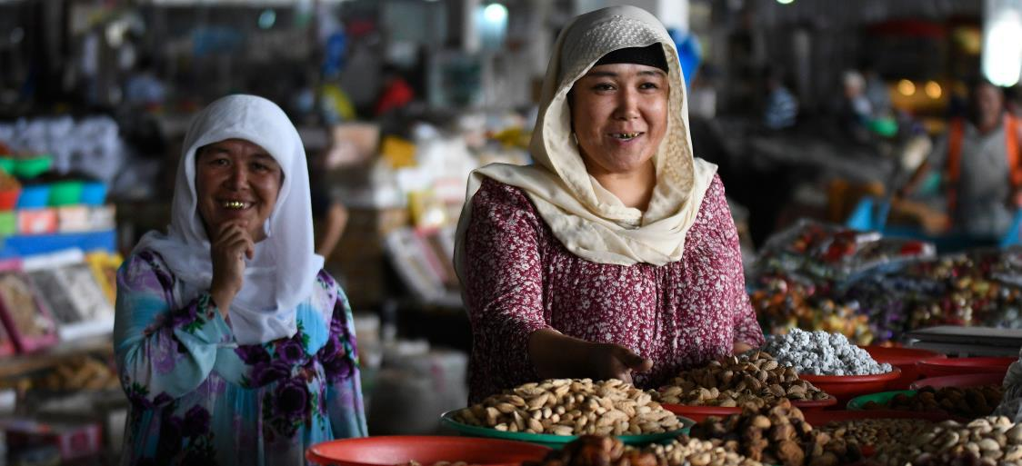

Photo: FAO, taken by Nazim Kalandarov

In brief

3rd Project Steering Committee Meeting (PSC) of CACILM-2 held in Bishkek

KAZAKHSTAN

Foundations laid for cooperation with specialized institutes
Training workshop on the AquaCrop tool
Training workshop on estimating greenhouse gas emissions using the EX-ACT tool
Two-day training on WOCAT technologies and approaches in the field of sustainable land management, questionnaires and databases

KYRGYZSTAN

Pasture use plan developed for the pilot area
Agriculture professionals explore tools to determine farmer resilience to climate change

TAJIKISTAN

SHARP training contributes to climate change adaptation

TURKMENISTAN

Introductory workshop held in Turkmenistan

UZBEKISTAN

Chickpeas sown on rainfed fields using no-till methods to bring high yields
Introduction of Shams salt-tolerant winter variety of wheat
Sunflower cultivation in rainfed regions of Uzbekistan

CACILM-2 | May 2020

3

A targeted and individual approach for each country

Makhmud Shaumarov, Regional Project Coordinator, Integrated Natural Resources Management in Drought-prone and Salt-affected Agricultural Production Systems in Central Asia and Turkey (CACILM-2)

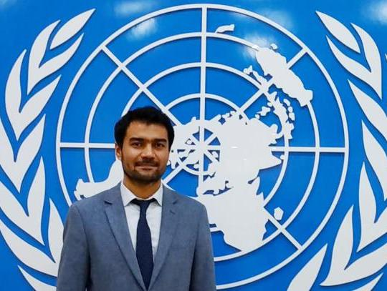

Photo: FAO

The large-scale regional programme that you are coordinating is in its third year of implementation in all five Central Asian countries. What achievements are you especially proud of and how did you manage to attain these results?

The FAO-GEF multi-country Project is a complex regional project and its unique feature is that a significant part of the cost, amounting to USD 76 million, was covered by the participating countries themselves – Kazakhstan, Kyrgyzstan, Tajikistan, Turkmenistan, Turkey and Uzbekistan (almost USD 50 million).

Therefore, one of the main achievements over these two years, I would say, is the effective interaction and the high level of understanding between countries at the level of national and international partners, government agencies and UN agencies.

Second, we were able to form a well-coordinated team of professionals who manage the project’s activities locally, in countries.

Since the Project’s main objective is to adapt and disseminate best practices for the efficient use of natural resources, the most important condition for success is the presence of highly professional technical experts.

They should have extensive knowledge and experience in the field of land and water resource management, and be able to use different technologies that take into account climate change trends, as well as agroforestry and other advanced resource-saving technologies developed in the world over the past 20 years.

Thanks to this over the last three years, field work has been ongoing in 18 drought-prone, salt-affected and soil degradation-prone pilot zones in Kazakhstan, Kyrgyzstan, Tajikistan, Turkmenistan and Uzbekistan.

Five regions of Kazakhstan, with the support of the Ministry of Agriculture of the Republic of Kazakhstan, are taking steps to adapt salinity and drought-tolerant crops, introduce resource-saving technologies and reclaim salt-affected soils, as well as produce grass and fodder crops and manage and restore pastures.

In Kyrgyzstan, the Project, in partnership with the NGO CAMP Alatoo, actively cooperates with local communities in the Naryn region, to strengthen their knowledge and skills in sustainable pasture management.

In four districts of Tajikistan, groups formed of female farmers have already started cultivating salinity-tolerant crops on their farms.

In arid zones of Uzbekistan, the Project, in close cooperation with the Ministry of Agriculture, the Forestry Committee, the Committee for Nature Protection and some UN agencies, has launched the campaign “Plant A Million Garden Trees”. To date, more than 300 000 fruit and nut trees have been planted in the Bukhara and Kashkadarya regions, as well as Karakalpakstan, and by the end of this year this figure will grow to 500 000. The campaign will continue for a further three years and we hope to plant more trees than initially planned.

All five Central Asian countries participating in the Project differ greatly from each other in many aspects ranging from their landscapes to economic status. How does the Project find common ground?

Each member country is unique, so it is impossible to apply the same standards and approaches in all countries. We take a targeted, individual approach to each country; moreover, well-coordinated work, mutual understanding and cooperation both in the team itself and with numerous local Project partners is very important.

Crucially, FAO and our donor GEF work to build a dialogue: we listen to people, analyse the current legislation, study the conditions and situation and – taking into account the opinions of specialists, local authorities, land users, scientific community and other partners – develop steps to effectively use land and water resources.

CACILM-2 | May 2020

4

In addition, at every stage, we involve local people –women and men, and representatives of all social groups – to ensure that the impact of the Project is as effective as possible and that it benefits everyone: agricultural producers and their families, the environment and the general population. This approach is at the heart of the success of the FAO/GEF Project in each country.

The team play a very important role, but what is no less important is continuous dialogue with all stakeholders who are aware of the problems in the countries and are interested in solving them. This helps to find common ground. The ability to adapt Project components to local conditions and take into account the interests of the Project partners plays an important role.

What are the plans for the Project in 2020? Are any new activities being introduced in the region?

Despite certain difficulties associated with COVID-19, which meant we had to postpone some planned activities, training sessions and procurement activities to a later date, 2020 is a very important year, as we plan to implement widely technologies across countries that have been piloted over the last two years and which have worked well in the field.

We will also further develop partner engagement in every country, including through the development and implementation of integrated natural resource management plans.

Today, more than 50% of agricultural land in Central Asia is subject to varying degrees of degradation. There is no doubt that soil is the most important resource for agricultural production and food security in the countries, so it is extremely important to take the necessary steps and make investments to reduce its further degradation. In this regard, work will continue to develop country action plans and approve goals to achieve land degradation neutrality and reduce greenhouse gas emissions under the UN Convention to Combat Desertification and the UN Framework Convention on Climate Change, respectively.

In these plans, we identify the most pressing problems and develop steps to stop degradation, mitigate the impact of drought, and return agricultural land withdrawn from circulation to agricultural production, thereby reducing greenhouse gas emissions.

The natural resource management plans take into account the economic state of the countries, the availability and potential for the development of value chains, and the institutional potential of the area. These plans represent a powerful tool for local authorities to use natural resources in a sustainable manner, efficiently budget and attract investment.

We will also continue to work with Project partners to create a regional knowledge exchange platform on sustainable natural resource management. This online platform will include a database of various practices and technologies collected from the entire Central Asian region, allowing decision-makers and land users to develop plans for the use of land and water resources tailored to a particular landscape, and to determine the optimal ways to implement them.

In addition, we will conduct an economic analysis to enable local people to see the benefits of applying such methods in practice. For example, we are currently collecting data for a study analysing how drought and agricultural land degradation affect GDP, population well-being, ecosystem services and agricultural productivity. This analysis will also help determine the amount of money that needs to be invested in order to significantly reduce the scale of soil degradation and facilitate its return to agricultural use.

The results of this work and support from the responsible agencies in participating countries are extremely important, since the regional population is growing and the demand for food is increasing. If we do not increase soil fertility and use water resources carefully today, in the short and medium term it will be very difficult and costly to ensure food security. Our goal is to ensure that after Project completion the use of these new practices will continue and spread within countries, so that both agricultural producers and the general population feel the benefits.

Could you tell us about your experience? What experience and qualifications were needed to become the coordinator of such a complex and interesting project?

To become a qualified specialist in the field of agricultural economics and rural development, I studied at national and European higher education institutions for over 10 years, then I worked for various international UN agencies. All this experience was extremely useful to me. My mentors and parents, who have supported me over the years, also played an important role.

I continue to learn because the Project is large and complex. It requires leadership and diplomacy skills, as well as constant innovation and the use of modern knowledge and approaches. Finding new solutions and learning best practices are essential.
***

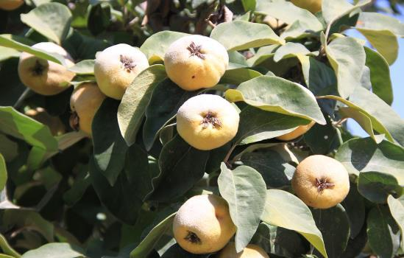

Photo: FAO, taken by Vlad Ushak

ov

CACILM-2 | May 2020

5

Regional implementation of the FAO-GEF Project on Integrated Natural Resources Management

Launched in late May 2018, the five-year Project with a budget of over USD 75 million is one of the largest natural resource initiatives to be co-financed by the governments of the participating countries. It forms part of the second phase of CACILM (Central Asian Countries Initiative for Land Management), which was established in 2003, on the basis of a joint agreement by Kazakhstan, Kyrgyzstan, Tajikistan, Turkmenistan and Uzbekistan to act together to address the challenges of climate change, desertification and fertile soil degradation.

The main goal of this multi-country FAO-GEF Project is to disseminate widely and scale up best practices and approaches for integrated natural resource management in drought-prone and salt-affected areas of Central Asia and Turkey.

Over the past 50 years, the population of Central Asia has grown exponentially, increasing threefold to reach 74 million. More than half of the population live in rural areas and are dependent on agriculture for their livelihoods. Experiencing extremely vulnerable climatic conditions, with a steady decrease in water resources and the need to provide food for growing population, the region faces serious challenges in the field of food security and sustainable use of land and water resources.

Climate change is undermining the productivity of agricultural land and pastures across the region. Pastures, for example, are at risk of desertification due to rising temperatures and declining rainfall, which directly affect livestock productivity. Another challenge is that pastures, which occupy 77% to 95% of all agricultural land in the region, are not properly managed.

More than 88% of arable land in Kyrgyzstan and 97% of agricultural land in Tajikistan are subject to erosion. In Kazakhstan, 66% of arable land has been affected, while in Turkmenistan and Uzbekistan this figure has reached 80%.

In addition, from 40% to 80% of irrigated farmland in the region is subject to salinization or waterlogging, with the highest figures in Turkmenistan (68%) and Uzbekistan (51%).

In order to demonstrate effective methods, improve and adapt approaches to integrated natural resource management, prepare for drought and use resource-saving agriculture technologies, field work has been conducted in 18 drought-prone, salt-affected and soil degradation-prone pilot zones of Kazakhstan, Kyrgyzstan, Tajikistan, Turkmenistan and Uzbekistan over the last two years.

With the support of the Ministry of Agriculture of the Republic of Kazakhstan, pilot sites were selected in five regions of the country, and field work commenced with a view to adapting salinity and drought-tolerant crops, and producing resource-saving technologies and practices for salt-affected soil reclamation for the production of grassland and forage crops, as well as pasture management and restoration.

In Kyrgyzstan, FAO in partnership with the NGO CAMP Alatoo, has been actively cooperating with local communities in the Naryn region, to strengthen their knowledge and skills in sustainable pasture management
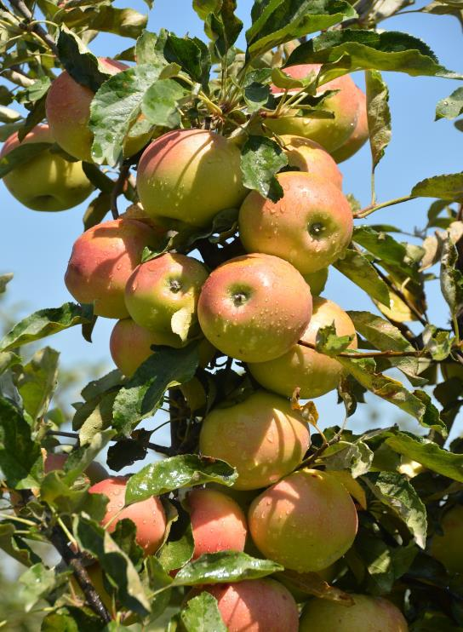

Photo: FAO, taken by Vlad Ushakov

In four districts of Tajikistan, groups of female farmers have already started cultivating salinity-tolerant crops on their farms. These groups were formed to disseminate sustainable and climate-resilient land use techniques through farmer field schools.

About 40 varieties of drought and salinity-tolerant crops – both plants and trees – were planted at pilot plots in four regions of Uzbekistan using various methods. One hundred farms in target districts, whose authorities were trained u the Project, have begun cultivating drought and salinity-tolerant crops such as corn, millet, black cumin, sweet sorghum, flax and many others using hydrogel and sustainable tillage methods, including zero tillage.

CACILM-2 | May 2020

6

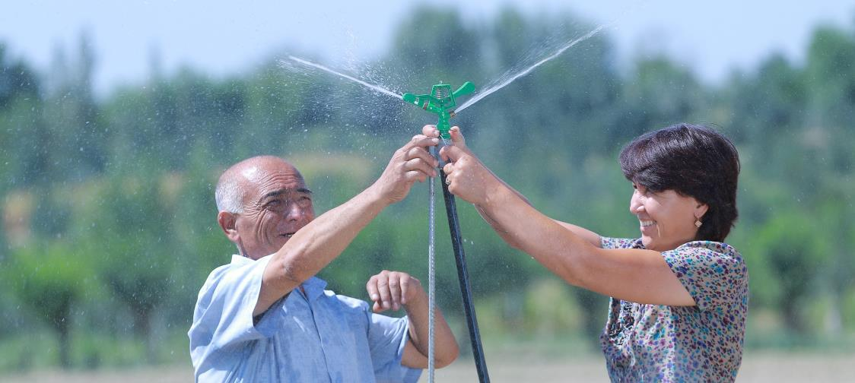

Photo: FAO, taken by Rustam Shagayev

In partnership with the Government of Uzbekistan, the Project is supporting the campaign “Plant a Million Garden Trees” by planting drought-resistant trees on the dried bottom of the Aral Sea and in other semi-desert areas.
All five Project countries actively participate in training sessions for government officials, farmers and a wide range of agricultural professionals on advanced water management, drought forecasting, and no-till and other approaches to promote environmental sustainability in agricultural production systems prone to drought and salinity.

In addition, under the Project, a number of scientific and applied studies have already been completed or are at the completion stage, including in the field of drought risk management, early warning systems and disaster risk reduction related to climate change.

In all the countries, the Project is developing special guidance on soil salinity control based on techniques for the sustainable management of salt-prone land resources.

“In a region where agriculture plays a major role in ensuring food security, natural resource conservation and efficient use are vital”, said Makhmud Shaumarov, Regional Project Coordinator. “Since the Project was launched, we have managed to build fruitful relationships with key partners in all participating countries, which contributes to the successful search for modern and effective solutions to a number of very complex challenges in the field of natural resources and agriculture in all participating countries”.

***

CACILM-2

7

Kazakhstan is carrying out research on climate change-induced natural disaster risk management

As part of the Project, Kazakhstan has launched a study on climate change-induced natural disaster risk management, as well as early warning and agrometeorological services.

One of today’s global challenges, climate change, produces unpredictable weather patterns, threatening food production and increasing the risk of natural disasters, which are increasingly global in nature and of unprecedented scale.

Scientists around the world warn that if we do not take urgent steps today, climate change adaptation in the future will require significantly more effort and financial resources.

Kazakhstan is highly susceptible to a wide range of climate change-induced natural disasters – from droughts to floods. In addition, the country has a vast territory with different climatic zones, ranging from extremely hot and dry desert zones in the south to extremely cold steppe and forest zones in the north of the country in winter.

Agriculture is the sector most vulnerable to natural disasters, since disasters of this nature lead to the destruction of food production systems and, accordingly, the livelihoods of the rural population.

In April 2015, 2 500 households and a large area of farmland in Karaganda, East Kazakhstan, Akmola, Pavlodar and North Kazakhstan regions were flooded. In March 2018, meltwater from the Irtysh and Syrdarya rivers flooded 287 households in East Kazakhstan. More than 600 land plots were affected, and the damage caused by the natural disaster amounted to KZT 3.2 billion.

May 2020

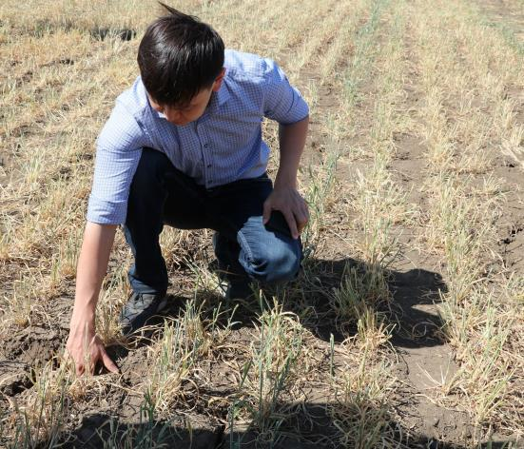

Photo: FAO, taken by Zhanyl Bozayeva

In December 2018, the dam on the Syrdarya river broke and flooded 60 hectares of pastures in the Kyzylorda region. In 2019, due to heat and drought in grain-growing regions of Kazakhstan, the grain harvest produced a shortfall of 3 million tonnes.

The study will form the basis of initiatives to change legislation and institutional mechanisms in the field of early warning systems and climate change-induced disaster risk reduction, improving the efficiency of agrometeorological services – and will be applied to practical work by a wide range of partners in the area.

The Project will provide the Government of Kazakhstan with technical assistance to introduce modern tools for drought control and monitoring. Approaches and tools will also be developed for a national adverse risk management strategy with a focus on early warning systems, climate change-related disaster risk reduction and improved efficiency of agrometeorological services.

The Project will conduct an analysis of the capabilities of the Ministry of Agriculture and the Ministry of Ecology, Geology and Natural Resources of the Republic of Kazakhstan in the field of early warning systems, climate change-induced disaster risk reduction and improved efficiency of agrometeorological services with a focus on the agricultural sector.

In addition, the Project will assess the effectiveness of the intersectoral coordination mechanism and develop a number of recommendations for capacity building in this area.

***

Adapting to change is our national objective

Climate change is not just a global challenge – today, almost everyone feels its consequences. But how do global processes impact agriculture? Matraim Zhusupov, National Project Coordinator in Kyrgyzstan and an expert in agriculture and water resource management, answers this and other questions.

Can we say that climate change is already affecting the agriculture of Kyrgyzstan?

Climate change and, in particular, global warming are undoubtedly already affecting agriculture throughout Central Asia, including Kyrgyzstan. Farming under our climatic conditions has included an element of risk, but in the coming years, climatologists predict that climate change will lead to unpredictable consequences in mountainous regions. Over the past three decades, severe weather phenomena have increased fourfold across the region. One figure to think about – by 2100, the annual damage to agriculture from extreme weather is expected to exceed KGS 3.5 billion.

The main task therefore is to ensure food security. The population of Kyrgyzstan is projected to increase by 15% every ten years. This means that every year we need to consistently increase agricultural production. This in turn requires more water resources. However, although the amount of water resources in the coming years it is planned to increase from the current level of 48 billion cubic metres up to 55 billion cubic metres, after 2030, international experts predict a gradual decrease primarily due to glacier melting.

There are 8 208 glaciers in the country, and they are decreasing on average by 0.2-1% per year. There are also other negative factors: studies conducted by the Institute of Water Problems and Hydropower under the National Academy of Sciences of the Kyrgyz Republic show that arable land fertility will invariably decrease, and that desert and semi-desert areas will expand significantly – from 15% (in 2000) to 23.3-49.7% (in 2100). It is possible that we will see a decrease in yields of wheat, sugar beet and fruit crops in the Chuy region, of wheat and barley in Talas, and of some crops in Jalal-Abad and Issyk-Kul. Today, we have more than 10 million hectares of agricultural land of which almost 90% is pasture. Climate change can lead to droughts, which can result in serious pasture degradation. The most arid areas are considered to be western Issyk-Kul and Kochkor valley, where droughts can last all year round.

These conditions significantly reduce yields in rainfed agriculture, and in some years, intense, prolonged droughts can cause serious damage to perennial plant species, making it difficult for farmers to provide animals with fodder. Droughts have already been observed in 2012 and 2014 and led to dire consequences. The sharp rise in prices for dry feed led to significant loss of livestock.

CACILM-2 | May 2020

8

Those droughts affected mostly households in the south of the country. Extreme weather left a deep mark and resulted in huge losses to hundreds of people. Increase in air temperature can have a number of unpleasant consequences including favourable conditions for agricultural pests as well as an increase in the incidence of livestock diseases. There is another risk – completely new types of pests and diseases affecting plants and animals that do not originate from the region. We also should not forget that agriculture is subject to hazardous natural processes and phenomena caused by climate change. There is a risk of an increase in geophysical disasters – landslides, mountain lake outburst floods, floods, forest and steppe fires, soil erosion, spring and autumn frosts, and heavy snowfalls

What do you think needs to be done in the near future to change the situation?

Our national objective is to adapt the sector to changes and changing conditions as much as possible. We must prepare now and take decisive and effective preventive adaptation measures. First of all, it is necessary to develop the country’s meteorological service, by actively introducing satellite methods of agricultural forecasting and mapping as well as advanced climate-resistant technologies. These include flood control, the cultivation of drought-tolerant crop varieties, degraded land restoration and the introduction of rational irrigation systems.

Which objectives will CACILM-2 focus on in Kyrgyzstan?

The Project is designed primarily to build the capabilities of national partners and government institutions. More specifically, our goal is to implement integrated natural resource management technologies and to introduce modern methods of climate change adaptation in agriculture. We help to create conditions for government institutions to develop and update strategies and adjust action plans in the field of integrated natural resource management and sustainable land use.

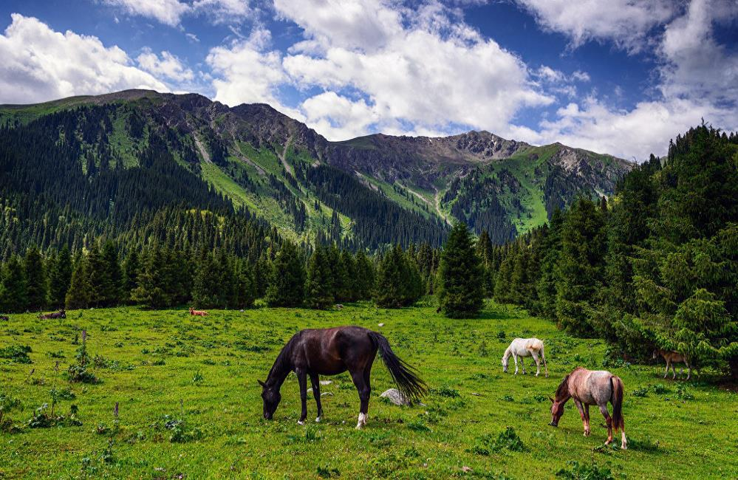
I would like to highlight another focus of the Project: the development, review and updating of national policies, strategies and guidelines. In the area of drought management, the Project carried out an analysis and assessment of national policies and institutional frameworks to determine the extent to which they include effective integrated natural resource management components. The Project also provides assistance to government agencies that work with the UN Convention to Combat Desertification. A baseline assessment of the early warning system, climate change disaster risk management and agrometeorological services in Kyrgyzstan was also carried out. The Project’s regional component provides for the exchange of experience in the implementation of new instruments.

We are constantly engaged in an intensive dialogue. We have organized regional training sessions and exchanged experience on a variety of important topics – the use of the EX-ACT tool to appraise CO₂ balance in agricultural subsectors, AquaCrop water use efficiency, SHARP agro-ecosystem resilience assessments and the compilation of maps on vulnerability to drought using FAO tools (Collect Earth, Google Earth Engine and ASIS – agricultural practices for climate change adaptation). We collaborate closely with experts from government agencies, and they, in turn, spread knowledge among specialists in governmental, non-governmental, educational, research and farming organizations. As I said, in Kyrgyzstan, the main agricultural focus is animal husbandry. Pastures are of great importance, so the Project focuses on the introduction of sustainable pasture management practices.

Photo: FAO, taken by Vlad Ushakov
CACILM-2 | May 2020

Why was Kochkor district in Naryn region chosen as the pilot area?

Droughts in these areas can last all year round. In addition, Kochkor district is located in the head of the large basin of the Chu River, that is, in the zone where the river flow is formed. In addition, in Kyrgyzstan, as you know, one-third of the irrigated area is located in the Chuy region, with the main water source being the Chu river. CAMP Alatoo, a well-known public fund which has extensive experience in the field of natural resource management, collaborates with the Project and, importantly, unites people who care about their country and who understand that climate change has already affected the country. We assessed the resilience of farmers to climate change using the FAO-SHARP tool, conducted a joint climate change risk assessment in the area and discussed the results of these studies with farmers in Kochkor district.

What difficulties do farmers in Kyrgyzstan face at present, and how can the Project help to resolve these problems?

The land reform allowed Kyrgyz farmers to privately own agricultural land. Today, there are over 350 000 farms in the country, but the main problem is that there is not enough land and only small areas of arable land. The total size of the latter is 1 202 600 hectares (0.25 hectares per person), of which 793.5 are irrigated (0.18 hectares per person). The average size of arable land in peasant households in Kyrgyzstan is 2.7 hectares, including 1.9 hectares of irrigated arable land. The largest average size of arable land is found among farmers in the Chuy region – 4.9 hectares (of which 3.5 hectares are irrigated); the smallest is found among farmers in the Jalal-Abad region – 1.3 hectares (of which 0.8 hectares are irrigated).

As and plots are small, it is not easy for farmers to compete globally in terms of quality and volume of food supplies. As mentioned above, agriculture in Kyrgyzstan is highly dependent on nature and climatic conditions: fruitful years alternate with poor harvests caused by droughts, frosts, heavy precipitation and other natural phenomena that lead to crop failures. Therefore, we aim to help and contribute to reducing the risks associated with these problems.

Photo: FAO
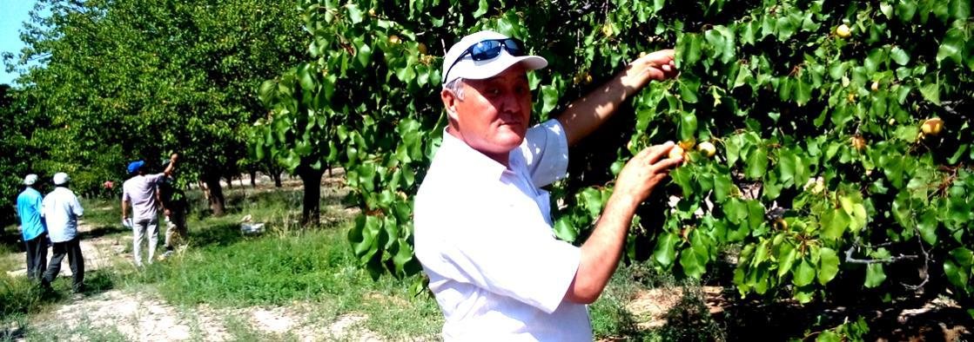

One should also not forget that irrigation infrastructure, canals and water distribution systems in a number of regions are dilapidated. The Project prepare farmers to face these conditions through the introduction of efficient resource-saving and water-saving technologies and drought-tolerant crops which, in turn, ensure high yields.

The Project will also introduce new mechanisms to provide our farmers with sustainable land use skills in the face of climate change and drought. The country needs to improve the legal framework and strategies for climate change adaptation, along with mechanisms to attract investment. We intend to help develop not only scientifically based pasture management plans, but also technologies for integrated natural resource management – agroforestry (almond/pistachio/saxaul), drip irrigation, afforestation of slopes, plastic house crop production, organic agriculture, crop rotation with perennial crops and production of grass mixtures. Farmers engaged in irrigated agriculture will be trained in water-saving technologies.

Agriculture is a sector that requires deep knowledge and, at present, both knowledge and practical application of the latest digital technologies. How will the Project contribute to the digitalization of agriculture in Kyrgyzstan?

There are 40 districts and 453 aimaks (consisting of several rural settlements) in Kyrgyzstan, and each has its own characteristics. Most of the country's territories are located in the foothill zone, which implies risks. Depending on weather conditions, farmers have to change sowing times and the amount of irrigation, and often use traditional production methods. Irrigation regimes developed in the past do not meet current requirements.

The irrigation systems currently in operation were designed and built for large fields. Land fragmentation led to the heterogeneity of crops grown in small areas and, accordingly, different irrigation regimes.

As a result, the water distribution system has become more complex. Under such conditions, it is impossible to ensure the projected yield and, accordingly, the investments made in irrigation are not effective.

CACILM-2 | May 2020

10

It is therefore necessary to introduce modern technologies (e.g. CROPWAT) such as software and automatic agrometeorological stations to remotely transmit agro-climatic and other data. As part of the Project, we analysed and assessed the state of hydrometeorological and agrometeorological services, and developed recommendations that will form the basis of decision-making by government institutions.

The Project provides for the use of space and satellite technologies – Collect Earth, Saiku instrument, LDN and ASIS. Our specialists have mastered these new technologies, conducted sessions nationally to train farmers to use them. The Project is also supporting the digitalization of land use maps across the country. Recently, we were asked by Kyrgyzgiprozem specialists to provide assistance in digitalizing existing maps. The only existing copies of these land use maps are kept in archives, so they must be digitalized to ensure all aimaks can access them.

Digital versions will make it possible to update information and delineate drought zones using the latest satellite technology. Moreover, we are actively cooperating with Kyrgyzhydromet and plan to exchange experience with the agrometeorological services of Turkey and other Central Asian countries, including Kyrgyzstan, so the work is ongoing.

***

Strengthening partnership within the framework of the Plant a Million Garden Trees campaign in Uzbekistan

On 20 April 2020, in Tashkent (Uzbekistan), a Memorandum of Understanding was agreed for the successful implementation of the Plant a Million Garden Trees campaign.

The Memorandum was signed by the FAO Country Office in Uzbekistan, the Country Office of the German Agency for International Cooperation (GIZ) in Uzbekistan, the Horticulture and Greenhouse Development Agency under the Ministry of Agriculture of the Republic of Uzbekistan, and the Academician Makhmud Mirzaev Scientific Research Institute of Horticulture, Viticulture and Wine-making.

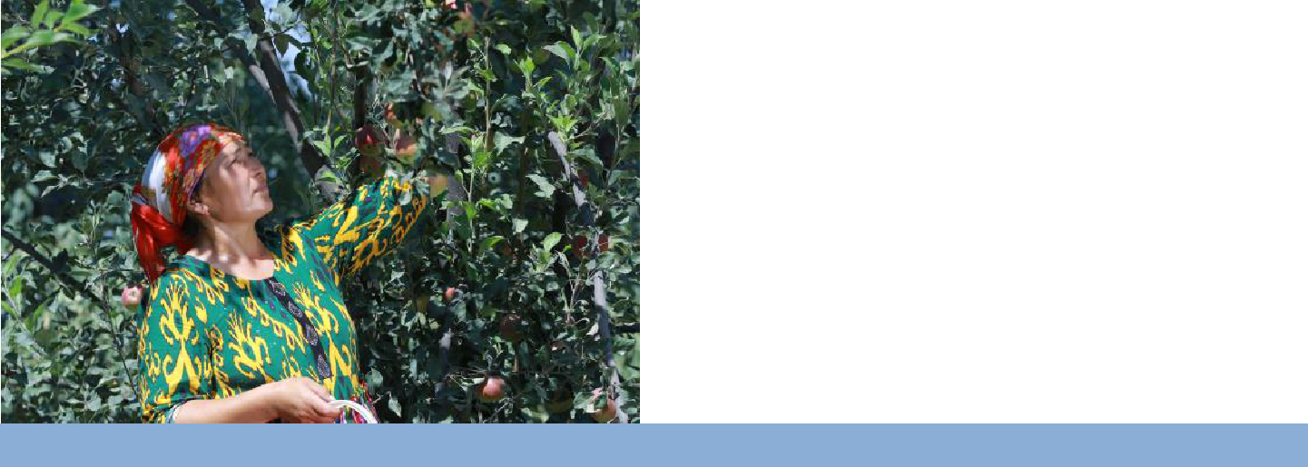
Photo: FAO
Taken by Rustam
By signing this document, the parties confirmed their intention to cooperate – each within their powers, experience and knowledge – to achieve the results outlined in the Plant a Million Garden Trees campaign.

Initiated by the Food and Agriculture Organization of the United Nations (FAO), the State Committee on Ecology and Environmental Protection, the State Committee on Forestry and the Ministry of Agriculture of the Republic of Uzbekistan, the Plant a Million Garden Trees campaign was launched at the end of October 2019 in Nukus and aims to increase the area of orchards and vineyards, and improve food security and environmental quality, as well as the well-being of the population in arid and salt-affected regions of Uzbekistan.

Under the Memorandum – and with the support of CACILM-2 at the Kegeili branch of the Academician Makhmud Mirzaev Scientific Research Institute of Horticulture, Viticulture and Wine-making, as well as the Beruni region of the Republic of Karakalpakstan, nurseries will be created to grow seedlings of fruit trees for farms and dekhkan farms, using various types of rootstocks and varieties, adapted to the conditions of the Aral Sea basin.

The campaign also implies the procurement of planting materials – seedlings of apple, plum, peach, sweet cherry, grapes and their rootstocks, and training and consulting by specialists working in nurseries, as well as farmers in pilot zones.

“We welcome the growing cooperation of the Project with key partners in Uzbekistan as part of one of the largest natural resource management initiatives in Central Asia”, said Makhmud Shaumarov, Regional Project Coordinator. “I am convinced that this partnership will yield fruitful results in the coming years.”

***

May 20

CACILM-2 May 2020
11

Tajikistan plans to sow more drought-tolerant crops this year

Within the FAO/GEF project “Integrated Natural Resources Management in Drought-prone and Salt-affected Agricultural Production Systems in Central Asia and Turkey”, seeds of drought-tolerant crops have been distributed over target districts of the Khatlon region in Tajikistan, including Yavan, A. Jami, Vakhsh and Kushoniyon.

One hundred and twenty-nine farms in pilot villages have already sown these crops, and specialists have started monitoring the seedlings.

“Growing drought-tolerant crops is one of the most important conditions for increasing farm incomes and resilience to climate change,” says Mavlon Pulodov, a Project's agronomist. This is especially important for arid regions, where crop production is the main source of income”.

With its high level of adaptability to the arid climate of Central Asia, as well as being one of the largest sources of high-quality vegetable oil after sunflower, flax and mustard, safflower is second to none in terms of versatility.

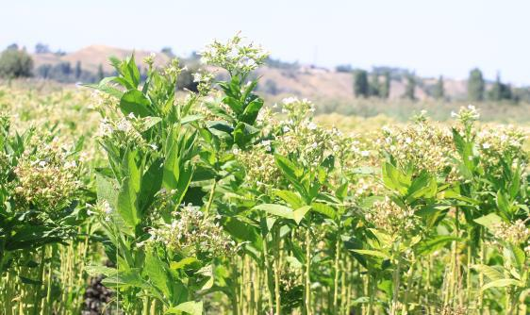

Photo: FAO
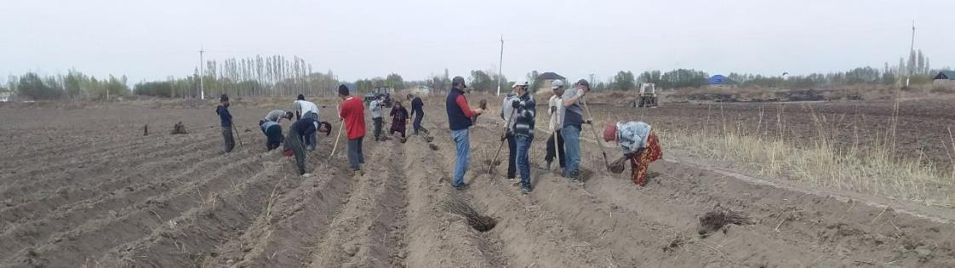

In addition to being a source of vegetable oil, thornless safflower varieties provide a solid forage base for livestock in arid zones. According to scientists, thornless safflower hay is not inferior to alfalfa in terms of nutritional value. Safflower seed press cake is also a valuable and highly nutritious feed for livestock and poultry. Furthermore, the crop has high melliferous properties – it begins to bloom earlier than the sunflower and the flowering period lasts longer.

Safflower is also a valuable industrial crop. Safflower oil is used to manufacture drying oil, varnishes, soap and linoleum, and red and orange safflower corolla has long been used for dyeing fabrics. Currently, safflower oil paints are used in painting, carpet making, dyeing soaps and food products. In the pharmaceutical industry, safflower is used as a source of vitamin E and A.

While not a new crop to Tajikistan, Safflower was previously sown in small areas – and only thorny varieties – which made it difficult to harvest and additional processing of stems was needed to use it as feed for livestock. A new variety, Shifo, supplied to farmers within the framework of the Project does not have thorns and surpasses analogues species or at least is not inferior to them in many respects.

***

 | Mission to Turkmenistan
 | In January 2020, Ekrem Yazici, Project Lead Technical Officer, Makhmud Shaumarov, Regional Project Coordinator, and Cinar Yavuz, Acting Reporting and Operations Officer, paid a working visit to Turkmenistan. The goal was to initiate a dialogue on Project implementation in Turkmenistan, explore the country's priorities in the field of effective natural resource management, and discuss the annual work plan for 2020 and the expected key results with national partner organizations in the country.
Photo: FAO
CACILM-2 |  |  | May 2020
 | 12

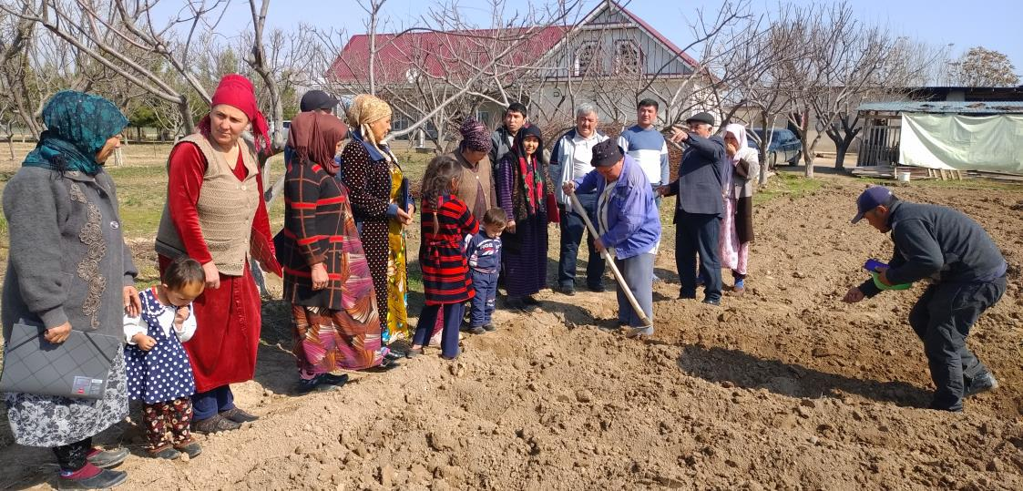

During the visit, fruitful meetings were held with the National Project Coordinator, representatives of the Ministry of Foreign Affairs, the Ministry of Agriculture and Environmental Protection, the Hydrometeorological Service under the Ministry of Agriculture and Environmental Protection, the State Committee of Water Management and other partner organizations. Meetings were also held with representatives of various international organizations accredited in Turkmenistan, such as the UN, UNDP, the World Bank and currently implemented UNDP agricultural and environmental projects to discuss cooperation possibilities.

On 11 August 2019, the Food and Agriculture Organization of the United Nations (FAO) and the Government of Turkmenistan signed an agreement to implement a joint project on the integrated natural resource management in drought-prone and salt-affected agricultural production systems of Turkmenistan, as part of the Regional Project.

Currently, the project is being actively implemented. The main objective is to scale up integrated natural resource management (INRM) in drought-prone and salt-affected agricultural production systems of the country. To this end, the project will provide technical assistance for the implementation of integrated agricultural production system management approaches and INRM methods to stabilize and reduce soil salinization, wind erosion, improve water resources collection and conservation, enhance carbon sequestration and reduce losses from agro and biodiversity, as well as desertification.

***

Photo: FAO

Project allocates KGS 12 million to support Kyrgyz farmers affected by COVID-19

The global crisis caused by the COVID-19 pandemic is seriously affecting the most vulnerable rural populations of Kyrgyzstan. A state of emergency was declared in mid-March 2020, and a curfew was established in regions most affected by the virus. The restrictive measures introduced both in Kyrgyzstan and in countries receiving Kyrgyz labour migrants have led to a sharp reduction or to a complete halt in remittances.

Before the pandemic, the volume of immigrant remittances accounted for 35% of the country’s GDP, and the country ranked first among 214 countries worldwide for this indicator.

Agricultural production in more than 350 000 farms in the country relied heavily on remittances from 1 million labour migrants; therefore, as a result of the COVID-19 pandemic, the well-being and food security of many rural families, including the most vulnerable and socially vulnerable, were under threat.

In response to numerous requests, the Ministry of Agriculture, Food Industry and Land Reclamation of the Kyrgyz Republic sent a request to FAO to provide agricultural resources such as diesel fuel, fertilizers and seeds to the most vulnerable and affected farmers.

CACILM-2 | May 2020

13

The National Project team, together with specialists from the Ministry of Agriculture, district departments of agricultural development and local authorities, examined the situation and compiled a list of the most vulnerable and affected farmers and households in the Project’s pilot area (Kochkor district, Naryn region) and in other districts where an emergency state was declared: Suzak district in the Jalal-Abad region, Karasu and Nookat districts in the Osh region, and the At-Bashy district in the Naryn region.

The list included 1 067 farmers from 47 aimaks (inscribed on the Aiyl Okmotu database) identified as severely affected families and lacking funds to buy agricultural resources. The Project will purchase 133.9 tonnes of fertilizer, 24.5 tonnes of diesel fuel and 81.6 tonnes of seeds for a total of USD 150 000 (KGS 12 million).

Currently, the procurement process is being completed in accordance with FAO procedures, and by June 2020, these agricultural resources will be distributed to farmers in need in the five regions of Kyrgyzstan.

In addition, by October 2020, winter wheat seeds, corn seeds, alfalfa and sainfoin seeds will be procured and distributed to affected farmers.

As Makhmud Shaumarov, Regional Project Coordinator, noted, measures to support vulnerable families and farmers through the purchase of agricultural resources, in addition to humanitarian goals, will also contribute to the successful implementation of the Project in terms of strengthening value chains for livestock production, introducing, producing and distributing seeds of drought-tolerant crops, and strengthening the food security of vulnerable population groups in Kyrgyzstan.
***

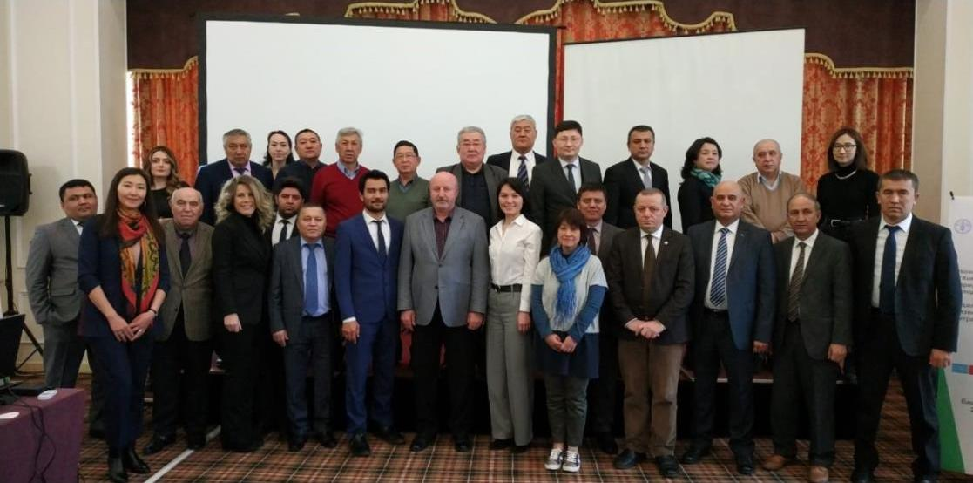
Photo: FAO

IN BRIEF

3rd Project Steering Committee Meeting (PSC) of CACILM-2 held in Bishkek
On 24 January 2020, the 3rd Project Steering Committee (PSC) Meeting was held in Bishkek. The meeting was attended by representatives of the ministries of agriculture of all participating countries, the Subregional coordinator for Central Asia, Viorel Gutsu, the Lead Technical Officer, Ekrem Yazici, the Regional Project Coordinator, Makhmud Shaumarov, staff of the FAO Subregional Office in Turkey, the FAO Assistant Representative, Dinara Rakhmanova and National Project Managers in Central Asia. The agenda included Project results for 2019 and work plans for 2020. The Project work plan for 2020 was approved, taking into consideration comments and suggestions received during the meeting. Based on a decision taken at the PSC first meeting regarding the annual rotation of participating countries, from July 2020, the chairmanship will be transferred to Tajikistan. The PSC members decided to hold the next meeting in the second half of January 2021 in Almaty.
***
KAZAKHSTAN

Foundations laid for cooperation with specialized institutes

CACILM-2 and the Kazakh Scientific Research Institute of Animal Husbandry and Forage Production signed a cooperation agreement to introduce, produce and distribute drought and salt-tolerant crops, support seed production systems for perennial forage crops, introduce improved pasture management, improve and restore degraded pastures, and introduce conservation agriculture practices. CACILM 2 and the U. Uspanova Kazakhstan Research Institute of Soil Science and Agrochemistry will cooperate on biological and chemical methods of salt-affected soil reclamation.

CACILM-2 | May 2020
14
Training workshop on the AquaCrop tool
In July 2019, Nur-Sultan, Kazakhstan, hosted a training on the AquaCrop tool to improve water use efficiency and sustainable management of irrigation systems.

Agriculture is the largest water consumer in the world, accounting for 70% of the world's water resources used for irrigation. Due to climate change and limited water resources, the introduction of resource-saving technologies and tools has become a priority to ensure food security for a rapidly growing population, especially in the world’s arid regions. To mitigate the impacts of climate change, FAO has developed a number of specific tools to maintain food system resilience and positively impact the environment in the region.

One such tool is AquaCrop 4.0, which was developed to simulate productivity under limited water resources and assess the impact of environmental and management conditions on crop yields. AquaCrop can be used as a planning tool and to facilitate strategic decision-making in both irrigated and rainfed agriculture.

Effective use of this tool requires training on the use of software and tools to monitor soil and water conditions. Trained specialists are able to conduct an effective analysis of current water use in agriculture, which allows for the development of long-term water use strategies, as well as assessment of current yields.

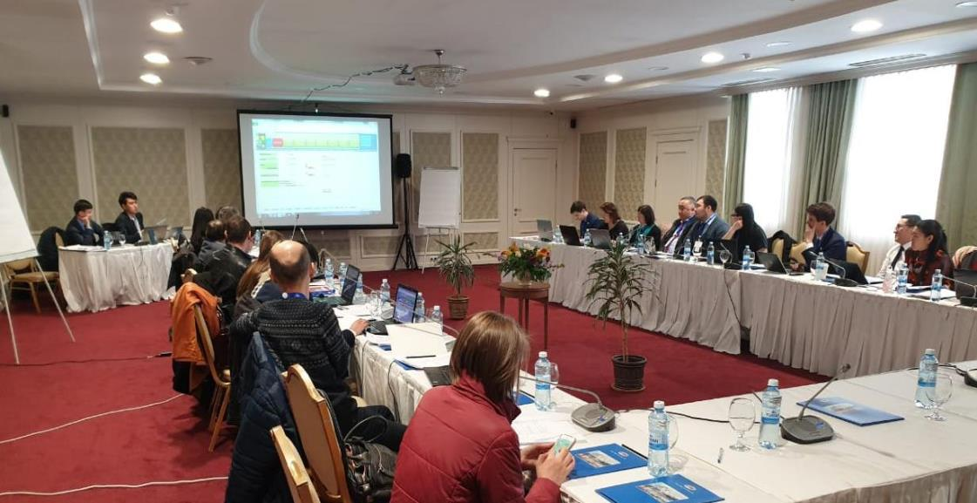

Photo: FAO

The training organized in Nur-Sultan was attended by staff of sectoral departments under the Ministry of Agriculture (MoA RK); the Water Resources Committee under MoA RK; the Land Management Committee under MoA RK; the Ministry of Ecology, Geology and Natural Resources of the Republic of Kazakhstan; research institutes under NASEC; the S. Seifullin Kazakh Agrotechnical University, the KAZWATER Association of water users, water consumers and water transport and other NGOs.
***
Training workshop on estimating greenhouse gas emissions using the EX-ACT tool
In May 2019, Nur-Sultan hosted a training workshop on EX-ACT technology. Agriculture is one of the main sources of greenhouse gases. The sector accounts for 14% of global emissions, or about 6.8 tonnes of carbon dioxide per year. At the same time, the sector has a wide range of opportunities to reduce greenhouse gas emissions and reduce the effects of climate change, if modern tools for assessing carbon balance and approaches to sustainable integrated natural resource management are used in everyday agricultural practice.

Many technical solutions to the problem of greenhouse gas emissions have been found, field-proven and can be immediately applied in agricultural production. These decrease carbon dioxide emissions by reducing deforestation and forest degradation, and introducing improved agricultural practices, including conservation agriculture, with no-till, efficient use of fertilizers and water resources.

The modernization of animal husbandry and the use of modern systems for production waste disposal lead to a decrease in methane and nitrous oxide emissions. Soil carbon sequestration is also facilitated by improved forest management, afforestation and reforestation, agroforestry, effective grassland management and the restoration of degraded land.

CACILM-2 | May 2020

15

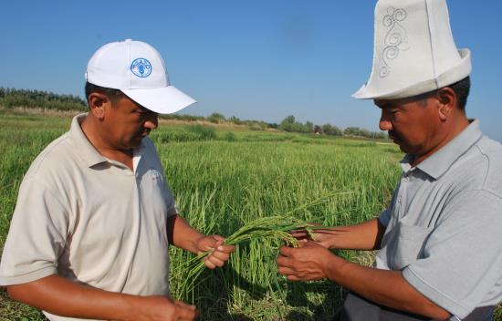
Photo: FAO

In order to obtain evidence-based data on the carbon balance and greenhouse gas emissions in the agricultural sector in Kazakhstan, FAO proposes the use of EX-ACT, a land-based accounting system that estimates C stock changes. In addition to assessment, EX-ACT assists specialists in choosing practical approaches that provide the greatest benefits in terms of economic development and climate change mitigation.

“EX-ACT is a computer-based tool developed by FAO that can appraise the carbon balance of almost any agricultural projects, which is becoming a mandatory requirement for receiving funding from many international organizations and donors”, said Kairat Nazhmidenov, Head of FAO Liaison and Partnership Office in the Republic of Kazakhstan at the opening ceremony. “We hope that the training will lead to expansion of the use of this tool in Kazakhstan which, in turn, will increase the inflow of investments for the introduction of efficient and sustainable resource-saving and climate-smart technologies in the agro-industrial complex, and improve the access of farmers and rural entrepreneurs to so-called carbon finance in exchange for reducing greenhouse gas emissions.” The workshop was attended by the staff of the Ministry of Agriculture of the Republic of Kazakhstan and its subordinate organizations, the Ministry of Energy of the Republic of Kazakhstan, representatives of research institutions, non-governmental, international organizations and farmers’ associations.

***

Two-day training on WOCAT technologies and approaches in the field of sustainable land management, questionnaires and databases
In August 2019, a training on WOCAT technologies and approaches was held in Nur-Sultan, Kazakhstan. Sustainable land use in the context of WOCAT refers to the use of land resources, including soil, water, flora and fauna, to produce goods and services to meet people’s needs, while ensuring the long-term productive potential of these resources and preserving their ecological functions. The Global Database on Sustainable Land Management, created by WOCAT (World Overview of Conservation Approaches and Technologies) provides free access to field-proven sustainable land use data, including descriptions of sustainable land management (SLM) approaches and maps, and offers an opportunity for experts to share information on their SLM approaches, including maps.

The purpose of documenting and appraising land use practices is to publish and disseminate important knowledge in the field of land use, promote best practices, and thereby contribute to the prevention and reduction of land degradation and land restoration. The training was attended by natural resource users, agricultural producers, experts and specialists from state organizations, development specialists, rural population and employees of local administrative offices. The first day was devoted to the study of theory, after which the participants undertook practical exercises to document sustainable land management practices in Shortandy village, Akmola region, using the WOCAT questionnaire.

***

Currently in Kazakhstan:

- Field work on resource-saving technologies has begun at pilot plots.

- A preliminary version of the national land degradation map in Kazakhstan has been developed

- An analysis of climate change-induced disaster risk management and early warning and agrometeorological services is nearing completion.

- Work has begun on an analysis of the institutional and legislative framework for pasture management.

***

KYRGYZSTAN

Pasture use plan developed for the pilot area
The pasture use plan was developed by the representatives of pasture committees in cooperation with CAMP Alatoo specialists within the framework of CACILM-2. It was preceded by the collection of information and a detailed analysis of problems that impede pasture users of Kochkor district, Naryn region, from efficiently and effectively managing pastures. The plan developed by the villagers was called upon to resolve a number of issues including: disputes over grazing plots, the payment system for grazing in territories belonging to the State Forest Fund, an increase in the number of yaks whose grazing is difficult to control, forage production, lack of pasture rotation, regulation of livestock numbers and unsatisfactory pasture infrastructure.

***
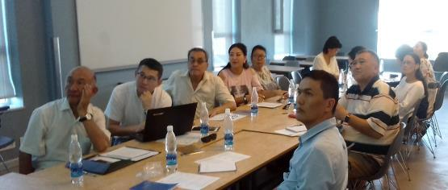
Photo: FAO

CACILM-2 | May 2020

16

Agriculture professionals explore tools to determine farmer resilience to climate change

SHARP (Self-evaluation and Holistic Assessment of climate Resilience of farmers and Pastoralists) is a tool that can be used measure the impact of climate volatility on farmers and test their resilience in a changing environment. The advantages and the means for using this tool were presented at a training session for representatives of the Ministry of Agriculture of the Kyrgyz Republic, the Academy of Sciences of the Kyrgyz Republic, the Kyrgyz National Agrarian University and public organizations. According to Abdybek Asanaliyev, Doctor of Agricultural Sciences, the use of SHARP will help fill in gaps in statistics and data on the impact of climate change on crop production, livestock production and the development of farms in Kyrgyzstan.

Collect Earth is a tool developed by FAO for dryland management around the world. Representatives of the Ministry of Emergency Situations and the State Agency for Water and Land Resources took an introductory course from Collect Earth developers at an interregional workshop in Turkey. Upon returning to Kyrgyzstan, they shared their knowledge with specialists from the State Agency for Environmental Protection and Forestry of the Kyrgyz Republic, the State Agency for Water Resources of the Kyrgyz Republic and the Design Institute on Land Management (Kyrgyzgiprozem), as well as the universities specialized in agronomy, architecture and construction.

Collect Earth is a free online resource for collecting data through satellite images via Google Earth, and processing and analysing them. According to Rakhat Sarybaeva, the leading GIS specialist at the Ministry of Emergency Situations of the Kyrgyz Republic, the tool is used to assess deforestation, reforestation and desertification, monitor agricultural land and urban areas, check existing maps and conduct fast, accurate and cost-effective research. “We are already using Collect Earth to map emergency risks and collect data on natural hazards.”

***
TAJIKISTAN

SHARP training contributes to climate change adaptation
In mid-March 2019, representatives of Central Asian countries and Turkey gathered in Dushanbe to participate in a regional training on SHARP methodology. Self-evaluation and holistic assessment of climate resilience of farmers and pastoralists (SHARP) was developed by FAO for use by farmers, rural development professionals and researchers to assess climate resilience.

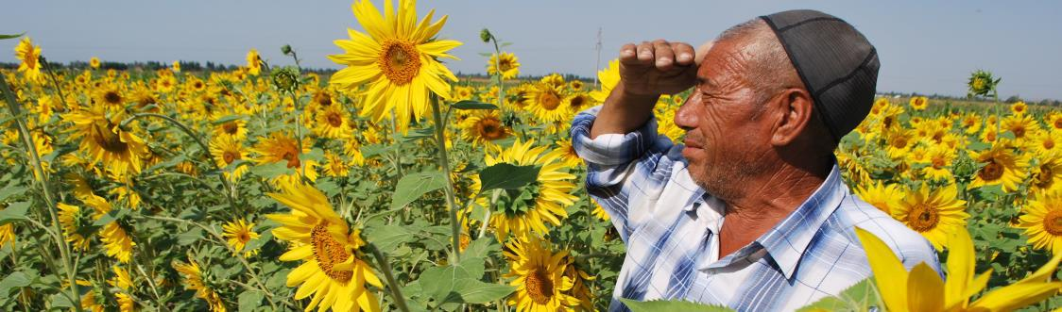
The four-day training-of-trainers workshop consisted of five sessions, including an introduction to the SHARP tool, downloading and running the application, interpreting the report on a tablet, analysing the data, and onsite visits to Vakhdat district to meet farmers, which allowed workshop participants to gain hands-on experience. Upon their return, the training participants conducted similar trainings for national specialists in their countries.

***
TURKMENISTAN

Introductory workshop held in Turkmenistan
In June 2018, an introductory workshop was held in Ashgabat, Turkmenistan. It was attended by interested partners from both public and non-governmental sectors, including the private sector, academia, UN agencies and the media. Dr. Mukhammet Durikov, Director of the National Institute of Deserts, Flora and Fauna under the State Committee for Environmental Protection and Land Resources, and the UNCCD Coordinator, opened the workshop and stressed that the Project is expected to make a significant contribution to sustainable and integrated natural resource management; the introduction of climate-smart agricultural technologies; mitigation of climate change adverse effects; the development of agribusiness, value chains and exports; integrated pasture management; restoration of abandoned arable land; combating soil salinization, desertification and soil erosion; and strengthening sustainable regional cooperation in the field of agriculture and food security.

In his speech, Shatlyk Berdiev, representing the Department of International Relations and Planning under the State Committee for Environmental Protection and Land Resources, noted that the issues of environmental protection, environmental safety and rational use of natural resources covered by the Project form the basis of Turkmenistan state policy. The Regional Project Coordinator, Makhmud Shaumarov, presented the Project, its structure, components, indicators and expected results, while the national coordinators presented a draft annual work plan for 2018, as well as defined project sites, project preparation stages, and potential national and international partners.

***

Photo: FAO

CACILM-2 | May 2020
17

UZBEKISTAN

Chickpeas sown on rainfed fields using no-till methods to bring high yields

The Project provided support for seed multiplication to the Kashkadarya branch, as a result of which more than 15 tonnes of the crop were supplied to the Kashkadarya and Bukhara regions. The seeds were distributed among farms to accelerate their multiplication and to increase wheat production on salt-affected soils.

“Chickpea has remarkable characteristics: the bacteria that live in root nodules convert life-giving nitrogen into organic form and improve soil health. Chickpea is one of the most important commercial crops and a source of protein for farmers in rainfed areas”, says Dr. Aziz Nurbekov, FAO expert on drought risk management in Uzbekistan. “The crop allows farmers to generate income more quickly compared to other crops in the region."

Chickpeas were sown on rainfed plots using both minimal and no-till methods at the CACILM-2 pilot site in 2019. The results showed that yields were higher in no-till plots compared to those with minimal tillage.

"The climatic conditions of the Kamashi region are more favourable for the cultivation of chickpeas using the no-till method", says Dr. Nurbekov. "The results prove that under conditions of rainfed agriculture, no-till cultivation of chickpeas can be the starting point for the introduction of conservation agriculture in Uzbekistan", he added.

Under the Project, 6 tonnes of chickpea seeds were distributed to 10 interested private farms in the Kamashi region. In the spring of 2020, chickpeas were planted on 100 hectares of rainfed land. It is expected that by 2021 the area under this crop will reach more than 10 000 hectares.
***

Introduction of Shams salt-tolerant winter wheat variety
Due to its arid climate, the irrigated soils in Uzbekistan are naturally prone to salinization. At present, the total area of saline irrigated land in the country is 1.9 million hectares.

"High soil salinity is a common agricultural problem in the country”, says Muhammadjon Kosimov, National Project Coordinator. “Farmers are often forced to pond fresh water onto their land plots to avoid lowering crop yields.”

The Project aims to introduce sustainable land management practices in Uzbekistan. Framers living in areas prone to drought and salinity are taught about drought and salinity tolerant crops in field schools.

One such crops is the Shams salt-tolerant winter wheat variety, bred by breeders of the Kashkadarya branch of the Grain and Leguminous Research Institute. During tests at various sites throughout Uzbekistan, Shams surpassed local varieties by 10-40% and was selected by project specialists as a crop suitable for introduction in salt-affected areas.

***

Sunflower cultivation in rainfed regions of Uzbekistan

In the Kamashi district of the Kashkadarya region in the southeast of Uzbekistan, the spring of 2019 brought unusually heavy rains creating favourable conditions for sunflower, which was sown on rainfed soils for the first time.

Originating in eastern North America, sunflower is the fifth most cultivated oilseed in the world after soybeans, rapeseed, cotton and peanuts.

"This crop is mainly grown in rainfed areas on a wide range of soils in all parts of the world", says Dr. Juraev, Deputy Director of the Kashkadarya Branch of the Grain and Leguminous Research Institute, the main partner of CACILM-2 in the region. "However, in Uzbekistan, as an oilseed crop, it is traditionally cultivated only on irrigated lands."

According to reports, in 2019 sunflower was planted on 13 000 hectares of irrigated land as a primary crop, and 27 000 hectares as a secondary crop following the grain harvest. The area of irrigated land in Uzbekistan covers more than 747 000 hectares, and the amount of precipitation exceeds 200 mm per year.

“Although irrigated land makes an important contribution to wheat production in the country, intensive tillage and lack of crop rotation lead to soil erosion, and to subsequent crop losses”, says Dr. Juraev.

Under the Project, it was decided to test new methods at the Kamashi pilot site with rainfed soils. In May 2019, more than 50 local farmers gathered on field day to compare crops sown using both conventional tillage and no-till methods, with or without hydrogel.

"The results obtained showed that sunflower, sown using a no-till method, has a greater potential to be introduced in the rainfed regions of Uzbekistan."

Most of the farmers who participated in Field days and training courses expressed their readiness to grow sunflowers using the new technology. As a result, 130 kg of sunflower seeds were distributed to farmers cultivating the land around the Project pilot site in the Kamashi region in 2020.
***ФАО

CACILM-2 | May 2020

18

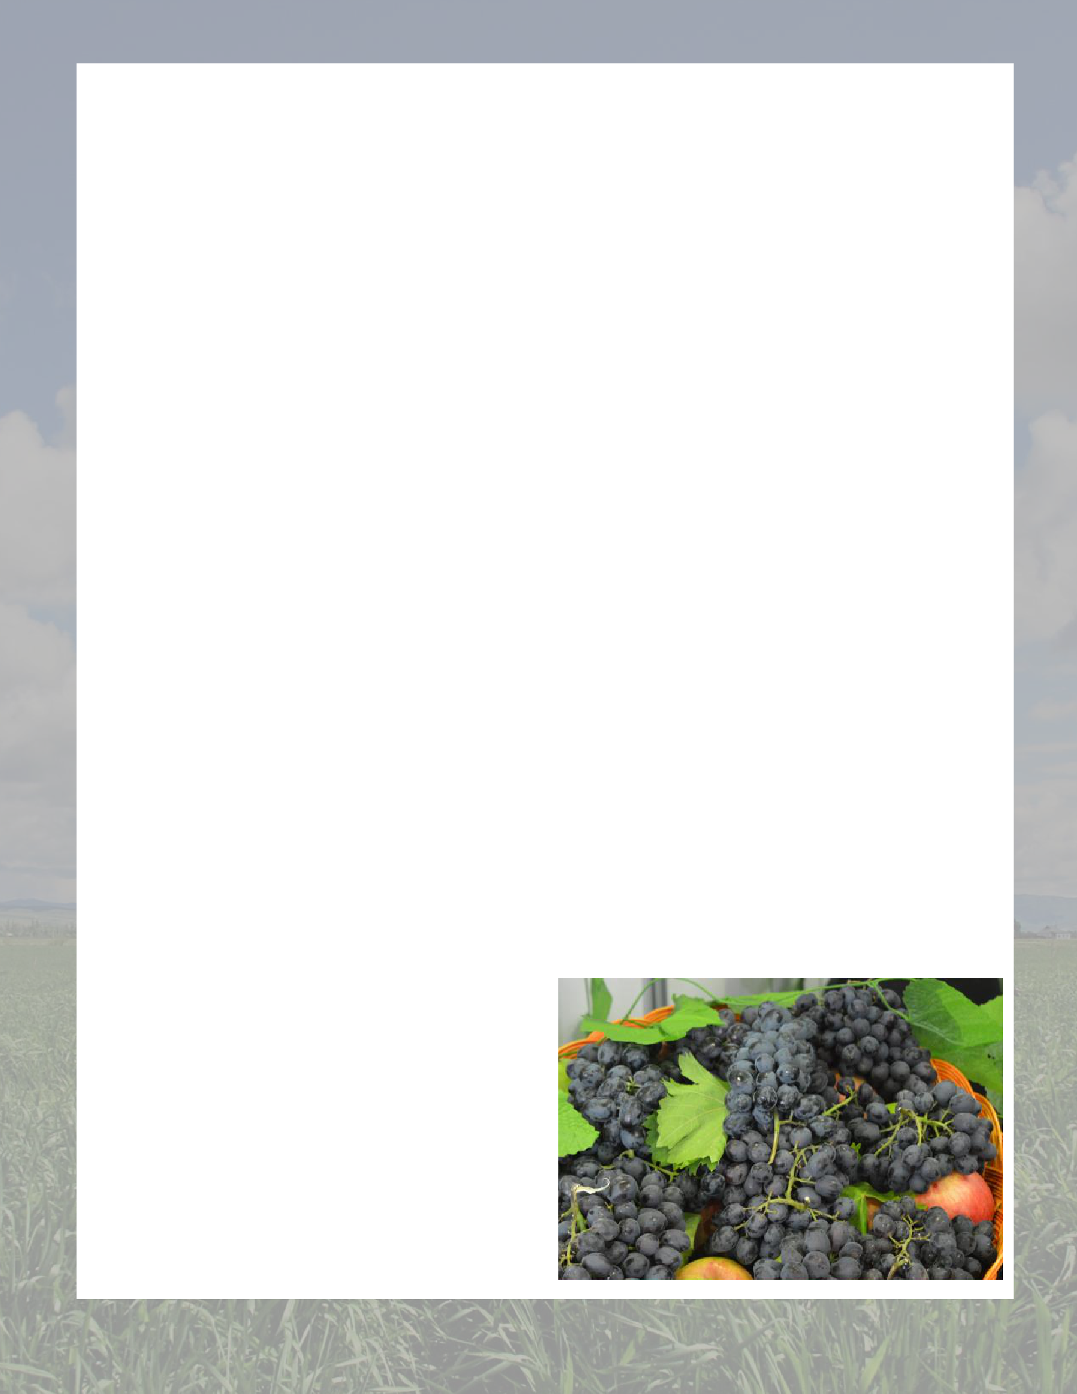
Calendar of CACILM-2 events for June, July and August 2020 (may change depending on the COVID-19 situation in Central Asia)

Regional training on agroforestry, nurseries and horticulture
– June-July
Regional training on economics of land degradation – June-
August

Regional training on knowledge dissemination services/Farmer Field Schools – June-August

Kazakhstan

Training on Collect Earth: Open Foris – June-August
Training on Farmer Field Schools – June-August
Field days and training on integrated natural resource management and climate-smart agricultural practices and related training on Farmer Field Schools – June-August
Three field days and three workshops on salinization mitigation and management methods – June-August
Field workshop for students of national universities on integrated natural resource management and climate-smart agricultural practices – July
National training on drought vulnerability assessment and map compilation – July
Field day on resource-saving ploughing methods – August

Two field days on improved pasture management – August

Kyrgyzstan

Round-table in the Ministry of Agriculture of the Kyrgyz Republic on the revision and adoption of the National Action Plan for the Implementation of the United Nations Convention to Combat Desertification (UNCCD) at the national level – July
Round-table with the CACILM-2 National Committee on strengthening intersectoral coordination mechanisms at the national level, including the integration of NAPs into the national sectoral budget – August
Workshop on improving individual value chains – August

Field workshops on climate-smart agriculture and the implementation of pasture management plans – August

Tajikistan

Farmer field schools for female farmers on drought and salt-tolerant crop production for scaling up to larger areas in Project regions – June
Preliminary and final seminars to review both UNCCD Country Reports – July-August

Training on FAO tools for local experts at national level (AquaCrop, Collect Earth and ASIS) – June, July

Training for eight farmer groups on the widespread introduction of approaches and methods to reduce salinity – August

Turkmenistan

Introductory workshops in the Project pilot zones – June-July
Meetings of working groups on various areas of integrated natural resource management and sustainable land management (Working group on the development of an assessment for strategies, and legal and institutional frameworks in the field of integrated natural resources management, working group on preparedness strategies for drought, salinity management, etc.) – June, August

Field visits to pilot sites for coordination and implementation of adaptation measures – June-November
Theoretical and practical training on new technologies and methods of combating soil salinization in drought-affected pilot regions – July-November

Training on FAO tools for local experts at national level (AquaCrop, Collect Earth, etc.) – July-December

Uzbekistan

UNCCD National Council Meeting – June
Workshop on national policies, strategies and guidelines on drought management – July
Workshop on identifying areas for strengthening agroforestry value chains – June, July
Staff training on drought risk management/integrated natural resource management approaches – August
Training and workshops for pasture users (Karakul breeding farms) in the Kashkadarya and Bukhara regions – July, August, September
Training course on appraising native saline land plants – August-November

CACILM-2 | May 2020

19

 |  | CONTACTS
 |  |  |  | DALER DOMULLODZHANOV
MAKHMUD SHAUMAROV
Project Regional Coordinator |  |  |  | National Technical Officer
51 Zhandosov str.  Almaty, 050008, Kazakhstan |  |  |  | for Land and Water Resources in Tajikistan
FAO Country Office
48 Aini str (Sozidanie Business Center), Dushanbe, 734024, Tajikistan
E-mail:
Makhmud.shaumarov@fao.org |  |  |  | E-mail:
+7 707 487 3015 (mobile/WhatsApp) |  |  |  | Daler.Domullodzhanov@fao.org
Skype: mshaumarov |  |  |  | +992 918 248084
 |  |  |  | (mob/WhatsApp, IMO, Viber)
 |  |  |  | Skype: dalerdomullojonov

ZHANYL BOZAYEVA |  | RAHMANBERDI HANEKOV
National Project Manager in Kazakhstan |  | National Project Manager in Turkmenistan
FAO Liaison and Partnership Office in Kazakhstan
6/1 Kabanbay batyr ave, Kaskad Business Center
office 33, Nur-Sultan, Kazakhstan |  | 59 Azadi str, Ministry of Agriculture and Environmental Protection, office 57
 |  | Ashgabat, Turkmenistan
E-mail:
Bozayeva.Zhanyl@fao.org
Tel.: +7 7172 790429 |  | E-mail:
(office), +77025601404 (mobile/
 |  | Rahmanberdi.Hanekov@fao.org
Telegram Messenger), +905075134927
 |  | + 993 65 036719 (mobile/IMO)
(WhatsApp) Skype:
 |  | Skype: hanekov.rahmanberdi
janil.bozayeva.Facebook: Zhanyl
Bozayeva Instagram: zhanyl7

 | MATRAIM ZHUSUPOV |  | MUHAMMADJON KOSIMOV
 | National Project Manager in Kyrgyzstan |  | National Project Manager in Uzbekistan
FAO Country Office
201 Akhunbayev str.
 | Bishkek, 720044, Kyrgyzstan |  | 2 Universitetskaya str, Kibrai district  Tashkent region, 100140, Uzbekistan
 | E-mail: |  | E-mail:
 | Matraim.Jusupov@fao.org |  | Muhammadjon.Kosimov@fao.org
 | +996 557200565 (mobile/WhatsApp)
 | Twitter: Matraim Zhusupov@Matraim |  | +998974448719 (mobile)
 | +996777909001 (Telegram: Matraim
 | Jusupov)
 | Skype: matraim65
CACILM-2 |  |  |  | May 2020
 |  | 20

