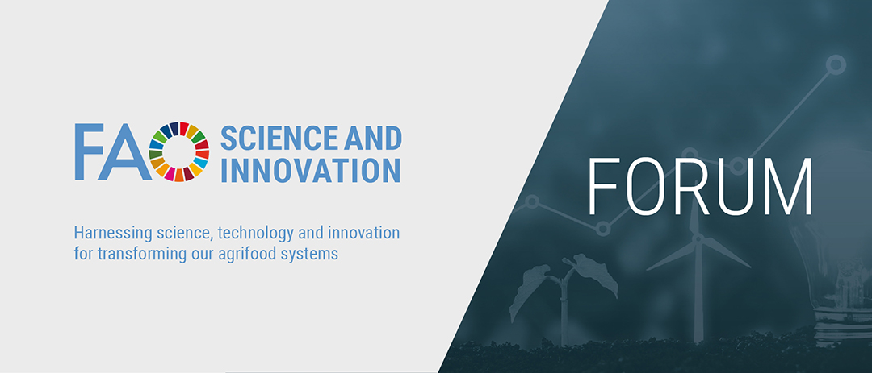

FAO Science and Innovation Forum 2022 | Call for side-events
17-21 October 2022

SIDE EVENTS
The Science and Innovation Forum (17 – 21 October 2022) will be preceded by independently organized side-events on 12-14 October 2022, with partners and Members showcasing their innovations and experiences. The deadline for submission of the side event proposals is 15 August 2022. The Secretariat will review the proposals after this deadline and notify the lead organizations the feedback and status of selection of the side event proposals on or before 15 August 2022. The side events will be organized independently between 12 and 14 October 2022 by the lead organizations together with their potential partners.

The side event proposals should be closely aligned to at least two or more of the themes and thematic areas listed under point 4 and 5 of the form below. The side event proposals could be relevant to one or more sub-sectors of food and agriculture focusing on the application of science and innovation in crops, livestock, forestry, fisheries/aquaculture; and in food processing, marketing, consumption, nutrition and food safety. Multi-stakeholder approaches involving governments, academia, research and extension institutes, civil society, producer organizations, private sector and international organizations are encouraged to collaborate in organizing the side events. Principles of gender equity and geographical diversity should be taken into account when selecting speakers and side-events showcasing this clearly will take precedence over others.

Side-Event Expression of Interest Form
Please fill out the attached form and send it by email to Science-Innovation@fao.org by 15 August 2022.

1. Name of Lead Organizations:
Click here to enter text.

2. Name(s) of other potential partner organizations:
Click here to enter text.

3. Proposed Title of Side-Event:
Click here to enter text.

4. Science and Innovation Forum thematic areas the side –event aligns with (select at least 2)

☐ Enhancing evidence base
☐ Science – Policy Interface
☐ Research for Development
☐ Access to technology and innovation by small scale producers
☐ Capacity Development
☐ Science communication

5. FAO Strategic Framework thematic areas the side-event aligns with (select at least 2):

☐ BETTER PRODUCTION (Innovation for sustainable agriculture production, Blue transformation, One Health, Small-scale producers’ equitable access to resources, Digital agriculture)

☐ BETTER NUTRITION (Healthy diets for all, Nutrition for the most vulnerable, Safe food for everyone, Reducing food loss and waste, Transparent markets and trade)

☐ BETTER ENVIRONMENT (Climate change mitigating and adapted agri-food systems, Bioeconomy for sustainable food and agriculture, Biodiversity and ecosystem services for food and agriculture, Achieving sustainable urban food systems)

☐ BETTER LIFE (Gender equality and rural women’s empowerment, Inclusive rural transformation, Agriculture and food emergencies, Resilient agri-food systems, Hand-in-Hand (HIH) Initiative, Scaling up investment)

6. Short description of event (100 words):
Click here to enter text.

7. Names and affiliations of potential speakers:
Click here to enter text.

8. Date AND Time of the Event (Side events will be scheduled between 12 and 14 October and duration of the side events should not be more than 2 hrs):
Click here to enter text.

9. Lead Contact
Name: Click here to enter text.
Email Address: Click here to enter text.

Phone Number: Click here to enter text.

Mailing Address: Click here to enter text.

