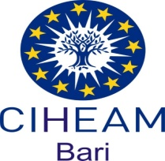

“The Blue Hope Technical Cooperation Programme”

Food and Agriculture Organization of the United Nations

International Centre for Advanced Mediterranean Agronomic Studies

Blue growth opportunities in fisheries and aquaculture

Value chains Analysis

Case study TURKEY - Gökova Bay fishing areas

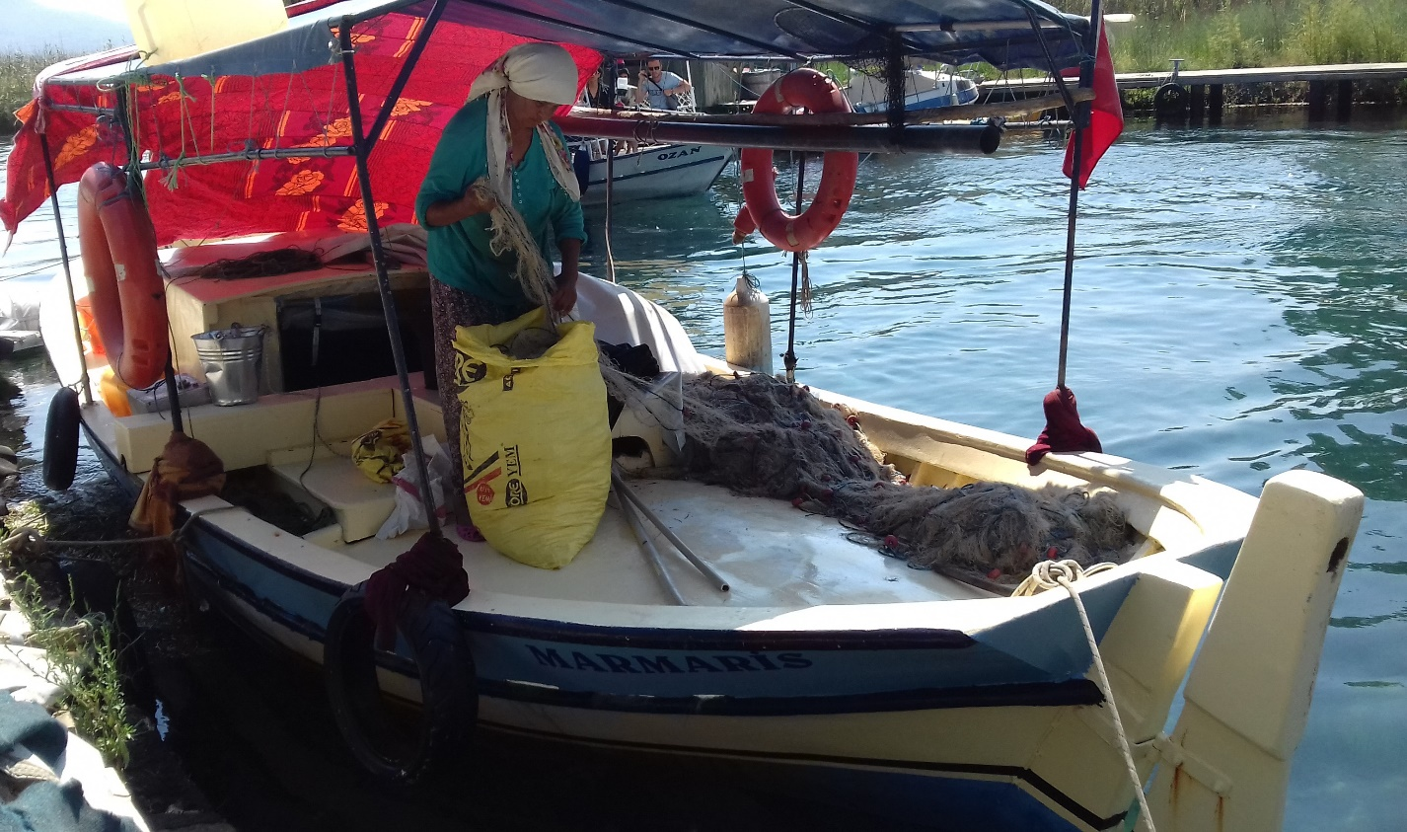

SEPTEMBER 2018

Table of Contents

FOREWORD 3
ACRONYMS 4
1. BACKGROUND AND OBJECTIVES 5
2. METHODOLODY 6
3. TURKEY MISSION CONTEXT 8
3.1 Brief review of SSF in Turkey 8
3.2 GÖKOVA BAY 9
3.3 SOCIOECONOMIC IMPORTANCE OF THE FISHERY 13
4. ACTION OF SECTOR DIAGNOSYS 14
4.1 Inception meeting 15
4.2 AKYAKA HARBOR AND FISHERY COOPERATIVE 19
4.3 FISHERIES STAKEHOLDERS IN AKYAKA 23
4.4 THE AKÇAPINAR COOPERATIVE 24
4.5 FISH RETAILER IN GÖKOVA BAY 28
4.6 MARMARIS FISHING HARBOR AND FISHERY COOPERATIVE 30
4.7 MEDITERRANEAN CONSERVATION SOCIETY NGO BOARD 33
4.8 AKBÜK SMALL SCALE LANDING SITE AND COOPERATIVE 35
4.9 LOCAL FISH RESTAURANTS 36
4.10 MANAGEMENT BOARD OF AKYAKA FISHERY COOPERATIVE 38
4.11 MEDITERRANEAN CONSERVATION SOCIETY GÖKOVA BAY 39
5. SWOT ANALYSIS 41
6. STRATEGIC OPTION AND Recommendations 45
6.1 Business development and investment opportunities and needs 47
6.2 Training needs/plan 47
6.3 Marketing opportunities 49
7. Conclusions 51
References 53

FOREWORD

FAO’s Blue Growth Initiative was conceived at the Rio+20 Conference and launched in 2013. It is developed from the concept of the Green Economy and based on the principals of the FAO Code of Conduct for Responsible Fisheries. The Initiative aims to develop fisheries, aquaculture and related aquatic sectors for maximizing social and economic benefits and minimizing environmental degradation, threats and stressors.

Currently FAO and CIHEAM are cooperating in support of the Blue Hope Technical Cooperation Program working with the National Local institutions of Turkey, Tunisia and Algeria to strengthen the stakeholders capacities, develop and implement integrated management policies, strategies and tools. The 2018-2019 Biennium Work Planning Results identified these Countries as needing capacity building, in order to make the sectors more productive and sustainable and the associated value chains more efficient and inclusive.

In several region of the world, coastal and rural communities involved in fisheries, aquaculture and sectors face increasing pressure as the result of limitations in governance, climate change and unplanned urban development. In the Mediterranean area, in the sub Saharan Africa and in the Indian sub continent these factors are particularly serious, exacerbated by poverty, lack of alternative livelihoods and political instabilities. This is so particularly evident that National Institutions, International Development Agencies and the private sector are engaged to lock for new models and approach, for starting with more effective development processes.

It is crucial to strength the political and institutional framework in support of the coastal communities’ population, to improving food security, technical, economic and social performance, and sustainable management of natural resources.

According to the LoA signed on with FAO , CIHEAM prepared three detailed, comprehensive and technical reports on blue growth opportunities in fisheries and aquaculture value chains in selected areas of Turkey, Tunisia and Algeria.

CIHEAM actions aims to contribute to FAO’s Strategic Objective 2 “Make agriculture, forestry and fisheries more productive and sustainable” by providing technical capacity to government agencies and communities in Turkey, Algeria and Tunisia related to the sustainable management of coastal areas and resources, including fisheries and aquaculture.

CIHEAM outputs are aligned with Output 2.3.2. “Capacities of institutions strengthened to implement policies and international instruments that foster sustainable production and address climate change and environmental degradation”.

The results from each report identified and recommend approaches for enhancing the fisheries and aquaculture value chains in these areas.

ACRONYMS

ACFM Advisory Committee of Fisheries Management
BGI: Blue Growth Initiative
EAF Ecosystem Approach to Fisheries
EastMed Scientific and Institutional Cooperation to Support Responsible Fisheries in the Eastern Mediterranean
EPASA Environmental Protection for Special Areas
FAO Food and Agriculture Organization of the United Nations
FMP Fisheries Management Plan
MEU Ministry of Environment and Urbanization
MFAL Ministry of Food, Agriculture and Livestock
MPA Marine Protected Area
NGO Non-Governmental Organizations
GFCM General Fisheries Commission for the Mediterranean
SEPA Special Environmental Protection Area SSF Small Scale Fisheries
CO Country Office
EastMed Scientific and Institutional Cooperation to Support Responsible Fisheries in the Eastern Mediterranean
LTO Lead Technical Officer
SDG Sustainable Development Goals
SSF Small-scale Fisheries
TurkStat Turkish Statistical Institute
TL Turkish Lira (Rate on 20/07/2018 1 Euro = 4.8 Turkish Lira)

BACKGROUND AND OBJECTIVES

CIHEAM is contributing to the FAO Blue Hope Technical Cooperation Programme analysing the Small Scale Fishery sector in 3 pilot areas of Turkey, Tunisia and Algeria.

FAO TCP must contribute to strength the capacity of government, key institutions and stakeholders in targeted coastal communities in Turkey (Gokova), Algeria (Gouraya and Algeri port) and Tunisia (Zarzis fishing port and clam productive areas in Medenine Governatorate ) to develop and implement integrated, multi sector management policies, strategies and tools trough the FAO Blue Growth Initiative (BGI) approach.

Sectors can become more productive and sustainable (FAO Strategic Objective 2), and the associated value chains more efficient and inclusive (FAO Strategic Objective 4) for helping to reduce rural poverty in these areas (FAO Strategic Objective 3).

FAO TCP must contribute to the United Nations Sustainable Development Goals (UN SDGs), as follows:

- reduce hunger (aligned with United Nations’ Sustainable Development Goal (UN SDG) 2);
- increase decent work and economic growth (UN SDG 8);
- reduce poverty and inequalities (UN SDG 1 and 10);
- increase responsible consumption and production (UN SDG 12);
- support life below water (UN SDG 14) and life on land (UN SDG 15).

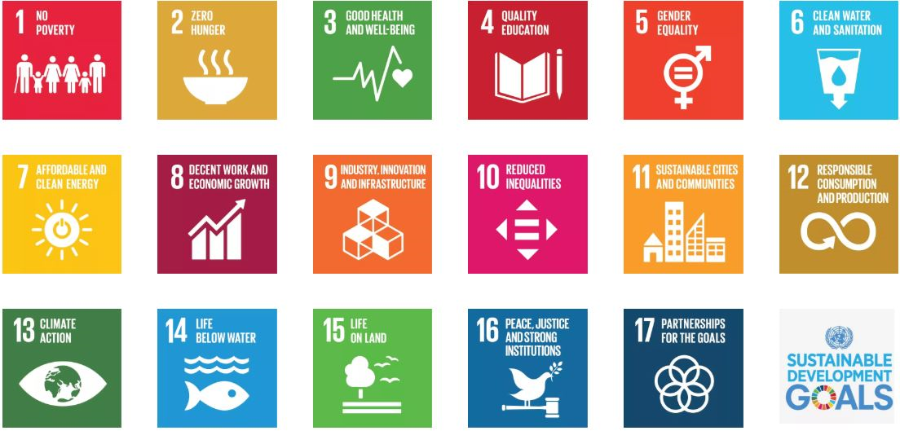

Development Goals Table (UN SDGs)

METHODOLODY

Outputs 1: Value chain analysis to identify blue growth opportunities (related to fisheries, aquaculture and value chain development) in Gokova Bay, Turkey. Analysis of training needs for stakeholders and value chain actors and strategy for implementation.
A1.1 | Review relevant documents and reports, required services for sustainable resource management linked to the small scale fisheries and aquaculture development (production, processing, and marketing).
A1.2 | Mission organisation and Institutional Inception meeting. Consult with sector stakeholders and project partners to evaluate/validate the scope of Project aimed to develop and improve the capacity of small scale fisheries
A.1.3 | Identify business development and investment opportunities and needs
A1.4 | Prepare a plan for training on improved sanitary controls and quality of fish, and value added fisheries products
A1.5 | Recommend opportunities to improve product quality, value added and profitability, and capacity to access to the market.

Outputs 2: Value chain analysis to identify blue growth opportunities (related to fisheries, aquaculture and value chain development) in Gouraya Bay/Protected area. Analysis of training needs for stakeholders and value chain actors and strategy for implementation.
A2.1 | Review relevant documents and reports, evaluate required services for sustainable resource management linked to the small scale fisheries and aquaculture development (production, processing, and marketing).
A2.2 | Mission organisation and Institutional Inception meeting. Consult with sector stakeholders and project partners to evaluate/validate the scope of Project aimed to develop and improve the capacity of small scale fisheries
A.2.3 | Identify business development and investment opportunities and needs.
A2.4 | Prepare a plan for training on improved sanitary controls and quality of fish, and value added fisheries products
A2.5 | Recommend opportunities to improve product quality, value added and profitability, and capacity to access to the market.

Outputs 3: Value chain analysis to identify blue growth opportunities related to fisheries, aquaculture and value chain development in the Zarzis port, Medenine area and El Bibane Lagoon. Analysis of training needs for stakeholders and value chain actors and strategy for implementation.
A3.1 | Review relevant documents and reports, evaluate required services for sustainable resource management linked to the small scale fisheries and aquaculture development (production, processing, and marketing).
A3.2 | Mission organisation and Institutional inception meeting.  Consult with sector stakeholders and project partners to evaluate/validate the scope of Project aimed to develop and improve the capacity of small scale fisheries
A3.3 | Identify business development and investment opportunities and needs.
A3,4 | Prepare a plan for training on improved sanitary controls and quality of fish, and value added fisheries and aquaculture products
A3.5 | Recommend opportunities to improve product quality, value added and profitability, and capacity to access to the market.

Outputs 4: Sharing action/Final meeting in Bari CIHEAM Headquarter on recommendations for interventions and activities to strengthen implementation, within context of blue growth in the analysed areas/locations
A4.1 | Consultation with project partners to evaluate/validate the Project outputs aimed to develop and improve the capacity of small scale fisheries: demonstrational actions, business development, support services and training
A4.2 | Final recommendation and opportunities to improve product quality, value added and profitability, and capacity to access to the market.

The FAO Lead Technical Officer (LTO) served as the main coordinator and manager of the project. The Budget Holder (BH) will advise upon and approve major decisions.

The LTO coordinated and managed contributions from Project Task Force Members including FAO Headquarters officers and Country and Regional Officers and Technical Officers. The LTO will also coordinate and manage contributions from Consultants. Consultants will liaise, as needed, with stakeholders in country—from the national level (e.g., Ministries) to the local level (e.g., community stakeholders in project sites)—via the FAO Country and Regional Offices.

The objective for this study is to provide an analytical basis for the development of a vision and strategy for the fishery value chain, which ultimately have to be developed by the stakeholders themselves.

Information was gathered on a comprehensive set of issues through literature review, key-informant interviews, site visits and discussion workshops.

The report is the outcome of a three-stage process, comprising a launch stakeholder workshop that provided a first sketch of the value-chain map and analysis of the strengths, weaknesses, opportunities and threats (SWOT) facing the value chain, a data-collection and analysis stage, and a findings review workshop that discussed the preliminary conclusions and provided guidance for completing the report.

The actual field study was conducted between May and September 2018 by a team consisting of CIHEAM staff.

TURKEY MISSION CONTEXT

Expected outputs: Value chain analysis to identify blue growth opportunities (related to fisheries, aquaculture and value chain development) in Gokova Bay, Turkey. Analysis of training needs for stakeholders and value chain actors and strategy for implementation.

A1.1 | Review relevant documents and reports, required services for sustainable resource management linked to the small scale fisheries and aquaculture development (production, processing, and marketing).
A1.2 | Mission organisation and Institutional Inception meeting. Consult with sector stakeholders and project partners to evaluate/validate the scope of Project aimed to develop and improve the capacity of small scale fisheries
A.1.3 | Identify business development and investment opportunities and needs
A1.4 | Prepare a plan for training on improved sanitary controls and quality of fish, and value added fisheries products
A1.5 | Recommend opportunities to improve product quality, value added and profitability, and capacity to access to the market.

3.1 Brief review of SSF in Turkey

Turkey has extensive water resources with its favorable geographical position between the Black Sea and Mediterranean Sea, and it is rich in fish and other marine and fresh water products.

There are some 154 known marine fish species in the Black Sea, 257 in the Sea of Marmara and 449 in the Aegean Sea and 441 in the Levantine Basin. There are total of 512 species all along Turkish Coasts (Bilecenoğlu et al., 2014). In contrast to its rich biologic diversity, the Mediterranean has a relatively low fish productivity.

Fisheries in Turkey are characterized as multispecies, multigears and both demersal and pelagic fish stocks are targeted as in most of the other Mediterranean countries. Trawls are exploiting demersal species, while purse seiners are concentrated on small and large pelagic fish stocks.

Lagoon fisheries also exist in the region focusing on seabass, sea bream, eel and mullet. Fishing with passive fishing gears (set nets longlines, traps etc.) and vessels <12 m small-scale fisheries are very common.

Fishery Statistics from the Turkish Statistical Institute (TurkStat) show that small-scale fisheries have more than 90 percent of the total number of fishing vessels, however they produce less than 10 percent of the total landings in terms of weight. The average length of vessels involved in the small-scale fishery is 8 meters and average engine power is about 10-25 HP. They are mostly locally built wooden vessels equipped with inboard engines and operate various gillnets and longlines (Ünal and Göncüoğlu, 2012).

3.2 GÖKOVA BAY

Gökova Bay is located on the southern Mediterranean coast of Turkey. Part of the Gökova Bay including both marine and land areas was designated, and declared as a Special Environmental Protection Area (SEPA) by the Decree no. 88/13019 of Cabinet of Ministers (June 12, 1988).

Afterwards, the Decree no. 2010/1089 of Cabinet of Ministers (official gazette number 22 December 2010 / 27793) approved the border change of Gökova SEPA (Aktaş et al., 2011). Considering only the marine area today, Gökova SEPA is one of the 31 Marine and Coastal Protected Areas (in other words MPA) in Turkey (Figure 1 - Aktaş et al., 2011).

With a land area of 270 km² and a marine area of 827 km², the economy of the region depends on agriculture, fishing and tourism. Fishing in the region has developed as small scale due to the conditions of the coastline, the geography and productivity of the bay as well as the status of the area pertaining to conservation (Ünal et al., 2016).

The marine area of Gökova Bay has high biological diversity, with about 723 species described; 34 of these species are protected under national and international treaties while 26 species non-indigenous species have moved to the Mediterranean through various routes (Okuş et al., 2016).

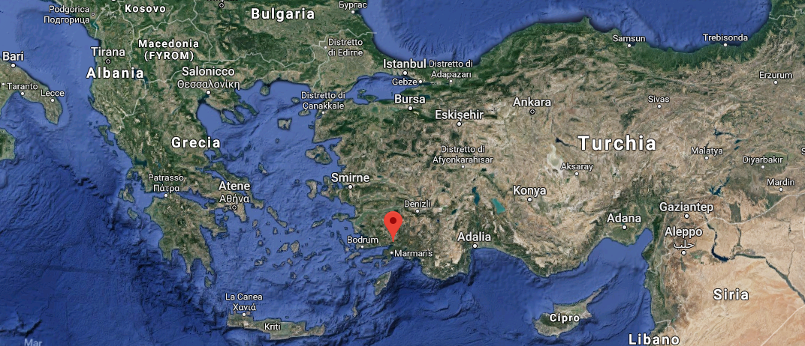

Map of Gökova - Mugla, Turkey

Gökova Bay represent a good example of best practice of management for small scale Fishery activity, due to the solidarity and cooperation among fishers, existing of fishery cooperatives, interest of marine related NGOs and universities to the area, past and on-going projects by joint venture of stakeholders, and most importantly special environmental status of the area.

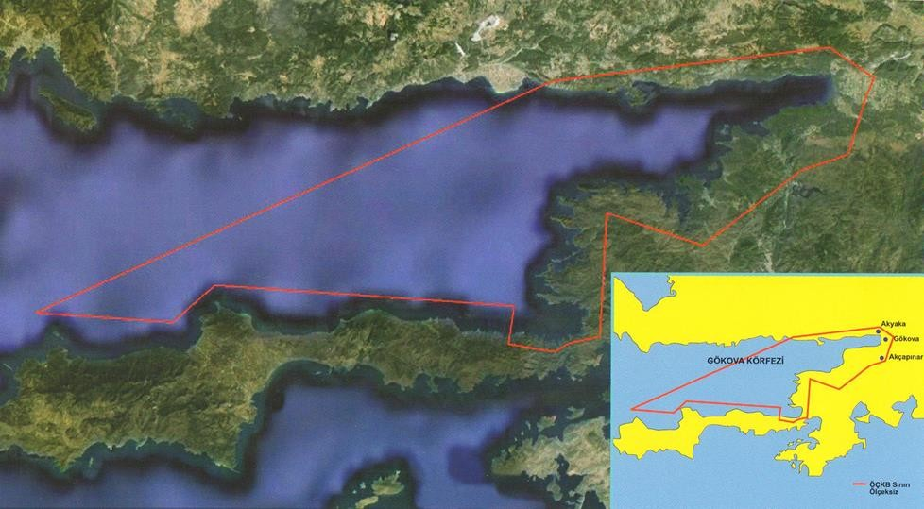

Map of Gökova MPA and protected area (Southern Aegean Sea), Turkey

Gökova Bay represent to a good example of employment of women in the fishery sector: here are total 28 fisherwomen actively fishing. On the other hand, presently, fisheries in Turkey need an example of a best practice much more than ever.

Cumulative effects of many projects and studies in Gökova MPA in the past have EAF Baseline Report, Gökova MPA, Turkey helped researchers, NGOs, and fishery cooperatives to act together to solve problems such as illegal fishing, decreasing catch and income. They established six No Fishing Zones in the bay in 2010. After five years protection, they have noticed the great success in increasing protection, catch amount and fishing income.

However, it needs to be sustainable. At this point, the stakeholders together are working on the implementation of a management strategy following the planning process of the EAF (Ünal et al., 2016).

Mediterranean Conservation Society set up a community based marine ranger patrol programme in 2013. Two patrol boats and four marine rangers were equipped for conducting patrols.
Although community rangers cannot impose a fine for an illegal activity, they record any incident with a camera and immediately report it to the Coast Guard; then, the Coast Guard legally completes the lawsuit using the pictures and video recordings as evidence.

The vessels used in small-scale fisheries in Gökova MPA are 5 - 12 meters in length, locally built and wooden. Usually each boat is operated by one or two fishermen. Fishermen using long line and gill nets go to the fishing grounds in the evening, set the gears and return home. In the morning, they retrieve the gear and return to the port with their catch (Ünal et al., 2016).

It is lack of regular institutional monitoring of fisheries in the bay, value and landing of catches from the fishery per year by species are not available. However, the relevant data is provided by some researchers (Ege University), NGOs (e.g. Mediterranean Conservation Society) and fishery cooperatives (e.g. Akyaka Fishery Cooperative) studying in the region.

According to the last data belonging to 2015 provided by Mediterranean Conservation Society based on Akyaka Fishery Cooperative, in terms of quantity, the top five species are Pagellus erythrinus, Epinephelus aeneus, Merluccius merluccius, Sparus aurata, Mugil spp. in the bay. Considering value of the species or their contribution to the gross income of the cooperatives, Epinephelus aeneus, Pagellus erythrinus, Sparus aurata, Mugil spp., Epinephelus costae are the most important species in the Gökova MPA (Ünal et al., 2016).
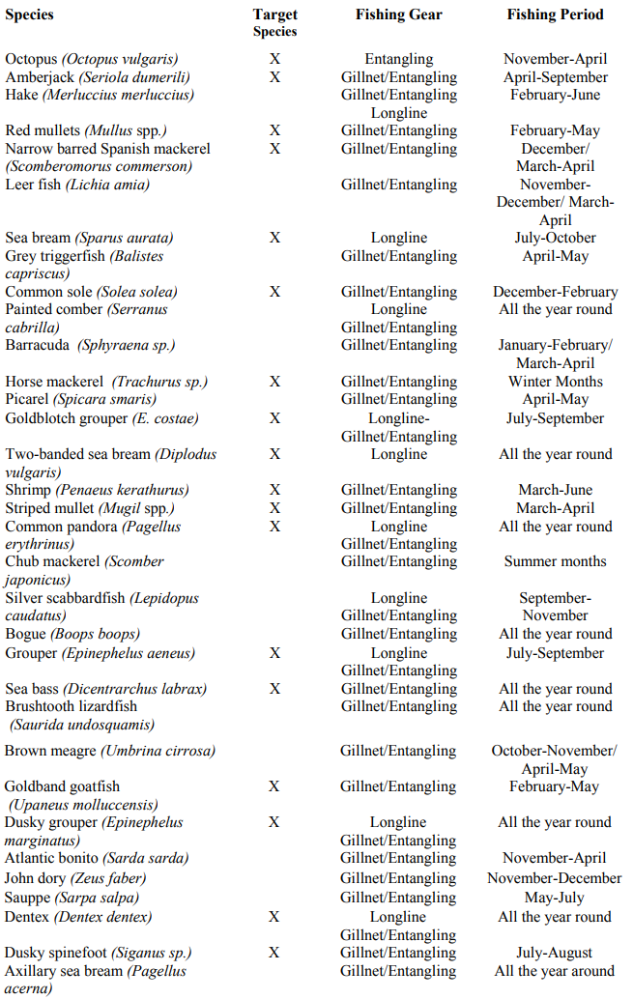

The main target species caught in Gökova MPA, fishing gears and fishing periods (Ünal et al., 2016)
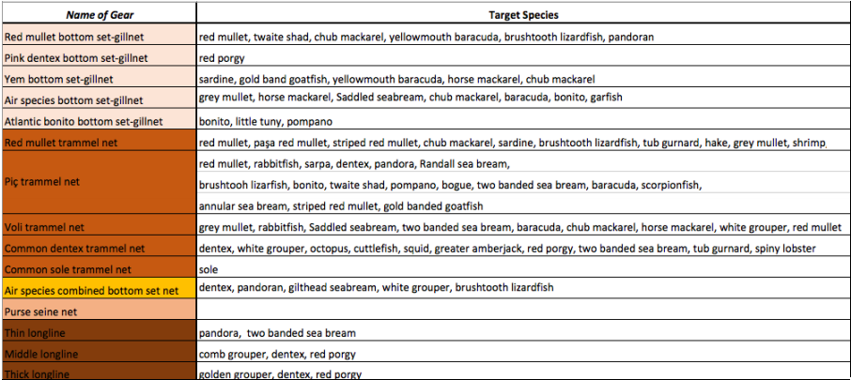

Target species caught by fishing gears used in Gökova MPA (AKD, 2016; Ünal et al., 2016)

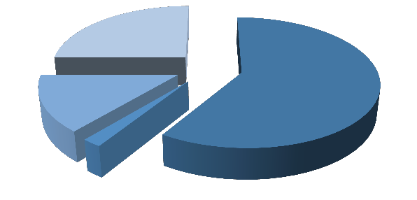
Longlines
25%
Gill nets and
longlines 59%
Gill nets
14%
Encirculing gill nets
2%

Distribution of preferred fishing gears (Ünal et al., 2016)

3.3 SOCIOECONOMIC IMPORTANCE OF THE FISHERY

Marine capture fisheries provide full-time and part-time employment opportunity to the 150-200 fishers respectively who directly work on fishing boats in the bay.

Fishery cooperatives pay salary to directors, heads and fish cleaners which means there are five full- time workers in these cooperatives. A system of marine rangers has been in practice in the bay since 2013, which also provides full-time employment authority to the three former fishers of the bay.

There are three permanent retailers/fish shops (cooperatives excluded) and two fish stands at Gökova bazaar (only Saturdays) in the region providing employment opportunities for nine people.

There are also 10 to 20 (depending on the season) fish restaurants located around the Gökova MPA and they provide service during the year.

Fish restaurants provide employment opportunities for approx. 142 people including their owners.

Additionally, there are four people fix and prepare nets and one of them works on board fishing with her husband. Percentages of those who accepted fishery as their only source of income were determined as follows: 38.9 % (Akyaka), 50 % (Akçapınar), and 100 % (Sarnıç-Akbük) (Ünal, 2010).

Most of the fishers work alone. Only one fisher from Akyaka Cooperative works with a partner as sharing system. Five fishers from Akyaka Cooperative goes to fishing with their wives and these women not only cook or clean on board, but also very well qualified for baiting, fixing fishing gears, laying nets/long lines and steering boat.

Due to the lack of regular monitoring of fisheries in the bay, value and landing of catches from the fishery per year by species are not available for the last five years. However, the relevant data is provided by some researchers (Ünal et al., 2009c), NGOs (e.g. Mediterranean Conservation Society) and Akyaka Fishery Cooperative (e.g. Akyaka Fishery Cooperative) working in the region. These data represent records of the fishery cooperatives rather than all of the fishers operating in the Gökova MPA.

According to the recent data belonging to 2015 provided by Mediterranean Conservation Society (AKD, 2016) based on Akyaka Fishery Cooperative, in terms of quantity, the top five species are Pagellus erythrinus, Epinephelus aeneus, Merluccius merluccius, Sparus aurata, Mugil spp. in the bay.

Considering the value of the species or their contribution to the gross income of the cooperatives, Epinephelus aeneus, Pagellus erythrinus, Sparus aurata, Mugil spp., Epinephelus costae are the most important species in the Gökova MPA (Table 3). However Randall’s threadfin bream (Nemipterus randalli) was first recorded in Gökova Bay in 2013 (Gülşahin and Kara, 2013) and soon after this species has reached the highest percentage of the total catch (22%) for the years 2015-2016 (AKD, 2016).

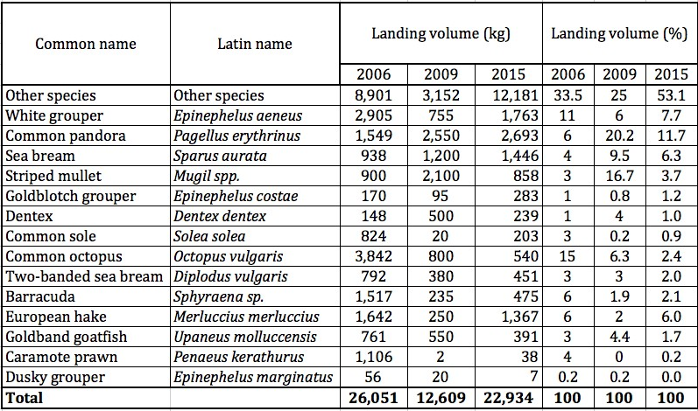

Landing volume and value of Akyaka Fishery Cooperative in Gökova (AKD, 2016; Ünal et al., 2016)

ACTION OF SECTOR DIAGNOSYS

The activity in Turkey has provided an analysis of the supply chain aimed to the identification of sites suitable for fishing and aquaculture activity in Gökova Bay aimed at gathering productive, economic and social data and of the reliability of the services in the aforementioned areas, so that recommendations and identifications of necessary interventions to strengthen the sector following the principles of the “Blue Growth”.

In particular, the mission was aimed to the following productive sites:

- Akyaka small scale fishing harbor and Akyaka Fishery Cooperative;
- Akçapınar Fishery Cooperative structures;
- Marmaris small scale fishing harbor and visit of the Marmaris Fishery Cooperative structures;
- Akbük of the small scale landing site and visit of the Akbük Fishery Cooperative structures; local fish restaurants; local retailers-fishmongers;
- Gökova MPA;
- Mediterranean Conservation Society NGO.

Mission Agenda 19-23 July 2018 Gökova Bay Fishery
Date | Note | Visits, Interviews and Meetings | Place
19/07/2018 | Meeting to start the mission and discuss the program | Turkish Exper (Vahdet Ünal) | İzmir
20/07/2018 | Visit of the Akyaka small scale fishing harbor and visit of the cooperative structures and Meeting with members and reviewing cooperative records | Akyaka Fishing port and Akyaka Fishery Cooperative  Member fishers of Akyaka Fishery Cooperative | Akyaka, Muğla
20/07/2018 | Meeting with Can Görgün (head of Akyaka Fishery Cooperative) and planning future cooperation perspective and data needs | President of Akyaka Fishery Cooperative | Akyaka, Muğla
20/07/2018 | Visit of the Akçapınar Cooperative structures , Meeting with members and reviewing cooperative records | Akçapınar Fishery Cooperative and member fishers | Akçapınar, Muğla
21/07/2018 | Visiting local fish restaurants and retailers in the area | Olta Resturant Fish Retailers  Burak Restaurant  Durmaz Balikclik-Major fishmonger (retailer) of the Gökova area | Akyaka, Muğla  Çamlı, Muğla  Dörtyol, Muğla
21/07/2018 | Visit of the Marmaris small scale fishing harbor and visit of the Balikcilar cooperative structures and Meeting with members and reviewing cooperative records | Marmaris fishing harbor  Balikcilar Fishery Cooperative and Director & president of the cooperative | Marmaris, Muğla
21/07/2018 | Meeting with the board of Mediterranean Conservation Society NGO | Mediterranean Conservation Society | Çamlı, Muğla
22/07/2018 | Visit Akbük of the small scale landing site and visit of the cooperative structures and Meeting with members and reviewing cooperative records  Visiting local fish restaurants | Sarnıç-Akbük Fishery Cooperative  President and member fishers of the cooperative  Altaş Restaurant  Kordon Restaurant | Akbük, Muğla  Akyaka, Muğla
22/07/2018 | Meeting with the Management Board of Akyaka Fishery Cooperative | Management Board of Akyaka Fishery Cooperative | Kozlukuyu, Muğla
22/07/2018 | Marine based field trip; visiting Gökova MPA by boat | Patrolling in Inner Gökova Bay | Akyaka, Maden İskelesi, Çınar, Akçapınar, Gelibolu

4.1 Inception meeting

19/07/2018

The meeting took place in Izmir with the purpose of sharing with the logistic coordinator Dr. Vahdet Ünal – Professor at the Ege University in Izmir, Faculty of Fisheries, Department of Fish Capture and Processing Technology, particularly concentrated on small-scale fisheries management and fishery cooperatives, with international experience on sustainable fisheries management.

The meeting was concentrated to describe the scope of the project in order to reach the highest number of actors of the fishing supply chain and stakeholders in Gökova Bay. Furthermore, the projects carried out and the studies concerning fishing in the area were discussed. Particular attention was dedicated to the strategies of environmental protection and the related socio-economic conditions of the fishing operators in the area. The discussion highlighted the importance of the role played by fisheries cooperatives and their functions in the value chain; the MPA in Gökova Bay and the diversification and enhancement activities that the same cooperatives have implemented and will be able to develop in the next future.

There are three active fishery cooperatives in the study area. The oldest cooperative was founded in 1973 (The Akcapinar Fishery Cooperative). The Akyaka Fishery Cooperative was founded in 1992 almost 20 years after establishment of the Akcapinar Fishery Cooperative and the most recent one was founded in 1999 (The Sarnıç-Akbük Fishery Cooperative).

There was also a fishery cooperative in Ören where located adjacent of Gökova MPA but it was not able survive due to several reasons. According to the recent data provided by cooperatives, cooperation rate (numbers of fishery cooperative members divided by numbers of total fishers) among small-scale fishers in Gökova MPA is 66%.

It seems to be quite low rate however 85 % in Sarnıç-Akbük are members of the cooperatives and 50 percent of fishers in Akçapinar, 78 % of fishers in Akyaka also are fishery cooperative members.

In overall Gökova MPA cooperation rate is quite low because fishery cooperative in Ören was closed and fishers in Bördübet, Çamlı etc. are not organized under any fishery cooperative so far. Akçapınar is a region with a population of approximately 700 inhabitants.

It is located on southern Turkish Aegean coast where the Gökova MPA meets the land. Fishing is the main economic activity together with agriculture in the village. The Fishery Cooperative was founded in 1973.

All fishermen in the region were cooperative members until 2008. However, because of mismanagement of the cooperatives and corruption, membership rate of the cooperative started to degrease between the years 2006-2009.

General assembly was organized in 2014 and the management board of the cooperative was changed. According the face to face interviews carried out with the head of the fishery cooperative, actual registered member and active fishermen (vessel owners) in Akçapınar are 25 and 10 respectively.
Of the 28 fisherwomen actively fishing in Gökova Bay, 9 of them live in Akyaka, 5 of them in Akçapinar and 14 of them in Akbük.

Fishery  Cooperatives | AKYAKA FISHERY  COOPERATIVE | AKÇAPINAR FISHERY  COOPERATIVE | SARNIÇ-AKBÜK  FISHERY  COOPERATIVE
Foundation | 1992 | 1973 | 1999
Major Activities | Fishing And Marketing | Fishing And Marketing | Fishing
Registered Members | 29 | 25 | 13
Active Members | 23 | 15 | 8
Active Members (%) | 79 | 60 | 61
Total Number Of Fishers (Vessel Owners) In the Cooperative Area | 37 | 50 | 15
Membership Rate (%) | 78 | 50 | 87
Employees | 3 | 1 | 0

Fishery Coperatives in Gokova Bay (Ünal et al., 2016)

Cooperatives with a marketing facility (Akyaka and Akçapınar) have four employees in total; none has a professional manager. In terms of marketing the fish, members are supposed to bring their catch to the cooperatives and sell them through the cooperative; however, some difficulties are being faced on marketing and some of the members sell their fish outside of the cooperative.

However, marketing fish generate 99% of the cooperative revenue. The Akyaka Fishery Cooperative is the most active fishery cooperative within the Gökova MPA, especially with regard to combating illegal fishing, marketing fish and meeting expectation of its members. This cooperative seems to be more successful to compare Akcapinar and Sarnıç-Akbük Fishery Cooperatives.

Name of Gear | January | Februay | March | April |  | May | June |  | July | August | September | October | November | December
Red mullet bottom set-gillnet
Pink dentex bottom set-gillnet
Yem bottom set-gillnet
Air species bottom set-gillnet
Atlantic bonito bottom set-gillnet
Red mullet trammel net
Piç trammel net
Voli trammel net
Common dentex trammel net
Common sole trammel net
Air species combined bottom set net
Purse seine net
Thin longline
Middle longline
Thick longline

Intensive season |  | Preferred season |  | Not-preferred season |  | Closed season

Temporal preferency and usage of fishing gears in Gökova MPA

4.2 AKYAKA HARBOR AND FISHERY COOPERATIVE

20/07/2018

Akyaka is a small Mediterranean village where fishing still remains a staple of the local economy. The town and the harbor are placed in an environment of high naturalistic value.

In the last years the village has recorded a strong tourist increase that worries the inhabitants for the environmental degradation but that surely strengthens the local economy.

Akyaka is an area with a population of approximately 2500 inhabitants. This number increases up to 25.000 – 30.000 in summer season. This number doesn’t include the daily visitors and campers.

The small scale fishing harbor is located in the town center of Akyaka which sits at the internal tip of the Gökova Bay. Akyaka is safe harbor, sheltered from the four winds and the waves. And given the condition, fishers are going to the sea from 250 to 330 days each year.

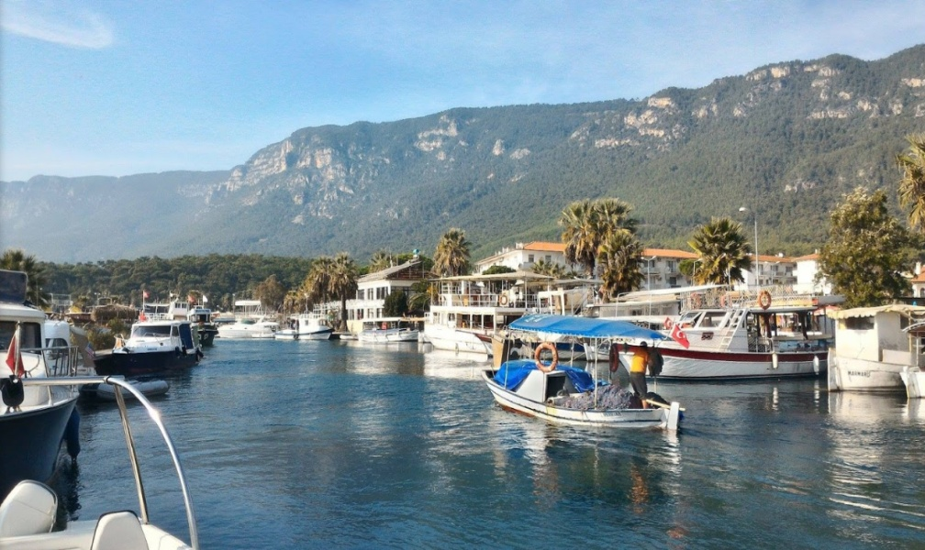

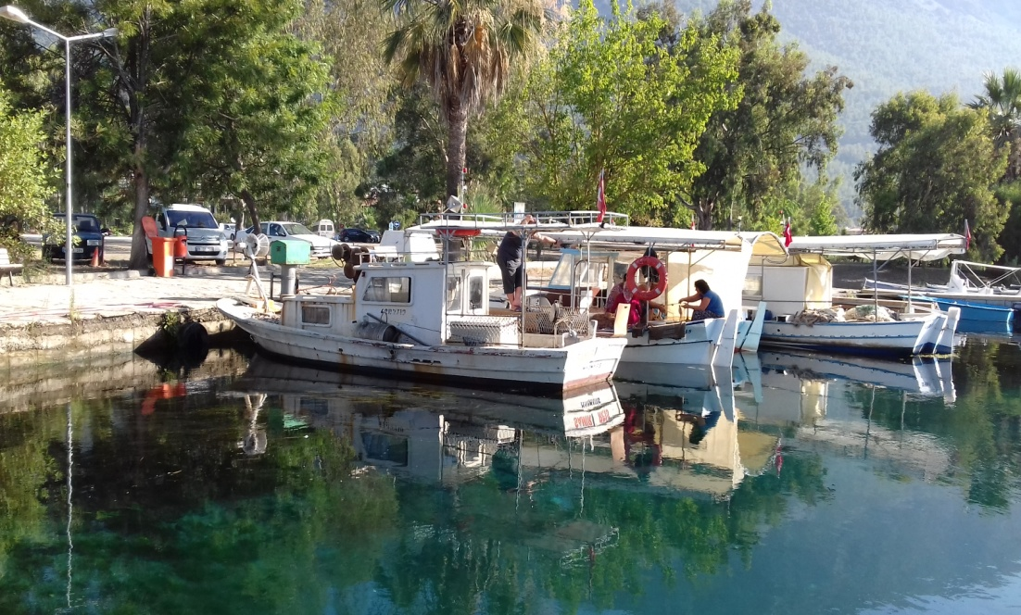

Akyaka small scale fishing harbor

The major focus of the visit was the meeting organized by the Akyaka Fishery Cooperative.
Akyaka Fishery Cooperative is an active fishery cooperative in the region since 1992 and has 29 members.

All fishers in the village are not cooperative members; the membership rate is 78% in relation to the total number of fishers (vessel owners) in the cooperative area. Gillnet-trammel net and longline fisheries dominate small-scale fisheries. Species belong to Sparidae and Epinephelinae are the most important and target species of the fishing area. Only one fisher from Akyaka Cooperative works with a partner as sharing system.

The Cooperative employs 3 people for accounting, marketing and sales service.

Almost all the fish caught by the cooperative members is delivered to the fish shop located at the Akyaka fishing port.

The shop, founded by an old member of the cooperative, is now managed by the cooperative in partnership and through the administrative staff and sales staff (fish monger and fish cleaning staff).

The shop is very famous in the area and recognized as the only selling point of th fish fished by the Akyaka Cooperative.

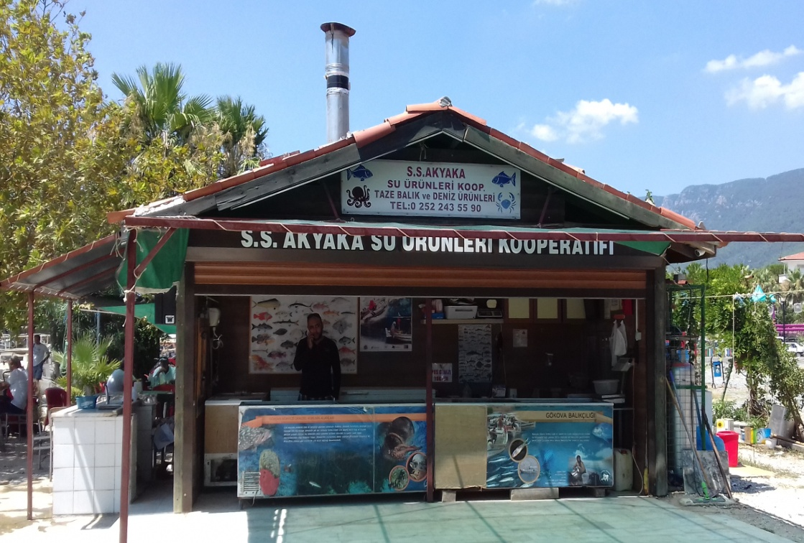
Fish shop in Akyaka supplied by cooperative members

The fishers supply the fish to the store every morning and in the summer very often the catch is not enough to cover the quantity necessary for the daily sale, therefore the possibility of booking the fish is offered to the customers.

The restaurants in the area are also customers of the cooperative. However, some difficulties are being faced in marketing and some of the members sell their fish outside of the cooperative.

The bar also serves as a tea room for the fishers, refreshment and meeting point. In addition, the shop offers the possibility of already receiving clean fish (gutted, scaled, filleted) and has a kitchen area and a small bar and restaurant area.

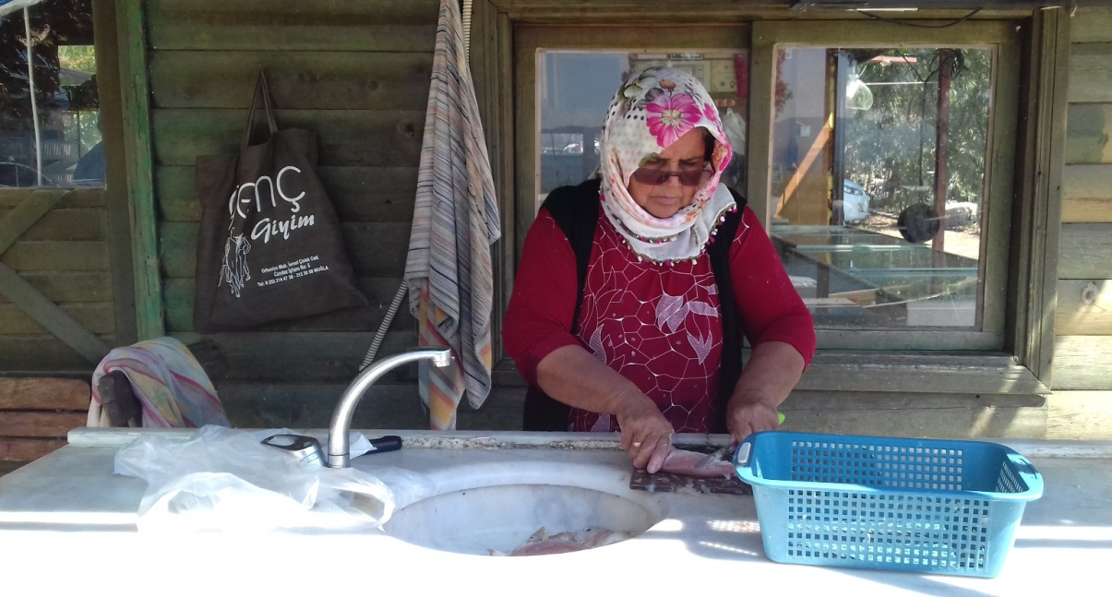

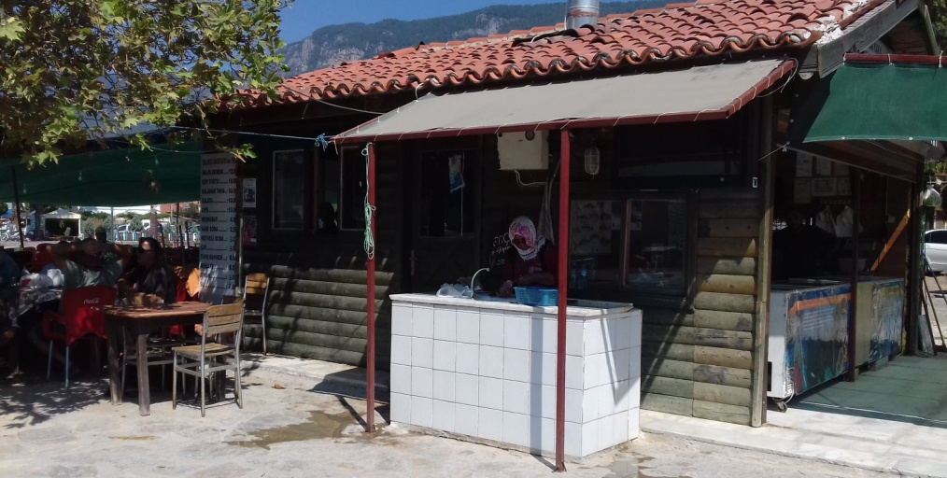

Fishing shop, cleaning fish area and Restaurant managed by Akyaka Fishery Cooperative

During the winter, the shop sells fish to local consumers but in particular during periods of abundance, the cooperative's fish is sold to local merchants. Sales to merchants compared to store sales also record a 20% decrease in profit for fishermen.

The shop pays for the supply of fish made by fisher members of the cooperative at the request of the fishers themselves (daily, weekly and in particular needs even in advance). All the operative costs of the cooperative and the shop management are covered by the markup (around 9%).

The first-sale price that the cooperative pay the fishermen is the price established in the meeting with the other cooperative.

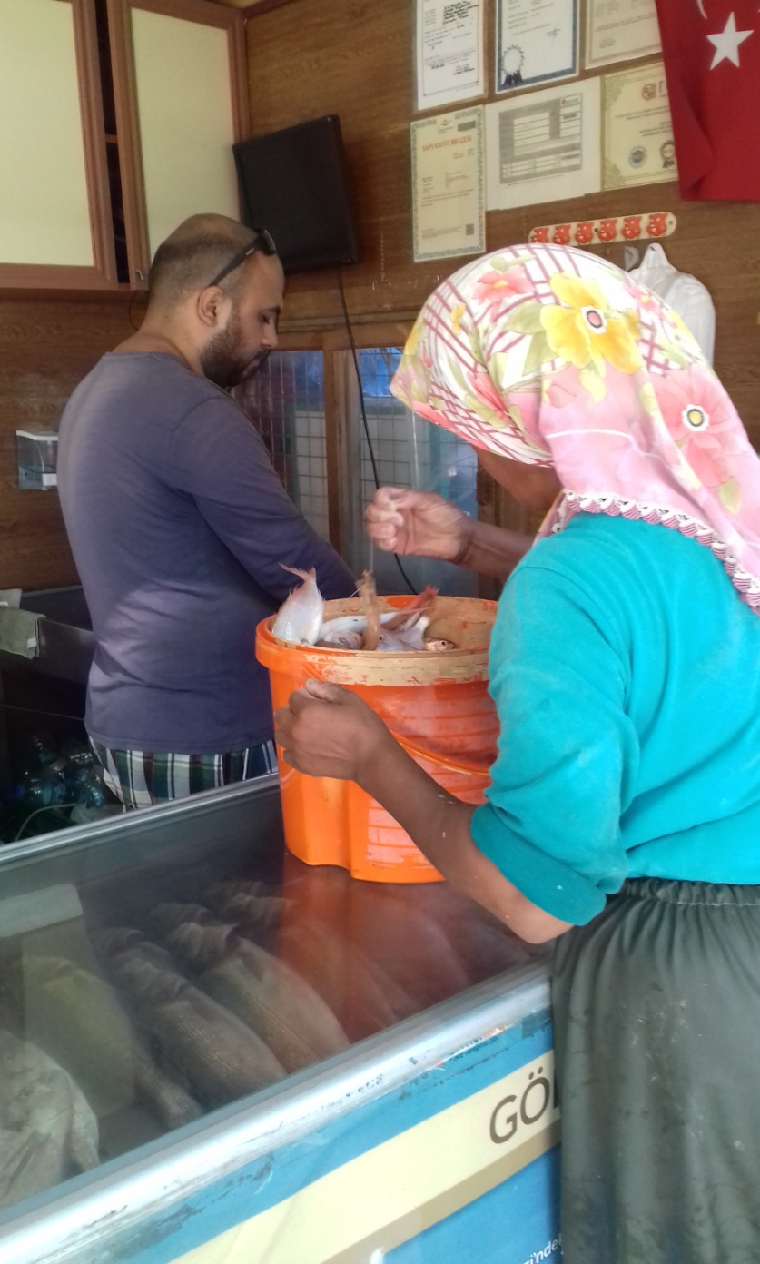

Fishing supply from the cooperative member to the fish counter in Akyaka

4.3 FISHERIES STAKEHOLDERS IN AKYAKA

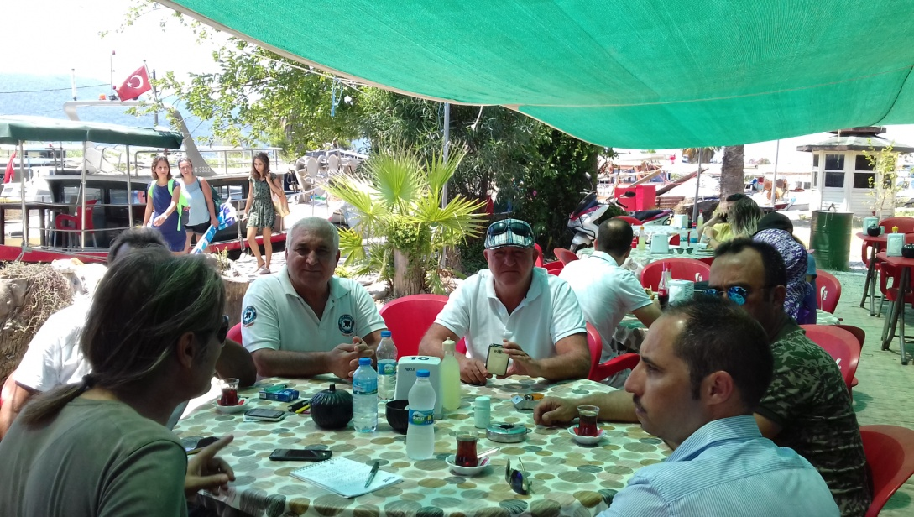
Meeting with Akyaka Fishery Cooperative boards

The Akyaka Fishing Cooperative Board, marine rangers, academics, NGOs, and the last but not the least President Can Görgün are a mile stone for the fishing sector in the area; they have been primary actors to support the following activities:

Constitution and management of Gökova Bay MPA through which was designated and declared part of marine and land areas as a Special Environmental Protection Area (SEPA) by the Decree no. 88/13019 of Cabinet of Ministers (June 12, 1988).

Afterwards, the Decree no. 2010/1089 of Cabinet of Ministers (official gazette number 22 December 2010 / 27793) approved the border change of Gökova SEPA. Fishing in the area has developed as small scale due to the conditions of the coastline, the geography and productivity of the bay and after the designation of the MPA, fishing was adapted to as well as the status of the area pertaining to conservation.

Proposal for a Management Plan for the Small-scale Fisheries in Gökova Bay through the FAO EastMed Project. The management plan was designed to assist institutional managers and stakeholders in making more informed decisions for the sustainable use of the resources based on priorities and recommended actions identified jointly by the main stakeholders in the fishery. The plan was designed in line with the FAO Code of Conduct of Responsible Fisheries, following the principles and methodology of the Ecosystem Approach to Fisheries (FAO, 2003).

Proposal for a fishing tourism boat: chances for implementing “pescatourism” in Turkey, following the example of EU countries, started a buyback program of fisheries boats in 2012.

One of the vessels decommissioned in the frames of this program was given to the Akyaka Municipality. The intention of this donation was to propose an alternative source of income for fishermen and to boost local tourism by adopting the concept of “pescatourism” in Gökova Bay.

This initiative was based on a partnership between the municipality and Akyaka Fishery Cooperative, supported by Mediterranean Conservation Society (AKD), to realize a pilot project to show that certain modification of the existing regulations could make “pescatourism” legal.

The aforementioned activities are just some of the exemplary actions carried out by Akyaka Fishery Cooperative. The common fisheries problems are fought every day around the Mediterranean, looking for new strategies to allow the survival of the cooperative and support its members.

The workload carried out and which carries out the cooperative is very much and exemplary. Akyaka Fishery Cooperative can be considered among a best practices model of small scale fisheries.

The cooperative performs the following functions among its members:
- selling fuel and oil for fishing boats;
- provide the baits for the longlines;
- selling the food for fishers;
- marketing of the fish landed trough the fish shop (buy the fish from the members and e sale the fish to consumers, restaurant and traders);
- meet the cooperatives in the area 3 times a year to establish the price of the catch; provide bureaucracy services for fishing licenses and other permit documents;
- lobbying activity in public institutions meetings and activities;
- rangers activity for the MPA.

4.4 THE AKÇAPINAR COOPERATIVE

The Akcapinar Fishery Cooperative is the oldest cooperative operative in Gökova Bay, founded in 1973.

In Akçapınar Fishery Cooperative, all fishers in the area were cooperative members until 2008. However, due to administrative problems, membership rate dropped between the years 2006-2009.

According to the most recent available information, actual registered are 18 members, active fishers and vessel owners.

The youngest member is 28 years old but the medium age is around 45 years. So the cooperative actual board is concentrated to give a good example on fishing cooperative management and moreover to attract more young members.

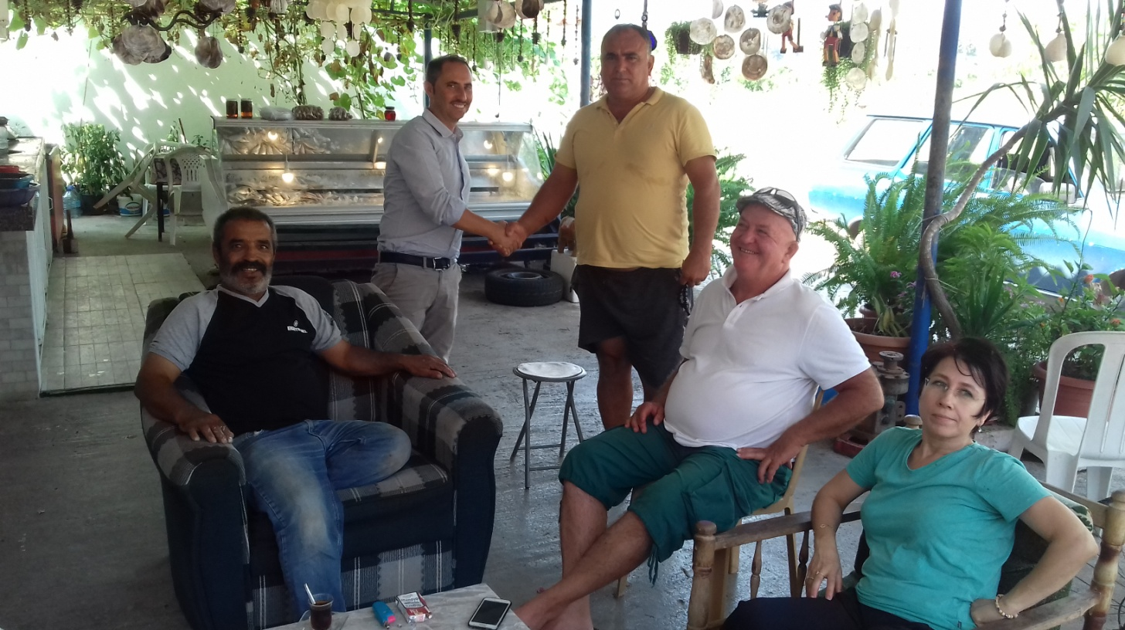
Meeting with Akçapinar Fishery Cooperative boards

The cooperative performs the following functions among its members:
- selling fuel and oil for fishing boats;
- provide the baits for the longlines;
- selling the food for fishers;
- marketing of the fish landed trough the fish shop (buy the fish from the members and re sale the fish to consumers, restaurant and traders);
- meet the cooperatives in the area 3 times a year to establish the price of the catch;
- provide bureaucracy services for fishing licenses and other permit documents.
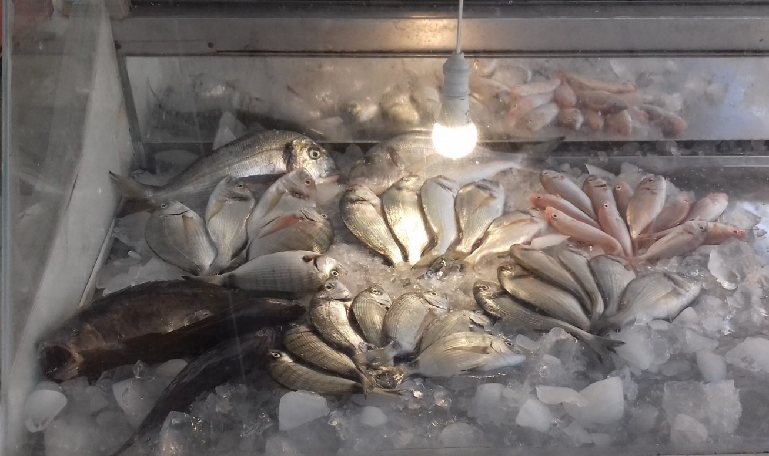
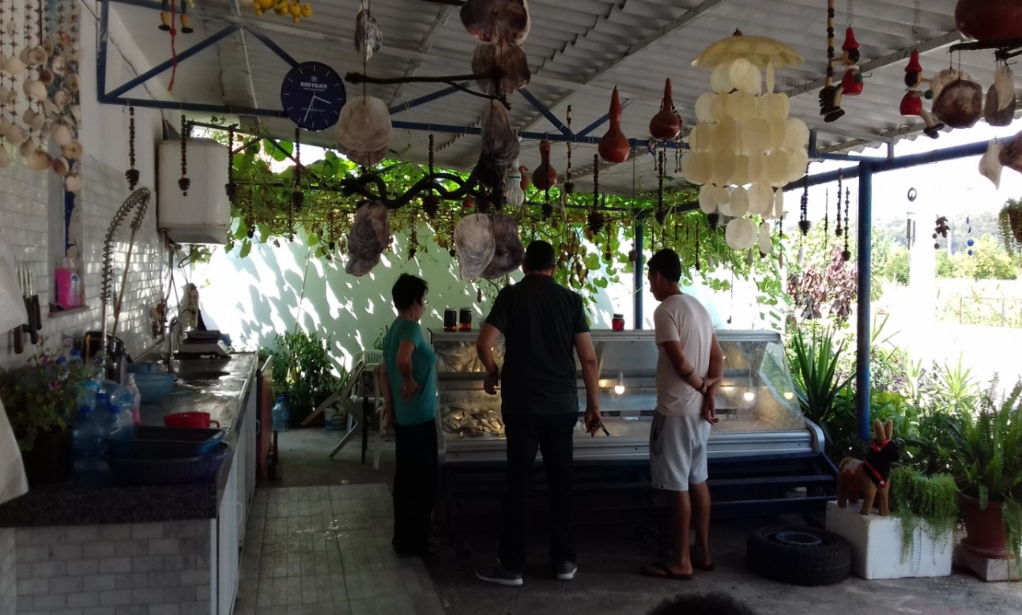
Fish counter in Akçapinar Fishery Cooperative

The fishers supply the fish to the store every morning. The cooperative sale 100% of the fish caught trough the shop.

This marketing service is fundamental for the cooperative members, which give the shop totally the fish landed, ending the working day.

The shop deals with buying ice and distributing it to fishermen - they are currently looking for funds to purchase an ice-making machine of capacity production of 500 kg of ice per day, that would alleviate the annual cost of ice (the first estimation of the investment for the ice machine is around 4.000 Euros).
A cooperation project could solve this problem and ice production could also be shared with Akyaka Fishery Cooperative, given the short distance.

The store is historical and very famous in the area.
In addition, the shop offers to the customers for free to clean the fish (gutted, scaled, filleted).

The cooperative after a period of bad management, at the moment has no employee and the store is directed by the president and his wife who voluntarily offers its free support, for the preparation of the fish counter, cleaning the fish and accounting.

The cooperative board hopes that in the near future the shop management can be entrusted to young members or employees. Furthermore, in order to improve the value chain of the fish and the strategic position of the shop, the cooperative could develop a small restaurant facilities within the same store.

The project to build a small catering area includes the restructuring of the cooperative premises, the relocation of the fish counter and the purchase of equipment.

The cooperative believes this investment is strategically and economically viable to strengthen its work. At the moment, all the operative costs of the cooperative and the shop management are covered by the markup (around 9%).

The first-sale price that the cooperative pay the fishermen is the price established in the meeting with the other cooperative.
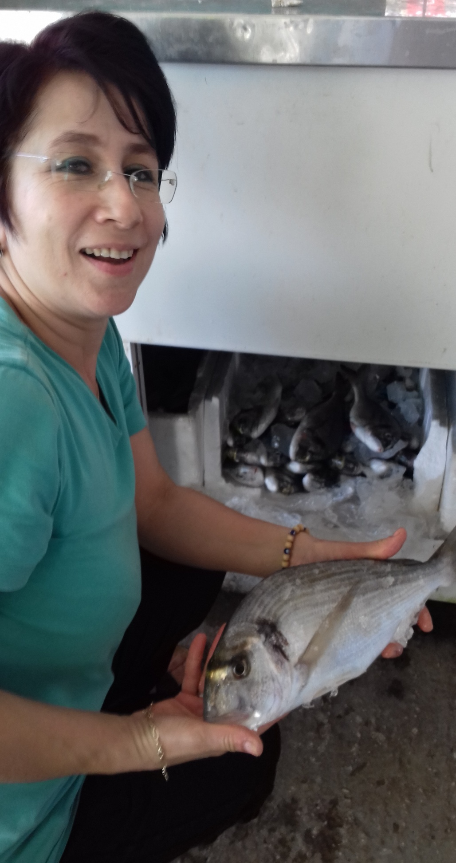
Manager of fish shop in Akçapinar Fishery Cooperative

4.5 FISH RETAILER IN GÖKOVA BAY

21/07/2018

There are 3 permanent retailers/fish shops (cooperatives excluded) and 2 fish stands at Gökova bazaar (only Saturdays) in the area.

They buy and sell only fish but they collect fish not only from Gökova but also outside of the region as well.

Durmaz Balikhanesi is the biggest and famous fish market in Gökova Area, located on the main road Izmir – Marmaris, so it represent the place for tourists and consumers were buy the local fresh fish caught in Gökova Bay.

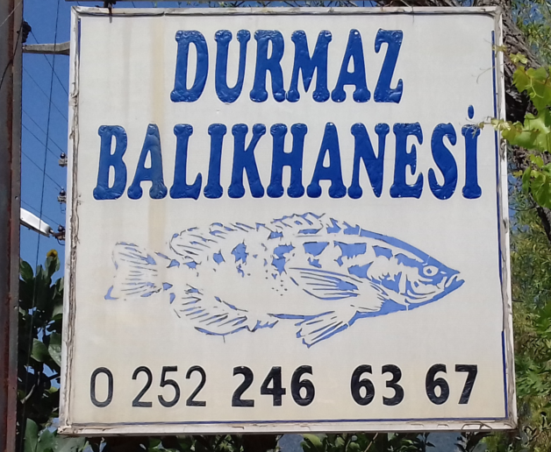
Fish monger in Gökova area

Unfortunately, in this shop only the 15-20% is local caught. The rest of the fish bought in the Izmir wholesale fish market (40 % is represented by farmed seabass, sea bream and meagre and other 40% is imported fish (grouper, red seabream, dentex from Senegal o Mauritania and salmon from Nord Europe), the rest 5% is represented by defrosted fish, cephalopods or crustacean coming from different countries.

The customers are represented by final consumers and restaurants. The price of the fish is almost the same for both category of clients, except for large quantity purchases.

The Grouper is the most appreciate fish for restaurant and consumer, but for this species, local fishing is prohibited and the procurement is represented by only imported fish. Farmed sea bass and sea bream represent the other common fish for the customers.

In the fish counter no label distinguishes local fresh fish from imported, farmed or defrosted fish.
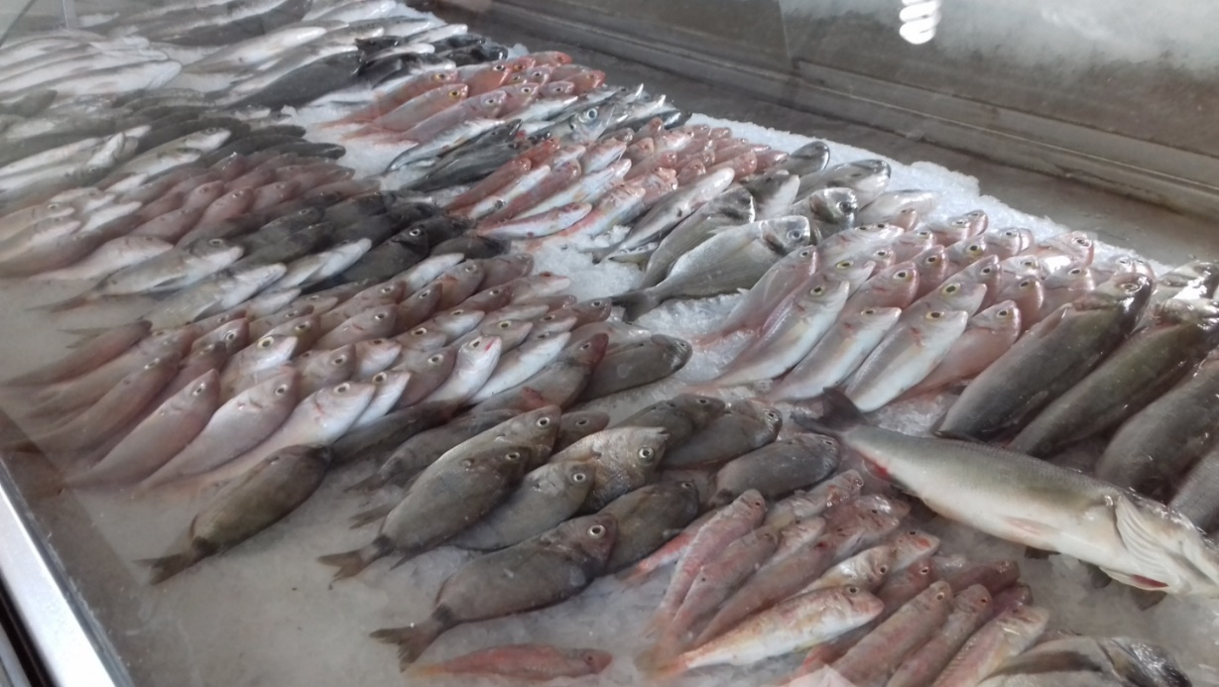
Durmaz Balikhanesi fish counter

The fish shop was founded almost 33 years ago and the owner is an experienced fish monger.

At the moment the company doesn’t buy fish from the cooperative in Gökova Bay but 3 independent local fishermen, supply the fish directly to the shop, that daily collects the fish from the landing points with its own refrigerated vehicle or refrigerated box provided to the fishermen.
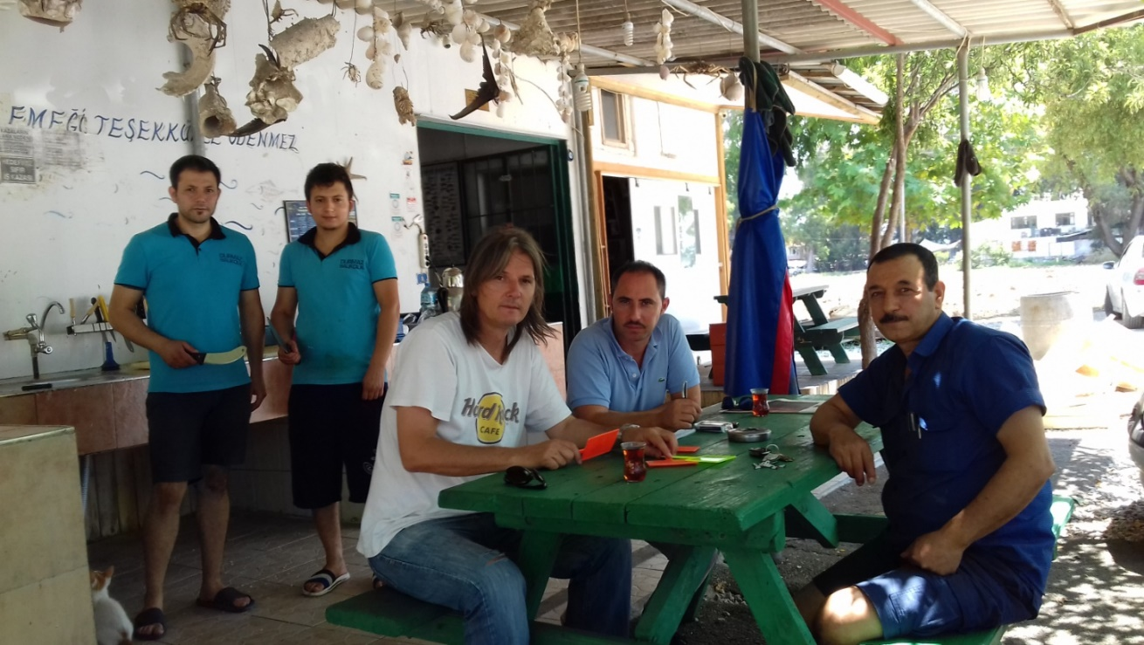

Meeting in Durmaz Balikhanesi shop and fish distributor

A supply agreement bound the shop to buy from the 3 local fishermen all the fish landed all the year. The first-sale price is not regulated but established according to the prices and quantities available on the market. The company daily provides ice to the fishermen.

The local fish is very important for the shop - as reported by the owner, represents the territoriality and the tradition of the shop. Actually, is very difficult to by local fish, they pass from 10 to 3 fishermen suppliers.

The fish locally available is not enough to guarantee the sale of the store and the prices are too high for the final consumers. In addition, grouper fishing is prohibited and many species of value have decreased significantly, particularly during the significantly periods of market sale.

For all this reasons the fish monger goes 2 -3 times a week to by the fish in the Central Izmir wholesale fish market.

The farmed fish is very easy to buy in terms of size, stable price and quality and transport cost. The imported fish it replaces the fish that is missing from local fisheries, especially for restaurants that have to serve their customers in a constant and simple way.
Very often the local fish has high markup and therefore still interesting to sell.

4.6 MARMARIS FISHING HARBOR AND FISHERY COOPERATIVE

Marmaris is located out of the Gökova Bay but was introduced in the visit program because an important mile stone for development is represented by the fishery cooperative operating in the area and the fish market facilities present in town.

For the following reasons the cooperatives of Gökova Bay are constantly in relationships with the Marmaris fishing activities:

- the largest nearest port with shipbuilding activities;
- an important fish market;
- fishing boats often share fishing areas;
- several studies have been conducted sharing the results between the areas of Gökova Bay and Marmaris;
- many meetings and issues of fisheries institutions unite the cooperatives of the two areas;
- Marmaris Fishery Cooperative in Marmaris is well organized and the members are very active to improve the conditions of the fisheries in all fishing zone.
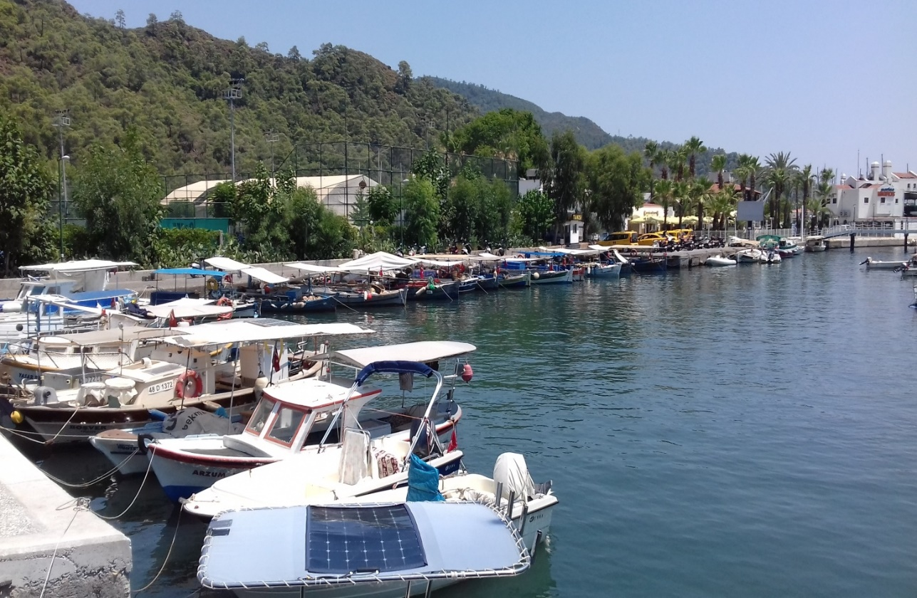
Marmaris small scale fishing harbor

Marmaris Fishery Cooperative is an active fishery cooperative in the region since 1974 and has 25 members. All of the members are using trammel nets and longlines for fishing bot the most preferred fishing gear is the longline. The Cooperative employs 5 people for accounting, marketing and sales service.

Almost all the fish caught by the cooperative members is delivered to the fish shop located at the Marmaris Agrofood Market.

The cooperative members daily supply the fish directly to the shop or the fish is collected by the cooperative refrigerated vehicle or refrigerated box provided to the fishermen. The first-sale price is regulated by the cooperative and trough the regional meeting of the cooperative.

The cooperative daily provide ice to the fishermen.

The scope of the cooperative and of the shop is to sale the fish caught from the members but the shop sale farmed fish as well because fish available is not enough to guarantee the sale of the store and the shop need to be competitive with the other shops in the Marmaris Agrofood Market.

One operator employed by the cooperative goes 4 – 5 times a week to sale the cooperative fish in the Central Izmir wholesale fish market where he buy farmed fish and other fish necessary to the fish counter.

The fish counter shows label in each box of the fish giving the right value to local fish caught by the cooperative members.

The cooperative operational cost are covered by the by the markup (around 8 -10%) on the price of the fish trading.

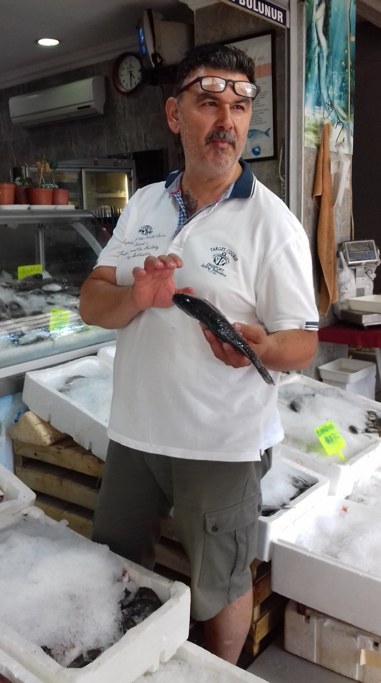
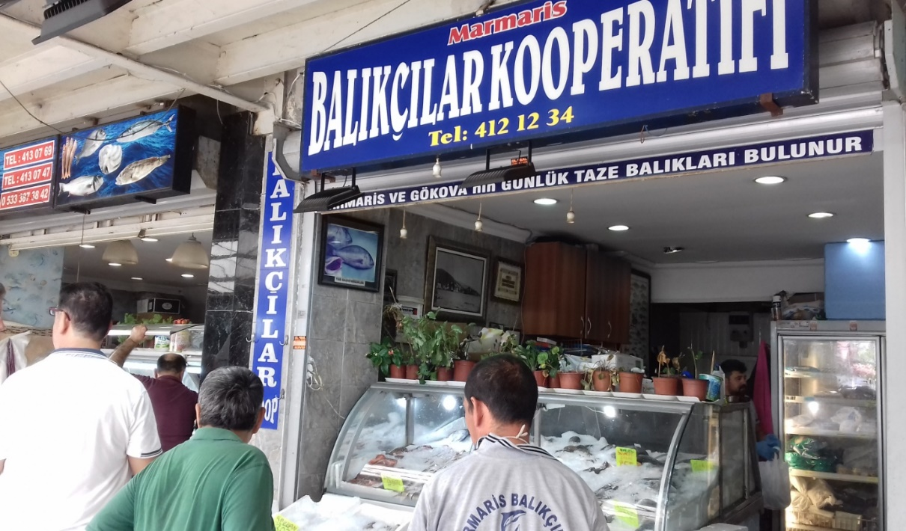
Marmaris Cooperative Fish Shop
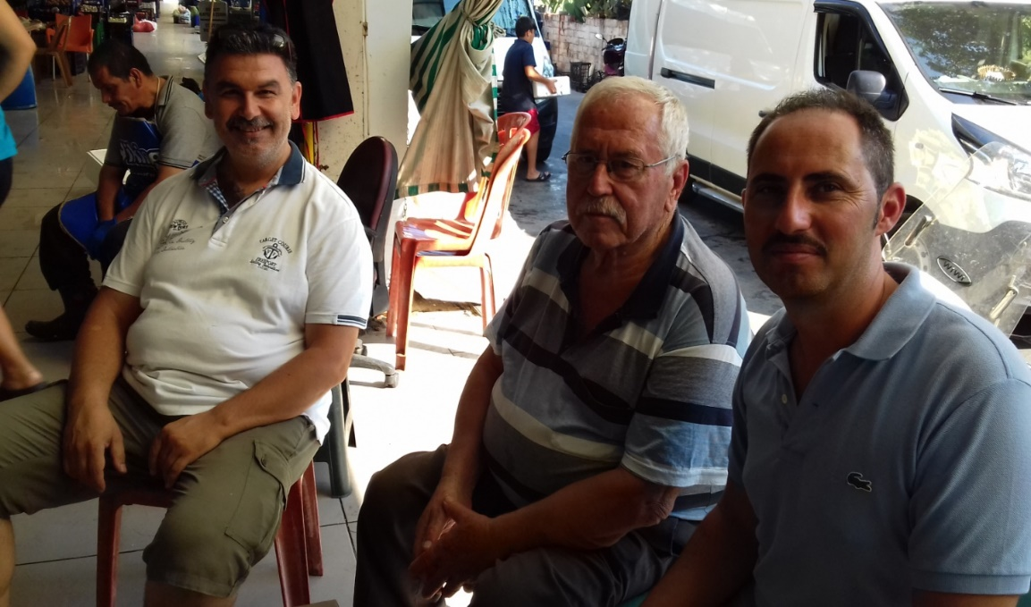
Meeting with Marmaris Fishery Cooperative boards

The cooperative performs the following functions among its members:
- selling fuel and oil for fishing boats;
- provide the baits for the longlines;
- selling the food for fishers;
- fish transport service in refrigerated vehicles. The service include the local transport and the transport of the fish in Izmir and other important market place.
- marketing of the fish landed trough the fish shop (buy the fish from the members and
- resale the fish to consumers, restaurant and traders);
- meet the cooperatives in the area 3 times a year to establish the price of the catch;
- provide bureaucracy services for fishing licenses and other permit documents;
- lobbying activity in public institutions meetings and activities.

4.7 MEDITERRANEAN CONSERVATION SOCIETY NGO BOARD

The Mediterranean Conservation Society is a young membership based NGO established in 2012 by a group of conservationists ranging from well-known business men, to scientists and local fishermen. It is based in Izmir, Turkey and collaborates with the Faculty of Fisheries and Faculty of Science at Ege University.

Even though the organization is young it has been awarded with Marsh Award in 2012, with Whitley Nature Conservation in 2013 and with UNDP Equator Initiative Award Nature Conservation in 2014 and Whitley Gold Award in 2017 within the 5 years. It works to conserve the Mediterranean ecosystem and to support communities to develop sustainable livelihoods through projects that are locally appropriate and based on good science and traditions.

The mission is the Mediterranean Conservation Society is to work to conserve the Mediterranean ecosystem and to support communities to develop sustainable livelihoods through projects that are locally appropriate and based on good science and traditions.

The vision of this NGO is that the Mediterranean basin is well protected and sustainably used, providing a healty home for local people and a basis for their cultural values while maintaining rich biodiversity.

The Mediterranean Conservation Society implemented a very interesting project in 2015 to promote four Lessepsian invasive species (Randall’s threadfin bream-Nemipterus randalli, Brushtooth lizardfish-Saurida undosquamis, Marbled spinefoot-Siganus rivulatus, Goldband goatfish-Upeneus moluccensis) which consist important percentage among the catches of the Akyaka Fishery Cooperative, in order to increase the demand and value of them. As the public did not know the species well enough there was very limited demand on those species resulting loss of potential income.

Recipes were prepared by a chef, the recipe cards have been published and are available in the Akyaka Fishery Cooperative; a fish tasting festival with invasive species was organized for over 400 people.

A promotional film was prepared and displayed on a screen on the wall of the cooperative during the day and night. The results of this activity are remarkable: demand for invasive species has increased by 400% according to the landing data; the price of invasive species has increased by at least 20% which also increased the fishermen's incomes.

Recently, the Mediterranean Conservation Society is managing the project entitled Assessment Of The Mediterranean Monk Seal, Monachus monachus, Population and Habitats In Gokova Special Environmental Protection Area.

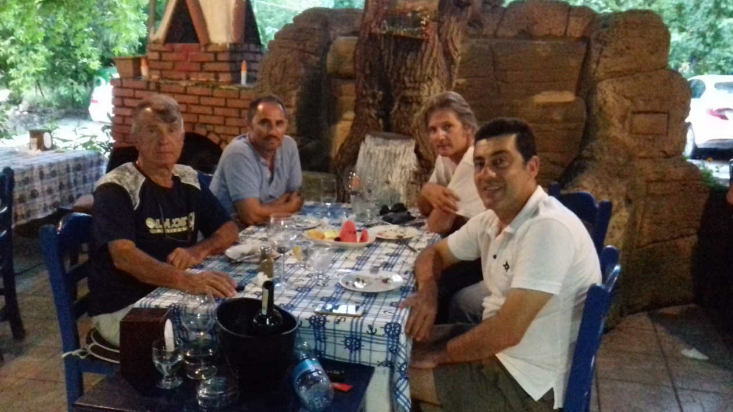
Meeting with president and members of Mediterranean Conservation Society
The meeting was concentrated to describe the scope of the project in order to reach new proposal for development projects concerning the fishing value chain in Gökova Bay. Furthermore, the projects carried out and the studies concerning fishing in the area were discussed.

Particular attention was dedicated to the strategies of environmental protection and the related socio-economic conditions of the fishing operators in the area and in particular the potential of the Sarnıç-Akbük Fishery Cooperative.

The Cooperative has considerable potential for growth and currently has scarce tools and funds, so it would be advisable to address projects that aim to consolidate work according to the Blue Growth guidelines.

Therefore, it was shared the possibility to implement the work of the cooperative through a marketing strategy for the direct sale of the fish and through future projects of transformation of the fish during the winter months of low sale.

4.8 AKBÜK SMALL SCALE LANDING SITE AND COOPERATIVE

22/07/2018

Sarnıç is a village located 10 km away from Akbük Bay with a population of approximately 485 inhabitants.

This number increases up to minimum 700 people in summer season. There are 13 small-scale and 5-6 subsistence fishing vessels in Akbük. 85 % of owners of small-scale professional fishing vessels are members of Sarnıç-Akbük Fishery Cooperative. Sarnıç-Akbük Fishery Cooperative is an active fishery cooperative in the region since 1999 and has 13 members. Almost all the fishers in the village are cooperative members.

The cooperative start to be operating as of 2016 with the new management board but at the moment the lack of marketing activities remains the main problem in enhancing the value chain of fish caught by members of the cooperative and for the same reason the cooperative has no income to support the operational cost.

Structure of Sarnıç-Akbük Fishery Cooperative
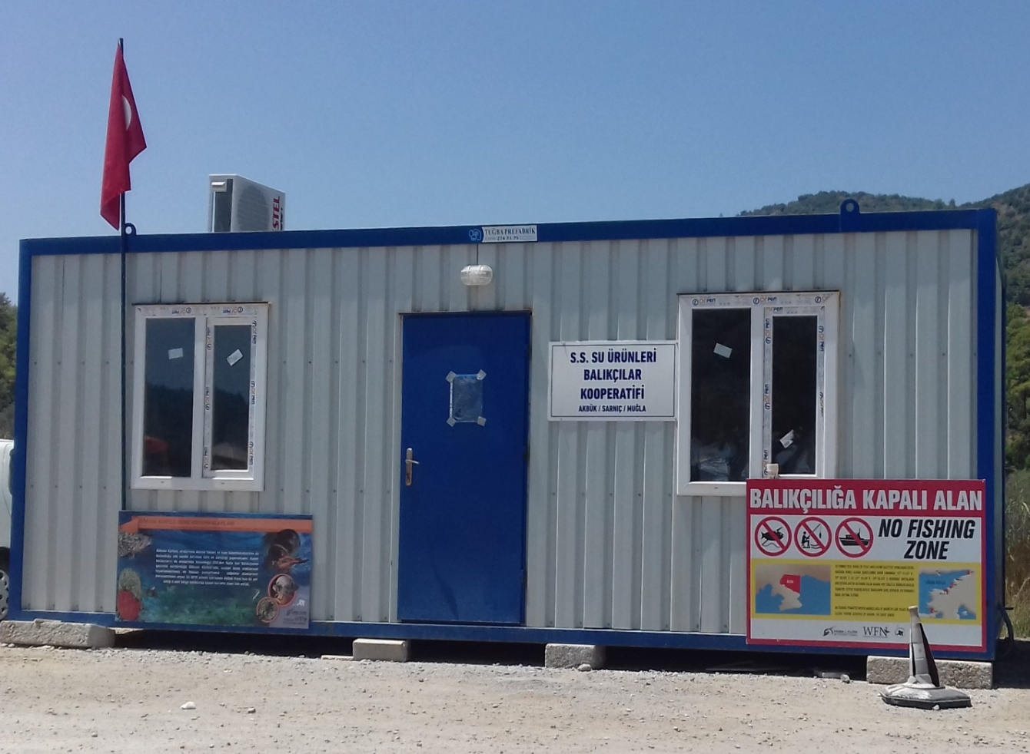
The operative office of Sarnıç-Akbük Fishery Cooperative is a container provided by a project carried out by Mediterranean Conservation Society, at the moment the structure is not connected to the electricity and it is used only for the meeting of members and to keep documents and equipment.

The president of the cooperative Erhan Uysal is the youngest fisher in the cooperative and he is very motivated to give the right effort to consolidate the fishing activity in the small village, where fishing still remains a staple of the local economy.

In Akbük, only two of the cooperative members go to fishing with their wives and these women are engaged to all process of the fishing activity (preharvest and postharvest).
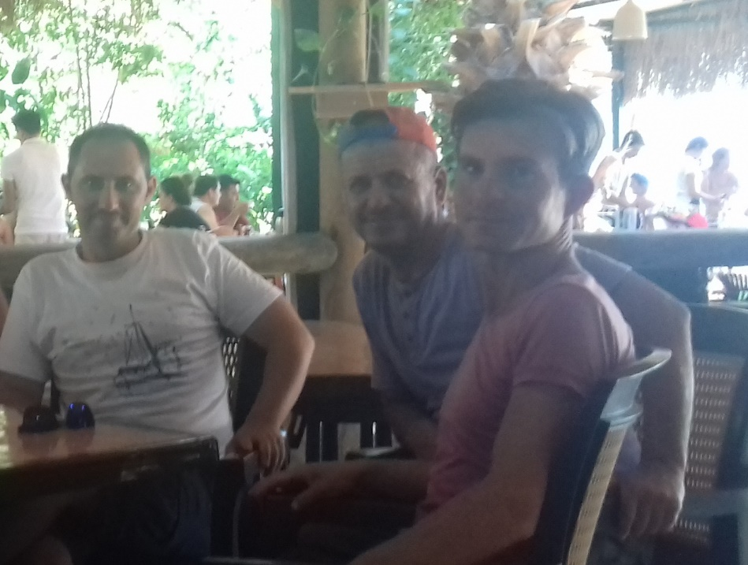
Meeting with Sarnıç-Akbük Fishery Cooperative boards

The cooperative performs the following functions among its members:
- selling fuel and oil for fishing boats;
- provide the baits for the longlines;
- meet the cooperatives in the area 3 times a year just to discuss about the price of the fish.
- Actually, the Cooperative is not doing any marketing activity so can not establish and regulate the first-sale price of the fish caught by the members.;
- project activities with NGOs and contact with local institution and other fishery sector stakeholders

4.9 LOCAL FISH RESTAURANTS

There's a 2 of restaurants in Sarnıç. ALTAS is historic restaurant specialized in local fish and that's open year-round and buy constantly the fish from 5 fisher of Sarnıç-Akbük Fishery Cooperative.

The restaurant is famous in the area for local fish and the owner promotes regularly the fish caught by the cooperative members like a value of the restaurant. The restaurant sale also the farmed sea bass and sea bream (around 30% of the fish utilized) to be competitive with other restaurants and to give the farmed fish to the customer that prefer this quality.

The restaurant could be considered a model of "short distribution chain" that buys the fish directly from the fishermen landed in front of the restaurant. The fish is bought directly from the fishermen and paid instantly or weekly.

The fish that is bought by the fishermen is directly exposed in a refrigerated fish counter where the end customer can select the fish to eat; at this point the restaurant waiter weighs the fish whole round and reports the value of the fish before cooking. The markup of the restaurant compared to the purchase price by the fishermen is equal to about 5 -30 TL per kg.

The restaurant owner has shown great interest in a project that enhances local fish through labeling and brochures, signs and informative videos that explain to the final customers the value of fishing activities in Gökova Bay, the quality of the sea and fish caught.

Often, the restaurant receives poorly manipulated and low quality fish. A project to improve the quality could improve the value chain of the local fish.

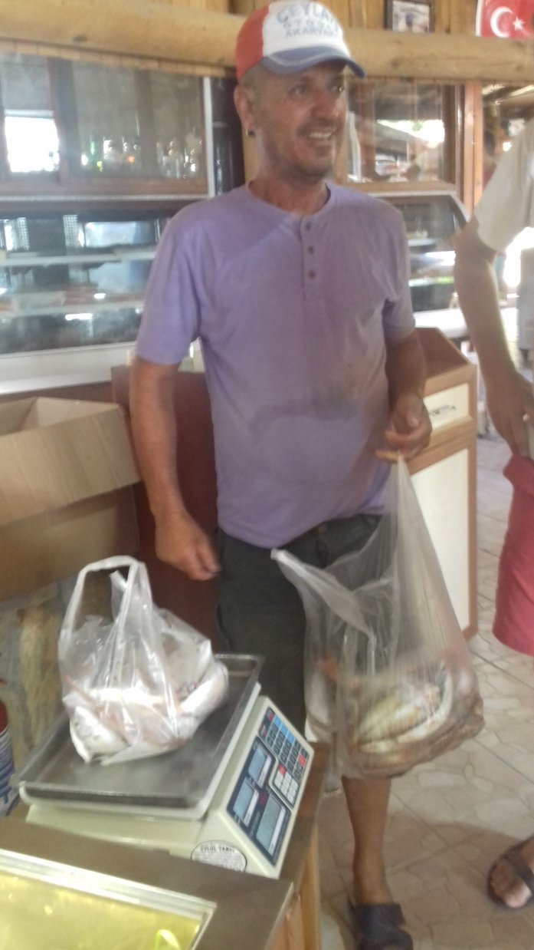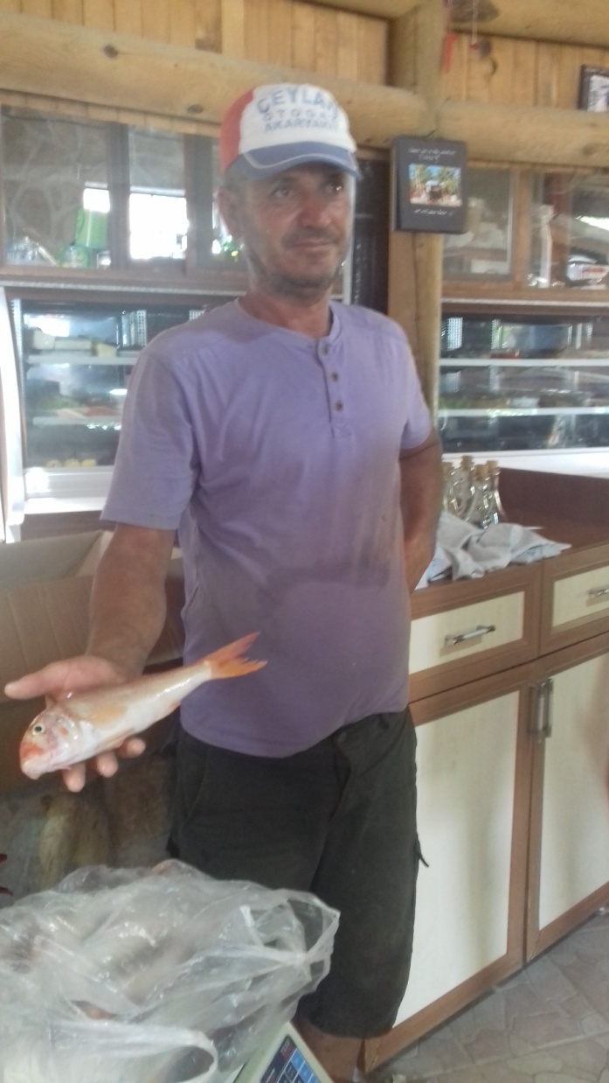

Fish supply to Altas restaurant by local fisherman

The second visit was made in Akyaka where in 2016, 16 restaurants specialized in local fish were registered but the number increase every year given the massive presence of tourists.

KORDON is a well-known fish restaurant run by local owner specialized in fish (several years ago was specialized in local fish) and that's open year-round.

The Restaurant buy fish very day from traders and occasionally from the Akyaka Fishery Cooperative and from same fishermen of Akyaka.

Before the closure of the grouper fishing the local catch represented 60% of the fish purchased from the restaurant that boasted of this characteristic. This feature remains only in the image of the restaurant, currently in winter the local fish can represent 40% of the fish purchased from the restaurant but in the period it represents only 5%.

The fish bought from traders is represented by aquaculture fish (sea bass, sea bream, meagre) and imported fish, usually from Senegal and Mauritania (especially Groupers, Pagrus, Dentex and Red Mullet) - no label distinguishes local fish from that farmed or imported fish.

Grouper still the favorite fish from the consumer in the restaurant. Sea bass and sea bream (size 300 - 400 gr) is the fish with the highest markup. The local fish still the quality of fish with the best image for the fish counter but the high purchase price makes it uninteresting for the restaurant and for average consumers.

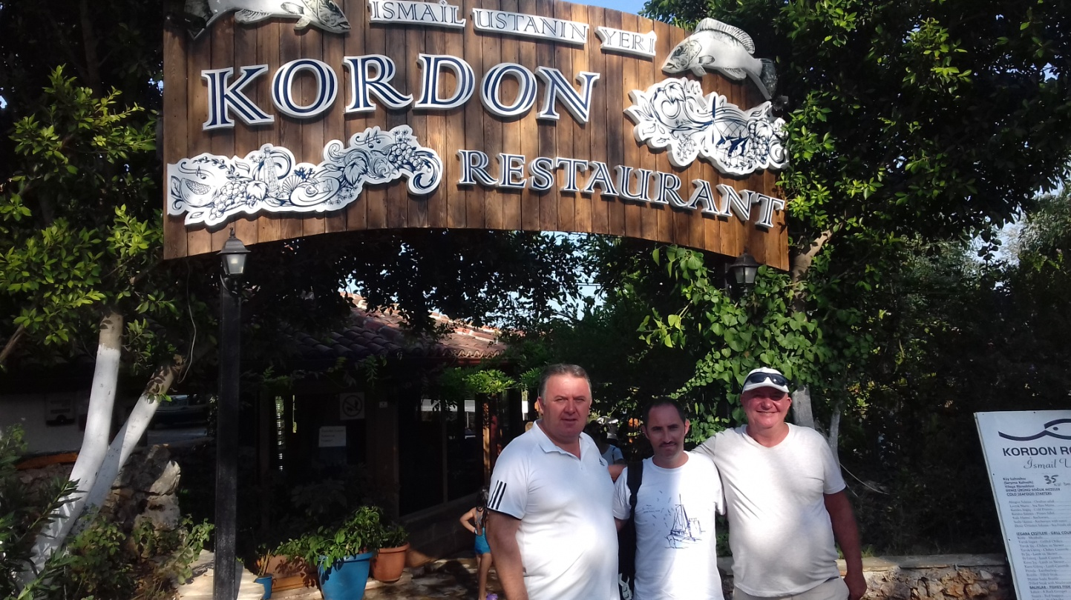
Meeting with Kordon Restaurant owner

The local fish bought by the Marmaris traders is less costive than the fish bought locally in Akyaka, this difference is around 5 TL per kg in the winter time and 20 TL in the summer time. This is only an example to explain the difficulty in buying local fish.

On the other hand, presently the restaurants still making and a huge profit on the local fish:

LOCAL FISH WHOLE ROUND
Average purchase price (TL per Kg) | average sales price (TL per Kg)
70 | 120
90 | 145
Markup around 60%

The restaurant owner has shown mild interest in a project that enhances local fish through labeling and brochures, signs and informative videos that explain to the final customers the value of fishing activities in Gökova Bay, the quality of the sea and fish caught.

The project could be promoted only in the winter time and absolutely not in the summer, when the restaurant don’t need to sale local fish and could be a conflict of interests.

Despite the high price of local fish, often, the restaurant receives poorly manipulated and low quality fish. A project to improve the quality could improve the value chain of the local fish.

4.10 MANAGEMENT BOARD OF AKYAKA FISHERY COOPERATIVE

Management board of the Akyaka Fishery Cooperative organized the meeting according to their routine-work system and evaluated their last month period and took necessary decisions.

We have informed the board members about the purpose of the value chain analysis and the potential upcoming projects. The board members of the cooperative have shown great interest in all.

The new data collection system established by Mediterranean Conservation Society (NGO) in the Akyaka Fishery Cooperative permits comparison of present and previous data in order to produce better management advice that management authority needs, indeed.

These daily data are collected by director of the fishery cooperative are based on each fishing vessel and they are catch amount data by species, price by species, fishing gears preferred, length of the nets (or number of hooks) are used fishing vessels go fishing etc.
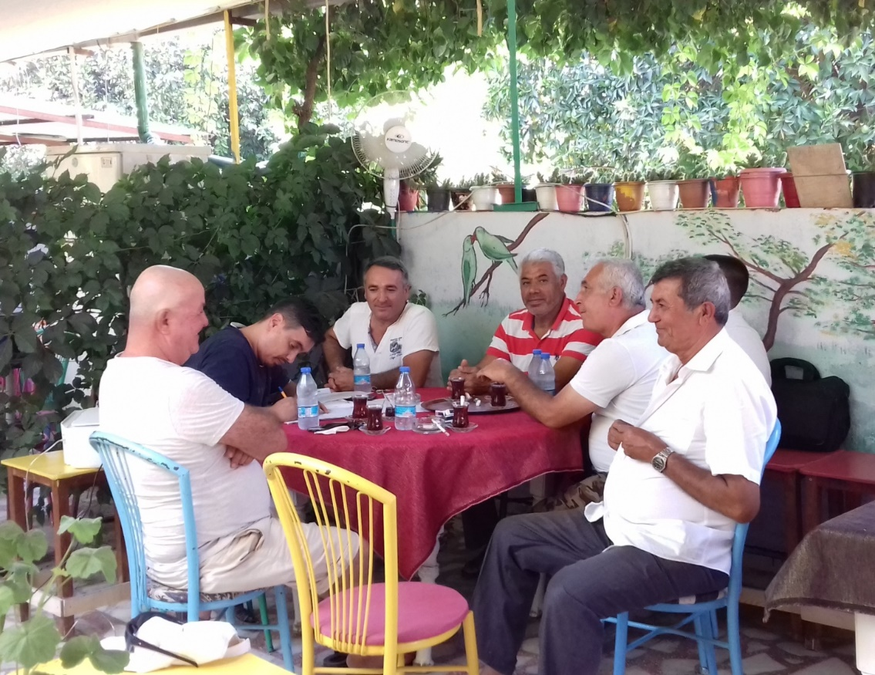

Meeting with Akyaka Fishery Cooperative boards

4.11 MEDITERRANEAN CONSERVATION SOCIETY GÖKOVA BAY

The marine area, Gökova MPA is one of the most important MPA in Turkey. The integration with fisheries is an example of a best practice for Blue Growth.

The established six No Fishing Zones in the bay in 2010 are respected thanks the control operated by the rangers in the area, and the fishers after eight years protection, they have noticed the great success in increasing protection, catch amount and fishing income.
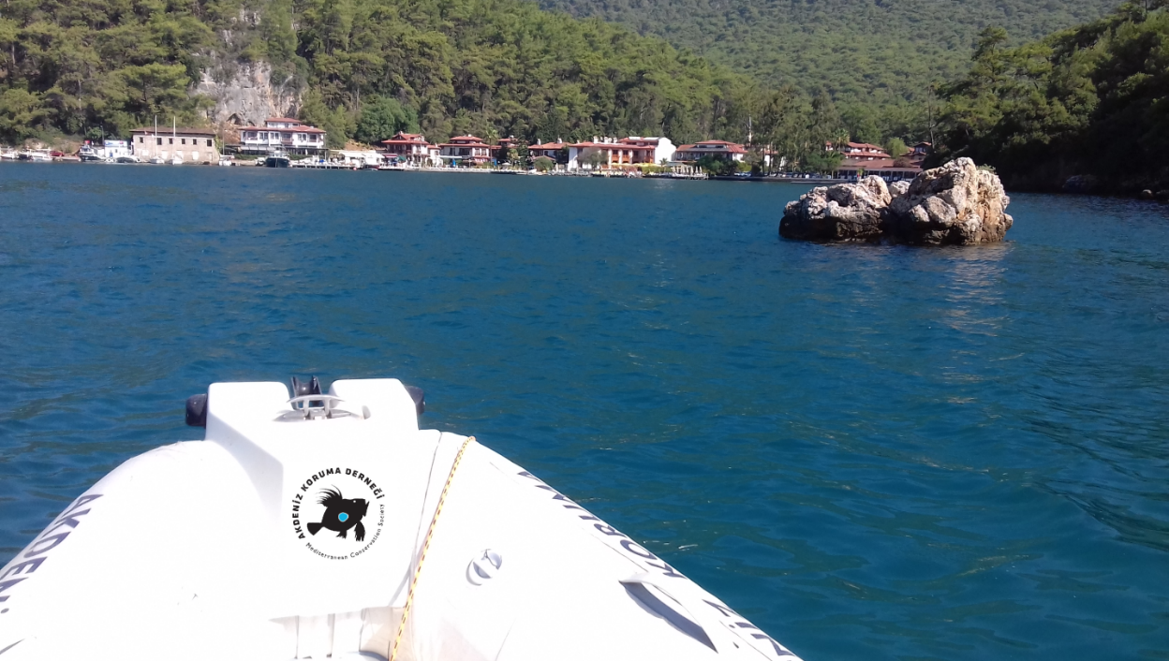

Gökova MPA Patrolling by Ranger boat

In 2012, the Mediterranean Conservation Society (a non-governmental organization) established a marine ranger system by training and employing local fishermen as marine rangers, equipping them with fast boats, and working in close cooperation with Turkey’s Coast Guard.

The new system puts small-scale fishermen at the forefront of monitoring compliance. These actions, have led to the conservation of fish stocks as well as increasing fishers’ incomes. Dramatic increases in abundance for some species have occurred in comparison to previous years. Biomass of predator fishes, such as groupers, increased significantly in NFZs.

Mean fishing income per vessel reached the highest level ever recorded. At the core of this approach is a participatory marine resource management model that engages a wide range of stakeholders (e.g. Coastguard, Fishery cooperatives, General Directorate for Protection of Natural Assets, General Directorate for Fisheries and Aquaculture etc) in monitoring, control and surveillance (Ünal and Kızılkaya, 2018). However, the system still need sustainability, looking for financial funds and support by the authority – at the moment any help is arriving by the Coast Guard to fight illegal fishing in the bay.

The visit of the Bay by boat confirm the high value of the sea in this area and the effort that every day we need to reserve for marine protection.

SWOT ANALYSIS

SWOT analysis (or SWOT matrix) is a strategic planning technique (Strengths, Weaknesses, Opportunities, and Threats) related to project planning.
It is intended to specify the objectives of the project and identify the internal and external factors that are favorable and unfavorable to achieving those objectives. Users of a SWOT analysis often ask and answer questions to generate meaningful information for each category to make the tool useful and identify their competitive advantage.
Strengths and Weakness are frequently internally-related, while Opportunities and Threats commonly focus on environmental placement.
- Strengths: characteristics of the project that give it an advantage over others.
- Weaknesses: characteristics that place the project at a disadvantage relative to others.
- Opportunities: elements in the environment that the project could exploit to its advantage.
- Threats: elements in the environment that could cause trouble for the project.
Identification of SWOTs is important because they can inform later steps in planning to achieve the objective. First, decision-makers should consider whether the objective is attainable, given the SWOTs. If the objective is not attainable, they must select a different objective and repeat the process.
An analysis of strengths, weaknesses, opportunities and threats (SWOT) provides an overview of the factors that need to be taken into account for developing a strategy for the value chain.
The essence of this analysis is that, while there is a long list of weaknesses and a shorter but equally serious list of threats, these weaknesses can largely be addressed in a short time period and the threats can be mitigated to an acceptable degree.

The challenge is that the fishery value chain in the study area as in other contexts is currently in a self-enforcing downward spiral where one weakness leads to another. Reversing this trend will require a major effort that can be nothing short of a fundamental structural change to the value chain. In order to realize its potential, the stakeholders in the SSF value chain will need to come together and tackle all core weaknesses simultaneously, relentlessly and persistently.

Strengths
SSF could be presented as a unique natural product, produced in an ecologically sustainable way. It appeals to consumers’ free from chemicals and pollutants, whose welfare during their life was guaranteed and that were slaughtered and processed under controlled (environmental monitoring system) clean conditions.
Production should not damage the environment and preferably contribute towards improved living conditions and happier lives for the producers and their families.
The scientific technical support of Izmir University and Turkish NGO is an important asset.

Weaknesses
The weaknesses of the SSF subsector include the high variable costs, related to the Political instability in the country and economic crisis and no political support for fishery sector (Turkish lira inflation). The sector has to to maintain essential services and infrastructure improving the whole aspects related to the products quality and marketing and currently the sector is not be able to give the guarantees many clients require in terms of traceability because there is no adeguate hygiene standard and institutional quality control. There are also natural resources conflicts between stakeholders on MPA management, fishermen cooperative and the other free fishermen

Opportunities
There are excellent market opportunities to promote the qualities of products to higher-income consumer segments in local markets linked to the touristic sector. The domestic market is growing rapidly, and can absorb products from small-scale producers who face high transaction costs in the export channel.
The MPA is any case a strong opportunity to develop quality label.

Threats
The SSF sector is exposed to some serious threats that increase risk all along the chain. This implies the need for higher profits during normal times to fund contingency plans when unpredictable but sure-to-occur-sooner-or-later threats materialize. Again, this makes the analysis of profitability such an important aspect.
Pollution must be considered a risk that can strongly impact on fishery production and creates a whiplash effect that makes the rest of the value chain difficult to manage. Various climatic and production-related factors can erode the SSF potential. markets change continuously, with consumers changing their preferences, competitors changing their strategies and countries changing their policies. This requires constant monitoring of markets, but the SSF gathers little market intelligence at the moment.

SWOT ANALYSIS FOR THE TURKEY STUDY AREA

INTERNAL SYSTEM FACTORS
STRENGTHS  - Meeting the high internation market requirements due the EU preaccession process  - Hig demand from domestic markets and consumption: no export.  - Sector can present itself with high nutritional/quality level products.  - Excellent environment water quality for production with no presence of industrial pollution.  - Good demand of fresh products linked to long history, strong traditions; good marketing story.  - Organisation of the 3/4 cooperatives of the buy and permanent consultative mechainsm for price policy  - Torism sector and price level  - Good tousistic infrastructure level /tourism  - Direct selling by fishermen cooperative for both consumers, restaurant, and hotel  - University of Izmir assitance and Turkish Ngo support | WEAKNESSES  - No Institutional extension services  - Weak enforcement of standards and innovation in smaller facilities  - Natural resources conflict between stakeholders on MPA management, fishermen cooperative and the other free fishermen  - Sector is not adeguate to hygiene standard and institutional quality control.  - No Political stability in the country and economic crysis and no political support for fishery sector (turkish lira inflation)  - No sustainble tourisitc developement and presence of pollution.  - Transport and distrivution system no good.  - No ice production and transport  - MPA stricly linked to NGO support
EXTERNAL SYTEM FACTORS

OPPORTUNITIES  - MPA as factor of natural respurces proteciotn and sustainble exploitation (Rangers)  - Combining SSF with ecotourism  - Marketing strategy for local market (branding) sutainble fisehry/MPA  - Fast-growing domestic market, growth to higher-income clients  - Development of restaurants manged diErctLy buìy the coopeatives  - Proccesing developped (bottarga. fillests, artisanl cunned) | THREATS  - No Institutional governance by Coastal guard for MPA  - No alternative market opportunities for a wide range of products  - No developped legistative sysem for pesca turismo  - Possible water pollution for other sector influencing fishery  - Import cheap products that reduce the price of local products  - Increasing competition on traditional markets by new actors in the international market and globalization,  - Severe climate change and loss of wildlife as source of economic wealth/income and presence of red sea species  - Sudden increase in fuel price and of imported material  - Unstable regional economies

STATUS OF GOKOVA BAY SSF CONTEXT

STRATEGIC OPTION AND Recommendations

The review of relevant documents and reports, and the technical surveys remarked the required services for sustainable resource management linked to the small scale fisheries and aquaculture development (production, processing, and marketing).

Institutional meetings and consultation with sector stakeholders and project partners have validate the scope of Project aimed to develop and improve the capacity of small scale fisheries

Given the potential indicated in the SWOT analysis, a number of core strategy options are listed and this report recommends the strategy of market differentiation as the best option at this point in time.

At this regards, Turkey is as a candidate country for European Union (EU) membership and has been involved with Acquis alignment as well as structural and infrastructural cohesion with relevant EU directives and sectoral approaches and this is an on-going process.
The Accession Partnership Document (2008/157/EC) regards strengthening monitoring, surveillance & control, resource management and data collection as short term priority and strengthening the institutional, administrative and monitoring capacity to ensure environmental, social and economic sustainability of the fisheries industry, including data collection, as medium term priorities.
Although the technical, hygienic, environmental and operational directives of CFP have been adapted into the primary and the secondary fisheries legislations of Turkey from 1998, further financial, administrative, institutional, human capital, Common Martket Organisation (CMO), monitoring, planning, stock management and incentive policies need to be accordingly adjusted and implemented. It is crucial to prepare a strategy to increase alignment with the Common Fisheries Policy (CFP) and strengthening institutional capacity and legal alignment for fisheries management to meet the requirements in the reformed CFP.
These actions are implemented trough program and projects under IPA 2007-13. Best practices available in the EU MSs will be proposed and adapted to the local structure and will include methodological protocols for data collection taking into account the departmental structure of the public bodies involved and the work force available.
The Indicative Strategy Paper for Turkey (2014-2020) states that "In the area of fisheries, assistance will help preparing a strategy to increase alignment with the Common Fisheries Policy (CFP) and strengthening institutional capacity and legal alignment for fisheries management to meet the requirements in the reformed CFP.
Activities will contribute to improved capacity for the conservation and the sustainability of fisheries resources, including resource and fleet management; eco-system based fisheries management and stronger enforcement. Support will be also granted to the preparation of the implementation of the fisheries Common Market Organization (CMO).
IPA II will also aim at increasing the stakeholder awareness and participation to ensure a smoother transition period in the EU alignment process. These activities will be complementary to assistance already programmed under IPA 2007-13, particularly on strengthening monitoring, surveillance and control, combating of illegal, unregulated and unreported fishing and data collection."
Focus on differentiation based on quality and uniqueness to become more competitive in high-end export markets such as the EU and market segments such as high-end restaurants, supermarkets etc. Even with a core strategy chosen, there has to be sufficient flexibility in the specific elements of the strategy to adapt to the very distinct wants and needs of the various types of production.

Nevertheless, some activities are considered of high priorities because they address the weakest leverage points in the chain that, if not addressed, will have immediate, large and negative impacts.

It is essential to take into account culturally relevant factors such as expectations, norms and daily practices when trying to upgrade the value chain. For example, smallholders may need more financial and capacity-building support, emerging medium-scale fishermen may need more access to technology and larger-scale fishery enterprises may benefit most from policy changes and subsector-wide collaboration.

Strategic activity options for SSF value chain
PRODUCTION | PROCESSING | MARKETING
HIGH PRIORITY
Studies on the economics of various production options for fishermen level profitability.  Strengthen fishermen groups at various levels | Transform the SSF value chain into best-practice’s operation, drastically reducing per unit productive cost  Consolidate the standard level for both domestic and export | Improve marketing performance and shift to  branded, value-added products
OTHERS
Promote stakeholder consultative mechanism  Promote co management of fishing areas  Consolidate the Institutions action for extension service  Increasing exchange of experience at Med Level  Improve the capacity of Institutions | Develop price information system | Develop niche markets  Partnership other regional producers on joint  marketing/branding  Partnership with supermarket chains  Open up domestic market to imports for higher-value export
SYSTEMIC ISSUES
High Priority
improve export performance and returns to fishermen
Facilitate collaboration and to promote branding

Other
Develop a training curriculum for best technical/business practices throughout the value chain
Request EU and other funds for capacity-building activities related to standards, training etc.
Research on government programme impact, market intelligence, basic time-series data on the value chain and other data combined into an integrated database for decision support at all levels

The main Interventions and activities to implement within context of blue growth in the studied area are the followings

6.1 Business development and investment opportunities and needs

The review of relevant documents and reports, the technical surveys and institutional meetings and consultation with sector stakeholders and project partners have validated the scope of Project underlining the Business development and investment opportunities and needs aimed to develop and improve the capacity of small scale fisheries.

- In the study area it is evident the need to support the Cooperative in the gathering and management of garbage and through side projects for the valorisation of parts of fishing tools such as ropes, floats, shards of wooden boat, for the making of hand crafted items, thus creating new workplaces (AKYAKA FISHERY COOPERATIVE)
- Technical and financial assistance for the establishment of an Ice production plant (500 kg per day). The ice production could also be shared between several cooperatives (AKÇAPINAR FISHERY COOPERATIVE and Akyaka Fishery Cooperative).
- Technical and financial assistance to the create a small catering and restaurant facility, includes the restructuring of the cooperative building, the relocation of the fish counter and the purchase of cooking equipment.
- Small restaurant to consume the fish in the cooperatives place and specialized takeaway restaurant. In particular the takeaway restaurant could be a business model for the cooperatives and allows the opening of new restaurants in different locations or in a Franchising scheme, generating an innovative way to enhance the fish caught by the cooperative members and attract new employment
- Technical and financial assistance to create an operational structure for the Cooperative: office, cold room, ice production facility, store for fishing gear and equipment (SARNIÇ-AKBÜK FISHERY COOPERATIVE).
- The COOPERATIVES need Technical assistance to create a Microcredit line for small-scale fishermen. Feasibility study for the creation of a processing plant for fishery products. The plant would collect the catch of the cooperatives in particular in the winter months when the market does not absorb the fish caught. The plant would be used to produce high value-added products, of particular interest are the canned fish and dried and smoked products (eg bottarga and smoked fillets).

6.2 Training needs/plan

The review of relevant documents and reports, the technical surveys and the institutional meetings and consultation with sector stakeholders and project partners have validated the scope of Project, remrking the need to prepare a plan for training on improved sanitary controls and quality of fish, and value added fisheries products resource management linked to the small scale fisheries and aquaculture development (production, processing, and marketing).

- Training can be aimed to consolidate The AKYAKA FISHERY COOPERATIVE short value chain by renovation of the fish counter and the restaurant area.
- Training can be aimed to market local seafood as a food business, bringing a new food product into the shops to increase the income (like sale of canned fish, smoked and salted fish, ingredients ed ecc.):
- training for restaurant personnel by a professional chef on how to cook, prepare and valorize local fish - project aims to raise the quality standards of local seafood restaurants; their products and hosting capabilities , notably by improving the use of fresh fisheries products and applying attractive communication tools in the restaurant.
- Finally training program related to: post harvesting fish quality management and value chain, Labeling and Traceability are cricial

Food safety Training Plan Tentative

Food safety is a scientific discipline describing handling, preparation, and storage of food in ways that prevent food-borne illness. The occurrence of two or more cases of a similar illnesses resulting from the ingestion of a common food is known as a food-borne disease outbreak.

This includes a number of routines that should be followed to avoid potential health hazards. In this way food safety often overlaps with food defense to prevent harm to consumers. The tracks within this line of thought are safety between industry and the market and then between the market and the consumer. In considering industry to market practices, food safety considerations include the origins of food including the practices relating to food labeling, food hygiene, food additives and pesticide residues, as well as policies on biotechnology and food and guidelines for the management of governmental import and export inspection and certification systems for foods.

In considering market to consumer practices, the usual thought is that food ought to be safe in the market and the concern is safe delivery and preparation of the food for the consumer.

Food can transmit pathogens which can result in the illness or death of the person or other animals. The main mediums are bacteria, viruses, mold, and fungus (which is Latin for mushroom). It can also serve as a growth and reproductive medium for pathogens. In developed countries there are intricate standards for food preparation, whereas in lesser developed countries there are fewer standards and less enforcement of those standards. Another main issue is simply the availability of adequate safe water, which is usually a critical item in the spreading of diseases.

In theory, food poisoning is 100% preventable. However this cannot be achieved due to the number of persons involved in the supply chain, as well as the fact that pathogens can be introduced into foods no matter how many precautions are taken. The five key principles of food hygiene, according to WHO, are:
- Prevent contaminating food with pathogens spreading from people, pets, and pests.
- Separate raw and cooked foods to prevent contaminating the cooked foods.
- Cook foods for the appropriate length of time and at the appropriate temperature to kill pathogens.
- Store food at the proper temperature.
- Use safe water and safe raw materials

Trrainig can be implemented as follows:

Nutrition issue
The nutritional value of the fishery products and food safety
Benefits of compliance with regulations.
Food hygiene

Fish handling including the use of ice
Understanding the causes of fish spoilage;
Being able to asses fish quality;
Being able to maintain fish quality;
Avoiding contamination;
understanding the causes of fish spoilage;
assessing fish quality;
maintaining fish quality;

Hygiene and handling from fishing to transportation from landing site
use of crates/boxes of fish handling;
use of ice and insulated boxes;
freezing;

Personal hygiene;
Use of potable wate
Proper waste disposal;

Haccp
Methodoogy and implementation
Best practices /Manuals editing and sharing

Non-training solutions to capacity building

Assuming capacity building is carried out, several critical issues which could influence the uptake and application of new knowledge and skill must be identified. Fishery operators generally lack access to credit or funding to help them invest in new ideas/better practices. Therefore improved access to finance needs to be considered. One of the difficulties of training fishermen and cooperative members is that there is a chance that they will exit the fishery once their permit expires, hence the knowledge and skills would also leave the sector. Selection of the right people to be trained is seen as key. There needs to be more awareness of fisheries and aquaculture and the management of natural resources amongst various stakeholders. Training must therefore be accompanied by wider awareness raising activities targeting other stakeholders including consumers. Lack of proper landing facilities and services, equipment will constrain the implementation of better and hygienic practices. Investment is required by government in better infrastructure at key locations where fish are landed and handled and marketed.

As well as training workshops, other initiatives to consider to improve knowledge and skills of fishery operators include:
- Awareness raising on topics covered in the training during community meetings;
- Production of posters to depict key messages using pictures and images and local language that can be displayed in key locations. More permanent messages could be presented using murals painted on walls and on fishing canoes;
- Use of radios for communicating key messages to fisheries stakeholders. Many people in fishing communities listen to radio.
- Drama to entertain and educate whether it be live in the community or films and then shown via DVD;
- Production of songs and music giving key messages;

6.3 Marketing opportunities

The review of relevant documents and reports, the technical surveys and institutional meetings and consultation with sector stakeholders and project partners have validated the scope of Project and th need to recommend opportunities to improve product quality, value added and profitability, and capacity to access to the market improving the capacity of small scale fisheries

Financial assistance to but a refrigerated vehicle to transport the fish in different market of the region, in order to solve the problem of unsold fish in the winter (SARNIÇ-AKBÜK FISHERY COOPERATIVE)

- The AKYAKA FISHERY COOPERATIVE needs technical and financial assistance to strengthen the short supply chain shop by renovation of the fish counter and the restaurant area;
- technical assistance in marketing and communication within the shop and restaurant, through labels, brochures, information panels, videos describing the work of the cooperative within the Marine Protected Area of Gökova Bay and the quality of fishery products.
- Assistance in communicating the values of the work carried out by the cooperative trough social networks, media advertisement, articles on newspapers and etc.
- Technical assistance for pre-assessment on a certification project for sustainable fisheries in Gokova Bay fishery, to gaining Friend of the Sea or MSC accreditation for the specie and relative health of local stocks. And assistance on Labeling and Traceability of the fish caught by the cooperative members.
- Technical assistance for cooperation and exchange program to support the Cooperative to: Improve fish quality and value chain, Labeling and Traceability; Improve the management of garbage and the valorization of parts of old and unused fishing tools such as ropes, boat boards, shards of wooden boat to create handicraft (attract new employment);
- Organize a Fish Festival to promote the work of the cooperative within the Marine Protected Area of Gökova Bay and the quality of fishery products.

GOKOVA BAY STATUS VS ACTIONS

Constrains and critical issue to face for improving the value chain system in the interest of SSF

Conclusions

SSF is playing an important social, economic and cultural role in the Mediterranean and Black Sea, providing an important contribution to food and livelihood security.
SSF activities, which typically involve small vessels with limited daily catches, represent 84 percent of the Mediterranean and Black Sea fishing fleet, 62 percent of the total workforce onboard fishing vessels and 24 percent of total landing value. SSF employ over 147 thousand fishers and it is estimated that they generate jobs for another 150 thousand people in the region.
Moreover, SSF are a vibrant and multi-dimensional sector, where modern activities and cultural heritage coexist and are embedded in the surrounding environment.
However, since 85 percent of the scientifically assessed fish stocks in the Mediterranean and the Black Sea are considered to be fished outside of safe biological limits, small-scale fishers and their families struggle for their survival as their livelihoods depend on dwindling catches and income.
It is in this context that the need to promote transnational collaboration between all actors involved in SSF has emerged.

Economic literature highlights that competitive environment for small scale agri-food businesses has been dramatically altered in recent years. The new environment is characterized by globalization, liberalization and extensive organizational, institutional and technological change.

This is equally true for SSFs, where we have to consider also changes and problems related to the sustainability of fish stocks and, more in general, to the provision of ecosystem services. In this context, SSFs have specific characteristics that make them less competitive but, at the same time, provide elements of higher flexibility and resilience.

SSFs, in particular, compete and conflict, with industrial fisheries. Negative features of SSFs are the scarcity of economic resources, the low investments, the lack of innovation, the smallness of enterprises, the weak market position, the fragmentation of production, the difficulty to comply with sanitary and safety standards, the low education and individualism of fishers. On the other hand, some of the relative advantages of SSFs in certain conditions are (Naji, 2015):
- Lower running costs and fuel consumption.
- Lower ecological impact (thus, higher sustainability) because SSFs fishers employ mainly passive gears.
- Higher employment opportunities (being more labour-intensive).
- Higher versatility (small-scale fishing boats can operate from small ports and landing sites relatively close to the fished resource).
- Lower construction costs.
- Less expensive technology (artisanal fisheries require relatively low investment in technology and equipment and are consequentially more competitive in most developing regions where labour is cheaper than equipment).

In other words, quite often, the same reasons that seem to make SSFs uncompetitive also can make them resilient. In this framework, it is necessary to find development approaches that could solve the points of weakness without compromising the strengths of SSFs. Even more complex is the concept of “enhancing SSFs value chain”, where different economic actors are involved at the same time with conflictual purposes.

Given these conditions, it is vital for the SSF sector (and for fishery in general) to step back and consider its options. For any improved future envisioned, fundamental improvements are needed on both the supply and the marketing side.

On the supply side, measures to be taken to increase the profitability of production and maintain or increase competitiveness in an increasingly liberalized world market should focus on increasing income/productivity trough the co management of fishing area, and lowering overhead costs in slaughter and processing through industry consolidation and rationalization.

On the marketing side, the SSF must develop additional export markets in order to reduce its heavy dependency on the EU market. The African, Russian and Middle Eastern markets appear to offer the best opportunities for exports of a wider range of products. At the same time, there are increasing opportunities in the domestic market. Domestic demand is growing and processors and butchers are paying ever-increasing prices for fishery products.

This study should be interpreted as an indicative picture of value-chain; some of the key findings of the analysis underlines that there are not enough incentives for fishermen to adopt improved management practices and the high cost of fencing is a big challenge to meeting the alignment with the Common Fisheries Policy (CFP) (IPA Program2007-13).

Finally, there are critical data gaps in the knowledge that is needed to make well-informed decisions on the sector. The most notable of these gaps are as follows:

• There are no detailed impact studies for the various government programmes. Studies needed include a quantitative and qualitative comparative analysis on which market management strategies are the most beneficial.

• There are no detailed economic studies on the commercial viability of various business models, including the more holistic management models that may prove to be critical for competitiveness.

• There is no systematic gathering of marketing intelligence, competitive position in various markets (benchmark studies).

• There are gaps in the basic data on the value chain, such as herd size, numbers of stakeholders by type, throughput numbers at various levels in the value chain and so on. Targeting more markets, all of which will likely become more demanding, makes tracking markets and their specific standards even more complicated. It is therefore highly recommended that this type of data collection and analysis be incorporated in the research that is planned to be undertaken in the near future.

References

AKD, 2016. Promoting the implementation of the EU Common Fisheries Policy in Gökova MPA, EU Project, Mediterranean Conservation Society, Turkey.

Aktaş, N., Menengiç, M., Ünal, İ., Akgül, E., Yapıcıoğlu, M.O., Taşeli, B., 2011. Reflections from the Special Environmental Protection Areas of Turkey. Ministry of Environment and Forestry Environmental Protection Agency for Special Areas, Ankara, 186p.

Bilecenoğlu, M., Kaya, M., Cihangir, B., 2014. An updated checklist of the marine fishes of Turkey. Turkish Journal of Zoology. 38:1-29.

Dereli H., Tosunoğlu Z., Göncüoğlu H., Ünal V., (2015) Ege J Fish Aqua Sci 32(3): 135-143 Catch per unit effort (CPUE) and catch composition of small scale fisheries in Gökova Bay
EAF project – WS 1 Report, (2016). First Stakeholder Meeting Report. FAO-EastMed project “The implementation of a pilot case study on the Ecosystem Approach to Fisheries Management in Gökova Bay”

EAF project – WS 2 Report, (2017). Second Stakeholder Meeting Report. FAOEastMed project “The implementation of a pilot case study on the Ecosystem Approach to Fisheries Management in Gökova Bay”,

EAF project – WS 3 Report, (2017). Third Stakeholder Meeting Report Issue Identification and Prioritization Workshop Report. FAO-EastMed project “The implementation of a pilot case study on the Ecosystem Approach to Fisheries Management in Gökova Bay”,15p.

EAF project – WS 4 Report, (2017). Forth Stakeholder Meeting Report. FAO-EastMed project “Introduction and Approval of Ecosystem Approach to Fisheries Management Plan of Small Scale Fishery in Gökova Marine Protected Area”, 13p.

EAF project – WS 5 Report, (2018). Fifth Stakeholder Meeting Report. FAO-EastMed project “The implementation of a pilot case study on the Ecosystem Approach to Fisheries Management in Gökova Bay”.

Ecorys, Deltares, Oceanic (2012). Blue Growth: Scenarios and drivers for Sustainable Growth from the Oceans, Seas and Coasts. Final Report. Call for tenders No. MARE/2010/01

FAO and World Fish Center (2010). Small-scale capture fisheries – a global overview with emphasis on developing countries. A preliminary report of the Big Numbers Project.

FAO, (2003). The ecosystem approach to fisheries, FAO technical guidelines for responsible fisheries. Rome, 112.

FAO, (2005). Putting into practice the ecosystem approach to fisheries. Rome, FAO. 76p.

FAO, (2012). EAF toolbox: The ecosystem approach to fisheries. Rome, 172pp.

GFCM, (2014). GFCM Data Collection Reference Framework. 50 pp.

Göncüoğlu, H., Ünal, V. 2011. Fisherwomen in the Turkish fishery, southern Aegean Sea. J. Appl. Ichthyol. 27:1013–1018.

Gülşahin, A., Kara, A., 2013. Record of Nemipterus randalli Russell, 1986 from the Southern Aegean Sea (Gökova Bay, Turkey). Journal of Applied Ichthyology, 29: 933-934.
Malorgio, G., Mulazzani, L., Di Terlizzi, B., Zuccaro, M., and Petruzzella, D. (2015) Enhancing small-scale fisheries value chains in the Mediterranean and Black Sea: Part 2. In, Srour, A. (Ed.) First Regional Symposium on Sustainable Small-Scale Fisheries in the Mediterranean and Black Sea. GFCM - FAO, Rome.

Mulazzani, L., Trevisi, R., Manrique, R., and Malorgio, G. (2015). Community-led coastal development and the relationships between human activities and ecosystem services. Paper presented at the XXII Conference of the EAFE. Salerno, April 28-30, 2015

Okuş E., Yüksek A., Yokeş B., Yılmaz İ.N., Aslan-Yılmaz A., Karhan S.Ü., Demirel N., Demir V., Zeki S., Taş S., Sur H.I., Altıok H., Müftüoğlu A.E., Balkıs N., Aksu A., Doğan E., Gazioğlu C. (2006). Gökova Özel Çevre Koruma Bölgesinin Kıyı ve Deniz Alanlarının Biyolojik Çeşitliliğinin Tespiti Projesi Final Raporu, (Sunulan Kuruluş, T.C. Çevre ve Orman Bakanlığı Özel Çevre Koruma Kurumu Bakanlığı) ISBN:975-8273-91-4

Piasecki W., Głąbiński Z., Francour P., Koper P., Saba G, García A. M., Ünal V., (2016) Acta Ichthyologica Et Piscatoria Pescatourism—A European Review And Perspective

Tirasin, E. M. and Unluoglu, A. 2012. Demersal and deep water fisheries resources in Turkish seas. In A. Tokaç, A. C. Gücü and B. Öztürk (eds), “The State of the Turkish Fisheries”. TÜDAV, Pbl. No: 35, 28-92.
TurkStat, 2004-2009. Fishery Statistics. Turkish Statistical Institute, Prime Ministry, The Republic of Turkey.

TurkStat, 2015. Distribution of fishery workers by age groups, working time and sea products regions. https://biruni.tuik.gov.tr/medas/?kn=97&locale=tr (11.12.2017)

Unal V., Franquesa R., 2017 Journal of Applied Ichthyology A comparative study on socio-economic indicators and viability in small-scale ﬁsheries of six districts along the Turkish coast

Ünal, V. (2017) FAO-EastMed project Draft Management Plan for the Small-scale Fisheries in Gökova MPA, Turkey

Ünal, V. and Erdem, V. 2009(a). Combating illegal fishing in Gökova MPA (Aegean Sea), Turkey. Çiçek, B.A. and Öniz, H. (eds). Proceedings of the 3rd International Symposium on Underwater Research, 19–21 March, 2009, Eastern Mediterranean University, Famagusta, Turkish Republic of Northern Cyprus, 125 p.

Ünal, V., 2010. Fishery Management in Gökova Special Environment Protection Area. (In Eds. Kıraç, C.O. and N.O. Veryeri with contributions by H. Güçlüsoy and S.D. Çağlayan. “Putting PEEN to Practice in Marine and Coastal Areas; Gokova Integrated Coastal and Marine Management Planning Project” Final Report (submitted to BBI Matra, the Netherlands.) 31 October 2010. SAD-AFAG, Ankara. 92 p.+Annexes.

Ünal, V., Erdem, M., Göncüoğlu, H., Güçlüsoy, H., Tosunoğlu, Z., 2009(c). Management paradox of groupers (Epinephelinae) fishing in the Gökova MPA (Eastern Mediterranean), Turkey, Journal of Food, Agriculture & Environment, 7(3-4):914-917.

Ünal, V., Franquesa, R, 2010. A comparative study on socio-economic indicators and viability in small-scale ﬁsheries of six districts along the Turkish coast. J. Appl. Ichthyol. 26 (26-34).
Ünal, V., Göncüoğlu, H., 2012. Fisheries management in Turkey. 263-288 pp. A. Tokaç, A.C. Gücü, B. Öztürk [eds.], The State of The Turkish Fisheries, Turkish Marine Research Foundation. Pub. Number: 35, 516 p

Ünal, V., Güçlusoy, H. and Franquesa, R. 2009(b). A comparative study of success and failure of fishery cooperatives in the Aegean, Turkey. Journal of Applied Ichthyology 25:394-400.
Ünal, V., Yıldırım, Z.D., Tıraşın, E.M., (2016). Ecosystem Approach to Fisheries Baseline Report. FAO-EastMed project “The implementation of a pilot case study on the Ecosystem Approach to Fisheries Management in Gökova Bay”. 84p.p.

