COMMITTEE FOR INLAND FISHERIES AND AQUACULTURE OF AFRICA
Seventeenth Session
Banjul, Gambia, 9-11 May 2017
Aquaculture Network for Africa (ANAF): achievements and constrains

Executive Summary
Launched but not yet fromalized in 2006 based on the decision taken at the 14th Session of the Committee for Inland Fisheries and Aquaculture of Africa (CIFAA) held in Accra, the Republic of Ghana in November 2006, the Aquaculture Network for Africa (ANAF) is a unique Network for sub-Saharan Africa dealing with sustainable aquaculture development. It was created to optimise the utilisation of available resources and strengthen the member countries capacity to foster sustainable aquaculture development in Africa as a mean to fight poverty, ensure food and nutritional security, create wealth, income and provide youth employment. Its current membership consists of 14 member countries of the African Union (AU). This document contains background information and describes the ANAF’institutional structure, procedures and analyses its strengths and weaknesses. Moreover, it presents two possible structure options and operating procedures available to ANAF to adapt to the members’ current needs, promote greater impact, effectiveness and visibility of its works; and it also presents a possible vision of how ANAF could better serve its members are also discussed.

The Committee is invited to:
- Reaffirm the importance of this Network in supporting aquaculture development in the sub-Sahara African region.
- Provide guidance on the future of ANAF by endorsing one of the two options proposed in this document to turn ANAF into a full formalized and functional Network.

- Background

- Aquaculture in Africa, which supplies less than 3 percent of fish production, has been growing slowly. Per capita fish consumption in Africa is the lowest in all regions and, according to the FAO 2016, is the only part of the world where consumption is declining. The reason for this decline has likely been the levelling off in capture fish production and the growing population. The degradation of aquatic environments through human activity and the potential impact of climate change on marine and freshwater ecosystems are some of the factors hindering aquaculture production from achieving its potential. There are many other constraints, which range in nature from biological to technical, economic and environmental.

- Other than these are the institutional weaknesses. In some countries, there is a lack of coordination between the existing directorates and agencies that share aquaculture regulatory responsibility. There are legislations that may not be in harmony with present and future status of the industry, and there are unclear or conflicting priorities within the policy making and regulatory spheres. There is a need for improved governance and management systems, a collaboration between different stakeholders and targeted investments in infrastructure and marketing to accelerate the growth of aquaculture in the region.

- All the above-mentioned constraints led to the decision taken at the 14th Session of the Committee for Inland Fisheries and Aquaculture of Africa (Accra-Ghana, November 2006) to establish a “NACA-Like” Network called Aquaculture Network for Africa (ANAF).

- However, although much has been achieved by the network since its establishment, its performance has not yet always been to the full satisfactory of member countries. At several time member countries highlighted the importance of having an efficient and formalized network if Africa’s aquaculture has to be managed in a sustainable and responsible manner.

- Specifically, its fifth annual meeting suggested that its role and performance as a regional network be re-examined. Thus, the meeting created an ad hoc working group to elaborate the ANAF Agreement and to identify the legal steps for ANAF to become an International Government Organization (IGO). The meeting further recommended that the ANAF National Focal Points to consult with the legal departments of the respective Ministries in order to identify national legal procedures to present and adopt the international agreement.

- In support of this initiative, FAO in collaboration with Lake Victoria Fisheries Organization (LVFO) supported the sixth ANAF annual meeting held in Entebbe, Uganda from 6 to 9 December 2016, in which two working group were established. The first group was composed of Legal Officers from ANAF member countries and the second by ANAF National Focal Points. During the meeting, the drafts of ANAF legal documents were reviewed by Legal Officers, which include: the Founding Agreement, the Rules of Procedure, the Financial Regulations and the Headquarter Agreement. A concept note on the establishment of ANAF was developed by ANAF National Focal Points. Based on this concept note, the meeting further proposed the two following options for the establishment of ANAF as full functional network: (1) ANAF Secretariat hosted by a member country as an IGO and/or (2) ANAF integrated as a unit with the African Union.

- MEMBERSHIP, FUNCTION AND OBJECTIVES

- Membership is open to all African Member Nations and Associated Members of AU. They are selected on the basis of their active interest in aquaculture development in Africa and their potential contribution to the effective discharge of the functions of the network. The current membership consists of 14 African countries.

- The objectives of ANAF, from its establishment to present, are:
- To increase, disseminate and facilitate access to aquaculture information in the region, for the development of the sector.
- To generate access to quality inputs, and the adoption of appropriate and sustainable technologies for quality seed production, feed formulation and development.
- To stimulate private sector investment as well as public-private partnership in aquaculture.
- To establish institutional links and stronger collaboration among member countries.
- To facilitate access to quality inputs, and the adoption of appropriate and sustainable technologies for quality seed production, feed formulation and development.
- To increase rural income and employment, gender and youth equity.
- To increase and delivery aquaculture production and enhance productivity and profitability.
- To harmonise policies and strength regulatory frameworks and standards.
- To strengthen technical capacities and promote collaboration research and development in aquaculture.
- To develop and promote best management practices to ensure a healthy environmental and ecosystems in all aquaculture practices.
- To reduce post-harvest losses and ensure the quality and safety of aquaculture products.
- To facilitate regional trade and access to markets for aquaculture products.

- PERFORMANCE AND STRENGTHS

- The performance of the network over the years has already generated some good results; in particular its annual meetings activities and their outcomes. The network has held six annual meetings and produced related reports. ANAF has developed a web-based information system using the Typo3 Content Management System, hosted by the Lake Victoria Fisheries Organization in Jinja, Uganda.
- Two consultancy reports were prepared and published within the fourth ANAF annual meeting report:
- The Role of Aquaculture Advisory Groups and Aquaculture Farmer Organisations: the Lessons Learned from the Republic of Zambia and Republic of Uganda and Guidelines for Developing Aquaculture Farmer Organisations
- Towards Aquaculture Network for Africa (ANAF) Intergovernmental Organisation (IGO) - Small Steps for the Final Lead.

- Field visits to aquaculture facilities were undertaken during every annual meeting, to allow national focal points to share technical information on aquaculture issues, be aware of aquaculture developments in member countries and therefore strengthen the network.

- Legal documents for the formal establishment of ANAF were elaborated and published in the sixth ANAF Annual Meeting Report.

- MAIN CONSTRAINTS AND WEAKNESSES

- Several constraints impede ANAF’s performance. Among other factors, there are inadequate financial and technical resources; several member countries are unwilling or unable to bear the cost of the participation of their representatives to the annual meetings, the absence of legal status.

- CONSIDERATIONS AND ADOPTIONS FOR STRENGTHENING ANAF EFFECTIVENESS

- For ANAF to be capable of delivering services to members and involve other stakeholders in improving aquaculture in Africa, it is important to address its constraints and weakness, as discussed above.

- The two options that were proposed during the sixth ANAF annual meeting were:
- Turn ANAF into an Intergovernmental Organization (IGO) hosted by a member country with an independent budget and Secretariat (see structure in annexe I) and
- ANAF to be integrated as a unit within the African Union (see structure in annexe II).
- Members could contribute financially to activities of ANAF and participate at the annual meetings at their own expenses (FAO presently undertakes almost all these activities).
- Countries could propose hosting meetings of ANAF on a rotational basis and or based on their specific interest.

- DECISIONS BY THE COMMITTEE

- Taking into account the acknowledge critical need for a strengthened and effective ANAF for the long-term sustainability of aquaculture development in the African continent, the committee is invited to:
- Reaffirm the importance of ANAF in supporting aquaculture development in the sub-Sahara African region.
- Provide guidance on the future of ANAF by endorsing one of the two options proposed in this document to turn ANAF into a full formalized and functional Network.

ANNEXE I

Proposed structure of ANAF-IGO hosted by a member country

ANAF
Council
CIFAA FAO
AU-IBAR
Associate Members
Private sector
Farmer associations
Donors
SECRETARIAT
Technical Advisory Committee

ANNEXE II

Proposal on where ANAF might be placed within the structure of AU.

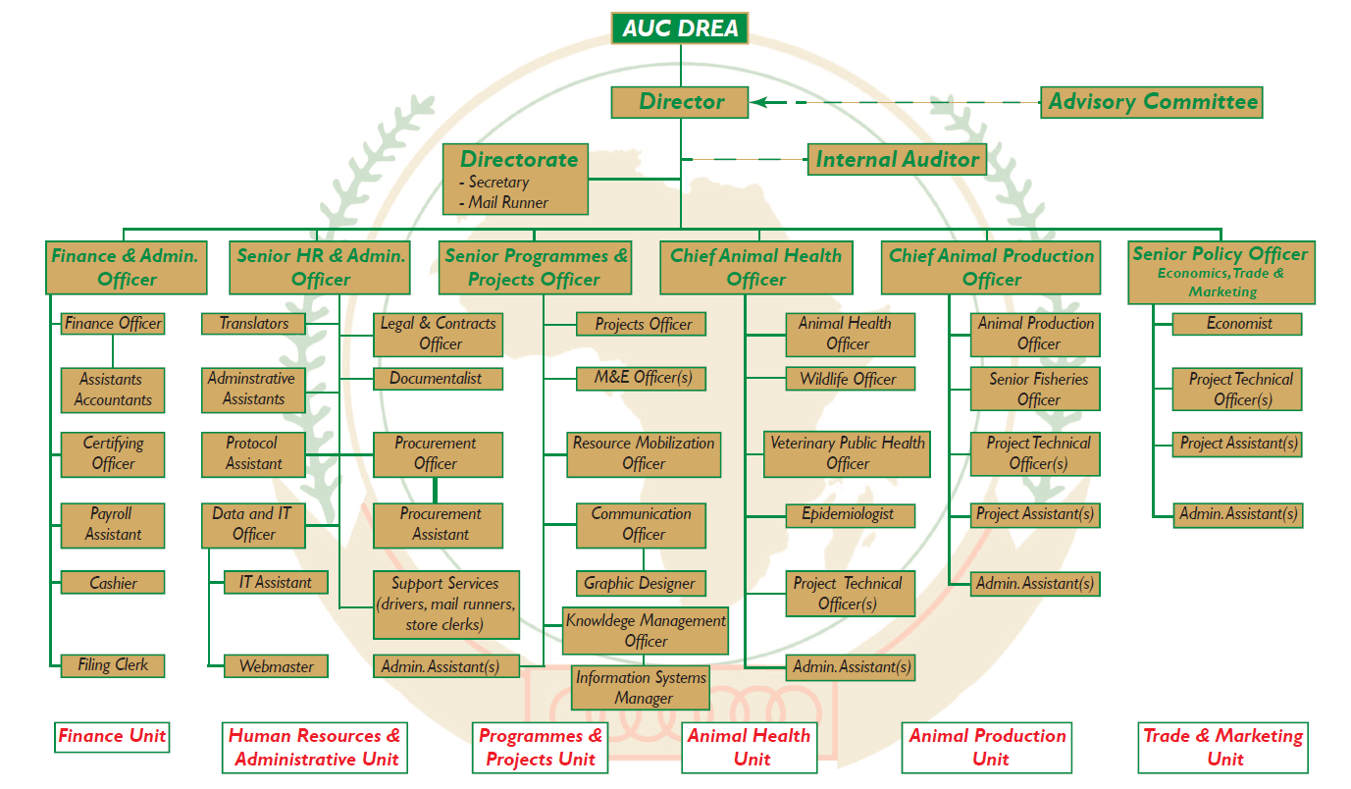
ANAF

FAO. 2016. The State of World Fisheries and Aquaculture 2016. Contributing to food security and nutrition for all. Rome. 200 pp. (www.fao.org/3/a-i5555e.pdf)
Cameroon, Chad, Ghana, Kenya, Liberia, Mali, Mozambique, Namibia, Nigeria, Senegal, South Africa, Tanzania, Uganda and Zambia
Reports of ANAF Annual Meetings FAO. 2013. Report of the Technical meeting and training on the Aquaculture Network for Africa (ANAF) website: data collection and dissemination tools. Jinja, Uganda, 22–25 November 2011. FAO Fisheries and Aquaculture Report No. 1010. Rome. FAO. 58 pp. FAO. 2013 Report of the Fourth Aquaculture Network for Africa (ANAF) Annual Meeting. Entebbe, Uganda, 4–6 December 2012. FAO Fisheries and Aquaculture Report No. 1049. Rome. 82 pp. FAO. 2016 Report of the Fifth Aquaculture Network for Africa (ANAF) Annual Meeting. Dakar, Senegal, 11–13 September 2013. FAO Fisheries and Aquaculture Report. No. 1179. Rome, Italy. FAO. 2017. Report of the sixth Aquaculture Network for Africa (ANAF) annual meeting, Entebbe, Uganda, 6 to 9 December 2016. FAO Fisheries and Aquaculture Report. No. 1187, Rome, Italy.

