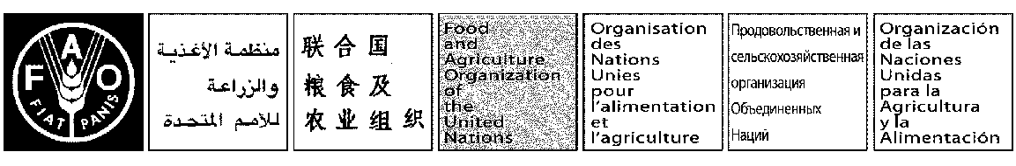
May 2017

Time Table
E

SEVENTEENTH SESSION OF COMMITTEE ON INLAND FISHERIES AND AQUACULTURE OF AFRICA
Banjul, Gambia, 9-11 May 2017
PROGRAMME

Tuesday 09 May 2017

08:00

- Registration

9:30

- Opening of the Session

  - Meeting called to order, Secretariat
  - Speech by outgoing Chair, Mozambique
  - Speech of FAO Representative in the Gambia
  - Opening Speech by the Ministry, Gambia

- Adoption of the Agenda and Arrangements for the Session CIFAA/XVII/2017/1

- Statement by the African Development Bank

10:30

Coffee / Tea break and Group photo

11:00

- Report on the intersessional activities and way forward CIFAA/XVII/2017/2

LUNCH BREAK 12:30

14/30

- Outcomes of the Sixth annual meeting of the Aquaculture Network for Africa (ANAF)

  - The Future of the Network CIFAA/XVII/2017/3

Wednesday 10 May 2017

09:00

- Summary of the first day

- Status of Inland fisheries in Africa, way forward for a strategy for its development

CIFAA/XVII/2017/4

LUNCH BREAK: 12:30

14:00

- Feed Africa Strategy Presentation by AfDB

Thursday 11 May 2017

Morning: 09:00

- Summary of the second day

- Proposal for Topics of the 18th Session

- Election of Chair and Vice chair for the 18th Session

- Any Other Matters

- Date and place of the 18th Session

LUNCH 12:30

Afternoon: 15:30

- Adoption of the report

- Closing Session

