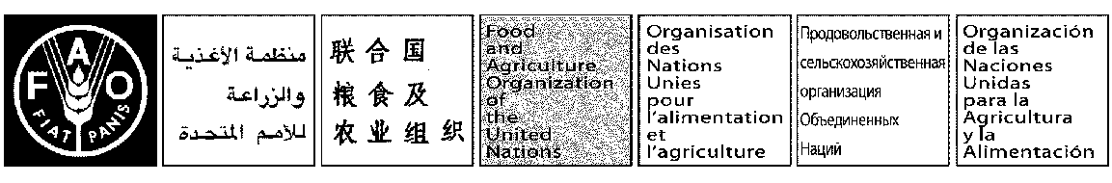
May 2017 Document List
E

COMMITTEE ON INLAND FISHERIES AND AQUACULTURE OF AFRICA
Seventeenth Regular Session
Banjul, Gambia, 9-11 May 2017
DOCUMENT LIST

Working Documents

- Provisional Agenda CIFAA/XVII/2017/1
- Follow up action of intersessional activities and way forward CIFAA/XVII/2017/2
- Outcomes of the Sixth annual meeting of the ANAF CIFAA/XVII/2017/3
- Status of Inland fisheries in Africa CIFAA/XVII/2017/4

Information Documents

- Report of the 16th CIFAA Session, Maputo, Mozambique CIFAA/XVII/2017/INFO-1
- Report of the Extraordinary Session: Lusaka, Zambia, 2014 CIFAA/XVII/2017/INFO-2
- Report of the Extraordinary Session: Dakar, Senegal, 2015 CIFAA/XVII/2017/INFO-3
- 153rd FAO Council CIFAA passage CIFAA/XVII/2017/INFO-4

