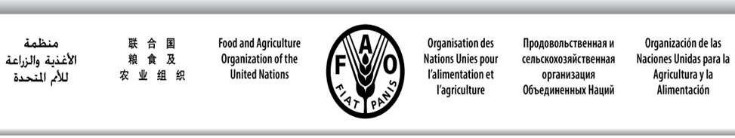

SWIOFC/WPCCTF/19/2 E
SOUTHWEST INDIAN OCEAN FISHERIES COMMISSION

Ninth Working Party on Collaboration and Cooperation in Tuna Fisheries
Maldives, 29 September 2019

OUTCOMES OF THE 9TH SWIOFC SESSION RELEVANT TO WPCCTF ATTENTION AND FOLLOW UP

The Ninth Session of the Southwest Indian Ocean Fisheries Commission (SWIOFC) was held at Cape Town, South Africa, from 9 to 12 October 2018 and the deliberations and recommendations relevant to the WPCCTF were as follows:
- The Commission was informed that a timeline of 5 months was recommended by the WPCCTF for members to submit inputs for the preparation of a Policy brief by the MTCTF.
Some members have submitted inputs and the Policy brief was developed through a consultancy supported by the SWIOFish1 project, with further inputs by the SWIOFC Secretariat which will be presented in this WP meeting for consideration and subsequent actions by the member states.
- The Commission noted that in some occasions the focal points appointed by the countries were not able to respond in time to requests by the Secretariat and recommended to develop a list of additional institutions/contact points that should be included as addresses in communications requesting governmental commitments.
The Secretariat updated the contact list based on the contacts of attendants to the 8th WPCCTF meeting and on notifications by members requesting replacements of contact persons / institutions.
- A special Bureau meeting of the SWIOFC would be held by the end of February 2019 to finalize the guidelines upon submission of clarifications by Seychelles on Article 4 and circulated to all member states for adoption.
After the submission of the amendments to article 4 of the MTC guidelines by Seychelles on 2 November 2018 to the SWIOFC Secretary, a virtual meeting of the Bureau was held via email and the final text of the MTC Guidelines was endorsed. Subsequently, on 18 February 2019 the Secretariat circulated an email to all SWIOFC Member States with the final version of the MTC Guidelines.

Under this agenda item SWIOFC MS are invited to note the progress in the implementation of the recommendations of the 9th SWIOFC Session relevant to the WPCCTF.

