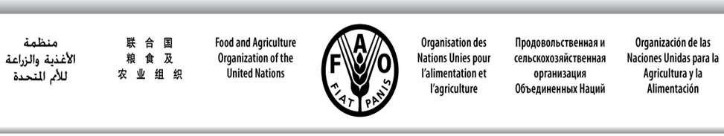

SWIOFC/WPCCTF/19/7 E
SOUTHWEST INDIAN OCEAN FISHERIES COMMISSION

Ninth Working Party on Collaboration and Cooperation in Tuna Fisheries
Maldives, 29 September 2019

ACTIONS FOR IMPROVED COORDINATION AND COMPLIANCE OF THE SWIO STATES TO IOTC CONSERVATION AND MANAGEMENT MEASURES (CMMs)

The Working Party on Collaboration and Cooperation in Tuna Fisheries (WPCCTF) has been created as a platform for SWIOFC Member States (SWIOFC MS) to cooperate in matters related to tuna fisheries, including voicing common positions at the Indian Ocean Tuna Commission (IOTC) and improving performance in the implementation of IOTC Conservation and Management Measures (CMMs).
The WPCCTF meetings have been instrumental to allow the SWIOFC MS to exchanging views and prepare common CMM proposals to be tabled at the IOTC annual Sessions. In the last IOTC Session (Hyderabad, India, 17-21 June 2019), joint proposals from SWIO states have been considered for discussion, namely:
- On Mobulids species, rebuilding yellowfin tuna stocks, chartering agreements, record of fishing vessel authorized to operate and on FADs, which was adopted;
- On record of licensed foreign vessels fishing for IOTC species in the IOTC area of competence and access agreement information, which was withdrawn; and
- On allocation of fishing opportunities, which was deferred and further work was recommended for the IOTC Technical Committee on Allocation Criteria (TCAC).
With regards to compliance to IOTC CMMs, the majority of SWIO States has improved its compliance rates, although some countries have had a slight decrease in the level of compliance and there is concern for those countries which level of compliance is still rated below 50%. The graph in Figure 1 shows the compliance assessment for the last two years.
Under this agenda item SWIOFC MS are invited to note the progress in the performance on IOTC CMMs and recommend actions in order to improve cooperation and enhance performance in the IOTC.

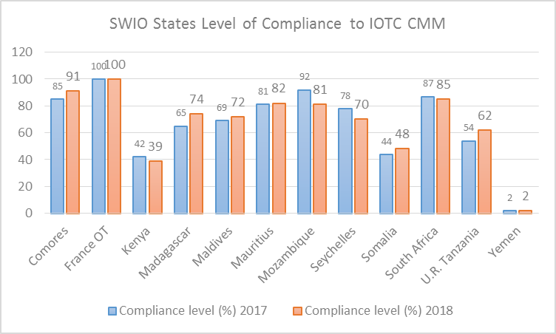
Figure 1. Level of Compliance of SWIO States to IOTC CMMs

