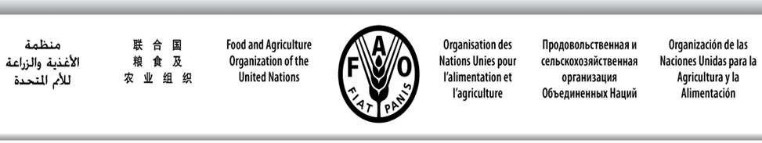

SWIOFC/WPCCTF/19/9 E
SOUTHWEST INDIAN OCEAN FISHERIES COMMISSION

Ninth Working Party on Collaboration and Cooperation in Tuna Fisheries
Maldives, 29 September 2019
PROGRAMME OF WORK FOR THE WPCCTF

Taking into account that, with the adoption of the “Guidelines for Minimum Terms and Conditions (MTC) for Foreign Fisheries Access in the SWIOFC region”, one of the main past activity of the Working Party has been achieved, under this agenda item the Members States are invited to discuss the continuation of activities and role of this WP and, in case, propose a Programme of Work for the intersessional period.

During the past intersessional period, due to delays on finalizing consultancy studies (SWIO FFA policy brief and SWIOFC financing mechanisms) and budget constraints, it was only possible to organize the WPCCTF back to back with the 10th SWIOFC Session.

For the next intersessional period the Chairperson of the WPCCTF could be supported to attend only one of the following:
- IOTC Scientific Committee;
- IOTC TCAC;
- 24th IOTC Session.

In case the Working Party will decide to continue its activities, the WP should suggest if its annual Session should be held in the second half of the year back-to-back to the SWIOFC Commission as it was for this 9th Session, or if it should be held in the months before the IOTC annual Session (as it was for the 5th and 6th Working Parties) in order to exchange views and prepare common CMM proposals to be tabled at the IOTC annual Session.

