MARPLESCA Plan

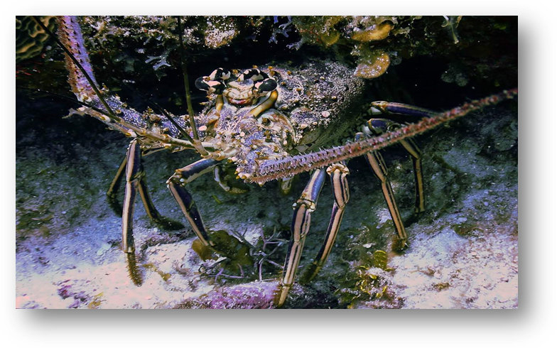

CARIBBAN SPINY LOBSTER (Panulirus argus) FISHERY REGIONAL MANAGEMENT PLAN

November 2018

The preparation of this document was supported by the "Ecosystem Based Fisheries Management for the Caribbean Spiny Lobster (Panulirus argus)” (ECOLANGOSTA +) sub-project of the Shared Living Marine Resources of the Caribbean and North Brazil Shelf Large Marine Ecosystems (CLME +) Project (GEF/ UNOPS-OSPESCA)

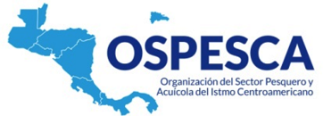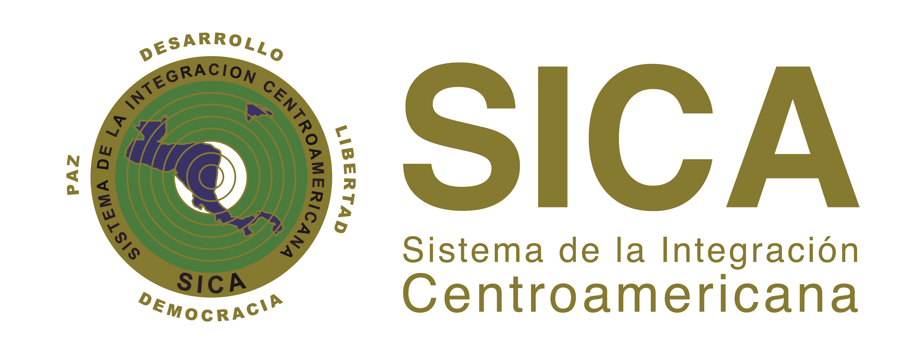

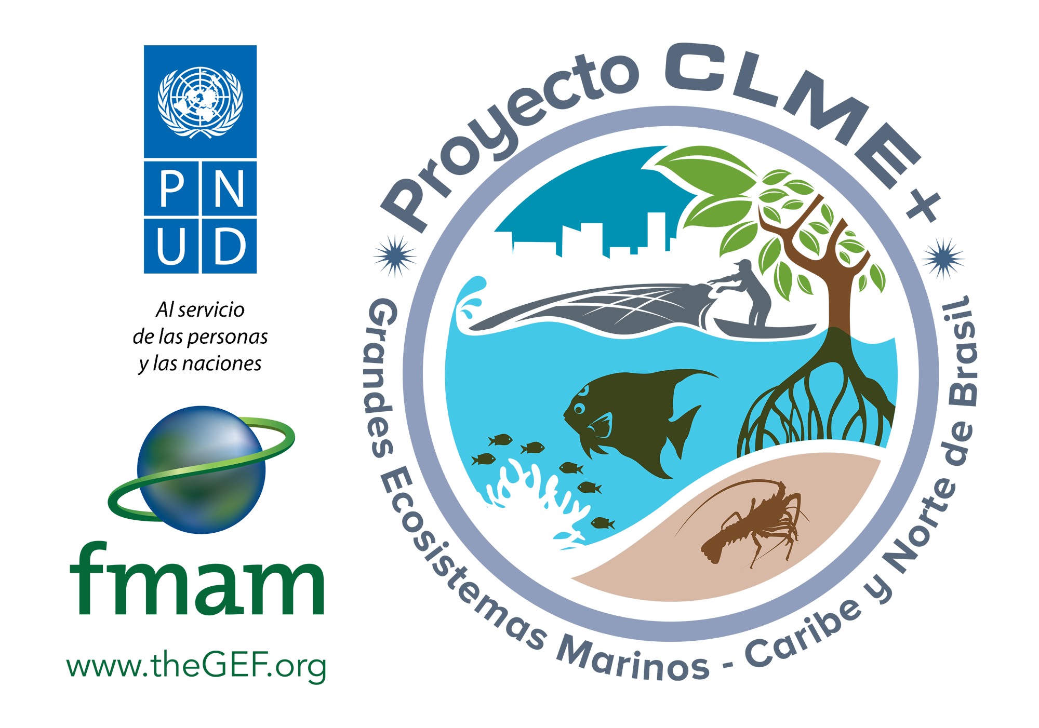

ECOLANGOSTA +

All rights reserved. The reproduction and dissemination of material in this document is authorized for educational or other non-commercial purposes without any prior written permission of the copyright holders. The reproduction of material in this information product for resale or other commercial purposes is prohibited without written authorization of the copyright holders. Applications for such permission should be addressed to the OSPESCA Regional Director (info.ospesca@sica.int).

Contents

EXECUTIVE SUMMARY 2
PROLOGUE 4
REGIONAL AND INTEGRATED APPROACH 4
I. INTRODUCTION 5
II. CARIBBEAN SPINY LOBSTER 6
2.1 General overview 6
2.2 Life Cycle, Habitat 8
2.3 General information on Caribbean spiny lobster fisheries capture production and fishing effort 9
III. COMMON ELEMENTS MATRIX 10
IV. ASSUMPTIONS 16
V. OBJECTIVES 16
VI. IMPLEMENTATION STRATEGIES AND GOALS 16
VII. REGIONAL ACTIONS OF THE MARPLESCA PLAN 17
7.1 Implementation of Regulation OSP-02-09, St. George’s Declaration and WECAFC Recommendations 17
7.2 Access Regime Harmonization 18
7.3 Best Practices for Lobster Fishing 18
7.4 Harmonized Landing Controls 18
7.5 Common Protocols for Fishing Fleets 18
7.6 Common processing protocol 19
7.7 Traceability of the lobster production chain 19
7.8 Common biological sampling methodology (on board and in processing plants) 19
7.9 Commercialization 20
7.10 Consumption 20
7.11 Monitoring, control and surveillance 20
7.12 Fisheries diversification 21
VIII. REGIONAL RESEARCH AND RECOMMENDATIONS 21
IX. ECONOMIC AND SOCIAL ASPECTS 22
X. CLIMATE CHANGE 22
XI. TECHNICAL ASSISTANCE AND TRAINING 24
XII. REGIONAL ORGANIZATION 25
12.1 Synergies 25
12.2 Provisional timeline and budget 26
ANNEXES 29
ANNEX 1 30
ANNEX 2 49
ANNEX 3 54
ECONOMIC AND SOCIAL ASPECTS 55
REFERENCES 62
ACRONYMS 64

EXECUTIVE SUMMARY

This document presents the Caribbean Spiny Lobster Fishery Regional Management Plan (MARPLESCA plan) prepared under the "Ecosystem Approach for the Caribbean Spiny Lobster Fisheries subproject (aka ECOLANGOSTA +)", which is executed in the framework of the " Shared Living Marine Resources of the Caribbean and North Brazil Shelf Large Marine Ecosystems (CLME +)” and the implementation of the Strategic Action Program 2015-2025 of the CLME region.

Caribbean Spiny Lobster (Panulirus argus) continues to be one of the most commercially valued resources and, since the decade of the 60s, it has generated social and economic benefits to many countries in the Caribbean region, including SICA/OSPESCA and CARICOM/CRFM countries. The management of this resource is characterized by increased regional cooperation and the fishery shows a steady increase in exploitation which has apparently led to fully exploited levels.

The MARPLESCA Plan capitalizes valuable contributions such as the former "Subregional management of the Caribbean spiny lobster fishery (Panulirus argus)" sub-project of the first CLME project which developed a Caribbean spiny lobster fisheries management plan for Central American Integration System (SICA) member States. Enhanced regional cooperation has led to other management tools such as the binding Regulation for the Regional Management of the Caribbean Lobster Fishery (Panulirus argus) OSP-02-09 as of July 1, 2009. Also, the St. George's Declaration, in the CRFM/CARICOM framework, was adopted in 2015.

The MARPLESCA Plan has as general objective the establishment of a systematic process for the Caribbean spiny lobster fishery (Panulirus argus) range countries for fisheries management in a sustainable use framework, promoting ecological balance and social and economic stakeholder benefits.

It will specifically address:

  - Strengthening effective application of OSPESCA Regulation OSP-02-09 and CARICOM St. George’s Declaration as well as WECAFC recommendations.

  - Manage with regional scope in a coordinated and participatory way the Caribbean spiny lobster fishery under the SICA/OSPESCA, CARICOM/CRFM and WECAFC governance model.

  - Promote adequate organization for institutionalized key stakeholders’ participation in the management of the fishery.

  - Provide conditions for the adoption an implementation of the Plan in the Caribbean spiny lobster (Panulirus argus) geographical distribution range in the framework of the CLME+ Strategic Action Program (SAP).

Experiences already generated and human resources available will be capitalized. At present, the Interim Coordination Mechanism for Sustainable Fisheries, integrated by WECAFC, CRFM and OSPESCA, seems to be the most viable mechanism to coordinate the MARPLESCA plan implementation. The Regional WECAFC/ CRFM/ OSPESCA/ CFMC Caribbean Spiny Lobster Working Group can play a monitoring technical support role. A regional advisory committee will be formed, if necessary, with stakeholders where key actors are represented. Participation of native communities’ leaders should be ensured.

At the national level, national focal points should be appointed, where needed, and involved in monitoring national activities and act as liaisons with the corresponding entities implementing the plan. It should be recalled that under SAP implementation and the CLME+ project national intersectoral committees were established and also national focal points were nominated.

Synergies will be established with major stakeholders in the region represented for regional and national institutions, such as government or intergovernmental; the fishing industry; unions, associations, non-governmental organizations, donors and civil society who represent and support fishers and universities with regional coverage.

National fisheries administrations of the region will be invited to institutionalize the MARPLESCA Plan into national planning to achieve harmonized regional action. The 10-year Strategic Action Program (SAP 2015-2025) for the sustainable management of shared Living Marine Resources in the Caribbean and North Brazil Shelf Large Marine Ecosystems (CLME+ region) which is implemented through the 5-year CLME+ Project (UNDP/GEF; 2015-2020) can be the framework for implementation of the Caribbean Spiny Lobster Fisheries Regional Management Plan, in particular if we consider to start its full implementation in 2020 for an initial period of 5 years. Also, the region can continue working in a possible third phase of the CLME+ Project which is expected to start in 2020.

The MARPLESCA plan will seek to start financing with resources provided by SICA, CARICOM or WECAFC member countries WECAFC on some specific issues that can be coordinated and executed by the national fisheries administrations and the interim coordination mechanism for sustainable fishing conformed by FAO, CRFM and OSPESCA. Alliances and partnerships with other regional and international cooperation bodies and donors will also be sought to generate a project to implement the plan.

The schedule and budget for the execution of the 10-year plan considers resources in the order of US$ 11,240,000 with an annual average of USD. 1,124,000, which will allow to undertake the process of change for the regional management of the Caribbean spiny lobster fishery in the Greater Caribbean.

PROLOGUE

REGIONAL AND INTEGRATED APPROACH

Various regional instruments such as the Central American Fisheries and Aquaculture Integration Policy and the Common Fisheries Policy for the Caribbean Community have as their general objective the establishment of a common regional system to increase the integrated participation of the Central American and all Caribbean countries, and thus contribute to the appropriate and sustainable use of fisheries resources and aquaculture products. In addition, as part of its implementation strategies, the region approved and implemented the Code of Conduct for Responsible Fisheries of the Food and Agriculture Organization (FAO) of the United Nations, and the Code of Ethics for Responsible Fisheries and Aquaculture in member States of the Central America Integration System.

The aforementioned mentioned policies and codes recognize fisheries management as one of the priority focus areas that include species of high commercial value requiring intervention to ensure their sustainability. In this regard, Caribbean spiny lobster is a major migratory species that has been historically characterized as having economic and social impacts.

Originally, in 2012 a regional plan under the "Subregional management of the Caribbean spiny lobster fishery (Panulirus argus)" sub-project was developed only for Central American Integration System (SICA) member States. Now, the updated plan, which encompasses all the Caribbean, was developed under the "Ecosystem Approach for the Caribbean Spiny Lobster Fisheries subproject (aka ECOLANGOSTA +)", which is executed in the framework of the " Shared Living Marine Resources of the Caribbean and North Brazil Shelf Large Marine Ecosystems (CLME +). The plan will be known as the MARPLESCA plan,

In this plan all Caribbean spiny lobster fisheries commonalities across Caribbean countries are considered, and also the plan intends to capitalize on the previous work and past experience at regional and national levels from other projects or initiatives that have had significant contributions.

The MARPLESCA Plan took into consideration the OSP-O2-09 Regulation for regional management of the Caribbean Spiny Lobster (Panulirus argus) fishery which was precisely one of the first results obtained by OSPESCA. This regulation has a strict regional and integrated approach based on the governance model supported by the Protocol of Tegucigalpa which is the legal regime for the Central American Integration System. The Plan is expected to be applicable under the Declaration of St. George’s for the Caribbean Regional Fisheries Mechanism (CRFM) countries of the Caribbean Community and non-member countries with lobster fisheries.

INTRODUCTION

Caribbean Spiny Lobster (Panulirus argus) continues to be one of the most commercially valuable resources and, since the decade of the 60s, it has generated social and economic benefits to SICA/OSPESCA and CARICOM/CRFM countries, and other countries in the region. The fishery of this resource has been characterized by a steady increase in exploitation which has apparently led to fully exploited levels.

One of the recent management foundations was the “Strengthening Interdisciplinary Research for Responsible Fisheries of Central American Countries (FIINPESCA for its Spanish acronym)” project executed by OSPESCA with assistance from the Food and Agriculture Organization of the United Nations (FAO) and financing from Sweden. This project contributed in 2005 with the "Memorandum of Managua" which produced the first voluntary sub-regional fisheries agreement based on "Regional Alternatives to Harmonized Management of Caribbean Spiny Lobster Fisheries and Lines of Action" where an initial agreement between Honduras and Nicaragua to harmonize closed seasons, minimum legal sizes and other fisheries management measures was reached. Afterwards, this agreement was extended in 2007 to all Central American countries.

The progress of these agreements gave rise to the binding Regulation for the Regional Management of the Caribbean Lobster Fishery (Panulirus argus) OSP-02-09 as of July 1, 2009. Also, the St. George's Declaration for the management of the resource, was adopted in 2015 in the framework of the Updated Chaguaramas Agreement. These instruments can be improved and consolidated over time. Considering the migratory behavior of the Caribbean spiny lobster, it is convenient to link and make integration efforts among all Caribbean countries with Caribbean spiny lobster fisheries.

Therefore, the " Shared Living Marine Resources of the Caribbean and North Brazil Shelf Large Marine Ecosystems (CLME +)” through an Interagency Agreement with the United Nations Office for Project Services (UNOPS), regarded OSPESCA as the executing body of the "Ecosystem Based Fisheries Management for the Caribbean Spiny Lobster" (ECOLANGOSTA+)" pilot subproject, which provides an opportunity to strengthen the application of Regulation OSP-02-09 and the Declaration of St. George’s, establishing conditions for an understanding among CLME+ participating countries.

The MARPLESCA Plan capitalizes valuable contributions such as the Local Management Plans and stakeholder analysis developed in 2012 by a previous subproject of the CLME Project for Belize, Honduras and Panama. In a similar way, other contributions such as the Management Program for Aquatic Resource and Economic Alternatives (MAREA program) executed by the United States Agency for International Development (USAID) and the FAO former Caribbean lobster working group meetings and workshops outputs under the Western Central Atlantic Fisheries Commission (WECAFC) were also considered.

National fisheries administrations have made important contributions to Caribbean lobster fisheries management in spite of limited human and financial resources available. Nevertheless, more efforts are needed to strengthen regional approaches such as coordination for statistical monitoring; monitoring, control and surveillance, as well as commercialization and traceability, which includes the sale, transport and storage of fish products. Currently, strengthening sustainable management through national working groups and adoption and implementation of a seafood traceability system, among other developments, has also been endorsed.

A recent 2016 initiative was the establishment of the OSPESCA-FAO-CRFM Interim Coordination Mechanism for Sustainable Fisheries which will facilitate the adoption and implementation of the MARPLESCA Plan.

II. CARIBBEAN SPINY LOBSTER

2.1 General overview

Caribbean Spiny Lobster (Panulirus argus) is an important fishery resource as a target species throughout its range from the south-eastern shelf of the United States of America, the Gulf of Mexico, the continental shelf of the Bahamas to Rio de Janeiro, Brazil, Including the chain of Caribbean islands from Cuba to the Lesser Antilles, the coasts of the Mexican Caribbean and the Central American Caribbean (Figure 1). These areas include different reef types, large extensions of seagrass meadows, atolls and mangrove swamps. Most of the distribution area is classified as the Western Central Atlantic Region, Fishing Area 31 by FAO (Figure 2).
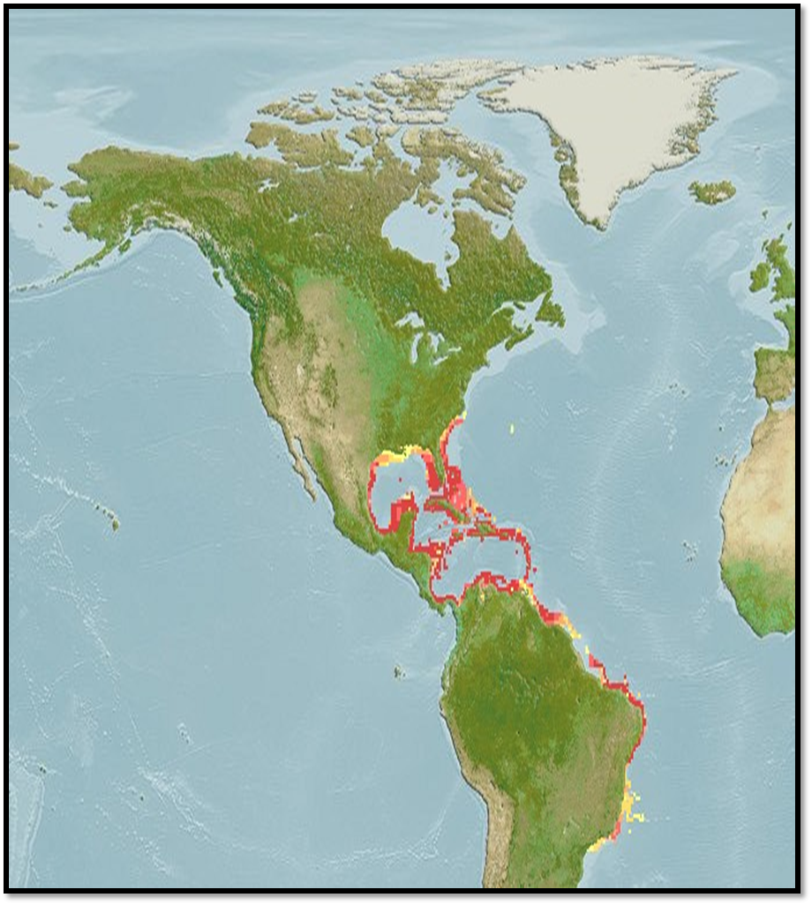

Fig. 1. Caribbean spiny lobster distribution

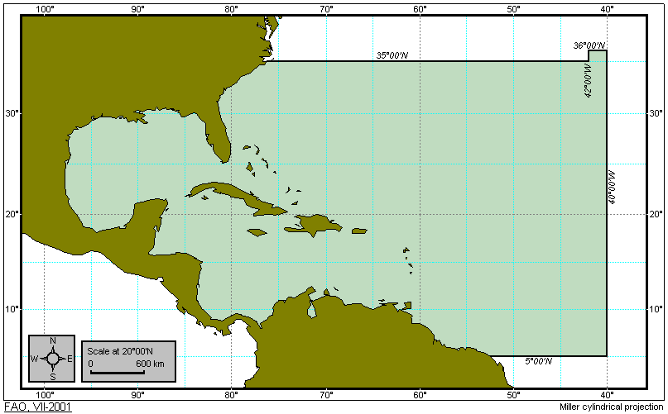
Fig.2. FAO Fishing Area 31

Caribbean spiny lobster distribution is influenced by the occurrence of the Caribbean Current which is a warm ocean current flowing to the northwest across the Caribbean from the east along the coast of South America. One of the features is the Colombia-Panama Gyre which flows in an anti-clockwise direction (Anisimov et al, 1986). To the east of the Caribbean, the North Equatorial current is known as the Antilles Current (Figure 3).
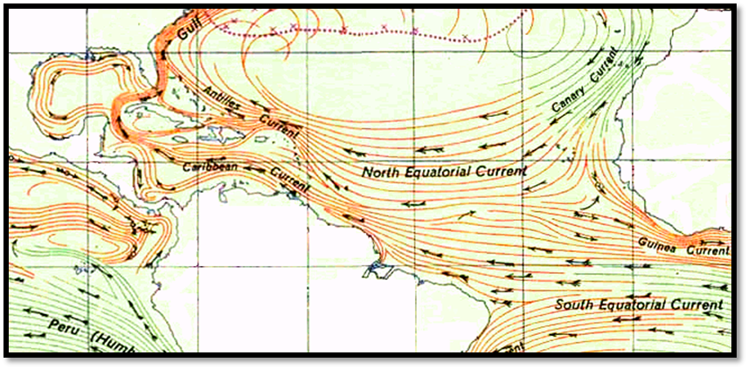

Fig. 3. Currents inside and outside the Caribbean

Most countries within the lobster distribution range have marine protected areas (MPAs) that function as replenishment areas. Globally, MPAs have been shown to increase fish size, density, biomass, as well as species richness. These increases are also seen beyond the boundaries of the protected area, through the so-called spillover effect. This spillover effect applies to larvae, juvenile and adult fish moving beyond MPA boundaries (Lester et al., 2009). The community composition outside the protected area becomes like that inside, essentially exporting recovery beyond the protected zone (Russ & Alcala, 2010). As such, MPAs are an important tool in stock replenishment, long-term food security and fishing-related livelihoods. Figure 4 shows a map of MPAs in the Caribbean region that may benefit Caribbean spiny lobster populations

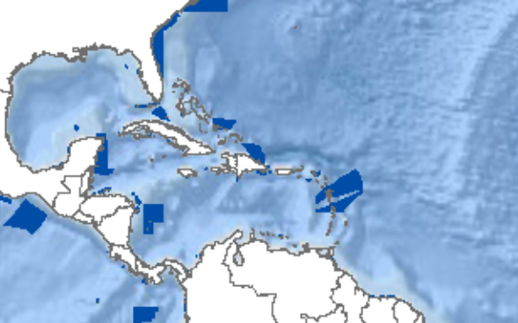
Fig. 4: Marine protected areas in the Caribbean (UNEP-WCMC-IUCN, 2018)

Due to its wide distribution and its larval dispersion process, Caribbean spiny lobster has been considered as a meta-population which means that it should be managed jointly by all countries with lobster fisheries (Seijo, 2007; WECAFC, 2001). Studies of the life cycle also suggest that larval transportation by ocean currents constitutes an important replenishment that allows fishing in areas far from spawning sites (Ehrhardt, 1994). This in turn is an important transboundary link and could be considered as an externality of the fishery.

Challenges and opportunities around this fishery are similar. For example, obtaining information on the biology, distribution and abundance of lobster from all fishing areas is more feasible and of greater coverage if it is done harmonized and at regional level. Therefore, the SICA/OSPESCA, CARICOM/CRFM and WECAFC countries should strengthen efforts to establish harmonized and systematic guidelines at regional level to implement policies and fishery management.

2.2 Life Cycle, Habitat

Caribbean spiny lobster has a complex life cycle that includes five stages: egg, larva (phyllosoma), postlarvae (puerulus), juvenile and adult (Marx and Herrnkind, 1986). The life cycle begins with the mating of mature adults, from 78 mm to 81 mm carapace length (CL) (Cruz-Leon, 1991). Upon mating the male attaches a spermatophore to the female, which is a sperm package or patch wrapped in a cementing substance. Next, fertilization occurs when the female breaks the spermatophore releasing gametes that fertilize the female's eggs, which remain attached to the pleopods until spawning. Usually gravid females spawn in deep reef areas with appropriate conditions such as shelter, water quality and larval transport by currents (Marx and Herrnkind, 1986).

Reproductive fecundity varies directly with the size of the female (Max and Herrnkind, 1986) and can be affected by the intensity of fishing effort (Lyons et al., 1981). Sexual maturity is reached between 78-81 mm LC sizes (Cruz and Leon, 1991; Baisre and Cruz, 1994) and mating takes place mainly from February to March. In ovigerous females hatching occurs in 3-4 weeks, mainly from April to May. The number of eggs in the pleopods range between 159.000 and 1,629,000 and is related to carapace length (mm) by the following equation: F = 59,110 CL^{2.9666} (Cruz-Leon, 1991). After the eggs are released, the lobster begins its life as a phyllosoma larva: tiny, flat and transparent except for the eye pigment. The phyllosomas are dispersed in the ocean, where they feed on plankton and go through eleven stages or phases over a period of 6-12 months.

After successive metamorphosis, the phyllosomas become postlarvae or pueruli, which migrate to the coast where they settle on substrates with complex structures preferably covered with red algae of the genus Laurencia (Marx and Herrnkind 1986). This crustacean can reach 40 cm in total length and as adult inhabits coral reefs at depths of 3-55 meters. In Nicaragua, Caribbean spiny lobster has shown increased sexual activity in May and October (Martinez, S., 1997) with a peak in recruitment in June (Barnutti, 2000; Barnutti, 2001, FAO, 2003). This documented information was a key element in establishing the four-month regional closed season in the OSPESCA Regional Regulation OSP-02-09.

2.3 General information on Caribbean spiny lobster fisheries capture production and fishing effort

According to FAO (2018), 286,765 tons of Caribbean spiny lobster (live weight) were captured between 2007 and 2016 in FAO area 31. Figure 5 shows Caribbean spiny lobster total capture production by year between 2007 to 2017 of 26 fishing countries in FAO area 31 where an upward trend is observed. Main fishing countries are The Bahamas with capture production in the order of 76 thousand tons followed by Cuba, Honduras and Nicaragua in the order of 45-46 thousand tons (Figure 6).

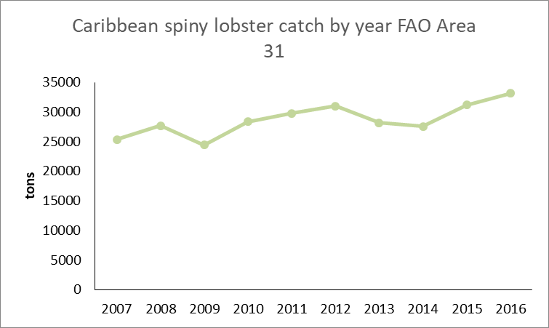

Fig.5. Caribbean spiny lobster capture production (tons) by year in the Caribbean FAO fishing area 31 (2007-2016)
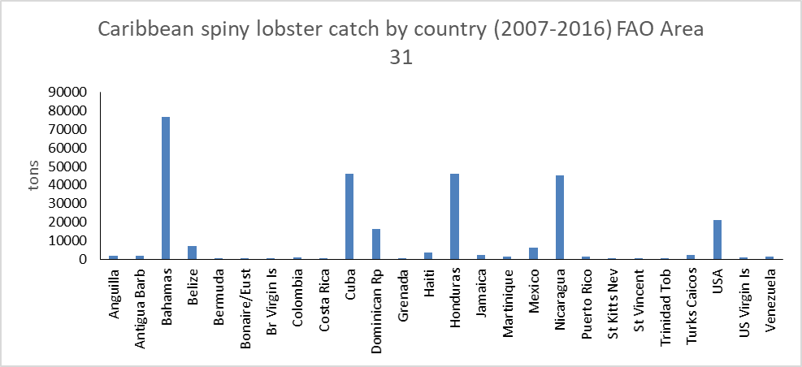

Fig. 6: Caribbean spiny lobster capture production (tons) by countries in the Caribbean FAO fishing area 31 (2007-2016)

Figure 7 shows the historical capture production trend for the 2007-2016 period of the main fishing countries in FAO area 31. As in Figure 5, the general trend is positive with The Bahamas, Honduras and Nicaragua increasing their capture production in the last years of the reported period. In 2017, the volume of the lobster extraction from all the Caribbean area was more than 40,000 metric tons with a value of $1 billion dollars of the United States of America.
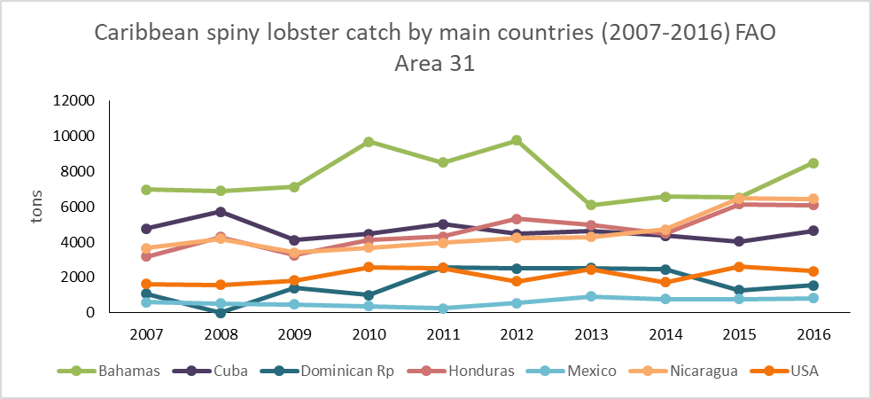

Fig. 7: Caribbean spiny lobster capture production (tons) by main fishing countries in the 2007-2016 period. Caribbean FAO fishing area 31.

In 2017, Caribbean spiny lobster artisanal fisheries involved about 15,000 vessels which are made of fiberglass or wood between 20 to 38 feet (6 to 11.5 m) in length with the majority using outboard motors of 25, 40, 60 and 75 HP (country reports, CRFM 2017 unpublished). Fishing gears and methods include traps, shades, scuba diving, hookah and free diving. The number of fishers involved is estimated at 60,000.

At the industrial level for 2017, an estimated 620 active vessels are reported of which 90% use traps/pots and 10% diving. These vessels are built of steel or fiberglass, their length is between 16 and 24 meters with a load capacity of 25 to 150 tons with diesel engines of 325, 425, 450 and 540 HP. The number of vessels is lower than the ones reported in 2007. Fishers participating in the industrial fishery are estimated at 8,000 with 40% fishing by diving and 60% with traps/pots. The catch level depends on the fishing gear, time of the year and weather conditions but the most productive time is in the first three months of the fishing season.

COMMON ELEMENTS MATRIX

Table 1 summarizes the most important aspects of fisheries and management in countries with Caribbean spiny lobster fisheries.

Table 1. Common elements matrix
 |  | COUNTRIES
 |  | Belize | Costa Rica | Guatemala | Honduras | Nicaragua | Panamá | Dominican Republic
Type of fishery | Artisanal | x | x | x | x | x | x | x
Type of fishery | Industrial |  |  |  | x | x
Harvest capacity in tail weight | Artisanal and Industrial fleet | <855 TM | <300 TM | <50 TM | >1500TM | >1500TM | <300 TM | <800 TM
Fishing gear | Traps/pots | x |  |  | x | x |  | x
Fishing gear | Casitas/ shades | x |  |  |  |  | x | x
Fishing gear | Trammel nets |  | x | x
Fishing gear | SCUBA |  |  |  | x | x |  | x
Fishing gear | Free diving | x | x | x | x | x | x | x
Fishing gear | Hooka diving |  |  | x | x | x |  | x
Processing | Tails | x | x | x | x | x | x | x
Processing | Whole frozen whole |  | x | x | x | x | x | x
Processing | Whole precooked | x |  |  | x | x
Processing | Live |  |  |  |  | x | x
Market | Domestic | x | x | x | x | x | x | x
Market | USA | x | x | x | x | x | x | x
Market | European Union |  |  |  |  | x
Export measure unit | Ounces | x | x | x | x | x | x | x
Export measure unit | Pounds | x | x | x | x | x | x | x
Fisheries  administration  agency |  | Department of the Ministry of Agriculture and the Environment | Costa Rican Institute of Fisheries and Aquaculture (INCOPESCA) | Fisheries and Aquaculture Regulation Directorate (DIPESCA) of the Ministry of Agriculture and Livestock Agricultura y Ganadería | Fisheries and Aquaculture General Directorate (DIGEPESCA)  of the Ministry of Agriculture and Livestock | Nicaraguan Institute of Fisheries and Aquaculture (INPESCA) | Aquatic Resources National Authority of Panamá (ARAP) of the Ministry of Agriculture and Livestock | Fisheries and Aquaculture Dominican Council (CODOPESCA) of the Ministry of Agriculture and Livestock
Fisheries legislation | Fishery act | x | x | x | x | x | x | x
Fisheries legislation | Regional regulation OSP 02-09 | x | x | x | x | x | x | x
Industrial vessel monitoring system |  | x | x | x | x | x | x | x
Stock assessment studies |  | x |  |  |  | x
Management Plan
Catch quotas |  |  |  |  |  | x
Systematic statistical monitoring of fishing activity |  | x |  |  |  | x
Monitoring, control and surveillance |  | x | x | x | x | x | x | x

 |  | COUNTRIES
 |  | Anguilla | Antigua & Barbuda | The Bahamas | Mexico | Dominica | Grenada | Guyana
Type of fishery | Artisanal | x | x | x | x | x | x | No fishing
Type of fishery | Industrial |  |  |  |  |  |  | No fishing
Harvest capacity in tail weight | Artisanal fleet | <135 TM | <165 TM | <5,800 TM | <350 TM | <15 TM | <30
Fishing gear | Traps/ pots | x | x | x | x | x | x
Fishing gear | Casitas/ shades | x |  | x | x
Fishing gear | Trammel nets |  |  |  | x
Fishing gear | SCUBA |  |  |  | x
Fishing gear | Free diving | x | x | x | x | x | x
Fishing gear | Hooka diving |  |  |  | x
Processing | Tails | x | x | x | x | x | x
Processing | Whole frozen |  |  | x | x
Processing | Whole precooked |  |  |  | x
Processing | Live |  |  |  | x
Market | Domestic | x | x | x | x | x | x
Market | USA | x | x | x | x | x
Market | European union |  |  | x | x |  | x
Export measure unit | Ounces | x | x | x | x | x | x
Export measure unit | Pounds | x | x | x | x | x | x
Fishery  administration  agency |  | Fishery department | Fisheries Division of the Ministry of agriculture, fisheries, lands and relations | Marines resources department of the Ministry of agriculture and marine resources | Environment and Natural Resources Secretary | Fisheries Division of the Ministry of agriculture, fisheries and forestry | Fisheries Division of the Ministry of agriculture, fisheries and forestry
Fishery legislation | Fishery act | x | x | x | x | x | x
Fishery legislation | St. George’s Declaration or another | x | x | x |  | x | x
Industrial vessel monitoring system
Stock assessment studies |  | x | x | x | x
Management plan |  |  |  | x | x
Catch quota
Systematic statistical monitoring of fishing activity |  | x |  |  | x
Monitoring control and surveillance |  | x | x | x | x | x | x

 |  | COUNTRIES
 |  | Haiti | Jamaica | Monserrat | St. Kitts y Nevis | St. Lucia | St. Vincent & The Grenadines | Suriname
Type of fishery | Artisanal | x | x | No fishing | x | x | x | No fishing
Type of fishery | Industrial |  | x | No fishing |  |  |  | No fishing
Harvest capacity in tail weight | Artisanal and industrial fleet | <250 TM | <350 TM |  | <30 TM | <20 TM | <57 TM
Fishing gear | Traps/ pots | x | x |  | x | x | x
Fishing gear | Casitas/ shades | x | x
Fishing gear | Trammel nets |  | x |  |  | x
Fishing gear | SCUBA |  | x
Fishing gear | Free diving | x | x |  | x |  | x
Fishing gear | Hooka diving
Processing | Tails | x | x |  | x |  | x
Processing | Whole frozen |  | x |  |  | x
Processing | Whole precooked | x | x
Processing | Live |  | x |  | x | x
Market | Domestic | x | x |  | x | x | x
Market | USA | x | x |  |  |  | x
Market | European union
Export measure unit | Ounces | x | x |  | x | x | x
Export measure unit | Pounds | x | x |  | x | x | x
Fishery administration agency |  | Fisheries Department of the Ministry of Agriculture, Natural Resources and Rural Development | Fisheries Department of the Ministry of Industry, Trade, Agriculture and Fisheries |  | Fisheries Division of the Ministry of Agriculture, Cooperatives, Fisheries and Land and Housing | Fisheries Department of the Ministry of Agriculture, Fisheries, Natural Resources | Fisheries Division of the Ministry of Agriculture, Fisheries, Forestry, Rural Transformation and Industry and Labor
Fishery legislation | Fishery act | x | x |  | x | x | x
Fishery legislation | St. George’s Declaration or another | x | x |  | x | x | x
Industrial vessel monitoring system |  |  | x
Stock assessment studies
Management plan |  |  |  |  |  | x
Catch quotas
Systematic statistical monitoring of fishing activity
Monitoring, control and surveillance |  | x | x |  | x | x | x

 |  | COUNTRIES
 |  | Trinidad & Tobago | Turks & Caicos | Brazil | Colombia | Venezuela | USA | CUBA
Type of fishery | Artisanal | x | x | x | x | x | x | x
Type of fishery | Industrial | x |  | x | x
Harvest capacity in tail weight | Artisanal and Industrial fleet | <20 TM | <260 TM | <4,500 TM | <150 TM | <100 TM | <1,850 TM | <1,470 MT
Fishing gear | Traps/ pots | x | x | x | x | x | x | x
Fishing gear | Casitas/ shades | x |  | x |  |  | x | x
Fishing gear | Trammel nets |  |  | x
Fishing gear | SCUBA |  |  | x |  |  | x
Fishing gear | Free diving | x | x | x | x | x | x | x
Fishing gear | Hooka diving |  |  |  |  |  | x
Processing | Tails | x | x | x | x | x | x | x
Processing | Whole frozen |  |  | x | x |  | x | x
Processing | Whole precooked | x |  |  |  |  |  | x
Processing | Live |  |  |  |  |  | x
Market | Domestic | x | x | x | x | x | x | x
Market | USA | x |  | x | x |  | x
Market | European union |  |  | x | x |  | x | x
Export measure unit | Ounces | x | x | x | x | x | x
Export measure unit | Pounds | x | x | x | x | x | x
Fishery  administration agency |  | Fisheries Division of the Ministry of Agriculture, Land and Fisheries | Environmental and Coastal Resources department | Agriculture and Fisheries Secretariat of the Ministry of the Environment | Fisheries and Aquaculture National Authority (AUNAP); Ministry of Agriculture and Land Development; Secretary of Agriculture and Fisheries of San Andres Islands. | Instituto Socialista de Pesca y Acuicultura (INSOPESCA) | National Oceanic and Atmospheric Administration (NOAA) Florida Fish and Wildlife Conservation Commission (FWCC), Caribbean Fishery Management Council (CFMC) | Ministry of the Food Industry
Fisheries legislation | Fishery act | x | x | x | x | x | x | x
Fisheries legislation | St. George’s Declaration or another | x | x
Industrial vessel monitoring system Langostera |  | x |  | x | x |  | x | x
Stock assessment studies |  | x | x | x | x |  | x | x
Management plan |  |  |  | x | x |  | x | x
Catch quotas |  | x |  |  | x |  | x | x
Systematic statistical monitoring of fishing activity |  |  |  |  |  |  | x | x
Monitoring control and surveillance |  | x | x | x | x |  | x | x

ASSUMPTIONS

This MARPLESCA Plan aims to be consistent with reality, harmonic in the region, accessible to stakeholders and especially viable in its execution. The following assumptions are considered:

- Region´s POLITICAL WILL (and of every government in particular), facilitating and adapting a regional structure in coordination with national authorities.

- INTEGRATED PARTICIPATION of all stakeholders in management, mainly by fishery leaders who preserve the principle of sustainable use of the resource with consciousness and responsibility.

- A cross-cutting strategic ALLIANCES scheme is considered important to implement all necessary management measures in a harmonized way in SICA-OSPESCA, CARICOM-CRFM and WECAFC Countries.

- Coordinated and oriented COOPERATION driven towards a common regional goal of fishery sustainability.

OBJECTIVES

The MARPLESCA Plan has as general objective the establishment of a systematic process for the Caribbean spiny lobster fishery (Panulirus argus) range countries for fisheries management in a sustainable use framework, promoting ecological balance and social and economic stakeholder benefits in the value chain.

It will specifically address:

  - Strengthening effective application of OSPESCA Regulation OSP-02-09 and CARICOM St. George’s Declaration as well as WECAFC recommendations.

  - Manage with regional scope in a coordinated and participatory way the Caribbean spiny lobster fishery under the SICA/OSPESCA, CARICOM/CRFM and WECAFC governance model.

  - Promote adequate organization for institutionalized key stakeholders’ participation in the management of the fishery.

  - Provide conditions for the adoption an implementation of the Plan in the Caribbean spiny lobster (Panulirus argus) geographical distribution range in the framework of the CLME+ Strategic Action program (SAP).

IMPLEMENTATION STRATEGIES AND GOALS

Firstly, the MARPLESCA Plan adopts the full extent of Regulation OSP-02-09 and of St. George’s Declaration in a process of continuous improvement.

The Ecosystem Approach will be applied in the implementation of the Plan in such a way that planned and implemented actions embrace an interdisciplinary approach, promoting better environmental, social and economic well-being.

The Plan will promote synergies in resources, infrastructure, equipment and materials and all assets available in the region. These synergies can form the basis of an integration scheme that can result in sustainable management and generate economies of scale. Also, an operational organization scheme will be established that is accessible to national and regional institutions, including universities. In the same way, active participation of industrial and artisanal fishers’ associations allowing representation of different partnership arrangements is considered.

Public-private partnerships with regional focus will be promoted in order to generate value-added alternatives to the various components of the MARPLESCA Plan.

Information and experience exchange at the intergovernmental and private sector levels will be one of the arrangements of the regional approach.

To achieve long-term sustainable use and users’ participation at regional level, a regional fisheries database will be prioritized based on the countries commonalities, in particular fishing methods, to harmonize monitoring and management. Interaction with the FAO Resource and Fisheries Monitoring System (FIRMS) will be essential for this purpose.

In this framework the following goals are proposed:

- Strengthen and improve control mechanisms to combat illegal, unreported and unregulated fishing and ensure compliance with domestic regulations and provisions of Regulation OSP-02-09 and St. George’s. Declaration

- Determine fishing effort considering the number of fishers, fishing capacity and fishing gears to promote sustainability of the resource.

- Promote the generation, organization and availability of biological, fishery and socio-economic information to allow appropriate decision making in the management of the resource.

- Promote the sustainable use and management of coastal and marine ecosystems related to the resource to maintain the supply of ecosystem goods and services.

- Fishing access rights will be promoted so that fishers and stakeholders are encouraged to protect the resource ensuring its sustainability.

REGIONAL ACTIONS OF THE MARPLESCA PLAN

7.1 Implementation of Regulation OSP-02-09, St. George’s Declaration and WECAFC Recommendations

The Regulation, Declaration and Recommendations will continue to be implemented capitalizing Ecolangosta+ subproject contributions. In particular, those related to monitoring, closed seasons, and fishing gear and methods. For this, the Regional Caribbean Spiny Lobster OSPESCA/CRFM/ WECAFC Working Group should include in its work plan the evaluation and monitoring of compliance of the OSPESCA Regulation, St. Georges´s Declaration, WECAFC recommendations and the management plan itself. In a similar manner, in the OSPESCA framework, the Fisheries Legislation Working Group will monitor legal issues to ensure compliance and adoption by CLME+ participating countries.

7.2 Access Regime Harmonization

Along with competent authorities, harmonization of current access arrangements to Caribbean spiny lobster fishery will be procured. Studies to determine catch quotas (total allowable catch) by countries and by regions, if possible, will be conducted. Fisheries can be closed when quotas have been exhausted. Different administrative arrangements to manage access will be harmonized, such as authorizations and procedures, licenses, fees, penalties and offenses, amongst others.

7.3 Best Practices for Lobster Fishing

The region aims to consolidate reputable Caribbean spiny lobster management and sustainable use based on best practices. This work will require an inter-institutional approach to capitalize inter and extra-regional experiences of organizations specializing in the topic. This will also be accompanied by training activities based on the Trainer of Trainers model so that the region has skilled human resources.

7.4 Harmonized Landing Controls

Catch/ landings are a common denominator of the Panulirus argus regional lobster fishery in all countries with industrial or artisanal fishing. Nevertheless, data are recorded in different ways making regional approaches difficult. To harmonize data collection, the "Production by Vessel / Fisher” form is recommended, which can be found in Annex 1 (Form 1).

7.5 Common Protocols for Fishing Fleets

The Plan considers vessels engaged in lobster fishing for any of the categories and types of fishing methods. Fleets, most of all the industrial, must have all security requirements at sea so that crew has a decent working environment. Possible recommendations on the harmonized type and conditions vessels must have will be made. The proposal will consider validation or changes of fishing gears and methods ensuring elimination of harmful fishing gear and methods to fishers and ecosystem health.

For control and monitoring of the industrial regional lobster fishing fleet, the vessel monitoring system will be promoted as in the OSP 03-10 Regulation for the Creation and Gradual Implementation of a Regional Satellite Monitoring System for fishing vessels of Central American Countries. Daily monitoring for artisanal vessels can be made with the Fleet control form (Annex 1 Form 2).

The participation of local authorities will be promoted, when collecting information, by establishing agreements with the fisheries administrations of the countries to delegate tasks, and structure a digitized municipal registry of artisanal vessels. Recommend the use of departure permits and landing controls according to the Fishing Fleet Registry (Annex 1 Form 3).

For harmonized catch and effort analysis to standard units, the use of the international metric system and conversion factors, when required, will be proposed. Catch per unit of effort should be expressed in catch/ fishing days based on the industrial vessel fishing logbook according to the “Lobster Trap Fishing Logbook” form (Annex 1 Form 3) and “Lobster Dive Fishing Logbook” form (Annex 1 Form 4) and from daily report on the artisanal fleet logbook (Annex 1 Form 1 mentioned before).

7.6 Common processing protocol

Usually, lobster tails are processed and selected in commercial weight categories in ounces which is the measure unit used in global markets. The Plan considers harmonized data collection at processing plants. Another recent lobster presentation is precooked whole lobster. For data collection of any presentation the “Registry of Processed Lobster in Processing Plants” form is suggested (Annex 1 Form 5).

7.7 Traceability of the lobster production chain

Illegal, unreported and unregulated (IUU) fishing is considered a risk to the sustainability of many fisheries and their ecosystems producing economic loss to countries. For this reason, it is important to know whether a product sold in the market was legally caught. Several target market countries now require traceability as compulsory for seafood trade as it is considered essential to ensure food security. Target market countries urge all agencies and government offices associated to the supply chain of seafood products to improve transparency and traceability through the implementation of policies, regulations and standards that ensure marketed products have been legally caught and they are properly labelled for further monitoring, quality and safety.

As part of the technical cooperation between the International Regional Organization for Agricultural Health (OIRSA) and OSPESCA, actions have been developed aimed at the elaboration and implementation of a Regional Traceability Standard for seafood products. This is supported by Ecolangosta+ subproject as part of the CLME+ Project, in which Caribbean spiny lobster has been considered a priority. In a first draft, contents of the traceability standard were identified, and harmonized data collection forms agreed on. The forms include the minimum common information among countries and can be adapted to local conditions but keeping common elements. When the final traceability standard is ready, it is expected to be adopted and implemented to reinforce Caribbean spiny lobster sustainability and well-being of people who depend on this transboundary resource.

7.8 Common biological sampling methodology (on board and in processing plants)

Basic data collected directly at sea, landings sites and processing facilities will continue to be recorded to periodically analyze and evaluate the resource state through benchmark indicators. The compiled data and information will be used to expand knowledge on the impact of fishing on the stock.

Biological sampling at processing plants is aimed at obtaining data on weights and sizes. Proposed forms for recording information are as follow: “Biological lobster sampling onboard vessels” (Annex 1 Form 6), “Biological lobster sampling in processing plants” (Annex 1 Form 7), and “Biological whole lobster sampling in Processing Plants” (Annex 1 Form 8). Also, samplings will be made in processing plants to know frequency distributions by commercial categories using the form “Lobster Tails Biological Data Sampling in Processing Plants” (Annex 1 Form 9), and/or “Whole Lobster Biological Data Sampling in Processing Plants” (Annex 1 Form 10).

Monthly and annual spiny lobster length and weight data samples will be used as input for fisheries stock assessment models.

The proposed sampling methodology of Caribbean spiny lobster is described in the FAO Sampling Methods Manual for the assessment of the Spiny Lobster stocks (Cruz, 2002).

Optional sampling on board commercial fishing vessels for catch data collection, logbooks and size sampling is recommended to get independent biological and fishery data.

7.9 Commercialization

The MARPLESCA Plan considers providing information on access to markets and responsible trade actions so that only products harvested following established national and regional standards can be sold. Joint efforts for control and monitoring to eradicate intraregional commercialization of illegal products will be promoted. In this regard, work will be conducted on the security strategy framework of the Central American Integration System and the Caribbean Community of the regional monitoring, control and surveillance network for fisheries and aquaculture.

A regional scheme will be established, and regional and extra-regional experiences capitalized to progressively allow products certification and access to more specialized markets.

Along with regional unions, access to market intelligence information will be promoted. This can be achieved not only for Caribbean spiny lobster but also for other species of high commercial value.

To be acquainted with target markets and assess their importance for the region, weight and trade value of Caribbean spiny lobster exports per country of destination in a regional harmonized way will be monitored. The “Exports” form is recommended (Annex 1 Form 11).

7.10 Consumption

Caribbean spiny lobster is a product for foreign markets but is not readily accessible to the domestic consumers because of its high prices. Therefore, studies will be made and alternatives on economies of scale will be proposed to allow Central American and Caribbean consumers to have more access to spiny lobster consumption.

Awareness rising campaigns for regional domestic consumers will be promoted to have selective choices of lobster sizes appropriate for consumption. This action would be accompanied by an outreach and communication strategy to strengthen seafood consumption culture in general.

7.11 Monitoring, control and surveillance

This Plan should be considered for incorporation into Illegal, unreported and undeclared fishing regional plans and the monitoring, control and surveillance plans that are being promoted in the Central American and Caribbean fishing industries framework. If possible, coordination synergies among competent authorities to implement regional specific legislation in this matter should be procured. Vessel monitoring systems data sharing will be promoted among national fisheries authorities, the navy and maritime authorities where applicable and required.

7.12 Fisheries diversification

Caribbean spiny lobster is considered, in many countries, fully exploited facing illegal, unreported and undeclared fishing, habitat degradation of coastal and marine habitats, and pollution. As a result, planned diversification of Caribbean spiny lobster fishing effort should be considered as an alternative to management. Fishing effort is a factor that can be controlled to reach sustainable harvest limits. Industrial or artisanal surplus fishing capacities could be targeted to other resources or activities of interest. Such a policy would also avoid the risks of overinvestment in the Caribbean spiny lobster fishery.

In this regard, some economic alternatives have been proposed in some Caribbean countries and may be relevant where appropriate and applicable:

- Grouper/snapper fishery with hand line, vertical and bottom longline.
- Finfish fisheries in coastal communities.
- Finfish fishery with pots.
- Construction of drying facilities for Sea Bob (Xiphopenaeus kroyeri) in fishing communities.
- Tilapia farming in ponds.
- Tilapia and inland endemic species hatcheries and fingerling production.
- Mangrove oyster culture.
- Mariculture.
- Queen conch (Lobatus gigas) and Cassis madagascariensis fisheries.
- Sea cucumber fishery.
- Jellyfish (Stomolophus meleagris) harvest and processing.
- Construction of fiberglass vessels.
- Recreational fishing, sightseeing and tourist guiding.
- Bait fishing for sport fishing.
- Underwater habitats observation.
- Agricultural crops.
- Lionfish fishery.

REGIONAL RESEARCH AND RECOMMENDATIONS

The Plan considers research as a major priority so that scientific data and information is available for regional decision making. The Regional WECAFC/ OSPESCA/ CRFM/ CFMC Caribbean Spiny Lobster Working Group would have, amongst its functions, the harmonization of issues and topics to be included. In this framework, information update on Caribbean spiny lobster life cycle in its distribution range is considered by conducting a study on the reproductive behavior to update the dates of breeding season and size of sexual maturity of this species.

Also, a monitoring program to better understand marine environment and reef health status to implement precautionary measures to ensure a healthy spiny lobster habitat and control invasive exotic species present in the Caribbean spiny lobster distribution range will be established. This study could be conducted together with the State of the Marine Environment and its associated Economies Report (SOMEE Report) which is being developed by the CLME+ project.

In the research planning program lobster fisheries interaction with other fisheries and the impact of invasive species on lobster fisheries will be considered.

In this section, a regional model for production and management of statistics will be promoted and made accessible. Data collected using some of the forms provided in the MARPLESCA Plan could be used for the basic stock assessment using the harmonized length-based cohort model. Countries with catch and effort data could use more advanced models for stock assessments.

Along with regional public and private stakeholders the organization and implementation of an onboard observer program (all year round) will be evaluated.

It is also recommended to follow up on the recommendations generated by the Regional WECAFC/ CFRM/OSPESCA/ CFMC Caribbean Spiny Lobster Working Group. The working group meets periodically to assess the resource status and generates recommendations for its sustainable use. This working group can provide technical assistance in the implementation of the MARPLESCA plan.

The stock assessment model (i.e. calibrated length-based cohort analysis) in Annex 2 is recommended as part of a first stage to be adopted and applied in order to obtain regionally harmonized results to measure the state of the stocks and recommend potential regional management decisions. As data and technical capacity improves more sophisticated length-based methods could be used. Also, a set of indicators based on length and/or catch per unit of effort (cpue) could be used as complementary information.

ECONOMIC AND SOCIAL ASPECTS

The MARPLESCA Plan considers the incorporation at regional level of components that address economic and social issues and, along with other fisheries, may establish data collection, management and interpretation of socioeconomic information related to economic, social and environmental, employment indicators, among others.

In coordination with the SICA General and Caribbean Community Secretariats, fishery-related gender and child care programs can be promoted. Spiny lobster fishing communities in the region should promote responsible fisheries to ensure a decent standard of living. Periodically and contextually, the participation of ethnic groups involved, and social characterization of these communities related to the fishery will be descriptively analyzed.

At least every five years, countries of the region should conduct a census on lobster fisheries including fishing effort and socioeconomic aspects. The outputs will serve for improving the Regional Management Plan.

The MARPLESCA regional management plan recommends the implementation of an annual dissemination program for all stakeholders involved in the management of the Caribbean spiny lobster fishery.

Annex 3 shows the required forms to harmonize social and economic data collection.

CLIMATE CHANGE

Climate change is a change in the statistical distribution of weather patterns when that change lasts for an extended period (i.e., decades to millions of years). Climate change may refer to a change in average weather conditions, or in the time variation of weather around longer-term average conditions (i.e., more or fewer extreme weather events).

Impacts on fisheries are due to direct and indirect effects by physical and chemical factors, which include temperature, winds, vertical mixing, salinity, oxygen and pH amongst others. The direct effects act on the physiology, development rates, reproduction, behavior and survival of organisms which can, in some cases, be studied experimentally and in controlled conditions. Indirect effects act via ecosystem processes and changes in the production of food or abundance of competitors, predators and pathogens.

Ocean Acidification

When water (H₂O) and CO₂ mix, they combine to form carbonic acid (H₂CO₃) which works the same way as all acids: it releases hydrogen ions (H⁺) which bond with other molecules in the area. The building of skeletons in marine creatures is sensitive to acidity as one of the molecules that hydrogen ions bond with is carbonate (CO₃⁻²), a key component of calcium carbonate (CaCO₃) shells. To make calcium carbonate, shell-building marine animals such as corals and crustaceans combine a calcium ion (Ca⁺²) with carbonate (CO₃⁻²) from surrounding seawater, releasing carbon dioxide and water in the process. Acidification has a direct effect on the exoskeleton of the Caribbean Spiny lobster especially during the moulting process delaying larval development and growth to market size. Predation risk may increase as well, causing fewer individuals to grow into adults and lowering the overall abundance of adult lobsters. Changes in lobster abundance can in turn upset ecosystem balance by changing the abundance of organisms that depend on lobster as prey and organisms that lobsters prey on.

Warmer Ocean Temperatures

Scientists use satellites to track the daily temperature of the planet both over land and across the seas. These data are then averaged over different time scales to determine how hot, globally speaking, a given month, year, or decade is. Each of the past 15 years (2001–2015) have been among the hottest 16 years on record (since 1880); 2014 and 2015 shattered temperature records (Figure 8).
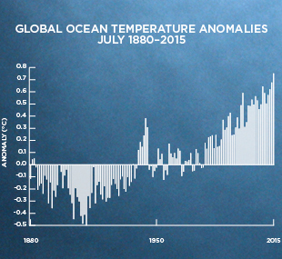
Fig. 8. Historical ocean warming trend (source: ncdc.noaa.gov)

In the oceans, surface temperatures have increased at an average rate of 0.12°C per decade since 1976—triple the rate of warming that occurred in the 75 years before that (0.04°C per decade). And the warming is hastening: global ocean temperatures in 2016 have been 0.82°C (1.48°F) above average and 0.21°C (0.38°F) hotter than 2015, making them the hottest waters since record-keeping began 137 years ago (NCDC.NOAA.GOV).

Fishers have anecdotal information that during prolonged periods of warm sea temperatures the lobster stocks seek deeper waters with lower temperatures. During this period production is very low.

Fluvial impacts

During rainy season, influx of fresh water into the marine environment lowers the salinity, especially in coastal areas, causing lobster stocks to move to deeper water.

Hurricanes

Spiny lobster catch landings has always declined for months after an area has been directly impacted by hurricane. Direct impact causes environmental damage to the habitats that support this species.

Disease

Climate change is promoting the spread of infectious agents in oceans as lot of marine bacteria, viruses, and fungi grow better at warmer temperatures. Warming water temperatures can expand these agents’ ranges and introduce diseases to areas where they were previously unknown. Also, many diseases of marine species are secondary opportunist infections that take advantage when a host organism is stressed by other conditions, such as changes in pH, salinity or temperature.

PaV1 Virus

The Panuliris argus_1 virus (PaV1) in Caribbean Spiny lobster was discovered around 2000 and is now present from the Florida Keys, USA to Venezuela. The virus can infect up to 60 percent of lobsters in some areas. Laboratory studies show that lobsters held in high-temperature seawater and exposed to PaV1 develop active and more intense infections much more quickly than those held at lower temperatures. If PaV1 continues to spread, it could have significant effects on the health of Caribbean reefs, as well as on the valuable Caribbean lobster fishery.

Lobster fishers are recommended to report changes in fishing, ecosystems and climate to the OSPESCA, CRFM and WECAFC Secretariats to develop adaptation efforts to increase production and ensure food security despite climate change and variability.

TECHNICAL ASSISTANCE AND TRAINING

The Plan considers technical assistance activities with regional staff except for very specialized topics, if not available in the region, extra-regional experienced personnel will be used. The idea is to stay technologically up-to-date with new techniques that are efficient and environmentally friendly. Training and capacity building will be areas that will be permanently considered in various topics of the MARPLESCA Plan.

A training and reachout program in fishing methods and gears friendly to the environment and human health will be promoted. Also, an awareness program for the direct and indirect users of the SICA/OSPESCA Countries will be promoted so that they are aware and understand the need to participate in a joint Caribbean spiny lobster management process. Training for trainers’ modules and fishers’ professionalization initiatives will also be considered.

REGIONAL ORGANIZATION

Experiences already generated and human resources available will be capitalized. At present, the Interim Coordination Mechanism for Sustainable Fisheries, integrated by WECAFC, CRFM and OSPESCA, must be considered the most viable mechanism to coordinate the MARPLESCA plan implementation, and must be strengthened to become a permanent mechanism. The Regional WECAFC/ CRFM/ OSPESCA/ CFMC Caribbean Spiny Lobster Working Group can play a monitoring technical support role. A regional advisory committee will be formed, if necessary, with stakeholders where key actors are represented. Participation of native communities’ leaders should be ensured.

At the national level, national focal points should be appointed and involved in monitoring national activities and act as liaisons with the corresponding entities implementing the plan. It should be recalled that under SAP implementation and the CLME+ project national intersectoral committees were established and national focal points nominated. These actions will strengthen implementation of the plan in the countries.

12.1 Synergies

Major stakeholders in the region are represented in four main components:

- Regional and national institutions such as government or intergovernmental responsible structures guiding and facilitating fisheries management.

- The fishing industry is the main component covering from harvest to trade. It involves industrial and artisanal fishers, collectors, processors, middlemen and other direct/ indirect employees. Some of them are part of national unions which in turn are part of regional organizations. Their participation in resource management is crucial due to the wide range of participants, coverage and market linkages.

- Unions, associations, non-governmental organizations, donors and civil society who represent and support fishers are present in all countries of the region with varying degrees of participation and are represented regionally by Federations and Foundations. Their participation is no less important than that of the industry. All these stakeholders are key to get the sector´s participation and socioeconomic equity which is part of the harmony that is intended.

NGOs and donors will be invited to coordinate their resources and activities with the MARPLESCA plan to harmonize their work plans.

- Universities with regional coverage should consider establishing agreements or arrangements of mutual collaboration with universities related to marine resources and fisheries management areas. Also, establish collaboration with SICA/OSPESCA, CARICOM/CRFM and WECAFC. Within these agreements joint activities should be established to strengthen Caribbean spiny lobster fishery research and monitoring, and engaging students in fisheries administration offices to ensure generational replacement and capacity building in the short, medium and long term.

12.2 Provisional timeline and budget

National fisheries administrations of the region will be invited to institutionalize the MARPLESCA Plan into national planning to achieve harmonized regional action.

The 10-year Strategic Action Program (SAP 2015-2025) for the sustainable management of shared Living Marine Resources in the Caribbean and North Brazil Shelf Large Marine Ecosystems (CLME+ region) which is implemented through the 5-year CLME+ Project (UNDP/GEF; 2015-2020) can be the framework for implementation of the Caribbean Spiny Lobster Fishery Regional Management Plan, in particular if we can consider to start its full implementation in 2020 for an initial period of 5 years. The region can continue working with the CLME+ Project which is expected to enter its third phase in 2020.

The MARPLESCA plan will seek to start financing with resources provided by SICA, CARICOM or WECAFC member countries WECAFC on some specific issues that can be coordinated and executed by the national fisheries administrations and the interim coordination mechanism for sustainable fishing conformed by FAO, CRFM and OSPESCA. Alliances and partnerships with other regional and international cooperation bodies and donors will also be sought to generate a project to implement the plan.

The time schedule and budget presented in Table 2, for the execution of a 10-year plan considers resources in the order of USD 11,240,000 with an annual average of USD 1,124,000, which will allow undertaking the process of change for the regional management of the Caribbean spiny lobster fishery in the Greater Caribbean.

Table 2 Provisional budget and timeline
Action | When | Who | Recommendation for implementation | (US dollars x 1000) | Year |  |  |  |  |  |  |  |  |  | Total
 |  |  |  |  | 1 | 2 | 3 | 4 | 5 | 6 | 7 | 8 | 9 | 10
Adoption of the plan | First year | Interim Coordination Mechanism | Follow internal procedures by OSPESCA, CRFM and WECAFC
Start implementation | First year | National fisheries administrations | Activities incorporation into national plans of action
Plan revision | Every five years | Interim Coordination Mechanism | Coordination for revision through the WECAFC/ OSPESCA/ CRFM/ CFMC working group in a regional meeting | 70 |  |  |  |  | 70 |  |  |  |  | 70 | 140
OSP 02 09 Regulation and St. George´s Declaration implementation | Annual | CRFM and OSPESCA | Activities incorporation into national plans of action | 200 | 200 | 200 | 200 | 200 | 200 | 200 | 200 | 200 | 200 | 200 | 2,000
Access regime harmonization | Annual | Interim Coordination Mechanism | Coordination through the WECAFC/ OSPESCA/ CRFM/ CFMC working group and national intersectorial committees | 200 | 200 | 200 | 200 | 200 | 200 | 200 | 200 | 200 | 200 | 200 | 2,000
Best practices
Harmonized landing controls
Fishing fleets common protocols
Traceability of the spiny lobster production chain | Annual | Interim Coordination Mechanism and animal health authorities | Coordination through the WECAFC/ OSPESCA/ CRFM/ CFMC working group and national intersectorial committees | 100 | 100 | 100 | 100 | 100 | 100 | 100 | 100 | 100 | 100 | 100 | 1,000
Caribbean spiny lobster sampling | Annual | National fisheries administrations | Coordination through national intersectorial committees | 100 | 100 | 100 | 100 | 100 | 100 | 100 | 100 | 100 | 100 | 100 | 1,000
Monitoring , control and surveillance | Annual | National fisheries administrations | Coordination through national intersectorial committees | 200 | 200 | 200 | 200 | 200 | 200 | 200 | 200 | 200 | 200 | 200 | 2,000
Stock assessments | Annual | National fisheries administrations | Coordination through national intersectorial committees | 100 | 100 | 100 | 100 | 100 | 100 | 100 | 100 | 100 | 100 | 100 | 1,000
Spiny lobster fishery census | Every five years | National fisheries administrations | Interim Coordination Mechanism and national fisheries administrations | 250 | 250 |  |  |  | 250 |  |  |  |  | 250 | 750
Training and reachout program | Annual | Interim Coordination Mechanism and national fisheries administrations | Coordination through the WECAFC/ OSPESCA/ CRFM/ CFMC working group | 100 | 100 | 100 | 100 | 100 | 100 | 100 | 100 | 100 | 100 | 100 | 1,000
WECAFC/ OSPESCA/ CRFM/ CFMC working group meetings | Biennial | Interim Coordination Mechanism and national fisheries administrations | WECAFC/ OSPESCA/ CRFM/ CFMC working group biennial meeting | 70 |  | 70 |  | 70 |  | 70 |  | 70 |  | 70 | 350
TOTAL |  |  |  | 1,320 | 1,250 | 1,070 | 1,000 | 1,070 | 1,320 | 1,070 | 1,000 | 1,070 | 1,000 | 1,390 | 11,240

ANNEXES

ANNEX 1

Fishery biology forms

FORM 1: PRODUCTION BY VESSEL/ FISHER

This form will be used to collect Caribbean spiny lobster production or landings from industrial and / or artisanal fishing vessels. It will allow estimating fishing effort in travel days, the fishing gear utilized, and lobster landed weights in different presentations, as well as by- catch species weight. This format can be filled by a collection center staff, a processing plant staff or data collectors.

- Country: The name of the country
- Sheet No .: The sheet consecutive number
- Fleet: the name of the fleet is written down and industrial or artisanal is selected
- Company: the name of the company where the product is delivered
- Municipality, locality: the geographical name of the place where landings are registered
- Day, month and year: the registration date
- Name of the vessel: the name of the vessel is marked down
- Fishing trip, departure: the date on which you went fishing is recorded; Return: the date is recorded when you returned from fishing
- Fishing gear: the name of the fishing gear
- Lobster landed weight: the weight of lobster landed is recorded in kilos; tail: lobster tail; head meat: head meat landed; whole: whole lobster landed
- By-catch and other species landings: the weight in kg of by-catch or other species (e.g. grouper, queen conch, crab) that have been landed and are associated with Caribbean spiny lobster
- Mother ship name: the name of the mother or supply ship
- Observations: Any comments worth to record

COUNTRY |  |  |  |  |  | SHEET No._
FORM 1: PRODUCTION BY VESSEL/ FISHER
FLEET: | INDUSTRIAL | ARTISANAL_
COMPANY:
MUNICIPALITY, LOCALITY:
DAY/MONTH/YEAR: / / |  |  |  | LOBSTER |  |  |  | BY‐CATCH AND OTHER SPECIES: LANDED WEIGHT
 | FISHING TRIP |  | FISHING GEAR | MEASUREMENT UNIT (KILOGRAM) |  |  |  | MEASUREMENT UNIT (KILOGRAM)
VESSEL NAME | DEPARTURE | RETURN | FISHING GEAR | LANDED WEIGHT | TAIL | HEAD MEAT | WHOLE | GROUPER | QUEEN CONCH | CRAB
MOTHER SHIP NAME (IF APPLICABLE):
OBSERVATIONS:

FORM 2 FLEET OPERATIONAL PERFORMANCE CONTROL

Format aimed at knowing the operational performance of the industrial fleet more in detail, usually filled by processing companies with their own fleet of fishing vessels.

- Country: The name of the country
- Sheet No.: The consecutive number of the sheet
- Company/ collection center: The name of the company or collecting center where the product is delivered, and the fishing fleet operates
- Industrial fleet: the name of the fishing fleet
- Month and year: the registration date
- Name of the vessel: the name of the vessel(s) operating
- Numbered columns: Go from 1 to 31 indicating the days of the month and each cell is marked down according to the codes S: DEPARTURE TO FISHING AREA; P: FISHING; F: SHIP IS AT ANCHOR IN PORT OR FISHING BANK; E: ENTRANCE TO PORT; D = CATCH DOWNLOADING; T: TOTAL FISHING TRIP DAYS
- Prepared by: The name of the person who filled the form
- Observations: Any comments worth to record
- Signature: Signature of the person who filled out the form

COUNTRY: _______________________ |  |  |  |  |  |  |  |  |  |  |  |  |  |  |  |  |  |  |  |  |  |  |  |  |  |  |  |  |  |  | SHEET No._______
FORM 2 FLEET OPERATIONAL PERFORMANCE CONTROL
COMPANY/ COLLECTION CENTER: _____________________________________ |  |  |  |  |  |  |  |  |  |  |  |  |  | INDUSTRIAL FLEET: ______________________ |  |  |  |  |  |  |  |  |  |  |  |  |  | MONTH AND YEAR:___________
VESSEL NAME | 1 | 2 | 3 | 4 | 5 | 6 | 7 | 8 | 9 | 10 | 11 |  | 12 |  | 13 | 14 | 15 | 16 | 17 | 18 | 19 | 20 | 21 | 22 | 23 | 24 | 25 |  | 26 | 27 |  | 28 | 29 | 30 | 31 | T
PREPARED BY: |  |  |  |  |  |  |  |  |  |  |  | OBSERVATIONS:
SIGNATURE:

S: DEPARTURE TO FISHING AREA; P: FISHING; F: SHIP AT ANCHOR IN PORT OR FISHING BANK; E: ENTRANCE TO PORT; D= CATCH DOWNLOADING; T: TOTAL FISHING TRIP DAYS

FORM 3: SPINY LOBSTER TRAP/POT FLEET LOGBOOK

This is a form to be filled out by fishing masters or fisher in charge, both for lobster trap industrial or artisanal fishing fleets. It allows to get fishing effort and lobster catch data from this type of fleets.

- Country: The name of the country
- Sheet No.: The consecutive number of the sheet
- Name of the vessel: the name of the vessel that is reporting the data
- Industrial or Artisanal: type of fleet is marked down.
- Captain/ fisher name: the name of the person in charge onboard the boat
- Product: marked down whether it is delivered in a processing plant or in a collection center.
- Name of the company / collection center / others: The name of the company, collection center or another place where the fish product is delivered.
- Date: day, month and year the fishing operation was made.
- Start time: The time at which traps were deployed at sea.
- End time: The time when traps were hauled onboard.
- Position / fishing area: The geographical position is recorded in degrees, minutes and seconds (industrial fishing) or by geographical name (artisanal fishing).
- Depth (fathoms / meters or feet): Depth at fishing station in fathoms, meters or feet.
- Bottom type: Bottom type found in the fishing station (e.g., sand, gravel, seagrass).
- No. of hauled pots: The number of pots hauled onboard in each fishing operation.
- Catch (kilos of lobster tail or whole lobster): Catch in kilos of lobster tails or whole lobster if landed alive.
- Observation of the day: Any event occurred on the fishing day worth mentioning.
- Totals: Catch and number of pots utilized are added up.
- General observations: Any event or issue during the fishing trip worth mentioning.
- Signature of the captain / fisher: The signature of the captain/ fishing master or the fisher in charge on board

COUNTRY:_____________ |  |  |  |  |  |  | SHEET NO.:___________
FORM 3: SPINY LOBSTER TRAP/POT FLEET LOGBOOK
VESSEL NAME: ___________________________________
INDUSTRIAL: ______ ARTISANAL: _______ |  |  |  |  | CAPTAIN/ FISHER NAME: _________________
PRODUCT: PROCESSING PLANT: _______ COLLECTION CENTER: _______ |  |  |  |  | COMPANY/ COLLECTION CENTER/ OTHERS NAME: __________
DATE | START TIME | END TIME | POSITION/ FISHING SITE | DEPTH. (FATHOMS) |  | BOTTOM TYPE |  | No. HAULED TRAPS | CATCH (KILOS LOBSTER TAIL OR WHOLE LOBSTER) | OBSERVATION OF THE DAY
TOTALS
GENERAL OBSERVATIONS:

CAPTAIN/ FISHER SIGNATURE:

NB: Filled out by the captain or fisher and delivered to fishery authority

FORM 4: SPINY LOBSTER DIVE‐FISHING FLEET LOGBOOK
Form to be filled out by the captain or fisher in charge, both for industrial or artisanal dive-fishing. It allows to get fishing effort and lobster catch data of this type of fleets.

- Country: The name of the country
- Sheet No.: The consecutive number of the sheet
- Name of the vessel: the name of the vessel that is reporting the data
- Industrial or Artisanal: type of fleet is marked down.
- Captain/ fisher name: the name of the person in charge onboard the boat
- Product: marked down whether it is delivered in a processing plant or in a collection center.
- Name of the company / collection center / others: The name of the company, collection center or another place where the fish product is delivered.
- Date: day, month and year the fishing operation was made.
- Start time: The time at which traps were deployed at sea.
- End time: The time when traps were hauled onboard.
- Position / fishing area: The geographical position is recorded in degrees, minutes and seconds (industrial fishing) or by geographical name (artisanal fishing).
- Depth (fathoms / meters or feet): Depth at fishing station in fathoms, meters or feet.
- Bottom type: Bottom type found in the fishing station (e.g., sand, gravel, seagrass).
- No. of divers: Number of divers in each fishing operation.
- No. of tanks: Number of tanks utilized in each fishing operation
- Catch (kilos of lobster tails): Catch in kilos of lobster tails.
- Observation of the day: Any event occurred on the fishing day worth mentioning.
- Totals: Catch and number of divers and tanks utilized are added up.
- General observations: Any event or issue during the fishing trip worth knowing.
- Captain / fisher signature: The signature of the captain/ fishing master or the fisher responsible on board

COUNTRY: _____________ |  |  |  |  |  |  |  | SHEET No.: ________
FORM 4: SPINY LOBSTER DIVE-FISHING FLEET LOGBOOK
VESSEL NAME: _____________________________
INDUSTRIAL: ___ ARTISANAL: ___ |  |  |  | CAPTAIN NAME: ___________________
PRODUCT: PROCESSING PLANT: ___ COLLECTION CENTER:___ |  |  |  |  | COMPANY/ COLLECTION CENTER NAME: ___________________
DAT | START TIME | END TIME | POSITION/ FISHING SITE | DEPTH (FATHOMS/ METERS/ FEET) | BOTTOM TYPE | No. OF DIVERS | NO. OF TANKS UTILIZED |  | CATCH (KILOS LOBSTER TAILS) | OBSERVATION OF THE DAY
TOTALS
GENERAL OBSERVATIONS:

CAPTAIN SIGNATURE:

NB: Filled out by the captain and delivered to the fishery authority

FORM 5: SPINY LOBSTER PROCESSED IN PROCESSING PLANTS

Form must be filled out by data collectors or processing plant staff. It is the vital data type to be collected for stock assessment purposes since they are the input data for the application of the MARPLESCA, catch-at-age or similar models. Commercial categories can be transformed to lengths or ages through equations or morphometric relationships.

- Country: The name of the country.
- Sheet No.: The consecutive number of the sheet.
- Company name: The name of the company.
- Month / year: Month and year the report was made.
- Period: The time processing was carried out
- Industrial traps, industrial dive-fishing, artisanal: The origin of the processed product is marked down in the corresponding field.
- Lobster tail, whole lobster, precooked whole lobster, live lobster: The processed weight is recorded in kilos or pounds for each commercial category and type of product
- Head meat: weight of head meat
- Total: the total of processed product of all commercial categories is added up by type of product
- Observations: Any event or issue worth mentioning.

COUNTRY: ___________________ |  |  |  |  |  |  | SHEET No.: ___
FORM 5: SPINY LOBSTER PROCESSED IN PROCESSING PLANTS
COMPANY: ________________________ |  |  |  | INDUSTRIAL TRAP:________
MONTH/ YEAR: _______________________ |  |  |  | INDUSTRIAL DIVE-FISHING: _________
TIME PERIOD: |  |  |  | ARTISANAL: __________
COMMERCIAL CATEGORIES
LOBSTER TAIL |  |  |  | WHOLE LOBSTER |  |  | PRECOOKED WHOLE LOBSTER
GRAMS | OUNCES | KILOS | POUNDS | GRAMS | KILOS | POUNDS | GRAMS | KILOS | POUNDS
 |  |  |  | 400- 460 |  |  | 400- 460
142 | 5 |  |  | 400- 500 |  |  | 460- 520
170 | 6 |  |  | 460- 520 |  |  | 520- 575
198 | 7 |  |  | 500- 600 |  |  | 575- 630
227 | 8 |  |  | 520- 575 |  |  | 630- 690
255 | 9 |  |  | 575- 630 |  |  | 690- 785
284 | 10 |  |  | 600- 700 |  |  | 785- 900
284 - 340 | 10-12 |  |  | 630- 690 |  |  | 900- 1200
340-397 | 12-14 |  |  | 690- 785 |  |  | 1200- 1350
397 - 454 | 14-16 |  |  | 700- 770 |  |  | TOTAL
454-567 | 16-20 |  |  | 770- 830 |  |  | LIVE LOBSTER
567-680 | 20-24 |  |  | 785- 900 |  |  | GRAMS | KILOS | POUNDS
680 - UP | 24 UP |  |  | 830- 900
TOTAL |  |  |  | 900- 960
HEAD MEAT |  |  |  | 900- 1200
OBSERVATIONS: |  |  |  | 960- 1030
 |  |  |  | 1030- 1160
 |  |  |  | 1160- 1250
 |  |  |  | 1200-1350
 |  |  |  | TOTAL |  |  | TOTAL

FORM 6 SPINY LOBSTER BIOLOGICAL DATA SAMPLING ON BOARD VESSELS
Form must be filled out by biologists or data collectors who go on board industrial lobster fishing boats. Sampling must be done on deck. It is an important form to collect lobster maturity data, and with consistent sampling throughout a year, the results can provide signals of lobster maturity trends. This is important when establishing spatial and / or temporary closed seasons.

- Country: The name of the country.
- Sheet no .: The consecutive number of the sheet.
- Day: month: year: The date sampling was done.
- Vessel name: Name of the boat sampling was done.
- Company name: The name of the company owner of the vessel (if applicable).
- Fishing gear: The fishing gear used to fish.
- Captain name: The name of the captain of the boat.
- Sampler Name: The name of the person who carried out the sampling
- No. of fishing station: Enter the consecutive number of the haul or fishing station whose catch is being sampled
- Position: latitude: longitude: geographical position in degrees, minutes and seconds of the sampling site
- No .: consecutive number of the individual being sampled
- Size (long, cef.mm.): Length of the lobster cephalothorax in mm
- Sex: Male, female or juvenile
- Reproductive status in females: The reproductive status of the female is marked down according to the codes: ov (ovigerous or with eggs); ce: with spermatheca; cre: with traces of spermatheca; cre + ov: with traces of spermatheca and eggs; mu: in moulting period.
- Observations: Any event or issue worth mentioning.

COUNTRY: |  |  |  |  |  |  |  |  |  | SHEET No.: ___
FORM 6 SPINY LOBSTER BIOLOGICAL DATA SAMPLING ON BOARD VESSELS
DAY: ______ MONTH:_______ YEAR:_______
VESSEL NAME: __________________________________
COMPANY NAME: _______________________________ |  |  |  |  |  |  |  |  | FISHING GEAR: __________________________
CAPTAIN NAME: ___________________________________ |  |  |  |  |  |  |  |  | POSITION
SAMPLER NAME: _____________________________________ |  |  |  |  |  |  |  |  | LATITUD: ______________________________
No. OF FISHING STATION: _______ |  |  |  |  |  |  |  |  | LONGITUD: ____________________________
No. | SIZE (LONG, CEF.MM.) | SEX | FEMALE MATURITY STAGE (MARK DOWN) |  |  |  |  | No. | SIZE (LONG, CEF.MM.) | SEX | FEMALE MATURITY STAGE (MARK DOWN)
No. | SIZE (LONG, CEF.MM.) | SEX | OV | CE | CRE | CRE+OV | MU | No. | SIZE (LONG, CEF.MM.) | SEX | OV | CE | CRE | CRE+OV | MU
ov (ovigerous or with eggs); ce: with spermatheca; cre: with traces of spermatheca; cre + ov: with traces of spermatheca and eggs; mu: in moulting period.
OBSERVATIONS:

FORM 7 SIZE AND WEIGHT VALIDATION SAMPLING PER LOBSTER TAIL COMMERCIAL CATEGORIES

To collect males/females length and weight data per commercial category of lobster processed in tails. These data allow to calibrate the conversion of the commercial categories to theoretical sizes in length with morphometric relationship equations. This conversion is of fundamental importance to prepare input data for the stock assessment model of the MARPLESCA Plan. Sampling must be done when workers manipulate and classify lobster during processing. Sampling size is estimated at 500 animals per month per commercial category. Sampling should be done every 2 years.

- Country: The name of the country.
- Day:, month :, year: Sampling date.
- Location: The location of the processing plant where sampling took place.
- Observations: Any event or issue worth mentioning.
- Processing plant: Name of the processing plant.
- Fishery of origin: Where the product comes from, whether it is industrial/ artisanal trap or dive-fishing (where applicable)
- No .: The consecutive number of the animal sampled
Size biological sampling in tail length (mm) and tail weight (gr)
- Commercial category: The commercial category being sampled (e.g., 5 ounces, 10-12 ounces, etc.) for each sex females and males
- Size (mm): Tail length in millimeters
- Weight (g): Tail weight in grams

COUNTRY: _____________ |  |  |  |  |  | SHEET No.: ________
FORM 7 SIZE AND WEIGHT VALIDATION SAMPLING PER LOBSTER TAIL COMMERCIAL CATEGORIES
DAY: ____ MONTH: __________ YEAR: ___________
LOCATION: |  |  |  |  | OBSERVATIONS:
PROCESSING PLANT:
FISHERY OF ORIGIN:
No. | SIZE BIOLOGICAL SAMPLING IN TAIL LENGTH (mm) AND TAIL WEIGHT (g)
No. | COMMERCIAL CATEGORY |  |  |  | COMMERCIAL CATEGORY
No. | FEMALES ________ ounces |  | MALES _____________ ounces |  | FEMALES _______________ ounces |  | MALES _________________ ounces
No. | SIZE (mm) | WEIGHT (g) | SIZE (mm) | WEIGHT (g) | SIZE (mm) | WEIGHT (g) | SIZE (mm) | WEIGHT (g)
1
2
3
4
5
6
7
8
9
10
11
12
13
14
15
16
17
18
19
20
21
22
23
24
25
26
27
28
29
30

FORM 8 SIZE AND WEIGHT VALIDATION SAMPLING PER WHOLE LOBSTER COMMERCIAL CATEGORIES

To collect males/females length and weight data per commercial category of lobster processed in tails. These data allow to calibrate the conversion of the commercial categories to theoretical sizes in length with morphometric relationship equations. This conversion is of fundamental importance to prepare input data for the stock assessment model of the MARPLESCA Plan. Sampling must be done when workers manipulate and classify lobster during processing. Sampling size is estimated at 500 animals per month per commercial category. Sampling should be done every 2 years.

- Country: The name of the country.
- Day:, month :, year: Sampling date.
- Location: The location of the processing plant where sampling took place.
- Observations: Any event or issue worth mentioning.
- Processing plant: Name of the processing plant.
- Fishery of origin: Where the product comes from, whether it is industrial/ artisanal trap or dive-fishing (where applicable)
- No .: The consecutive number of the animal sampled
Size biological sampling in total length (mm) and total weight (gr)
- Commercial category: The commercial category being sampled (e.g.,400- 600 g) for each sex females and males
- Size (mm): Total length in millimetres
- Weight (g): Total weight in grams

COUNTRY: _____________ |  |  |  |  |  | SHEET No.: ________
FORM 8 SIZE AND WEIGHT VALIDATION SAMPLING PER WHOLE LOBSTER COMMERCIAL CATEGORIES
DAY: ____ MONTH: __________ YEAR: ___________
LOCATION: |  |  |  |  | OBSERVATIONS:
PROCESSING PLANT:
FISHERY OF ORIGIN:
No. | SIZE BIOLOGICAL SAMPLING IN TOTAL LENGTH (mm) AND TOTAL WEIGHT (g)
No. | COMMERCIAL CATEGORY |  |  |  | COMMERCIAL CATEGORY
No. | FEMALES ____________________ g |  | MALES ______________________ g |  | FEMALES _____________ g |  | MALES ___________________ g
No. | SIZE (mm) | WEIGHT (g) | SIZE (mm) | WEIGHT (g) | SIZE (mm) | WEIGHT (g) | SIZE (mm) | WEIGHT (g)
1
2
3
4
5
6
7
8
9
10
11
12
13
14
15
16
17
18
19
20
21
22
23
24
25
26
27
28
29
30

FORM 9 BIOLOGICAL SAMPLING OF LOBSTER TAILS IN PROCESSING PLANTS

Form utilized to collect size data from all lobster tails in a processing plant. The sample is not separated by commercial categories. The best is to carry out regular monthly samplings throughout a year. If good data collection is available, the observed size structure could replace the theoretical size structure obtained by converting industrial commercial categories into length units.

- Country: The name of the country
- Date: Day, month and year sampling was conducted
- Location: The location of the processing plant
- Fishery of origin: Where the product comes from, whether it is industrial/ artisanal trap or dive-fishing (where applicable)
- Processing plant: Name of the processing plant
- Observations: Any event or issue worth mentioning
- No .: The consecutive number of each animal sampled
Tail size biological sampling (mm)
- Sex: male, female or juvenile
- Length tail (mm): The length of the tail measured in mm

FORM 9 BIOLOGICAL SAMPLING OF LOBSTER TAILS IN PROCESSING PLANTS
COUNTRY: ___________________________________ |  |  |  |  | DATETION________________________________
LOCATION: _____________________ |  |  |  |  |  | FISHERY OF ORIGIN: ______________
PROCESSING PLANT: __________________
OBSERVATIONS:

No. | TAIL SIZE BIOLOGICAL SAMPLING (mm)
No. | SEX | TAIL LENGTH (mm) | SEX | TAIL LENGTH (mm) |  | SEX | TAIL LENGTH (mm) | SEX | TAIL LENGTH (mm)
1
2
3
4
5
6
7
8
9
10
11
12
13
14
15
16
17
18
19
20
21
22
23
24
25
26
27
28
29
30

ANNEX 2

METHODOLOGY FOR CARIBBEAN SPINY LOBSTER STOCK ASSESSMENT

Fishery-dependent harmonized Caribbean spiny lobster stock assessment

The Ecolangosta + subproject of the CLME + project promoted the adoption and implementation of a Caribbean spiny lobster stock assessment model based on the Nicaragua experience where a tuned length-based cohort analysis model is applied. This model was discussed and reviewed in a regional workshop where Ecolangosta+ member countries agreed on its use and requested training. Input data is collected through some of the forms described above in Annex 1.

This model seeks to harmonize input data and results to be shared at regional level so that units and methodologies are not different. It is a simple model which does not require fishing effort or catch per unit of effort data which very few countries in the region have the capacity to collect and analyze. Furthermore, it also allows an annual spiny lobster catch quota to be calculated.

Part 1: Proposed Methodology for Regional Monitoring and Evaluation of the Panulirus argus lobster fishery in the SICA/OSPESCA, CARICOM/CRFM and WECAFC Countries

Required data for monitoring and evaluation

- Catch data from industrial and artisanal fishing fleets.

- Industrial monthly data by commercial lobster categories from processing plants.

- Biological sampling data (lengths) on board commercial fishing vessels, scientific field sampling, sampling in processing plants and collection facilities.

- Length-weight calculation of morphometric relationships to convert commercial categories to length units.

Length weight formulas and conversion factors are used to apply the conversion model of commercial categories to lengths proposed by Alfonso et al., (1995), adapted by Perez (1998) and revised by Guevara (2009).

This conversion model (Figure 1) produces frequencies distribution of the total catch in number of individuals per group sizes per month which together with biological samplings are used to calculate growth parameters (M, KL ∞ and t0) with the FAO ICLARM Stock Assessment Tools (FISAT), if needed.

Both length frequency distributions and growth parameters are used as input data for part 2 of the model (Figure 2). Caribbean spiny lobster growth parameters can also be obtained from literature

  - Statistics generated by:
- Fishing fleet (artisanal & industrial)
- Processing plants (commercial categories)

1.2. Biological data sampling onboard commercial industrial and artisanal fishing vessels and processing plants

Input data for conversion model:
Commercial categories

1.3. Calculation of morphometric relationships (conversion formula)
Application of a conversion model of commercial categories to lengths

Output data: Total catch in number of individuals per length categories

Figure 1: Proposed Methodology for Monitoring and Evaluation Part 1

Part 2 - Application of Tuned length-based cohort analysis

Data requirements for cohort analysis deriving from Part 1 outputs:

- Growth parameters (natural mortality M, growth coefficient K, infinite length L∞ and starting age t₀.

- Monthly or annual catch frequency distribution of number of individuals caught by group sizes.

When applying the length-based cohort analysis model the following outputs are obtained: recruitment and spawners in numbers, fishing mortality and biomass in numbers (Population at sea or biomass) (Figure 2).

Growth Parameters
FISAT & LFSA Models
2.2 Input Data: Output from Part 1. Catch frequency distribution in numbers by length categories

Catch curve

F calculation
(Fishing mortality)

F calibration (tuning).
Exploitation Pattern.
F/Z
Terminal

Cohort analysis

Output data: Recruitment and spawners, fishing mortality and abundance (biomass)

Fig.2: Proposed Methodology for Monitoring and Evaluation Part 2

Calculation Methodology Part 3 – Application of a recruitment projection model for calculating an annual Total Allowable Catch (biologically acceptable quota).

The projected recruitment estimate uses as input data the outputs from part 2 and it allows the calculation of catch quotas (biologically acceptable quota) based on three approaches:

- Based on average recruitment.
- Based on density dependent recruitment with rain data
- Based on regression recruitment.

The output being an annual catch quota (total allowable catch (TACQ) or biologically acceptable quota (BACQ)) (Figure 3).

Input data for the recruitment projection model
(From Part 2. Length –based cohort analysis output )

Natural Mortality (M)

Rain data
Recruitment, fishing mortality
and biomass

Average recruitment

Density dependent recruitment

Regression
Recruitment
R & R t-1

BACQ 3
BACQ 2
BACQ 1

Biologically Acceptable Catch Quota (BACQ)

Fig. 3: Proposed Methodology for Monitoring and Evaluation Part 3

ANNEX 3

ECONOMIC AND SOCIAL ASPECTS

ECONOMIC AND SOCIAL ASPECTS

Main indicators for monitoring fishing activity from the socioeconomic point of view are: the economic contribution of fisheries to GDP and exports, employment generation, the size of the industrial and artisanal fleet, and market aspects (type of product, pricing, target markets, as well as the social characterization of fishing communities related to the fishery). As support tools training and extension programs will be required as well as conducting surveys at least every three years.

This information is intended to be collected through the following forms:

Production – Annual production statistics by the fisheries administrations are the basic elements for building the socioeconomic indicators according to the “Production Registry by Vessel” format (Annex 1 Form1) and Processing Plants (Annex 3 Form 11).

Prices - To calculate the GDP it is necessary to have the annual average prices of first sale. To have a monthly systematic monitoring of the activity, the first sale (fisher to fishing company) and export (FOB price) prices will be monitored. Refer to “First Sale Prices” (Annex 3 Form 12) and “Export Prices” (Annex 3 Form 13).

The Gross Domestic Product (GDP) – Indicates the value of the final production from all economic sectors that produce goods and services in a nation. It is measured in prices of a reference year, so GDP is equivalent to total income of the economy. National accounts that measure GDP classify the economy into three sectors: Primary (natural resource), Secondary (production of goods that has processing or industrial transformation) and Tertiary (trade and services). Fishing and aquaculture are part of the primary sector which in most countries is known as "Agriculture, livestock, forestry, hunting and fishing."

The contribution to GDP from the fisheries and aquaculture sector is based on the total value of production of fish and shellfish for human consumption, industrial products (such as fish meal and oil) and seedlings for aquaculture and ornamental fish. Historical data presented in current prices are calculated based on the following arguments: Production value (U.S. $) = Volume (Kilograms or TM) X Average Price (U.S. $ X Kilograms or TM).

Value of the production | = | Volumen | X | Average price
(US$) |  | (kilograms or metric tonnes) |  | (US$)/(Kilograms or metric tonnes)

To estimate fisheries contribution to the national economy the gross domestic product (GDP) and the primary contribution from each sector of each country in the region will be considered. Figures from the annual statistics of the Central Banks of each country will be taken at current prices. For comparative assessment of the lobster fishery contribution the fisheries administrations shall use annual exports of the last ten years at current prices (Annex 3 Form 14).

Employment Generation - Employment will be estimated in terms of the number of workers.

Employment generation on board (crews, industrial and artisanal fishers and divers) - The calculation of the number of people on board the fleet is the largest social impact indicator in fisheries analysis. On the one hand the number of people who derive their livelihood from fishing can be determined and secondly, estimates can be made about salaries using as reference the data provided by revenue units. To calculate employment generation aboard the industrial and artisanal lobster fishing fleet, it is necessary to consider the fishing method and gear used since the crew number varies in each case particularly when it comes to industrial fishing.

Employment generation in processing plants - In this case, the simplest and most accurate method is to ask for employees’ data from processing plants to calculate the number of people who are fully or partially employed as defined in some companies.

Service employment generation - In this case it refers to all those people who work in the industrial, artisanal or process areas as support staff or are linked from the business perspective.

There will be an annual indicator which reflects the number of lobster fishers separated by gender per industrial or artisanal category.

There will be an annual indicator which reflects the number of lobster fishers by gender in the processing plants directly and indirectly linked to the lobster resource.

There will be an annual indicator which will reflect the number of existing jobs by gender in the commerce sector (services).

Fishery Census - As an assessment and adjustment tool to the management plan, at least every five years countries in the region will jointly and harmonically conduct a fishery census which will have as objectives obtaining current social and economic indicators. Amongst these indicators the following will have outstanding social importance: employment generation, gender, ethnicity, housing, health, education and organizational levels. Among economic indicators, production issues will have special relevance regarding harvest, expressed in weight and monetary values, and fishing effort.

Form 11 Processing Plants Capacity

FORM 11 Processing plants installed capacity
Country: | Date:
General Information
Name of the processing plant:
Activity:
Address:
Telephone:
Installed capacity
Raw material storage capacity (in kg):
Freezing capacity in kg every 24 h:
Finished product storage capacity (in kg):
Ice production capacity every 24 h (in MT):
Observations

Form 12 Caribbean spiny lobster price of first sale (Ex-vessel Price)

FORM 12 Caribbean spiny lobster price of first sale (Ex-vessel Price)
Country: |  | Sheet No.:
Name of the company/ collection center/:
Month: |  | Year:
PRODUCT | PRESENTATION | PRiICE (us$/ kg)
Lobster | Tail
Lobster | Whole
Lobster | Live
Observations:

Prepared by:
Signature:

Date:

Form 13 Caribbean spiny lobster average export prices

FORM 13 Caribbean spiny lobster average export price
Country: |  | Sheet No.:
Month: |  | Year:
PRODUCT | PRESENTATION | PRICE (us$/ kg))
Lobster | Tail
Lobster | Whole
Lobster | Live
Observations:

Prepared by:
Signature:

Date:

Form 14 Gross Domestic Product (GDP)

FORM 14 Gross Domestic Product (GDP) by year
Country: |  |  |  |  |  | Date of preparation:
 | YEAR
INDICATORS | 201 | 202 | 202 |  | 202 |  | 202 | 202
A. Gross Domestic Product (GDP)(current US$)
B. Primary sector (GDP) (Current US$)
C. Caribbean spiny lobster annual landings (kg)
D. Average annual ex-vessel unit prices (in US$/kg)
E. Caribbean spiny lobster contribution (US$)
F. Caribbean spiny lobster contribution (% GDP primary sector)
Sources of information:

A: Central Bank
B: Central Bank
C: National fisheries administrations statistics
D: Data from Ex vessel Price form (Form 12)
E: C x D output
F: E x B output

Form 15 Sector employment

Form 15 Sector employment
Processing plants
 |  | Men | Women | Total
Administrative
Processing | Permanents
Processing | Temporal
Quality control
Maintenance
Other
At sea employment
 |  | Men | Women | Total
Industrial fishing
Boat owners
Fishing fleet operations assistance
Lobster boats crew
Shrimp boats crew
Finfish boats crew
Divers
Artisanal fishing
Fishers
Divers

REFERENCES

ALFONSO, A.R., R. SOTOMAYOR, R. CRUZ, R.PUGA Y M.E. DE LEON. 1995. Software para la evaluación de la biología y pesquería de la langosta (Panulirus argus) en Cuba. Rev. Inv. Mar.: 19 (2) (1-3):7781

ANISIMOV, V.P. et al., 1986. Informe de los Resultados de las Investigaciones Cooperativas Nicaragüense-Soviéticas de los Recursos Biológicos en las áreas Marítimas de la República de Nicaragua, realizadas en 1984-85. Ministerio de la Industria Pesquera de la U.R.S.S./AtlanNIRO: 265 p.

BAISRE y CRUZ, 1994. The Cuban spiny lobster fishery. In: B.F. Phillips, J.S. Cobb, J. Kittaka, (eds). Spiny Lobster Management, Chapter 8, Oxford, Fishing New Books.

BARNUTTI, R. 2,000. Aplicación de un modelo de análisis de cohortes a la pesquería de langosta espinosa Panulirus argus del mar Caribe de Nicaragua. Inf. Tec. CIPA.

BARNUTTI, R. 2,001. Evaluación del estado actual de explotación del recurso langosta del mar Caribe de Nicaragua y cálculo de la cuota biológicamente aceptable para el período biológico junio 2001 – Mayo 2002. CIPA.

CARRASCO, R. 2009. Informe del consultor en evaluación y ordenación de recursos pesqueros. Informe final. PROYECTO GCP/RLA/150/SWE - FIINPESCA Fortalecimiento de la Investigación Pesquera Interdisciplinaria para la Pesca Responsable en los Países del Istmo Centroamericano. Organización de las Naciones Unidas para la Agricultura y la Alimentación

CRUZ, R., y M.E. DE LEÓN. 1991. Dinámica reproductiva de la langosta (Panulirus argus) en el archipiélago cubano. Revista Investigaciones Marinas 12(13):234-245.

CRUZ, R., 2002., Manual de Métodos de Muestreo para la Evaluación de las Poblaciones de Langosta espinosa, FAO Documento Técnico de Pesca N° 399.

FAO. 2018. FAO yearbook. Fishery and Aquaculture Statistics 2016/FAO annuaire. Statistiques des pêches et de l'aquaculture 2016/FAO anuario. Estadísticas de pesca y acuicultura 2016. Rome/Roma. 104pp.

LYONS, W. G., D. G. BARBER, S. M. FOSTER, F. S. KENNEDY, JR. and G. R. MILANO. 1981. The spiny lobster, Panulirus argus, in the middle and upper Florida Keys: population structure, seasonal dynamics, and reproduction. Fla. Mar. Res. Publ. No. 38. 38 pp

MARTINEZ, S.2007. Informe temático sobre los recursos marinos vivos transfronterizos de la Sub-Región Centro/Sur América. CLME-TT/5 Prov. Barbados, February 2007. 56 p.

MARX, J.M. and W. HERRKIND, 1986. Spiny lobster. Species profiles: life histories and environmental requirements of coastal fishes and invertebrates (South Florida). Biological Report 82 (11-61)., U.S. Departm. of the Interior/U.S. Army Corps. of Engineers: 21 p.

PÉREZ, M. 1998. Adaptación de un modelo de conversión de tallas industriales a largos biológicos para los datos de las pesquerías de langosta y camarón de Nicaragua, CIPA, Octubre 1,998.

RUSS, G.R. and ALCALA, A.C. 2010. Enhanced biodiversity beyond marine reserve boundaries: the cup spilleth-over. Ecological Applications 21:241–250.

SEIJO, J.C. 2007. Considerations for management of metapopulations in small-scale fisheries of the Mesoamerican barrier reef ecosystem. Fisheries Research. 87: 86-91.

UNEP-WCMC and IUCN (2018). Protected Planet: The World Database on Protected Areas (WDPA)(on-line). September 2018, Cambridge, UK: UNEP-WCMC. Available at www.protectedplanet.net.

VALVERDE, M. 1999. Las metapoblaciones en la naturaleza, ¿realidad o fantasía?. Universidad Nacional Autónoma de México. Revista Ciencias 53 enero-marzo 1999: 56-63.

WECAFC. 2001. Report of the Workshop on Management of the Caribbean Spiny Lobster (Panulirus argus) Fisheries in the Western Central Atlantic Fishery Commission.

ACRONYMS

CARICOM Caribbean Community.
CFMC Caribbean Fishery Management Council.
CLME Caribbean Large Marine Ecosystem.
CLME+ Caribbean and North Brazil Shelf Large Marine Ecosystem.
CRFM Caribbean Regional Fisheries Mechanism.
ECOLANGOSTA+ Ecosystem Approach for Caribbean Spiny Lobster Fisheries” sub-project
FAO Food and Agriculture Organization of the United Nations
FIINPESCA Strengthening Interdisciplinary Research in Shrimp and Lobster Fisheries of Central America
FIRMS Fisheries and Resources Monitoring System
FISAT Fisheries Stock Assessment Tools
GDP Gross Domestic Product
GEF Global Environment Facility
IUCN International Union for the Conservation of Nature
MAREA USAID Regional Program for Aquatic Resources Management and Economic Alternatives
MASPLESCA Sub Regional Management of Caribbean Spiny Lobster (Panulirus argus) subproject.
MARPLESCA Caribbean spiny Lobster Fishery Regional Management Plan
MPA Marine Protected Area.
NCDC National Climate Data Center
NOAA National Oceanic and Atmospheric Administration
OIRSA Agricultural Health International Regional Organization.
OSPESCA Central America Fisheries and Aquaculture Organization.
UNDP United Nations Development Program.
UNEP United Nations Environment Program.
SAP Strategic Action Program.
SICA Central American Integration System.
SOMEE State of the Marine Ecosystems and Associated Economies
UNOPS Oficina de Naciones Unidas para Proyectos.
USAID United States Agency for International Development
WCMC World Conservation Monitoring Centre
WECAFC Western Central Atlantic Fishery Commission.

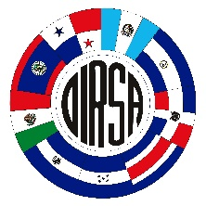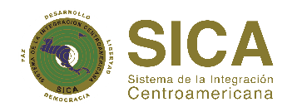

Convenio OSPESCA/OIRSA | Secretaria General del Sistema de la Integración Centroamericana (SG-SICA)  Direccion Regional Especializada de OSPESCA,  adscrita a la SG-SICA
Tel. (503) 2209-9200  Fax: (503) 2263-1128 | Tel. (503) 2248-8840/41  (503) 2248-8800 | Info.ospesca@sica.int
Calle Ramón Belloso, final pasaje Isolde, Colonia Escalón, San Salvador, El Salvador, C.A. | Final Boulevard Cancilleria, Distrito el Espino Nº154, Ciudad Merliot, La Libertad, El Salvador, Centroamérica.  Te. (503) 2248-8841  www.sica.int/ospesca

the different populations of a species are not isolated in nature, but maintain a certain contact through the migration of individuals. These groups or groups of populations of the same species, interconnected by the migration of individuals between them, are known as metapopulations (Valverde, 1999).
Information estimated from FAO annual statistics and information provided by countries. Most Caribbean spiny lobster fishing countries do not have reliable and consistent sources of data, particularly on landings and fishing effort of the artisanal fishing fleet.
Information gathered from various national reports and personal communications by fishery officers from the region.

