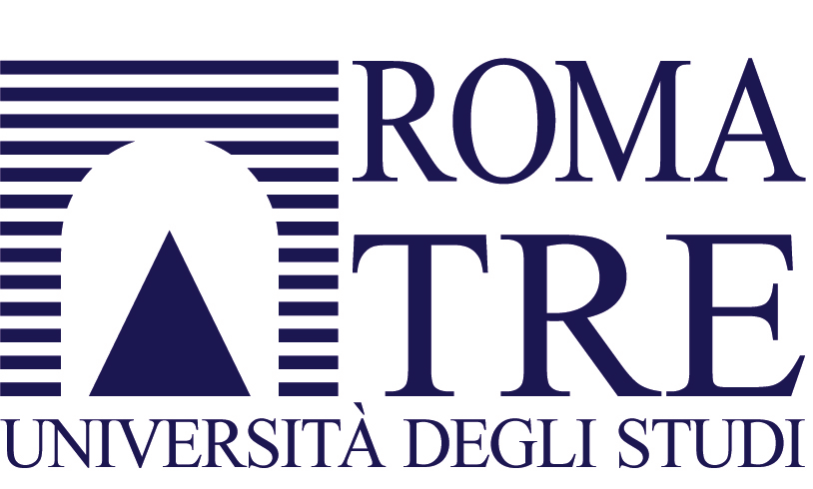
Facoltà di Economia “Federico Caffè”

Course in Human Development Economics
(prof. Pasquale De Muro)

ON MAY 13, 2011, AT 12.30, ROOM 14, 1st FLOOR

Presentation of the book

Education for Rural People:
the role of education, training and capacity development in poverty reduction and food security

by D. Acker and L. Gasperini, FAO, Roma 2009

Introduction by:
Lavinia Gasperini, Senior Officer, Food and Agriculture Organization of the United Nations (FAO), Rome

