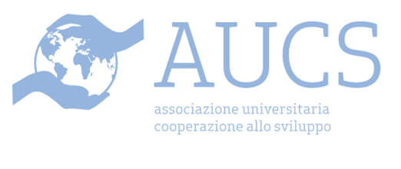
AUCS Florence (University Association for Development Cooperation/Associazione universitaria per la cooperazione allo sviluppo) was founded in 2002 at the University of Florence by a group of undergraduate and postgraduate students in Development Economics. The main purposes of the association include, among others, training, self-training and awareness-raising on the issues of development cooperation. For example, in 2012 AUCS has co-organised several conferences held at the University of Florence, for instance “Human Development and Food Sovereignty” by Dr. Lavinia Gasperini, senior Officer at FAO, and "From feeding the poor to helping the poor to feed themselves", by Olivier de Schutter, the United Nations Special Rapporteur on the Right to Food. Other activities that AUCShas promoted over the years include fund-raising events for
international cooperation projects, improvement of the environmental impact of our University, by actively campaigning for recycling, and several conferences on various issues such as immigration and integration, basic income and degrowth.

Links:
Web site: http://aucsstudentifirenze.blogspot.it/
email: firenzeaucs@gmail.com
facebook: http://www.facebook.com/aucsfirenze

