FAO SPECIFICATIONS

FOR PLANT PROTECTION PRODUCTS

TOLYLFLUANID (AGP:CP/332)



FOOD AND AGRICULTURE ORGANIZATION OF THE UNITED NATIONS

Rome, 1995

CONTENTS

DISCLAIMER 3

INTRODUCTION 4

SUBMISSION OF DRAFT SPECIFICATIONS TO FAO 7

TOLYLFLUANID 8
Technical 10
Wettable powders 11

DISCLAIMER

FAO specifications are developed with the basic objective of ensuring, as far as possible, that pesticides complying with them are satisfactory for the purpose for which they are intended. However, the Group on Pesticide Specifications of the FAO Panel of Experts on Pesticide Specifications, Registration Requirements, Application Standards and Prior Informed Consent wishes to emphasize that, owing to the complexity of the problem involved, questions such as the suitability of pesticides for the control of a particular pest must be decided at national or provincial level. These specifications should not be assumed to be an endorsement of the use of a particular compound for a given purpose by either the Group of Experts or FAO.

Accordingly, neither the Food and Agriculture Organization of the United Nations (FAO) nor the members of the Group on Pesticide Specifications of the FAO Panel of Experts on Pesticide Specifications, Registration Requirements, Application Standards and Prior Informed Consent warrant that pesticides complying with these specifications are suitable for control of any given pest or for use in any particular area.

Furthermore, the preparation and use of pesticides complying with these specifications are not exempt from any safety regulation or other legal or regulatory provision applicable thereto. Neither FAO nor any member of the FAO Group of Experts shall be liable for any injury, loss, damage or prejudice of any kind that may be suffered as a result of the preparation or use of pesticide complying with these specifications.

Additionally, the Group of Experts wishes to warn users of specifications that improper field mixing and/or application of pesticides can result in either a lowering or complete loss of their efficacy. This holds true even in cases where such pesticides comply with the specifications indicated.

Accordingly, the Group of Experts and/or FAO can accept no responsibility for the consequences of improper field mixing and/or application.

INTRODUCTION

From time to time, FAO publishes booklets of specifications for technical materials and related formulations of plant protection products. Revisions of, and additions to, already published specifications will be issued when necessary, but revisions may be printed in the FAO Plant Protection Bulletin during the interval between editions.

The specifications contained herein have been carefully reviewed and agreed by the Group on Pesticide Specifications of the FAO Panel of Experts on Pesticide Specifications, Registration Requirements, Application Standards and Prior Informed Consent after consultations with official government scientists, the pesticides industry through GIFAP (Groupement International des Associations Nationales de Fabricants de Produits Agrochimiques or, in English, International Group of National Associations of Manufacturers of Agrochemical Products) and, where appropriate, with individual manufacturers.¹

FAO has published a Manual on the development and use of FAO and WHO Specifications for Plant Protection Products, FAO Plant Production and Protection Paper No. 173, Rome 2002 (Revised First Edition available only on the FAO home page of the Internet at: http://www.fao.org/ag/agp/agpp/pesticid/)

This manual contains detailed definitions and other essential background information on basic procedures and technical principles adopted by the group on Pesticide Specifications of the FAO Panel of Experts on Pesticide Specifications, Registration Requirements, Application Standards and Prior Informed Consent, such as:

1. Categories of Specifications

FAO Tentative Specifications (Code ‘S/T’, formerly ‘ts’) are those which have been recommended by FAO as preliminary specifications and which are based on minimum requirements. The methods of analysis cited are normally supplied by the manufacturer or may already have been published or be the subject of collaborative work.

FAO Provisional Specifications (Code ‘S/P’, formerly ‘S’) are those for which more evidence of the necessary parameters is available and where some collaborative study of the methods of analysis has been carried out.

FAO (full) Specifications (Code ‘S/F’, formerly ‘S’).
Specifications that have all necessary requirements together with CIPAC (full) methods, or other collaboratively studied (proven) methods.2, 3

Wherever possible, standards for apparatus and common names for pesticides are those approved by the International Organization for Standardization (ISO).

2. Expression of active ingredient content

- for solids, liquid technical materials, volatile liquids (of maximum boiling point 50 °C) and viscous liquids (with minimum kinematic viscosity of 1 x 103 m2/s at 20 °C) the FAO Specification shall be based on expression of the content as g/kg;

- for all other liquids the active ingredient content of the product shall be declared in terms of g/kg or g/l at 20 °C. If the customer requires both g/kg and g/l at 20 °C, then in case of dispute the analytical results shall be calculated as g/kg.

3. Tolerance on content

A declared content of active ingredient must be included in all specifications, and one of the problems immediately arising is the level of tolerance acceptable about the nominal figure. The tolerance is influenced by (a) the reproducibility of the method of analysis, (b) the sampling error and (c) the manufacturing variance.

Allowable variations in analytical results (i.e. tolerances in content of active ingredient) with respect to specific pesticide consignments are intended to cover reasonable variations in the contents of active ingredients.

4. Containers/packaging

FAO guidelines are in preparation.

Containers shall comply with pertinent national and international transport and safety regulations.

Technical materials, dustable powders and granules

Containers shall be suitable, clean, dry and as specified, and shall not adversely affect, or be affected by, the contents, but shall adequately protect them against external conditions.

Wettable powders

The product shall be packed in suitable, clean, dry containers as specified in the order. The container shall provide all necessary protection against compaction, atmospheric moisture, loss by vaporization and/or contamination to ensure that the product suffers no deterioration under normal transit and storage conditions.

The product shall be protected by an adequate moisture barrier. This may be a suitable bag of polyethylene or alternative means of giving equal or better protection.

Solutions and emulsifiable concentrates

Containers shall be lined, where necessary, with a suitable material, or the interior surfaces shall be treated to prevent corrosion and/or deterioration of the contents.

Additional information should be given in all specifications where particular pesticides present problems in packaging.

5. Biological information

Phytotoxicity

No test can be specified to cover the possible phytotoxicity of a formulation to all crops. When a crop is not mentioned in the instructions for use, purchasers should check with the supplier that the material is suitable, always provided that such a use is not restricted or legally forbidden.

Wetting of crops

The dilute spray should satisfactorily wet the leaves of the specified crops when used in accordance with the instructions. Test method MT 53.2, CIPAC F, p.162, may be useful.

¹ Should national pesticide specifications developed from these approved FAO specifications deviate from them, the National Authority responsible for making such changes is requested to inform the FAO Plant Protection Service of the nature of, and the reasons for, the modifications.

² Methods of analysis and miscellaneous techniques referred to in these specifications have been developed and adopted by CIPAC (Collaborative International Pesticides Analytical Council Ltd.). See CIPAC Handbooks 1 (1970), 1A (1980), 1B (1983), 1C (1985), D (1988), E(1993), CIPAC Proceedings 1980 and 1981, obtainable from Black Bear Press Limited, King's Hedges Road, Cambridge CB4 2PQ, England. The page numbers of specific methods are given in parentheses in the specifications. Copies of methods not yet published can be obtained from the FAO Plant Protection Service.

³ Information on standard waters for laboratory evaluation of pesticidal formulations will be found in CIPAC Monograph 1, Standard Waters and an FAO Survey on Naturally Occurring Waters (1972), Black Bear Press Limited, King's Hedges Road, Cambridge CB4, England.

SUBMISSION OF DRAFT SPECIFICATIONS TO FAO

Any organization, commercial firm or interested individual is encouraged to submit relevant specifications, or proposals for revision of existing specifications, for pesticide products for consideration and possible adoption by FAO. Correspondence should be addressed to the Pesticides Control Officer, Plant Production and Protection Division, FAO, Viale delle Terme di Caracalla, 00100 Rome, Italy.

General guidelines on preparing draft specifications are given in the Manual on the development and use of FAO and WHO Specifications for Plant Protection Products, FAO Plant Production and Protection Paper No. 173, Rome 2002 (Revised First Edition available only on the FAO home page of the Internet at: http://www.fao.org/ag/agp/agpp/pesticid/)

Specifications which are considered suitable for further processing are assigned priorities and circulated to appropriate organizations and specialists to comment. Comments, together with other relevant information, are then reviewed in detail by the Group on Specifications of the FAO Panel of Experts on Pesticide Specifications, Registration Requirements, Application Standards and Prior Informed Consent. The drafts are converted into FAO Provisional Specifications, or full FAO Specifications.

AGP:CP/332

TOLYLFLUANID

N-dichlorofluoromethylthio-N′,N′-dimethyl-N-p-tolylsulphamide

INFORMATION

COMMON NAME: tolylfluanid (ISO)

STRUCTURAL FORMULA:
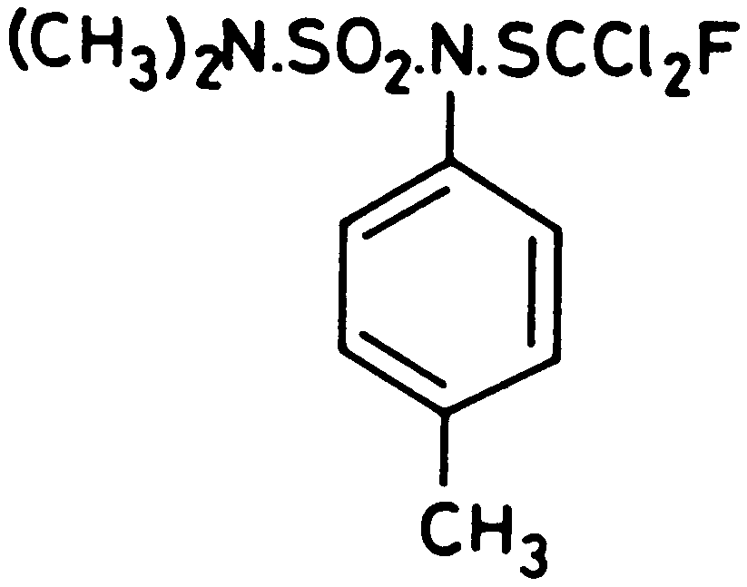

EMPIRICAL FORMULA: C₁₀H₁₃Cl₂FN₂O₂S₂

RMM: 347.2

CAS REGISTRY NUMBER: 731-27-1

CIPAC CODE NUMBER: 275

CHEMICAL NAMES:

N-dichlorofluoromethylthio-N′,N′-dimethyl-N-p-tolylsulphamide (IUPAC)

1,1-dichloro-N-[(dimethylamino)sulfonyl]-1-fluoro-N-(4-
methylphenyl)methanesulfenamide (CA)
TOLYLFLUANID TECHNICAL

FAO Provisional Specification 275/TC/S/P (1991)

1. DESCRIPTION

The material shall consist of tolylfluanid together with related manufacturing impurities and shall be in the form of colourless to whitish crystals free from visible extraneous matter and added modifying agents.

2. ACTIVE INGREDIENT

2.1 Identity tests*

An identity test is required if the identity of the active ingredient is in doubt.

2.2 Tolylfluanid (275/TK(M)/3, CIPAC E, p.223)

The tolylfluanid content shall be declared (not less than 960 g/kg) and, when determined, the content obtained shall not differ from that declared by more than ± 20 g/kg.

3. IMPURITIES

3.1 Material insoluble in acetone (MT 27, CIPAC F, p.88)

Maximum: 25 g/kg.

4. PHYSICAL PROPERTIES

pH range (MT 75, CIPAC F, p.205)

pH range: 9.0 to 11.0
TOLYLFLUANID WETTABLE POWDERS

FAO Provisional Specification 275/WP/S/P (1991)

1. DESCRIPTION

The material shall consist of a homogeneous mixture of technical tolylfluanid, complying with the requirements of FAO specification 275/TC/S/P (1991), together with filler(s) and any other necessary formulants. It shall be in the form of a fine powder, free from visible extraneous matter and hard lumps.

2. ACTIVE INGREDIENT

2.1 Identity tests*

An identity test is required if the identity of the active ingredient is in doubt.

2.2 Tolylfluanid (275/WP/(M)/3, CIPAC E, p.223)

The tolylfluanid content shall be declared (g/kg) and, when determined, the content obtained shall not differ from that declared by more than the following amounts.

Declared content Permitted tolerance

100 up to 250 g/kg ± 6% of the declared content
250 up to 500 g/kg ± 5% of the declared content
Above 500 g/kg ± 25 g/kg

3. IMPURITIES

3.1 Water (MT 30.1, CIPAC F, p.91)

Maximum: 15 g/kg.

4. PHYSICAL PROPERTIES

4.1 pH range (MT 75, CIPAC F, p.205)

pH range: 7.5 to 10.5.

4.2 Wet sieve test (MT 59.3, CIPAC F, p.179)

Maximum: 2% retained on a 75 µm test sieve.
4.3 Suspensibility (MT 15.1, CIPAC F, p.45. Notes 1 and 2)

A minimum of 50% of the tolylfluanid content found under 2.2 shall be in suspension after 30 min in CIPAC Standard Water C at 25 °C (Notes 3 and 4).

Alternatively, if the buyer requires other CIPAC Standard Waters to be used, then this shall be specified when ordering.

4.4 Persistent foam (MT 47, CIPAC F, p.152. Note 5)

Maximum: 10 ml after 1 min.

4.5 Wetting of the product without swirling (MT 53.3.1, CIPAC F, p.165)

The product shall be completely wetted in 2 min without swirling.

5. STORAGE STABILITY

5.1 Stability at 54 °C (MT 46.1.1, CIPAC F, p.149)

After storage at 54 ± 2 °C for 14 days, the determined average active ingredient content must not be lower than 97% relative to the determined average content found before storage (Note 6) and the product shall continue to comply with 4.1, 4.2 and 4.3.

NOTES

1. This test will normally be carried out only after the heat stability test 5.1.

2. Chemical assay is the only fully reliable method of measuring the mass of active ingredient still in suspension. However, simpler methods such as gravimetric and solvent extraction determination may be used on a routine basis provided that these methods have been shown to give equal results to this of the chemical assay method. In case of dispute the chemical method shall be the ‘Referee method’.

3. Unless another temperature is specified.

4. The product should be tested at the highest and lowest rates of use recommended by the supplier, provided this is consistent with the conditions given in the method MT 15.1, CIPAC F, p.45.

5. The mass of sample to be used in the test should correspond to the highest rate of use recommended by the supplier.

6. Samples of the product taken before and after the storage stability test should be analysed together after the test to reduce the analytical error.

* Method available from the Plant Protection Officer, FAO Plant Production and Protection Division.
* Method available from the Plant Protection Officer, FAO Plant Production and Protection Division.

