RAF/AFCAS/09 – 6.2a

E
October 2009


AFRICAN COMMISSION ON AGRICULTURAL STATISTICS

Twenty-first Session

Accra, Ghana, 28 – 31 October 2009

Building, Using and Updating Area Frame
Assessment of Experience of Morocco

Summary

Having established area sampling frames for the Moroccan agriculture in 1980, the Moroccan Division of Statistics staff has been always focusing on more extensive use of remotely sensed data and geographic information systems to further enhance the Moroccan agricultural statistics system. This has become a must since many constraints were encountered with regard to frames updating dealing with old aerial photos, crops dynamics, administrative borders changing and mostly samples renewing difficulties. The Moroccan Division of Statistics has then started a new project entitled ‘AL MAJAL OPERATION’ based on updated satellite high resolution images. This project has proven more efficient not only in building sampling area frames and automatically generating samples but also in providing more accurate results.

Introduction:

In 1983, Morocco's Ministry of Agriculture cooperating with the United States Department of Agriculture's National Agricultural Statistics Service (USDA/NASS) build a fully operational area sampling frame based survey program enabling probability based samples to be drawn to meet the goals of crop area estimation using aerial photos.

Since then many of the trained staff has either retired, quite administration or died; which has negatively influenced the experience capacity build in this field. Furthermore, samples have become older and sample renewing via old procedures seem to be cost ineffective and both effort and time consuming. Also, administration border have witnessed many changes making statistics difficult to refer to region with new borders. A new project called ‘AL MAJAL OPERATION’ based on updated images with high resolution acquired at the Royal Center for Remote Sensing (CRTS) helped tackling most of these issues, manly that of building a basic and dynamic tool for collecting agricultural statistics.
Methodology:
Stratification:

The construction of the area sampling frame consists of the following steps:
- The first step consists of the delineation of stratum blocks on SPOT-5 images 2.5 meter resolution. These are large contiguous areas of homogeneous land use. All of the stratum blocks of the same land use constitute a stratum. The delineated strata boundaries are identifiable in the field. This step is accomplished by enumerators belonging to the provincial services’ staff, thus have good knowledge of the area they operate in. Most of them have gotten more than 20 years experience. Field visits were also assured to validate the stratification work. In this project nine land cover/use strata were adopted namely (stratum 10) non-irrigated cropland, (stratum 20) irrigated cropland, (stratum 30) fruit trees, (stratum 40) forests, (stratum 50) rangeland, (stratum 60) small towns, (stratum 70) large towns), (stratum 80) big villages and (stratum 90) uncultivated areas.

- The next step is to divide the strata blocks into smaller areas, the primary sampling units (PSU's) called ’Natural Zones’. The way this step used to be accomplished, with the aerial photographs, was time and effort consuming.

According to the new method the split into natural zones is accomplished automatically according to a grid framework performed by a computer assisted program (an application). Each square of the grid corresponds a natural zone unite. These PSU's vary in size depending on which stratum they belong to. Out of each stratum a suitable number of PSU's is then randomly chosen with probability of selection proportional to the area of the PSU’s.

The purpose of the PSU's is to serve as an intermediate delineation between the large strata blocks and the individual segments to be surveyed, the Secondary Sampling Unites (SSU’s). The segments (pieces of land) are also generated automatically according to a grid framework by a computer assisted program. As for the zones, the SSU's vary in size depending on which stratum they belong to.

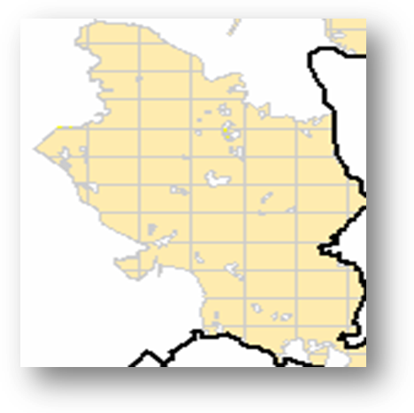
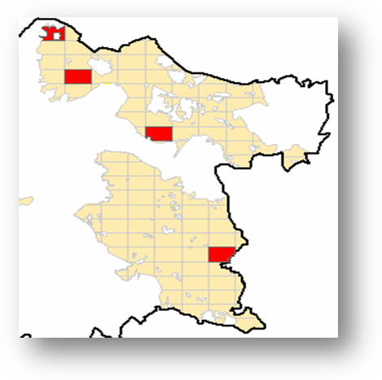

Grid framework applied to study area Natural zones sampled

By delineating PSU's all of the segments in the population need not be delineated. Instead, only the segments in the randomly selected PSU's are delineated by subdividing the PSU into an appropriate number of segments based on the area of the PSU and the target segment size.

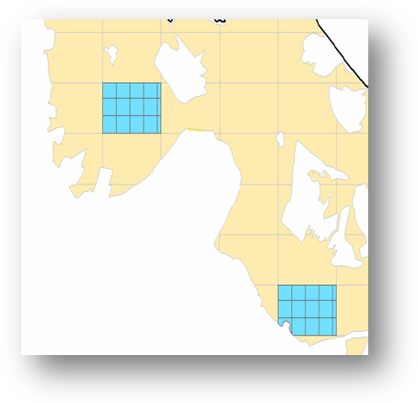
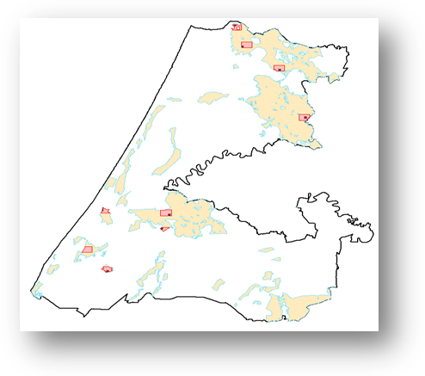

Natural zones segmentation segments sampled In kenitra province

After the selected PSU has been subdivided, one segment is randomly selected in each the PSU for field enumeration. Desired data are then collected from the sample segments both by surveyors’ observation and by interviewing farmers who operate land inside the sampled segments. The data collected from the segments are then expanded to the total area of the stratum. The desired estimate for the entire population is then obtained by summing the results for each stratum.

As the sampled segments shape are to be squares, most of the time they do not usually fulfill the rule of natural boundaries. To do so, another step of segment adjustment is accomplished according the nearest natural boundaries so as to have segments defined according to physical features such as roads, footpaths, rivers, and railways.
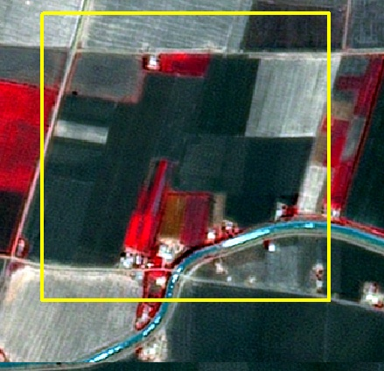
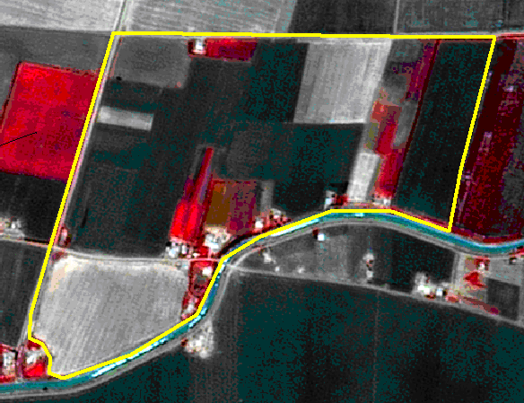

Case study

In order to test this new method a case study has been undertaken in the KENITRA province. Only stratum 20 was considered for This study. The whole area of stratum 20 is 187000 Ha. The drawn sample has 56 segments (k=8, r=7): 8 artificial stratum and 7 repetitions.

Fields survey

The field visits took place in April 2009; just after the soil occupation survey has been completed based on the old sample in the same stratum so as to compare both methods outcomes. Enumerators took satellites images of the sampled segments and reported the collected information based on ground truth (by observation) collected on the images they carried.

Results and discussion
Cereals in Hectares by repetition in each sampled segment

R  1 | Area  Ha | R  2 | Area  Ha | R  3 | Area  Ha | R  4 | Area  Ha | R  5 | Area  Ha | R  6 | Area  Ha | R  7 | Area  Ha
2 (*) | 0,5 | 4 | 11,5 | 5 | 2,4 | 39 | 9,5 | 52 | 19,0 | 26 | 9,8 | 12 | 0,0
35 | 7,9 | 27 | 14,7 | 34 | 3,0 | 38 | 7,5 | 62 | 16,0 | 21 | 13,0 | 48 | 38,0
1 | 16,0 | 30 | 3,0 | 64 | 0,0 | 20 | 18,8 | 32 | 0,0 | 19 | 3,5 | 53 | 26
24 | 0,0 | 74 | 2,0 | 23 | 0,0 | 16 | 0,0 | 78 |  | 36 | 24,5 | 37 | 0,0
54 | 15,0 | 17 | 12,3 | 11 | 15,1 | 6 | 0,0 | 14 | 0,8 | 44 | 0 | 22 | 23,0
42 | 0,0 | 46 | 19,0 | 55 | 36,0 | 57 | 17,8 | 65 | 2,0 | 50 | 13,7 | 76 | 0
51 | 32,5 | 41 | 0,0 | 56 | 34,8 | 58 | 16,0 | 43 | 7,0 | 79 | 2,0 | 3 | 0
29 | 10,3 | 61 | 46,5 | 69 | 11,0 | 68 | 5,6 | 33 | 21,5 | 77 | 9,5 | 45 | 0

R: Repetition,
Area Ha: Area of cereals in the segment,
(*) The numbers refer to code of the segments

Parameter | Repetitions
Parameter | R 1 | R 2 | R 3 | R 4 | R 5 | R 6 | R 7
$\sum{y_{\text{ij}}}$(i=1à 7, j=1 à 8) | 82,17 | 82,17 | 109,00 | 102,30 | 75,20 | 66,30 | 76,00
$${\bar{y}}_{i}$$ | 10,27 | 10,27 | 13,63 | 12,79 | 9,40 | 9,47 | 9,47
$${\bar{y}}_{i}−\bar{\hat{Y}}$$ | -0,49 | -0,49 | 2,87 | 2,03 | -1,36 | -1,29 | -1,29
$$({\bar{y}}_{i}−\bar{\hat{Y}})^{2}$$ | 0,24 | 0,24 | 8,23 | 4,12 | 1,84 | 1,65 | 1,65

$\bar{\hat{Y}}$=10,76 ; N=3775 ; $\hat{Y}$=40609,69
Var ($\hat{Y}$)=$N^{2}∗\frac{\sum{({\bar{y}}_{i}−\bar{\hat{Y}})^{2}}}{r(r−1)}$=6096860

$σ(\hat{Y})$=2469 ; CV ($\hat{Y}$)= 6%

Conclusion

Aerial photography has been used since 1980. Remote sensing digital images from Spot 5 are used now as primary input to land cover stratification. This satellite imagery provides a much better frame for strata boundaries than the aerial photos. Satellite imagery proved to be not only cost effective but also leads to more accurate crop area estimates. Furthermore, it allows us to move from area sampling frames based on paper products, subject to fire and loss, to digital versions, more accurate and better protected from loss.

