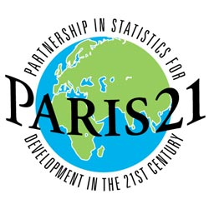
FAO/PARIS21 REGIONAL WORKSHOP ON THE INTEGRATION OF AND ACCESS
TO AGRICULTURAL STATISTICS FOR
BETTER FORMULATION AND MONITORING OF RURAL DEVELOPMENT POLICIES
Algers, Algeria 8-9 December 2007
Back-to-back with the 20th AFCAS

AW-07-02-2-A

The Philippine Experience in Establishing Metadata
and Setting up the CountrySTAT

Romeo S. Recide
Maura S. Lizarondo
Jing B. Jalisan

Résumé en français

Abstract

How does the agricultural statistical system of a country facilitate access to the data requirements by its internal and external clients? There are many ways of addressing this concern but, the establishment of the CountrySTAT system can make access to data easier and quicker for the data producer and all its clients. As the country – specific version of the FAOSTAT2, the CountrySTAT provides a framework for enhancing the quality of data that are produced and disseminated by the country’s statistical system.

This paper describes the processes, outputs, constraints and milestones recorded by the Philippine Statistical System, led by the BAS, in the development of the CountrySTAT. It traces the various stages of this development, from understanding concepts and frameworks, to mobilizing necessary resources, and finally to making CountrySTAT operational and accessible to the public. The paper gives special focus on the capacity building aspect of the CountrySTAT system, especially on the training on the use of the PC-Axis Software Suite which serves as the engine of the system. For better appreciation of the CountrySTAT system, the paper presentation will incorporate a demonstration of the CountrySTAT at work.

1. Background

The CountrySTAT is an Internet-based system that integrates national food and agricultural statistical information to ensure harmonization of national data and metadata collections for analysis and policy making. It provides statistical standards, data exchange tools and related methods without using external data sources such as databases. The data source is a text file in a specific format, called PX-file. The development of the CountrySTAT system started in May 2004 using PX-Web at the FAO headquarters in Rome. In 2005, the system was successfully tested in the statistical offices of Kyrgyz Republic, Kenya, and Ghana.

In recognition of the existence and potential uses of the CountrySTAT, the Philippine Statistical System (PSS) through the Philippine Statistical Association (PSA) has taken on the challenge of establishing the CountrySTAT system in the Philippines. This has been made possible through the Letter Of Agreement between the Food and Agriculture Organization of the United Nations (FAO) and the PSA to implement the project “Strengthening the National Statistical Systems of Selected Countries in the Asia and Pacific Region”. The key components of the project were the establishment of the CountrySTAT Philippines and its introduction to other countries in Asia, the conduct of the sub-regional workshop on CountrySTAT and Metadata and the preparation and publication of the Metadata for the national agricultural statistics in 16 Asia-Pacific countries.

Upon consultation with the key agencies in the PSS, the PSA designated the Bureau of Agricultural Statistics (BAS) as the host institution for the CountrySTAT. Collection and integration of data did not pose problems for the BAS since it handles most of the data requirements of the CountrySTAT. The Statistical Research and Training Center (SRTC) which is the training arm of the PSS has been tasked to organize and conduct all required trainings and workshops under the project.

2. The CountrySTAT System

The CountrySTAT is an applied Internet-based information system that disseminates statistical information and metadata on food and agriculture. It collects, organizes, integrates and harmonizes data and metadata from different statistical agencies in order for statistical tables to be consistent and compatible at the national, as well as, at the international levels. The CountrySTAT system facilitates access of statistical information in a single source which can provide efficient support to analysis and policy making. In understanding the CountrySTAT system, one should look at the developmental framework on which it is based and the technology that supports and is used in its development.

2.1. Statistical Framework

The statistical framework of the CountrySTAT system is based entirely on the framework of FAOSTAT. The CountrySTAT, therefore, is compatible with and easily loads information into FAOSTAT. The CountrySTAT framework identifies Core data sets that are anchored on the FAOSTAT Core accounts namely; food, resource, economic, trade and price accounts. The Core data sets are basically the national level data which are relevant at the national and international level. Through the Core data sets, policy makers and researchers can easily study relationships and processes across thematic areas. Apart from the Core, the system is flexible where it allows countries to organize data collections (or satellite modules) with extended levels of statistical data depending on the requirements of the country, i.e. data may be organized by province, by agency, by sector or by any other groupings/categories. These data collections provide more details (which are of sub-national relevance), and thus, are represented in the CountrySTAT system as Details data sets. Both data sets are coupled (or supported) with metadata (data about the data). These, in turn, enhance the value of data. The CountrySTAT system provides links to other institutions for those data outside the relevant scope of the system.

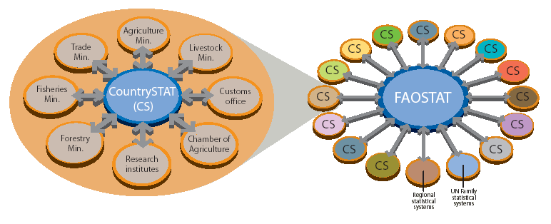
(1) Figure: Networking of FAOSTAT and CountrySTAT

The CountrySTAT systems of countries shall serve as a complementary system to FAOSTAT. Networking CountrySTAT systems with FAOSTAT will improve FAOSTAT’s capacity to provide high quality statistical data at the international level (see figure 1). This also promotes exchanges of data within countries, between countries and between FAO and countries.

2.2. Information Technology Solution

In matching the needs of developing countries, FAO developed CountrySTAT using web-based IT solutions. Thus, there is no need to build costly computer networks to link government offices. The solution or engine that powers the CountrySTAT system is called PC-Axis. PC-Axis is a practical solution because: (1) it requires no expertise in relational database management; (2) it requires only a few days of training to be able to set up efficient storage and design the organization’s data dissemination system; and (3) the PC-Axis software is tested and has been used for many years in Nordic and other countries.

The PC-Axis software product is owned by Statistics Sweden. This can be freely downloaded from the web (http://www.pc-axis.scb.se/pcaxis.htm). However, the software requires a license from Statistics Sweden when it is used for disseminating statistics either in CDs or in the Internet.

The PC-Axis software suite consists of different software designed to handle PX-file in a Microsoft Windows environment. The most popular of these are the following: (1) PC-Axis main module (see figure 2) is metadata-driven software used for dissemination of statistics on CDs or via the Internet; (2) PX-Web is the web version of PC-Axis main module which is written in ASP 3.0 and uses DLLs to handle its functionality; (3) PX-Make can produce PC-Axis files from MS-Excel spreadsheets or MS-Access tables; (4) PX-Edit is a tool for editing, manipulating, and generating PC-Axis file; and, (5) PX-Map is a program making thematic maps from a PC-Axis file.

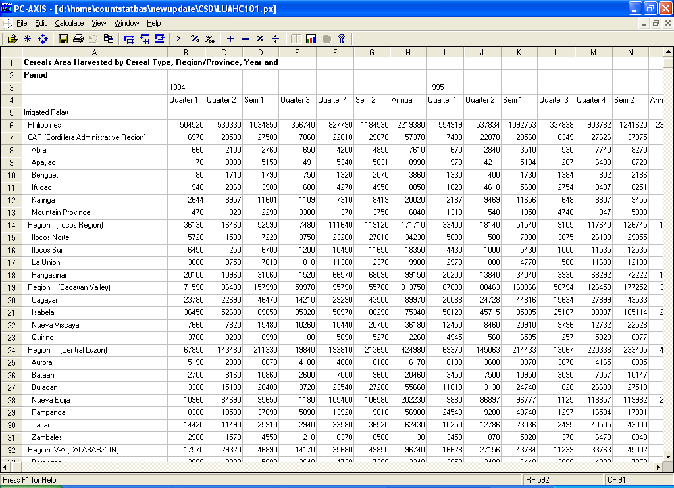
(2) Figure: PC-Axis Main Module

PC-Axis file (or simply PX-file) is an ideal file format for dissemination of statistical tables compared to other popular file formats such as Excel, MSWord, PDF, MS Access, or HTML. PX file offers a lot of options such as: (1) dynamic generation of tables where users are able to interactively query the data and do transposition of variables (or pivoting) easily to generate the desired table formats; (2) quick generation of commonly used statistical charts to support data analysis; (3) easier generation of thematic maps; and (4) quick conversion to several file formats such as Excel, CSV, MS-Access, HTML, and others.

3. Capacity Building for the CountrySTAT System

3.1. Training on CountrySTAT administration

As an initial step of the capacity building towards the development of the CountrySTAT Philippines, the PSA sent two BAS personnel to a training workshop on CountrySTAT Administration at the FAO Headquarters in Rome, during the period 01 to 10 February 2006. Earlier in November, one personnel from the National Statistical Coordination Board (NSCB) attended a similar training at the FAO HQs. One BAS personnel focused on the CountrySTAT statistical framework while the other was engaged more on the development, management and administration of the CountrySTAT system. Apart from the concepts and the skills acquired about the CountrySTAT system, the other significant output of this training was the identification of the requirements and other considerations to enable BAS to host the CountrySTAT Philippines. This paved the way for BAS and PSA to proceed and lay out the plans covering the main activities of the project like; capacity building, conduct of sub-regional workshop on CountrySTAT and metadata and the installation of the CountrySTAT at the BAS.

3.2 National Training Workshops

In the Philippines, the institutions or agencies that supply data to the CountrySTAT system are the National Statistics Office (NSO), National Statistical Coordination Board (NSCB), the Bureau of Labor and Employment Statistics (BLES) and the different operating units of the Bureau of Agricultural Statistics (BAS). The second stage of the capacity building was the training of selected personnel from these agencies. The project plan scheduled two national training workshops.

The first national training workshop was conducted on 27 to 31 March 2006. The main objective of the training was to provide and enhance the skills of the statisticians and IT staff in using the PC-Axis software suite. The three (3) personnel from NSCB and BAS who have earlier attended the training in Rome served as the resource persons. During the preparations for this training, it has become evident that the resource persons had to study the PC-Axis software suite in detail in order to have a better understanding of the PC-Axis. In the process, the resource persons have discovered other aspects of the PC-Axis and have got to know more than what they have learned from the training in FAO HQs in Rome.

At the end of the first training, the agencies identified other key elements or requirements for CountrySTAT. Since data come from different sources, CountrySTAT needs a document that will serve as a guide to harmonize the data. Specifically, the document should contain guidelines for (1) data submission, (2) standardized file-naming convention, (3) conversion procedure, (4) standardized format for PX file keywords. The guidelines will ensure the consistency of statistical tables when viewed in the CountrySTAT webpage. The CountrySTAT document containing guidelines was drafted by the BAS Webmaster who serves as the designated CountrySTAT administrator with the help of the participants.

Another important requirement was the forging of a Memorandum of Agreement (MOA) among agencies involved. The MOA defined the responsibilities and the level of data to be supplied by the member agencies. This was drafted by SRTC in consultation with the PSA, NSO, NSCB, BLES and BAS. The MOA underwent several modifications until it was signed by the heads of agencies on August 2006.

The second national training workshop was conducted during the period 08 to 12 May 2006. The first two days from May 8 to 9 served as a follow-up to the first training and had the intention to foster better appreciation and understanding in handling PC-Axis files. This was attended by the participants of the first training workshop. In the next three (3) days, 10 to 12 May 2006, the training workshop on metadata among Statisticians or Sector Specialists was held. The workshop included presentation of agencies’ data and metadata systems. It was interesting to note that none of the agencies have similar metadata format or outline. The major output of the workshop was the draft metadata outline. This metadata outline was further enhanced at the BAS. It was submitted to FAO for information and reference. The draft outline was also circulated among the operating units of the BAS as reference in the preparation of their respective metadata. Thus, when the FAO – prescribed metadata outline was forwarded to the BAS, concerned operating units just did some adjustments in the sequence of presentation of topics.

3.3 Sub-regional Workshop on CountrySTAT and Metadata

The FAO-PSA Sub-Regional Workshop on CountrySTAT and Metadata, co-organized by BAS and SRTC, was held in the Philippines from 23-27 October 2006. Basically, the workshop aimed to raise awareness on CountrySTAT, including its opportunities and challenges, based on the Philippine experience and to provide discussions about metadata documents on national agricultural statistical systems prepared by participating countries. The workshop also served as the official launching of the CountrySTAT Philippines. The major output of the workshop was the enhancement and streamlining of the FAO prescribed metadata outline that is agreed upon and understood by participating countries. The Philippines has modified its metadata based on the final FAO prescription. This was published last July 2007 and was made accessible via the metadata link in the CountrySTAT Philippines webpage.

3.4 BAS In-house PC-Axis Software Training

The administration and updating of data and metadata in the CountrySTAT system suggested additional work and time on the part of the Website operating unit of the BAS. Also, the PC-Axis has evolved as a standard for disseminating statistical tables. These required more involvement in terms of personnel who should be technically knowledgeable in using the PC-Axis software. In solving this, the BAS conducted in-house PC-Axis software trainings in two (2) batches. Technical operating units of the BAS were properly represented in the trainings. The first batch was conducted in 27-29 November 2006, while the 2nd batch was conducted in 6-7 June 2007. The participants of the trainings will help in the conversion of data file to PX files. The BAS plans to conduct similar trainings in the Provincial Operations Centers (POCs) across the country.

4. Installation of the CountrySTAT System

4.1. Installation Requirements

Just like in any other system, CountrySTAT has system requirements for its successful installation. The CountrySTAT system is a Microsoft Windows-based application. This should be installed in a Windows server either 2000 or 2003 with Internet Information Server (IIS) version 5.0 or 6.0. The system requires that a PX-Web application with license from Statistics Sweden be installed in the web server. The PX-Web is written in ASP 3.0 and uses DLLs to handle all its functions. The directory where the CountrySTAT files are located should be configured with READ and WRITE authorization for Internet User Accounts (or IUSR), Launch Process Account (or IWAM), and local group account (or IIS_WPG). The READ and WRITE authorization is necessary since the system frequently creates temporary files to speed up the process of presenting its output to the users. The functions that require temporary files are (1) when a Query is made to the PX file, (2) when generating charts and maps, and (3) when users download the generated report in other formats such as Excel or PC-Axis file.

The Food and Agriculture Organization (FAO) suggested that the CountrySTAT system should be installed as part of the website of the implementing agency. The implementing agency should designate a CountrySTAT website administrator who is knowledgeable in Active Server Pages (ASP) and Visual Basic Scripting (VBScript). The designated administrator should also attend the CountrySTAT administration and PC-Axis Software training which are provided by the FAO.

4.2. Obtaining PC-Axis License

The NSCB had acquired a license for disseminating PC-Axis files in their previous project with Statistics Sweden. Through email communications, the BAS contacted Statistics Sweden and enquired on how to obtain a license for BAS similar to NSCB. Based on the discussion with Statistics Sweden regarding the licensing terms on PC-Axis, a country needs only one license. The agency who owns the license should report and request permission from Statistics Sweden for another agency to be covered in the license. Recognizing the terms, the NSCB required a separate MOA with the BAS on the exclusive use of PC-axis in the CountrySTAT system. The MOA was signed on the 21 September 2006.

4.3. Enhancement of the CountrySTAT System

Prior to the installation of the CountrySTAT system, the designated CountrySTAT Administrator did some modifications on the programs of the original CountrySTAT system. The changes in the programs were due to the following: (1) installation of the Philippines shape map; (2) making the system into a cross-browser; (3) enhancing and speeding up the viewing of metadata in the Query interface, including the quick tables and maps; and (4) linking of data tables with their corresponding metadata.

4.4. Shift in Website Hosting Service

Until the early part of May 2006, the BAS website (http://www.bas.gov.ph) was hosted under a shared server of Filipino Web Services, Inc. (FilWeb). The shared server operates in Linux platform (Unix-based operating system) with Apache as its web server. The BAS website uses Hypertext Pre-processor (PHP), PERL, and MySQL Database. All of these languages and software are cross-platform which means that they can be installed either in MS Windows or Unix-based (such as Linux) platforms.

In installing the CountrySTAT system, BAS made some adjustments in its website setup. The FilWeb’s shared server cannot accommodate the CountrySTAT system since it requires Windows platform and installation of PX-Web. FilWeb thought that the system might compromise the operations of other websites in their shared server. As a result, the BAS transferred its website to a dedicated server. The BAS website is now currently hosted by ServoBox, a hosting service trademark of WebFocus Solutions, Incorporated. The dedicated server operates using Windows 2003 server configured with IIS. It provides more benefits than FilWeb’s shared server. The benefits would include faster accessibility, 99 percent uptime, no set-up fee, affordable, less server administration on the part of the BAS. The server is installed with updated Antivirus / Spam filtering, and more importantly only the BAS is using the server.

Transferring the website did not create major problems since the BAS website has been developed using Cross-platform languages and software. The setting up and configuration of the CountrySTAT system and the BAS website were done by the Systems Administrator of ServoBox. The BAS Webmaster coordinated with ServoBox and provided the list of requirements in order for the CountrySTAT system to work. The Philippine CountrySTAT system as shown in figure 3 is working and has been made accessible since May 2006. It is a sub-domain of the BAS website with URL http://countrystat.bas.gov.ph.

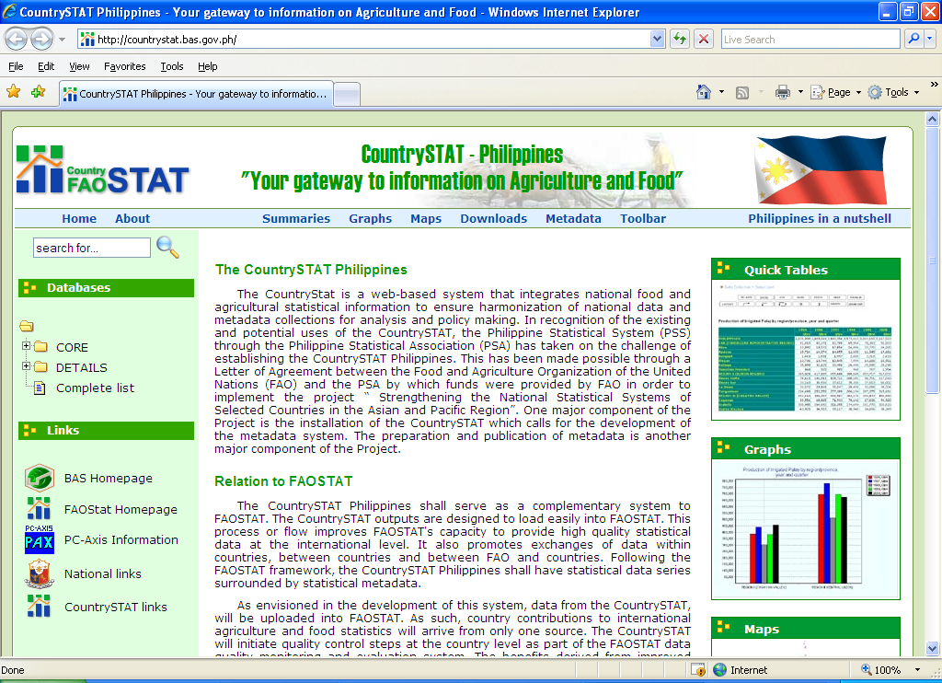
(3) Figure: CountrySTAT Philippines http://countrystat.bas.gov.ph

4.5. Initial Data

In preparation for the first national training workshop, the priority data sets to be loaded in the CountrySTAT were already identified. The priority data were those that support the statistical framework under the Core data set. The SRTC which organized the workshop earlier advised the participants to bring the required data with them in the training. The training included exercises in converting their existing data (in Excel format) into PX files. Towards the end of the training, the resulting PX files were collected. The PX files were further enhanced after finalizing the CountrySTAT guidelines. These PX files served as the initial data of the CountrySTAT Philippines during its installation in May 2006.

5. The CountrySTAT Philippines

5.1. CountrySTAT Core Group

The CountrySTAT Core Group was created by the BAS management at the start of FAO-PSA project. This was made up of selected personnel across operating units in the Central Office. The group was tasked to do the following: (1) implement the CountrySTAT activities and advocate for its use; (2) facilitate the consolidation of inputs to the preparation of metadata report; and (3) serve as the Clearing House for the inputs to the CountrySTAT. Thus, the continuous development and maintenance of the CountrySTAT Philippines would largely rely on this group.

5.2. Major Domains

The CountrySTAT Philippines, as of July 2007, has provided access to 31,399,466 figures (rows x columns) in 112 PX files (or statistical tables) distributed into 10 major domains. The 10 major domains that comprise both the Core and Detail data sets for CountrySTAT Philippines are the following: (1) Production, (2) Trade, (3) Food Consumption, (4) Prices, (5) Agricultural Machinery, (6) Fertilizer, (7) Pesticides, (8) Land use, (9) Labor and employment and (10) Others. The time series data in the Core data set cover at least 12 years. All the statistical tables posted in the CountrySTAT Philippines are adequately backed up by metadata.

5.3. File Naming Convention

The CountrySTAT Core Group developed and adopted a File naming convention (see figure 4) in organizing the data in the CountrySTAT Philippines webpage. This is included in the CountrySTAT guidelines. The first two-character code represents the domain. This will be followed by a three-character “statistics and indicators” code, and then followed by an integer representing the agency code. The last two characters will serve as the numerical id of the PX-file. The file name should be the same as the Matrix keyword of the PX file. By just looking at the file name of the PX-file, one can identify the location of the domain or category of the file and the source agency. The linking of data to its metadata and vice versa is another significant function of this convention.

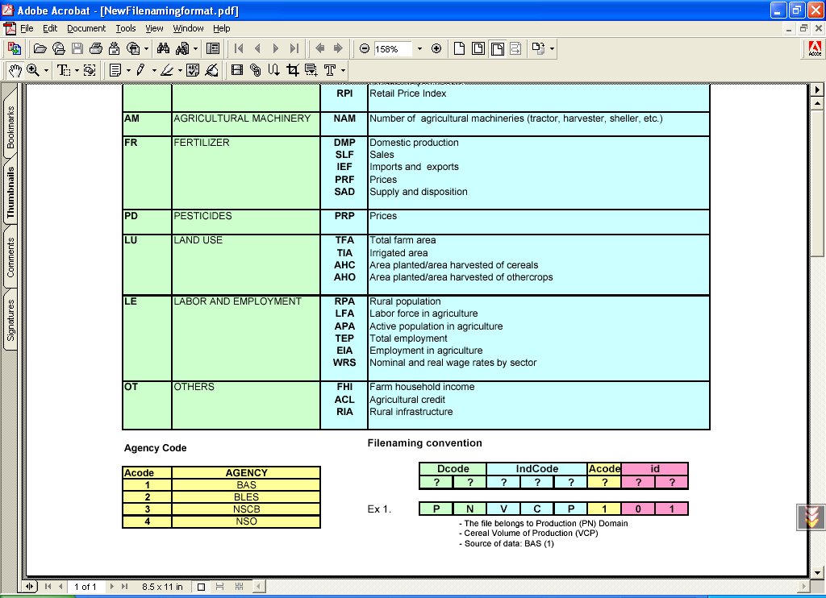
(4) Figure: File naming convention

5.4. Features and Outputs

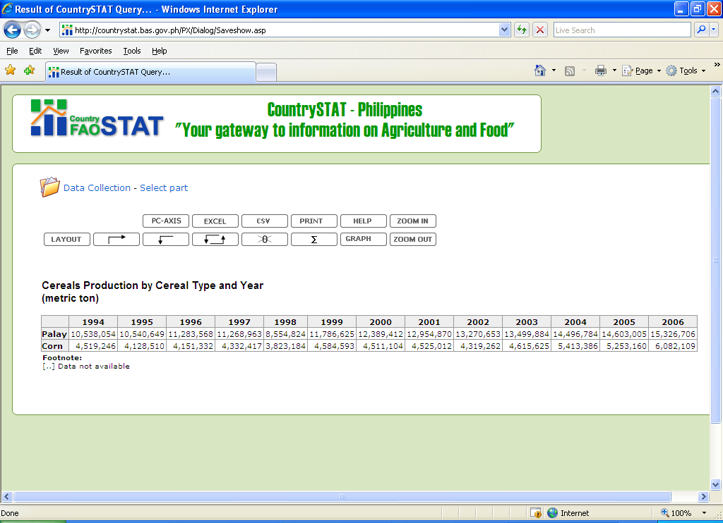
(5) Figure: Sample Result of CountrySTAT Query

The CountrySTAT Philippines is an applied system of PC-Axis. The features or outputs of the CountrySTAT Philippines are similar to that of the PC-Axis software. Figure 5 shows the sample generated table from a query. Looking at the interface, one can easily change the table format by transposition (or pivoting). Commonly used charts can easily be generated to support data analysis. Conversion to other file formats such as Excel, HTML, CSV and others is straightforward that can used for data exchange. Thematic maps such as shown in figure 6 can be easily generated. All of these features can be made from a single click of a button.

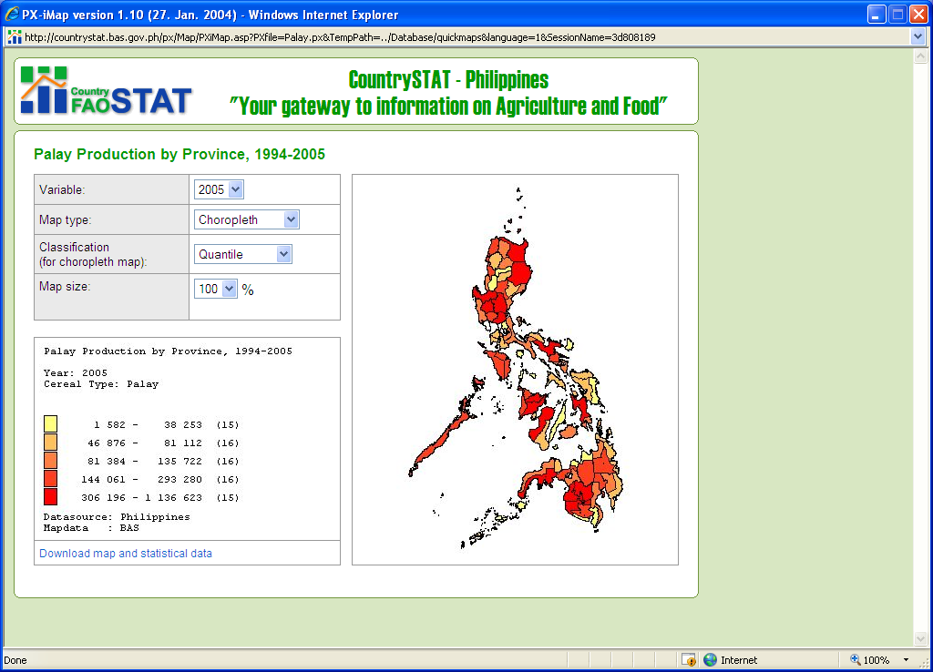
(6) Figure: Map Generated by CountrySTAT

5.5. Website Maintenance

The process of updating the CountrySTAT Philippines is illustrated in figure 7. Data updates from other agencies such as NSO, BLES and NSCB are submitted via email by their designated point persons. In the BAS, data updates are taken from the BAS Centralized PC-Axis Database System (CPXDBS) by the designated database coordinators and submitted thru the BAS Local Area Network (BASLAN). The CPXDBS is a system developed by the BAS using PX-Web designed for walk in clients and accessible only in the BASLAN. This system serves as a parallel system and source of CountrySTAT updates. After receiving the updates, the CountrySTAT Core Group initiates quality control and ensures that the PX-files are in conformity with the CountrySTAT guidelines. If the PX files pass the quality check, then these will be submitted to website operating unit of the BAS thru the BASLAN. The CountrySTAT administrator will upload the PX-files to the server via FTP. If the uploads are completed successfully, the publishing program of the CountrySTAT will be executed to finally publish the updated PX-files.

(7) Figure: Updating the CountrySTAT Philippines

6. Concluding Notes

The CountrySTAT Philippines which has been successfully established is lodged at the BAS. The success can be attributed to the hard work and team effort of the CountrySTAT Core group with full support from the BAS management and the agencies under the PSS. The CountrySTAT Philippines is still in its early stages and the BAS is looking forward to lot of developmental work. The main activities that would need further attention are the following: (1) the linking of the CountrySTAT Philippines and the BAS website; (2) training on PC-Axis across operating units of the BAS in the Central Office and over the medium term plan this capacity building program will be brought down to the operations centers in the regions and even in the provinces; (3) development of more applications to support the maintenance of the CountrySTAT; (4) the presentation or demonstration of CountrySTAT as an advocacy on the use of statistics; and (5) the presentation of metadata for the major statistical domains and surveys in internal and external fora.

With CountrySTAT system backing up the BAS main website, access to data will now be easier and quicker for the policy makers, researchers and other clients.

The experience in the Philippines can easily be duplicated in other countries.

References:

CountrySTAT Official Website <http://www.fao.org/es/ess/countrystat/ > (FAO)

FAOSTAT <http://faostat.fao.org/default.aspx > (FAO)

Report of FAO PSA Sub-Regional Workshop on CountrySTAT and Metadata, October 23-27, 2006 (BAS-SRTC)

Director, Assistant Director and Senior Statistician, respectively, Bureau of Agricultural Statistics, Department of Agriculture, Republic of the Philippines

