RAF/AFCAS/07 – 10 b

E
December 2007

Agenda Item 9
AFRICAN COMMISSION ON AGRICULTURAL STATISTICS

Twentieth Session

Algiers, Algeria, 10 - 13 December 2007

AGRICULTURAL AND RURAL STATISTICS TO SUPPORT THE EVALUATION OF AGRICULTURAL DEVELOPMENT POLICIES AND STRATEGIC INVESTMENT OPTIONS: NIGERIA SPECIFIC COUNTRY PAPER

1.0 INTRODUCTION

1.1 NIGERIA AND AGRICULTURAL DEVELOPMENT POLICIES IN BRIEF

1.1.1 NIGERIA AND HER SYSTEM OF GOVERNMENT

Nigeria with land area of about 910,770 square kilometers is one of the largest countries in West Africa. It shares a common Boundary with the Republic of Benin to the west, the Republics of Cameroon and Chad to the east, and the Niger Republic to the north. In the south it is bounded by the Atlantic Ocean which creates a coastline of 960 Kms. Nigeria is a physically and climatically diverse country. It encompasses three major ecological regions, a humid forest region, a sub-humid region with high land, and a semi-arid region where annual rainfall ranges from about 250 mm in the sahelian north to over 3000mm in the southern coastal areas. The natural vegetation varies from rain forest to savanna with physical and climatic diversity which permits the growing of a wide variety of crops. There are also substantial inland water resources. The country thus, has a great agricultural production potential, the sustainable exploitation of which holds a considerable promise for providing livelihood and food security to the people of Nigeria as well as meeting their increasing economic aspirations (Ref. Table 1).

Nigeria is the most populous country in Africa with a population of 140.0 million (2006 census) which is growing at an annual exponential rate of 3.2. Population is characterized by nearly equal proportion of males (51.22%) and females (48.77), rapid rural-urban Migration, and is ethically diversed comprising over 250 distinct ethnic groups that include Hausa-Fulani configuration in the north, the Yorubas in the south-west, and the Ibos in the south-east. Some of the other large ethnic groups are kanuri, Ibibio, Tiv, Ijaw and Edo.

Nigeria has three-tier system of government which comprises a Federal Government, 36 State governments / Federal Capital Territory (Abuja) and 774 Local government Areas (LGAs). The Federal Government is responsible for nation-wide development polices while State Governments are for most of the state level development policies, and the local government, for the local affairs and development. However, in practice, the activities of these different levels of government often overlap as agriculture is on the concurrent list.

    - AGRICULTURAL SECTOR POLICIES
In order to provide enabling environment for the agricultural sector to fulfill its roles, the Federal Government, from time-to-time introduce various development policies and strategic investment options. Such major agricultural policies include:
- AGRICULTURAL LAND POLICY
- AGRICULTURAL CREDIT POLICY
- COOPERATIVE DEVELOPMENT POLICY
- NATIONAL POLICY ON INTEGRATED RURAL DEVELOPMENT
- NFRASTRUCTURAL DEVELOPMENT POLICY
- AGRICULTURAL PRICING POLICY
- AGRICULTURAL TRADE POLICY
- NATIONAL FERTILIZER POLICY FOR NIGERIA; AND
- NEW AGRICULTURAL POLICY

The New Agricultural, adopted in year 2001, is the synthesis of the frame work and action plans of Government designed to achieve overall agricultural growth and development. The policy aims at attainment of self-sustaining growth in all the sub-sectors of agriculture and structural transformation necessary for the overall socio-economic development of the country as well as the improvement in the quality of life of Nigerians.

Table 1: Land Use Pattern in Nigeria

Land Use | Area (million ha) | % of total
Crop land | 30.96 | 34
Pasture | 20.94 | 23
Forest | 14.57 | 16
Rivers/Lakes/Reservoirs | 11.66 | 1
Others | 12.93 | 14
Total | 91.06 | 100
Source: Federal Ministry of Agriculture and Water Resources

2.0 BACKGROUND
Statistics can provide not only a record of the dynamics of agricultural development but also the quantitative foundation for assessing the impacts of future change. This paper is intended to enhance the review of the need for and availability of some important statistical elements required to support evidence-based evaluation of agricultural development policies and strategic investment options in Nigeria. This has been done by trying to provide an overview of the availability of statistics of relevance to a number of key elements of evaluation data for crop production systems as much as possible.

  - THE MAJOR CROPPING SYSTEMS IN NIGERIA

The cropping systems are greatly influenced by the ecological zones in place across the country. And due to substantial variations that still exist as a result of unequal amount and pattern of rainfall, altitude, soil types and types of vegetation the three Regions have been further subdivided into eight (8) Ecological zones. These zones, the states within them and the crops and livestock they support are as presented in Table 2.

TABLE 2: ECOLOGICAL ZONES

Ecological Zone | States in the Zone | Ecological Crops and Livestock Specialialization
Sahel | Borno, Yobe | Cereals, Grain Legumes, and Livestock.
Intermediate  Savannah | Niger,Kwara,Kaduna, Osun Plateau, Taraba, Enugu, Abuja, Nassarawa, Benue,Kogi,Cross River | Cereals,Grain Legumes, Tubers Nuts, Cattle, Sheep, Goats, Pigs, Poultry
Western Moist  Forest | Oyo,Ondo,Ogun,Ekiti | Treecrops,Tubers,Cereals,Fruits, Vegetables,Fruits, Seeds and Nuts,Legumes,,Piggery,Sheep and Goats, Poultry
Central | Edo,Delta | Treecrops,Rootcrops and Tubers, Cereals,Fruits, Seeds and Nuts Legumes,piggery,sheep and Goat, Poultry, Vegetables
East Moist  Forest | Anambra, Imo,Rivers,Cross River, Akwa-Ibom,Bayelsa,Ebony  i,Abia | Treecrops, Rootcrops and Tubers, Cereals,Fruits, Seeds and Nuts Grain Legumes, Poultry,piggery, , Vegetables,Fruits,sheep and Goat
Forest savannah  Mosaic | Kogi,Edo,Enugu,  Cross-River, Benue, | Tree crops,Root crops and Tubers, Cereals,Fruits, Seeds and Nuts Grain Legumes, cattle, Goat and Poultry,Sheep and Vegetables
Mangrove Swamp | Lagos,Ogun,Ondo,  Delta,Rivers, Bayelsa  ,Akwa-Ibom | Tree crops,Root crops and Tubers, Cereals,Fruits, Seeds and Nuts Grain Legumes ,Poultry Fisheries, Vegetables
Dry Savanna | Sokoto,Katsina,Kano  ,Bauchi, | Cereals,Grain,Legumes,Vegetable,OilSeeds,
Source: Federal Ministry of Agriculture and Water Resources

Also, although the performance of crops and livestock are influenced, to a great extent, by the ecological zones in which they are produced there are also the influence/effect of the care and inputs of the producers on them. Consequently, agriculture being on the concurrent list in Nigeria with intervention coming from each level of the three-tier of Government, the inputs into and outputs from any agricultural production irrespective of the ecological zones are of keen interest to the political owners of that place. Hence, the states are presented in their six Geo-Political zones in Table 3 to ensure easy understanding when compared or merged with that of Ecological zones, as in Table 4.

TABLE 3: DISRTIBUTION OF STATES BY THEIR GEO-POLITICAL ZONES

S/N | GEO-POLITICAL ZONES (GPZ) | STATES I N THE ZONES | NUMBERS OF LGAs IN THE ZONES | REMARKS
1 | NORTH WEST | Jigawa, Kaduna, Kano, Katsina, Kebbi, Sokoto, Zamfara | 173
2 | NORTH EAST | Adamawa, Bauchi, Borno, Gombe, Taraba, Yobe | 111
3 | NORTH CENTRAL | Beune, Kogi, Kwara, Nassarawa, Niger, Plateau, FCT | 119
4 | SOUTH WEST | Ekiti, Lagos, Ondo, Ogun,Osun,Oyo | 124
5 | SOUTH EAST | Abia, Anambra, Ebonyi, Enugu, Imo | 92
6 | SOUTH SOUTH | Akwa-Ibom, Bayelsa,Cross River, Delta , Edo, Rivers | 116

Table 4: COMBINATION OF TABLES 2 & 3

S/N | ECOLOGICAL ZONE | GPZ | STATE (IN FULL OR PART) | APPROX NO | ECOLOGICAL CROPS/LIVESTOCK SUPPORTED
1 | Sahel | N.E. | Borno, Yobe | 2 | As in Table 2
2 | Dry Savannah | N.W | Sokoto, Katsina, Kano | 3 | -Ditto-
2 | Dry Savannah | N.E | Bauchi | 1
3 | Intermediate Savannah | N.E. | Taraba | 1 | -Ditto-
3 | Intermediate Savannah | N.W. | Kaduna | 1
3 | Intermediate Savannah | N.C. | Niger,Kwara, Plateau, FCT Nassarawa, Benue,Kogi | 7
3 | Intermediate Savannah | S.W | Osun | 1
3 | Intermediate Savannah | S.E. | Enugu | 1
3 | Intermediate Savannah | S.S | Cross River | 1
4 | Western Moist Forest | S.W. | Oyo, Ondo, Ogun, Ekiti | 4 | -Ditto-
5 | Central Moist Forest | S.S | Edo, Delta | 2 | -Ditto-
6 | Easter Moist Forest | S.S | Cross River, Rivers, Bayelsa, Akwa-Ibom | 4 | -Ditto-
6 | Easter Moist Forest | S.E.. | Anambra, Imo, abia, Ebonyi | 4
7 | Forst Savannah Mosaic | N.C | Kogi, Benue | 2 | -Ditto-
7 | Forst Savannah Mosaic | S.E. | Enugu | 1
7 | Forst Savannah Mosaic | S.S | Edo, Cross River | 2
8 | Mangrove Swamp | S.W. | Lagos, Ogun, Ondo | 3 | -Ditto-
8 | Mangrove Swamp | S.S. | Delta, Rivers, Bayelsa, Akwa- Ibom | 4
Source: Federal Ministry of Agriculture and Water Resources, Abuja

2.1.1 DISTRIBUTION OF THE MAJOR CROPPING SYSTEMS BY SIZE OF HOLDING

Farm holdings in Nigeria fall into three broad categories, namely, small scale, medium scale and large scale. Small – scale holdings range from under 0.10ha to 5.99ha and accounts for about 81% of the total farm holdings in Nigeria. Medium – scale holdings range in size from 6 ha to 9.99 ha, while those in excess of 10 ha are classified as large – scale holdings. These represent about 14% and 5% of all the holdings in the country, respectively. In addition, there are a few scattered large commercial farmers. Small and medium farm holdings account for over 95% of the total crop output in Nigeria.

In the south where population density is high, farm land is more fragmented and farming is largely subsistence. The medium and large size holdings are more common in the central as well as in the northern zones, where population densities are relatively low, and farming is seen as an economic enterprise.

Small-scale farmers have plots of varying fertility and sizes at four or five sites. Most of the farmers in the south practice traditional subsistence food farming and generally grow crops in mixtures.
A few specialized small farms also exist which concentrate production on one or two plantation crops like cocoa, kolanut and other such cash crops.

In the north, besides mixed farming, there is a tendency towards sole cropping particularly under irrigation ( Fadama/ Dry season farming).

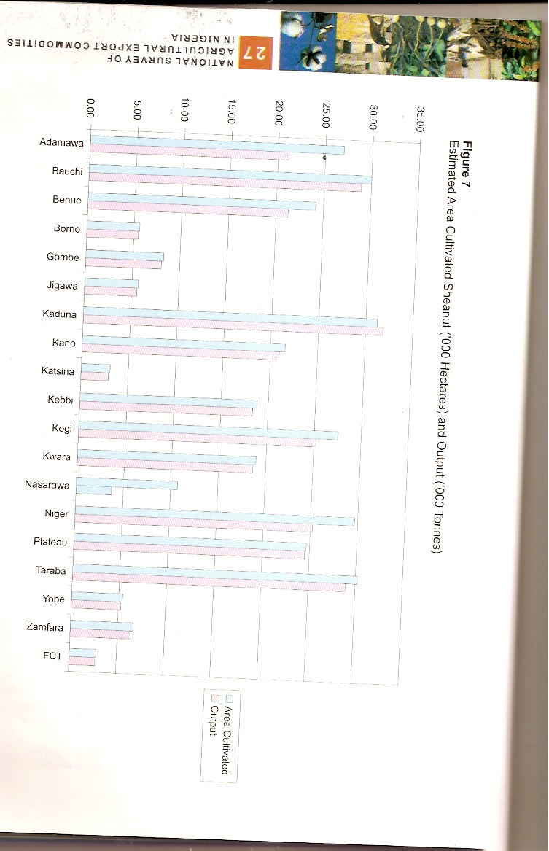

2.1.2 MIXED CROPPING PATTERNS

Crop production in mixed patterns is still the popular practice among the farmers in the country. Cereal legume intercrops are the predominant crop mixtures in the North-West, North-East and the Central Zones. In addition, yam, cassava or vegetables are grown in mixture with cereals in the central zone. The South-West and South-East zones have similar mixtures of tubers/cereal/vegetable intercrops with such crops as yam, cassava, cocoyam, melon and vegetables either grown in mixtures with one another and/or along with maize. (Ref. Table 5 for sample of major/common crop mixtures observed in 2003 during the Wet Season Crop Performance Assessment Exercise).

2.1.3 RAINFED AND IRRIGATED CROPPING PATTERNS

Rainfed cropping pattern is the main system practiced by farmers nationwide. This system accounts for over 90% of the crop production in the country. While Dry Season/Fadama/Irrigation cropping pattern is also gaining popularity as a result of serious support given the system and the farmers by the federal Government and Donor Agencies. Consequently, a lot of new irrigation facilities and river/dam plains are being commissioned by the 15 River Basin Authorities, PCU, and the Drainage and Irrigation Dept of the FMAWR. In addition to these big schemes, several State Ministries of Agriculture operate special schemes to boost Dry season crop production. Unfortunately, there is still problem generating comprehensive statistics on Dry season cropping system to determine the proportion of production(Mostly vegetables, Tomatoes, Pepper and maize) contributed at state, LGA and Zonal levels. Nevertheless, the bulk (over 70%) of irrigation farming is done in Northern Nigeria (NW, NC, and NE zones ). The on-going National Agricultural Sample Census is expected to confirm this and much more.

3.0 AVAILABILITY OF SUB-NATIONAL STATISTICS

3.1 DATA COLLECTION ARRANGEMENT

The national Bureau of Statistics (NBS) has the overall responsibility for national coordination of statistical information production. NBS, therefore, sets standards and conducts censuses and surveys where necessary. Under the newframwork NBS is to obtain its data from the following sources :-

- its mandate National Surveys:
(i) the General Household Survey;
(ii) the Labour Force Survey;
(iii) the National Agricultural Sample Survey;
(iv) the National Living Standard Survey;
(v) the CWIQS;
(VI) the Multiple Indicator Cluster Survey;
(vii) the Annual and Quarterly Surveys of Establishments; and
(viii) the National Agricultural Sample Census Survey;

- Collaborative Efforts with Ministries, Departments and Agencies (MDAs) at all tiers of Government; as well as

(c) Other Special Data Collection Effort
The FMAWR, through the PRSD/the Statistics Branch, is the overall coordinating agency for agricultural statistics production. And there is a framework (NASCCO/ TCADM) that streamlines and harmonises the statistical activities of various sub-sectors at local, State and national levels. This framework recognises the activities of the State statistical agencies and the different specialised depts like: Fishery, Livestock, Forestry, PCU, Fertilizer, Strategic Food Reserve ,Research Institutes, Rural Development, Cooperative, etc as well as the interests of stakeholders like CBN, FAO-NG, the World Bank, USA Embassy, UNDP, NBS,NPC etc.

Therefore, sub-national Statistics are available on Area, Production Yield etc through some important surveys that include the following:-

(i) Annual Crop Area and Yield Survey (CAYS) which covers only the small-scale farmers (that account for about 81% of the total farm holdings in Nigeria).

(ii) Annual Agricultural Statistics Survey generated by the Planning, Research and Statistics Dept (PRSD) through the Field Projects Monitoring Units (FPMUs) of the FMA&WR in collaboration with the State ministries of Agriculture and their respective Agricultural Development Programmes (ADPs). This survey covers the small and medium scale farmers mostly (as the large scale farmers usually have all it takes to obtain their inputs from open and Government Markets don’t co-operate). Others co-operate with Government basically to obtain Government inputs easily and at low prices. The report is disaggregated at state level and effort is being made to disaggregate at LGA level soon. Lack of funds, however, makes the survey irregular.

(iii) National Survey of Agricultural Export commodities in Nigeria which was instituted by the Federal Executive Council (FEC) of Nigeria and is conducted by the consultative committee on Agricultural Export Commodity Statistics (CCAECS), with experts drawn from the National Bureau of statistics (NBS), Federal Ministry of Agriculture and Water resources (FMAWR), Central Bank of Nigeria (CBN) and Federal Ministry of Commerce (FMC).

This survey covers all the farmers (Small and medium on HH basis, and Large on establishment basis). Nevertheless, it has been very difficult to get the inputs (response) of the large scale farmers. It was designed to generate data on all major export crops, industrial crops and food crops of strategic importance to national food security programme.
Information dissemination is currently in hard copy but will soon be in any form the users want it.
Figures are also presently available on 14 Export crops/commodities at state and national levels but would soon cover many more food crops and reported at LGA and/or ward levels, to further empower the political heads at those levels (the LGA Chairmen and Councillors, respectively) for better governance.

Although the survey was designed to capture and report data on marketed share of each important food and cash crop for each region the first three rounds of survey conducted have not reported this aspect directly but would do so very soon. And, even now because they are export crops and commodities such as cocoa, cotton, Garlic etc the portions sold formally are captured and reported in the Export Trade Statistics.

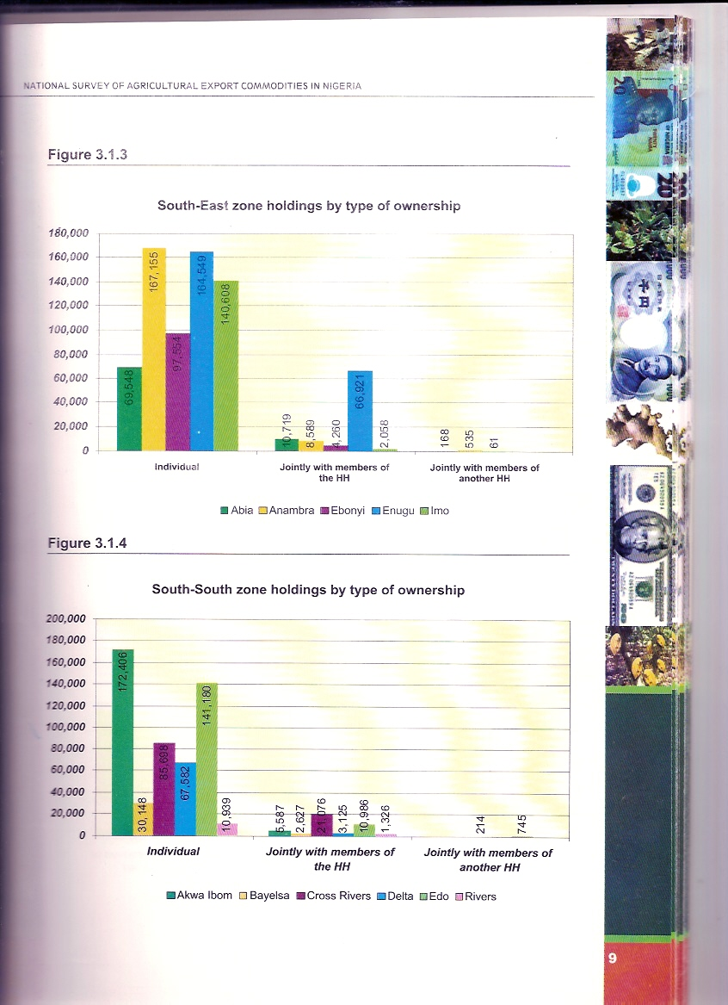

4.0 THE SCALE AND MIX ON PRODUCTION INPUTS
Virtually all statistical studies of various agricultural agencies (and related) ensure seeking information on the use of these essential agricultural inputs. Hence, there are places to obtain some form of these information even if not as comprehensive as required. For instance, information on these inputs to agricultural production should be obtainable or derivable from the reports of the three surveys mentioned under availability of sub-national statistics above. The producer of CAYS (i.e. PCU, FMAWR) also collaborates with PRSD, FMAWR and National Agricultural Extension, Research and Liaison Services (NAERLS) to conduct the field Assessment of wet season Agricultural production in Nigeria on Annual basis. The Assessment exercise covers and generates useful information on inputs (improved seeds of cereal and tubers as well as inorganic fertilizer of all types).
The Annual Agricultural Statistics Survey of PRSD, FMAWR also generates Time Series data on:-
(i) Breeder seed production of major cereal and legume crops;
(ii) Foundation seed production by National Agricultural Research Institutes (NARIS) and Contract Growers;
(iii) Certified seed production by ADPs; and
(iv) Quantity of fertilizer used by state.
Unlike the last two editions (2004/5 and 2005/6), the current edition of the report on National Survey of Agricultural export commodities in Nigeria is expected to include information on inputs used in Agricultural production including labour.
In addition to these fore-going surveys, there exists Core Welfare Indicator Questionnaire (CWIQ) survey being conducted by National Bureau of Statistics (NBS) with the support of the World Bank to generate, on household basis, minimum/basic information on: access, use and satisfaction with provision of basic services and also for providing basic indicators for monitoring poverty alleviation programmes, in order to rapidly inform programmes and policy
decisions.
This survey in its year 2006 outing generated the inputs related information on Agricultural production as presented in Table 6.
The corresponding findings from the 2007 survey are expected shortly and would be useful basis for comparism.

Table 6: USES OF AGRICULTURAL INPUTS IN NIGERIA
S/No. | SITUATION IN 2006 | SITUATION IN 2007 | REMARK
A. | General Use of Agric Inputs  3.6%of household i n Nigeria used  45.6% of households in Rural Areas used  More households in the North used  Highest use (70.5%) HHS in NW  Lowest use (13.0%) HHS in SS
B. | Use of Fertilizers  82.1% HHs used nation-wide  84% Rural HHs used  73% Urban HHs used
 | 227,309.32 Delivered nationally by federal Dept. of Fertilizer | 318,530mt delivered nationally by fed dept of fertilizers, FMAWR.
S/No. | SITUATION IN 2006 | SITUATION IN 2007 | REMARK
C. | Use of Insecticides  19.2% HHs used nationally  About same (19.2% x 19.0%) used in urban x rural HHs  Highest use (42.6%) HHs in S.W  Lowest use (0.7%) HHs in S.E
D. | Use of Improved Seeds/Seedlings  13.4% HHs used nationally  15% Urban HHs used  13.1 Rural HHs used  Highest use (21.9%) HHs in S.W  Lowest use (4.8%) HHs in S.S

Access to Water Source
85.2% HHs have nationally
93.6% urban HHs have
80.9% Rural HHs have
Access to Improved Water Source
51.4% HHs have nationally
73.4% HHs (Urban) have
40.0% HHs (Rural) have

Electricity Supply
55.2% HHs have nationally
86.6% urban HHs have
38.9% Rural HHs have

Above all, the on-going National Agricultural Sample Census is expected to generate all that will be required and at all levels when conducted in year 2008.

TABLE 7: QUANTITY OF FERTILIZER DELIVERED TO STATES BY THE FEDERAL
MINSTRY OF AGRICULTURE AND WATER RESOURCES(2006 & 2007)

 |  | 2006 | 2007 | 2007
 | STATES | QUANTITY | QUANTITY | QUANTITY
 |  | DELIVERED | ALLOCATED | DELIVERED | % INCREASE
1 | Abia. | 8,373.90 | 19,560.00 | 13,360.00 | 37.32
2 | Adamawa | 21,700.29 | 29,900.00 | 12,060.00 | -79.94
3 | Akwa-Ibom | 4,800.00 | 7,000.00 | 6,858.40 | 30.01
4 | Anambra | 1,920.00 | 2,246.00 | 1,668.40 | -15.08
5 | Bauchi | 9,890.90 | 16,347.06 | 7,558.10 | -30.86
6 | Bayelsa | 2,170.00 | 4,320.00 | 1,950.00 | -11.28
7 | benue | 4,082.20 | 17,431.87 | 9,700.00 | 57.92
8 | Borno | 10,343.00 | 24,615.87 | 8,786.20 | -17.72
9 | Cross River | 1,180.00 | 5,100.00 | 2,100.00 | 43.81
10 | Delta | 1,110.00 | 3,460.00 | 1,560.00 | 28.85
11 | Ebonyi | 136.00 | 1,450.00 | 1,000.00 | 86.40
12 | Edo | 1,545.48 | 4,800.00 | 1,770.00 | 12.68
13 | Ekiti | 2,670.00 | 4,240.00 | 3,043.00 | 12.26
14 | Enugu | 3,617.50 | 11,468.25 | 8,768.80 | 58.75
15 | Gombe | 9,993.21 | 30,938.73 | 23,477.50 | 57.43
16 | Imo | 3,130.00 | 14,800.00 | 8,600.00 | 63.60
17 | Jigawa | 117,750.00 | 31,219.05 | 9,380.00 | -1,155.33
18 | Kaduna | 11,644.70 | 30,096.69 | 17,774.95 | 34.49
19 | Kano | 9,297.00 | 23,400.00 | 14,500.00 | 35.88
20 | Katsina |  | 8,328.88
21 | Kebbi | 5,278.80 | 11,800.00 | 4,650.00 | -13.52
22 | Kogi | 14,980.00 | 34,070.00 | 27,210.00 | 44.95
23 | Kwara | 3,980.00
24 | Lagos | 1,530.00
25 | Nasarawa | 5,440.00 | 19,506.34 | 14,372.25 | 62.15
26 | Niger | 15,450.00 | 35,350.00 | 33,050.00 | 53.25
27 | Ogun | 4,485.00 | 1,020.00 | 1,007.00 | -345.38
28 | Ondo | 4,520.00
29 | Osun | 4,147.50 | 6,950.00 | 4,950.00 | 16.21
30 | Oyo | 7,726.05 | 11,945.91 | 7,492.64 | -3.12
31 | Plateau | 7,617.10 | 23,340.84 | 9,089.70 | 16.20
32 | Rivers |  | 5,650.00 | 5,650.00 | 100.00
33 | Sokoto | 4,140.00 | 20,740.18 | 7,120.00 | 41.85
34 | Taraba | 10,514.09 | 29,490.18 | 17,280.00 | 39.15
35 | Yobe | 11,272.60 | 25,310.00 | 19,706.80 | 42.80
36 | zamfara | 5,650.00 | 28,234.73 | 13,040.00 | 56.67
37 | FCT
 | Total | 227,309.32 | 544,148.58 | 318,530.34 | 28.64

SOURCE: FMAWR.

5.0 COST OF PRODUCTION INPUTS,PER HECTARE (INCLUDING LABOUR) [OR PER KG]

Most often the ministry (FMAWR) uses the cost of production figures produced through :
- the Field Situation Assessment of Wet Season agricultural Production in Nigeria by NAERLS/PCU and PRSD (all of FMAWR);and
- the Report of the Farm Management Survey for Advisory Services (FAMAS) of PCU, FMAWR.

Presented as Table 8 on “Cost of Production (N/ha) of Selected Crops” is a typical example of the type of data generated from the Situation Assessment exercise in 2003 – this year’s report is being processed.

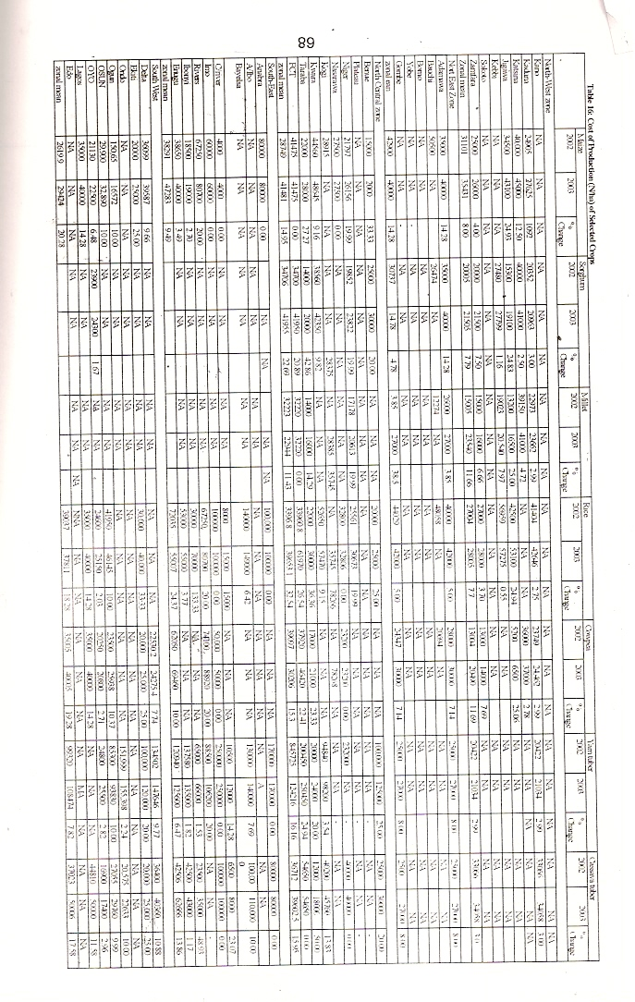

Similarly, the “Cost of Production and Revenue Profile Per Hectare for
Maize In Year 2004” computed by FAMAS, PCU is presented as Table 9.

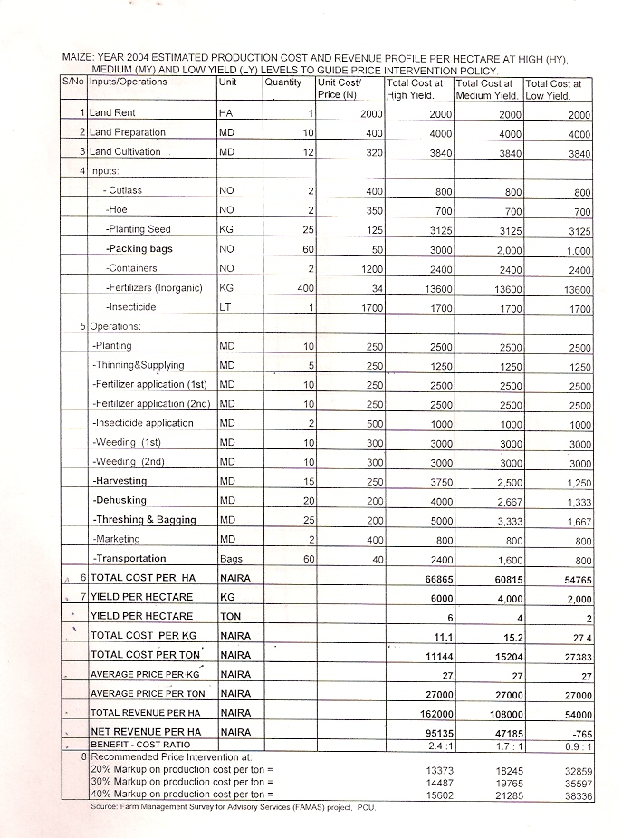

These two reports are valuable and widely used by the decision makers nation-wide, especially in the public sector. Figures from the Field Situation Assessment exercise have been used on several occasions to fine-tune policy issues relating to the price and subsidy on fertilizer to the farmers, the distribution modality and the likes. On the other hand the FAMAS’ report is, many a times, targeted at certain problem(s) awaiting statistical advice, but usually turns out to be useful to several other stakeholders who benefit directly ,by finding the data handy, or indirectly from the effect of the decision taken / policy formulated with the data (such as fixing the price at which to purchase cereals at the time of glut to fill the silos and stabilize the price, especially for the farmers). At the Statistics Branch of PRSD, FMAWR Where all food and agriculture sub-sectors related statistics in Nigeria are co-ordinated, monitored, gathered (with some generated to fill gaps),and publications produced for dissemination to stakeholders within and outside Nigeria as well as banking in the National Agricultural Data Bank (NADB) of the ministry; these PCU figures are handled appropriately (considering their technical features – scope, coverage etc) along and with other such vital statistical information to reach out to the users.

6.0 INFORMATION ON THE EXTENT AND SEVERITY OF PRODUCTION CONSTRAINTS

Some outstanding statistical achievements where recorded in recent years that give hope for better things to come in data production in Nigeria soon. These include the on-going reform of the national statistical system which has:-
- transformed the defunct Federal Office of Statistics (FOS) to National Bureau of Statistics (NBS);
- put in place the National Statistical Master Plan for effective co-ordination of the national statistics system and production agencies of all levels of government and the private sector ;
- put in place a Statistical Act to serve as a legal framework for smooth statistical data production in Nigeria;
- enhanced the skills of the professionals in NBS for better performance and service to data users;
- enhanced the status of the equipment and facilities of NBS (such that NBS and other collaborators of NBS like FMAWR can now use GPS for farm survey during data collection exercise and will soon use the Nigercomsat for GIS during the on-going NASC in 2008);
- enabled NBS to host a web site (www.nigerianstat.gov.ng) ;
- some provision for enhancing the status of the Front-line ministries (like Education, Agriculture etc) that feed the NBS sectoral templates ; Etc.

Despite all these seemly progress at NBS headquarters not much has happened in terms of better budgetary allocation of funds to statistical activities in the country (including NBS, which is still feeding on the World Bank’s grant for the National Statistics Reform).

And it is generally very difficult to obtain.

