Committee on Commodity Problems

INTERGOVERNMENTAL GROUP ON TEA

Twenty-second Session

Naivasha, Kenya, 25-27 May 2016

CURRENT MARKET SITUATIONAND MEDIUM TERM OUTLOOK

# INTRODUCTION

1. Document CCP:TE 16/Inf. 2 presents an overview of the current market situation and medium term outlook to 2024 for tea. The analysis is based on data received by the Secretariat from member countries, supplemented by data from other sources, including FAOSTAT and the International Tea Committee (ITC). Macro-economic data were sourced from the International Monetary Fund (IMF), World Bank and Organization for Economic Cooperation and Development (OECD), particularly for those used in the medium term projections.
2. To supplement the information in this document, member countries of the Intergovernmental Group on Tea (IGG/Tea) which have provided market commentaries to the Secretariat, will each be given ten minutes to make a presentation at the plenary session. The Secretariat is extremely grateful to China, India, Kenya, Sri Lanka and the United Republic of Tanzania for providing the Secretariat with an overview of developments in their tea sub-sectors. This spirit of cooperation among members should be encouraged as they promote marketing priorities of the Group in the areas of:

Improving market transparency;

Fostering market expansion; and

Value chain enhancement.

1. Delegates are invited to review the information presented in this document with its annexed tables and the presentations made by the countries which have contributed marketing commentaries of their respective tea industries. Additional information is also available in the Secretariat’s publication *World Tea Production and Trade: current and future development[1].*
2. Finally, delegates are kindly requested to amend and supplement the information where necessary, with updates pertaining to their countries.

# PRODUCTION

1. World tea production (black, green, instant and other) increased by 4.2 percent annually over the last decade to reach 5.13 million tonnes in 2014 (Figure 1). China was responsible for the accelerated growth in global tea output, as production in the country more than doubled from 934 857 tonnes in 2005 to 1.95 million tonnes in 2014. The expansion in tea production in China was in response to unprecedented growth in domestic demand, underpinned by the country’s economy which grew at an annual average rate of 10 percent over the last 30 years to 2015, culminating in the country becoming the world’s largest economy, by purchasing power parity[2].
2. China accounted for 38 percent of world tea production, with an output of 1.95 million tonnes in 2014; production in India, the second largest producer, increased to 1.21 million tonnes from 950 176 tonnes in 2005; and output in the two largest exporting countries, Kenya and Sri Lanka, reached 448 739 tonnes and 339 900 tonnes, respectively. At the world level, black tea production increased annually by 2.6 percent and green tea by 6.4 percent, in response to continued firm prices.

**Figure 1 – World Tea Production**

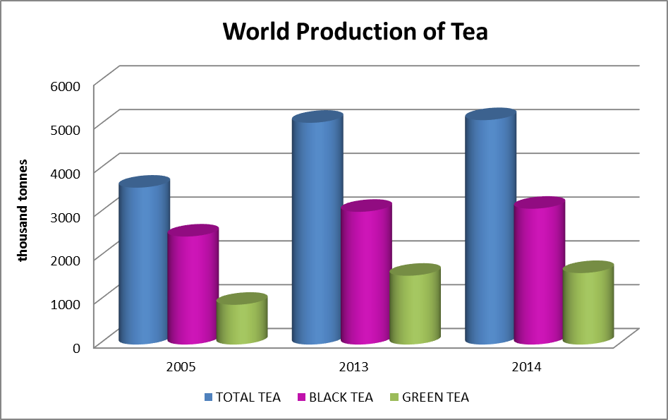

Source: FAO IGG/Tea Secretariat.

# EXPORTS

1. World tea exports increased annually by 1.6 percent over the last decade to reach 1.73 million tonnes in 2014 (Figure 2), underpinned by larger shipments from Kenya, with exports reaching a record level in 2013, as well as a strong annual growth of 3.8 percent in green tea exports (compared to the annual growth of black tea exports of 1.2 percent). Smaller annual growth in exports was recorded by China, India and Sri Lanka, as larger portions of production, particularly in China and India, were consumed domestically.

**Figure 2 – World Tea Exports**

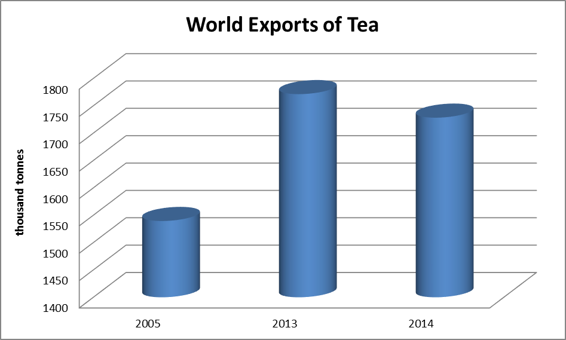

Source: FAO IGG/Tea Secretariat.

# PRICES

1. International tea prices, as measured by the FAO Tea Composite price, remained firm over the last decade until 2014 when there was a 5.3 percent decline. The FAO Tea Composite Price is a weighted average price index for black tea, which includes CTC and Orthodox teas. The decline in the Composite prices in 2014 was largely due to the weakening of CTC tea prices, as supplies exceeded demand at reigning auction prices, which took 12 months to clear. The decline would have been more substantial if it had not been for the firmness of Orthodox tea prices which persisted in 2014. However, by 2015, the roles were reversed. CTC prices recovered and reached levels which offset major declines in Orthodox teas as imports from the Russian Federation and the Near East (the main markets for Orthodox teas) fell due to weakened economic growth rates associated with lower world oil prices. The FAO Composite prices averaged slightly higher for most of 2015 (Figure 3).

**Figure 3 – FAO Tea Composite Prices**

Source: FAO IGG/Tea Secretariat.

1. Other main drivers of international tea prices are market access, the potential effects of pests and diseases on production and changing dynamics among retailers, wholesalers and multinationals.

# CONSUMPTION

1. The main determinant for growth of the global tea economy is demand for the commodity. The analysis of demand for tea carried out by the IGG/Tea Secretariat in selected markets indicates that both black and green tea are price inelastic. Price elasticities for black tea vary between -0.32 and  
   -0.80, while estimates for green tea price elasticities range between -0.69 and -0.98.
2. Several factors influence the demand for tea, including the traditional price and income variables and demographics such as age, education, occupation and cultural background. In addition, health has a great influence on tea consumption, which led the IGG/Tea to recommend strengthening consumer awareness of the health benefits of tea consumption through an international generic promotion programme.
3. World tea consumption increased annually by 4.3 percent to 4.95 million tonnes over the decade to 2014 (Figure 4). The expansion was underpinned by the rapid growth in per capita income levels, notably in China, India and other emerging economies. Growth in demand expanded significantly in most of the tea producing countries in Asia, Africa and Latin America. In China, consumption expanded spectacularly at an annual rate of 10.6 percent over the decade, reaching 1.67 million tonnes in 2014, or 34 percent of world tea consumption. India, with consumption at 1.02 million tonnes, was the second largest tea consumer in 2014, accounting for slightly more than 20 percent of the global total.
4. In traditional importing countries of Europe (except Germany) and the Russian Federation, tea consumption has declined over the last decade. The European tea market is mature and per capita consumption has been declining as competition from other beverages, particularly bottled water and carbonated drinks, has intensified, while for the Russian Federation, the decline in oil prices has negatively impacted on the country’s tea imports.

**Figure 4 – World Tea Consumption**

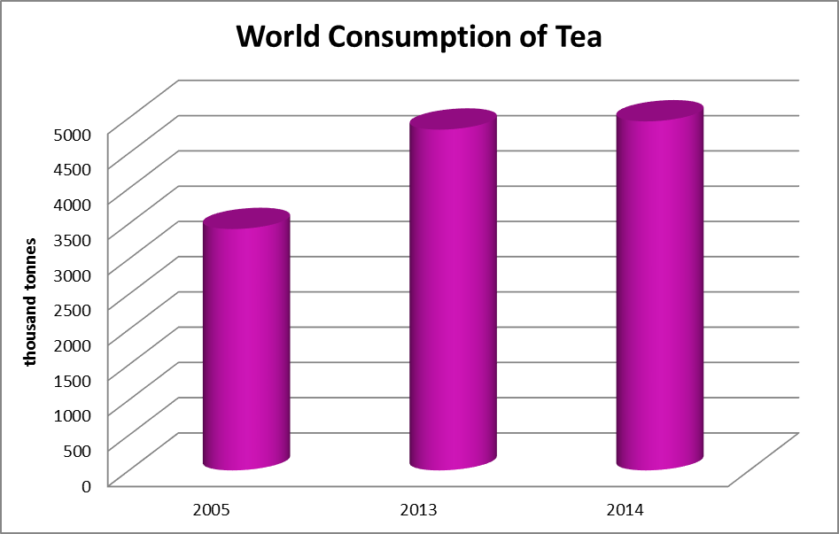

Source: FAO IGG/Tea Secretariat.

# PROJECTIONS

1. The medium term projections were generated by the FAO World Tea Model, which is a partial equilibrium dynamic time series model. Details of the model can be found in document CCP:TE 10/2[3].

## PROJECTED PRODUCTION

1. To 2024, world black tea production is projected to increase by an annual growth rate of 3.7 percent to reach 4.29 million tonnes, reflecting major increases in India, China, Kenya and Sri Lanka (Figure 5 and Annex Table 1). The expansion in China would be significant as output should surpass that of Kenya, the largest black tea exporter, underpinned by strong growth in domestic demand for black teas such as *Pu’er*.
2. World green tea output would increase at an even faster rate of 9.1 percent annually to reach 3.74 million tonnes, again reflecting an expansion in China, where green tea output is expected to more than double from 1.38 million tonnes in 2014 to 3.22 million tonnes in 2024 (Annex Table 2). The expansion is expected to result from increased productivity rather than an expansion in area, through replanting of higher yielding varieties and better agricultural practices.

**Figure 5 – Projected Production: Black Tea and Green Tea**

Source: FAO IGG/Tea Secretariat.

## PROJECTED CONSUMPTION

1. As for mid-term projections of tea consumption: for non-tea producing countries, net imports were used as a proxy for consumption; and for producing countries, actual domestic consumption was used. Data on green tea consumption were not complete and therefore, it was difficult to make any meaningful projections.
2. Black tea consumption is projected to grow at 3.7 percent annually to reach 4.27 million tonnes in 2024 (Figure 6 and Annex Table 2), reflecting the strong growth in consumption in producing countries, which should more than offset projected declines in traditional tea importing countries. The largest expansion is expected in China where an annual growth of more than 15 percent is projected over the next 10 years, followed by 10 percent in Malawi, 7 percent in Morocco, and 6 percent in Kenya, Uganda and Zimbabwe. Moderate growth rates ranging between 3 and 5 percent are expected in other tea producing countries such as Bangladesh (4.2 percent), India (3 percent), Sri Lanka (4.6 percent), Tanzania (3.3 percent) and Vietnam (4.8 percent).
3. Major factors contributing to the expansion in consumption in tea producing countries are the growth in per capita income and the increased awareness of the health benefits of black tea consumption which was initiated by the IGG/Tea in stimulating research and promotion of the health benefits of black tea consumption under the Common Fund for Commodities (CFC) funded programme in the early 1990s. The rapid growth of black tea consumption in China is due to the popularity of brick teas, such as *Pu’er*, which are heavily promoted for their health benefits.

**Figure 6 – Projected Consumption: Black Tea**

Source: FAO IGG/Tea Secretariat.

## PROJECTED EXPORTS

1. Black tea exports are projected to reach 1.70 million tonnes in 2024 (Figure 7 and Annex Table 3), with similar growth rates projected for both Africa and Asia. However, by 2024, export volumes for Asia are projected to reach 837 991 tonnes compared to 767 381 tonnes for Africa.
2. Major exporting countries are expected to remain the same, with Kenya being the largest exporter followed by Sri Lanka, India, China, Vietnam, Indonesia, Malawi, Uganda and Tanzania.
3. World green tea exports are projected to grow by 8.9 percent annually to reach 804 300 tonnes by 2024 (Figure 6). China is expected to continue to dominate the export market, with an export volume of 481 508 tonnes, followed by Vietnam at a distant second with 284 912 tonnes, Indonesia with 19 370 tonnes, and Japan at 8 394 tonnes.

**Figure 7 – Projected Exports: Black Tea and Green Tea**

Source: FAO IGG/Tea Secretariat.

# CONCLUDING REMARKS

1. Robust demand and associated high prices stimulated substantial supply increases over the past decade, resulting in significant growth in domestic consumption and trade. Export earnings at the global level more than doubled over the 10 years, from USD 2.58 billion in 2005 to USD 5.61 billion in 2014, contributing to improved rural incomes and household food security in tea producing countries.
2. The review of the world tea market indicates a 2.4 percent decrease in trade volumes in 2014, resulting in an estimated 4.4 percent decline in export earnings to USD 5.61 billion at the global level. However, the export revenues contributed significantly to financing the food import bills of tea exporting countries. For example, in Kenya and Sri Lanka export earnings of USD 1.15 billion and USD 1.63 billion, respectively, financed more than 60 percent of Kenya’s and 63.8 percent of Sri Lanka’s food import bills in 2014. Although foreign exchange earnings from tea were relatively less for other producing countries, they remained significant.
3. In terms of price developments, the average FAO Composite Price remained firm over the last decade until 2014 when there was a 5.3 percent decline, mainly due to the weakening of CTC tea prices. Prices recovered in 2015, reflecting the recovery in CTC prices offsetting the decline in orthodox teas as imports from the Russian Federation and the Near East fell due to weakened economic growth rates associated with lower world oil prices.
4. In the medium term, the projections suggest that supply and demand of black tea will be in equilibrium in 2024 at a price of USD 2.83 per kg. This continues the upward trend established over the last decade, from an annual average of USD 1.64 per kg in 2005 to USD 2.65 per kg in 2014, with monthly peaks of USD 3.18 per kg and USD 3.00 per kg reached in September 2009 and December 2012, respectively. Although the projections indicate an increase in nominal terms, in real terms, prices would actually decline by an annual average of 1 percent over the next decade (Figure 8).

**Figure 8 - Baseline projections to 2024 (USD per kg)**

Source: FAO IGG/Tea Secretariat.

1. Price developments in 2014 indicate the delicate balance between supply and demand, and the need to maintain this to achieve sustainability. For example, assuming that output increases a further 5 percent, the impact on prices would be quite dramatic: a nearly 40 percent decline over the next 10 years reaching USD 1.78 per kg in 2024 (Figure 9).

**Figure 9 – Effect on prices of a 5 percent production increase over the baseline**

Source: FAO IGG/Tea Secretariat.

1. On the contrary, if the reaction to the declining prices were to cut back on production, say by 5 percent less than the baseline, then prices could on average be 23 percent higher for the decade, reaching USD 3.44 per kg in 2024 (Figure 10).

**Fig 10 – Effect on prices of a 5 percent production decrease from the baseline**

Source: FAO IGG/Tea Secretariat.

1. Therefore, reiterating the advice and recommendations of the IGG/Tea over the last 15 years and the tireless work of its Working Groups, caution needs to be exercised by stakeholders in the world tea economy not to over react to periodic price hikes. Greater efforts should be directed at expanding demand.
2. For example, there is scope for increasing per capita consumption in producing countries as they are relatively low compared to traditional import markets. Diversification into other segments of the market, such as organic and specialty teas, should also be encouraged and the health benefits of tea consumption should be used more extensively in promoting consumption in both producing and importing countries. However, in targeting potential growth markets, recognition of, and compliance with, food safety and quality standards is essential.
3. Although the advice by the IGG/Tea, based on the analyses and recommendations of its Working Groups and the FAO Secretariat, may appear tedious, the effectiveness of its implementation has been significant. A review of the possible effects of the advice of the IGG/Tea on demand, diversification and accompanying compliance, indicates several noteworthy developments, including:

Per capita consumption levels in tea producing countries have increased over the last decade. Although not significantly large in most cases, except for China and India, collectively their contribution has been significant;

The impact at the global level was particularly significant for China, with an annual per capita growth rate in tea consumption over the last decade of 9.9 percent, and India with an annual growth rate of 2.1 percent, because combined, they accounted for more than 36 percent of the world’s population and 54 percent of tea consumption in 2014;

Almost exclusively, market promotion in producing countries was based on the health benefits of tea consumption. Research into, and test marketing of the health benefits of black tea consumption was initiated globally by the IGG on Tea in 1995 through funding from the Common Fund for Commodities. Results of the scientific and market research into the health benefits of black tea consumption were provided to the IGG member countries for use in their market promotion programmes;

Product diversification, targeting specific market segments, has developed strongly in several producing countries. Examples include organic tea in China and India, orthodox tea in Sri Lanka, and white, yellow, red and purple teas in several producing countries;

Value addition such as retail packing has increased in several producing countries, moving away from bulk shipments; and

Greater cohesion in the efforts of producing countries towards harmonizing market requirements (MRLs and quality) and reducing costs of compliance.

1. Other factors that could expand tea demand significantly over the next decade, but which have not been factored into the projections as data is not completely available, would be the innovative developments from non-traditional players in the retail and service sectors. These include Teavana, a company specializing in selling teas and tea products which is owned by Starbucks since 31 December 2012, and several large beverage companies that have expanded the production and marketing of ready to drink (RTD) teas globally, such as Ito En, Coca Cola and AriZona. Teavana currently has more than 400 stores in locations throughout North America and the Near East, and plans are to expand the franchise globally. In the meantime, teas and tea products are beginning to be sold through Starbucks outlets worldwide.
2. On the supply side, the tea plant (*Camellia sinensis*) is highly sensitive to changes in growing conditions. Hence, commercial growing of tea is geographically limited to a few areas around the world, which are at risk under climate change. Therefore, an expected supply response to expanding demand may not be as easy as it has been in the past, given the possible constraints to the availability of suitable land.
3. Finally, the IGG/Tea has to consider future strategies and appropriate enabling policies to maintain the sustainable development of the rapidly changing global tea economy.

# ANNEX TABLES

|  |  |  |  |  |  |
| --- | --- | --- | --- | --- | --- |
| **Table 1. Black Tea: Actual and Projected Production** | | |  |  |  |
|  |  |  |  |  |  |
|  | **P R O D U C T I O N** | | | | |
| Countries / Regions | **Actual** | | **Projected** | **Growth Rates** | |
|  | 2002-04 | 2012-14 | 2024 | 2002-04/2012-14 | 2012-14/2024 |
|  | Tons | | | Percent per year | |
|  |  |  |  |  |  |
| **WORLD** | **2324425** | **3000764** | **4294815** | **2.6%** | **3.7%** |
| **Africa** |  |  |  |  |  |
| Kenya | 301794 | 415707 | 602969 | 3.3% | 3.8% |
| Malawi | 43656 | 44936 | 47585 | 0.3% | 0.6% |
| Zimbabwe | 21080 | 8500 | 11442 | -8.7% | 3.0% |
| Rwanda | 14870 | 24884 | 44692 | 5.3% | 6.0% |
| South Africa | 7769 | 2104 | 5089 | -12.2% | 9.2% |
| Uganda | 35775 | 61424 | 103645 | 5.6% | 5.4% |
| Tanzania United Rep | 29227 | 33824 | 36037 | 1.5% | 0.6% |
| Other | 34993 | 39602 | 53305 | 1.2% | 3.0% |
| **Latin America and Caribbean** |  |  |  |  |  |
| Argentina | 70015 | 78522 | 92228 | 1.2% | 1.6% |
| Brazil | 8054 | 7267 | 6568 | -1.0% | -1.0% |
| Other | 9567 | 8718 | 7004 | -0.9% | -2.2% |
| **Near East** |  |  |  |  |  |
| Iran | 52617 | 26000 | 25978 | -6.8% | 0.0% |
| Turkey | 171667 | 232665 | 258076 | 3.1% | 1.0% |
| **Far East** |  |  |  |  |  |
| India | 861205 | 1164043 | 1519542 | 3.1% | 2.7% |
| Sri Lanka | 306404 | 331243 | 402253 | 0.8% | 2.0% |
| China | 41999 | 159211 | 673613 | 14.3% | 15.5% |
| Vietnam | 71047 | 92832 | 108002 | 2.7% | 1.5% |
| Bangladesh | 55973 | 63787 | 79253 | 1.3% | 2.2% |
| Malaysia | 3649 | 19606 | 33525 | 18.3% | 5.5% |
| Nepal | 9122 | 17300 | 21255 | 6.6% | 2.1% |
| Indonesia | 125077 | 112131 | 115821 | -1.1% | 0.3% |
| Other | 34213 | 42377 | 41294 | 2.2% | -0.3% |
| **CIS** |  |  |  |  |  |
| Russian Federation | 2567 | 3400 | 3098 | 2.9% | -0.9% |
| Other CIS | 5192 | 4200 | 5167 | -2.1% | 2.1% |
| **Oceania** | 6867 | 6467 | 5927 | -0.6% | -0.9% |
|  |  |  |  |  |  |



|  |  |  |  |  |  |
| --- | --- | --- | --- | --- | --- |
| **Table 3. Black Tea: Consumption** | |  |  |  |  |
|  |  | **C O N S U M P T I O N** | | | |
| Countries / Regions | **Actual** | | **Projected** | **Growth Rates** |  |
|  | 2002-04 | 2012-14 | 2024 | 2002-04/2012-14 | 2012-14/2024 |
|  | Tons | | | Percent per year | |
|  |  |  |  |  |  |
| **WORLD** | **2275355** | **2971307** | **4265506** | **2.7%** | **3.7%** |
| **Far East** |  |  |  |  |  |
| Pakistan | 110107 | 130575 | 157472 | 1.7% | 1.9% |
| India | 706967 | 976663 | 1313191 | 3.3% | 3.0% |
| Sri Lanka | 23995 | 31730 | 49520 | 2.8% | 4.6% |
| China | 4997 | 140371 | 584379 | 39.6% | 15.3% |
| VietNam | 45 | 207 | 331 | 16.5% | 4.8% |
| Bangladesh | 40772 | 62370 | 93679 | 4.3% | 4.2% |
| Malaysia | 14445 | 36481 | 59942 | 9.7% | 5.1% |
| Nepal | 8810 | 8872 | 9781 | 0.1% | 1.0% |
| Indonesia | 36923 | 36238 | 55528 | -0.2% | 4.4% |
| Other | 56614 | 72915 | 81511 | 2.6% | 1.1% |
| **Africa** |  |  |  |  |  |
| Kenya | 12968 | 27158 | 49126 | 7.7% | 6.1% |
| Malawi | 1281 | 4236 | 10873 | 12.7% | 9.9% |
| Morocco | 163 | 167 | 327 | 0.2% | 7.0% |
| Zimbabwe | 4762 | 2600 | 4758 | -5.9% | 6.2% |
| Rwanda | 1287 | 1541 | 1069 | 1.8% | -3.6% |
| South Africa | 17052 | 22140 | 30453 | 2.6% | 3.2% |
| Uganda | 1463 | 4700 | 8489 | 12.4% | 6.1% |
| Tanzania United Rep | 6545 | 5684 | 7884 | -1.4% | 3.3% |
| Other | 59029 | 76764 | 100489 | 2.7% | 2.7% |
| **Near East** |  |  |  |  |  |
| Iran Islamic Rep. of | 76198 | 83118 | 119309 | 0.9% | 3.7% |
| Turkey | 168248 | 234037 | 262856 | 3.4% | 1.2% |
| Iraq | 49564 | 34517 | 34104 | -3.6% | -0.1% |
| Saudi Arabia | 21162 | 30843 | 46767 | 3.8% | 4.3% |
| Syria | 30041 | 30333 | 31547 | 0.1% | 0.4% |
| United Arab Emirates | 39286 | 40000 | 66304 | 0.2% | 5.2% |
| Egypt | 70016 | 97425 | 139675 | 3.4% | 3.7% |
| Libyan Arab Jam. | 10294 | 13227 | 11628 | 2.5% | -1.3% |
| Sudan | 14667 | 25900 | 50715 | 5.9% | 7.0% |
| Jordan | 4843 | 5404 | 5945 | 1.1% | 1.0% |
| Israel | 1870 | 1065 | 1556 | -5.5% | 3.9% |
| Other | 60457 | 89171 | 151577 | 4.0% | 5.4% |
|  |  |  |  |  |  |
|  | |  |  |  | (cont.) |
| **Table 3. Black Tea: Consumption (cont’d.)** | | | | | |
| **Latin America and Caribbean** | |  |  |  |  |
| Argentina | 7950 | 5056 | 5120 | -4.4% | 0.1% |
| Brazil | 4478 | 6961 | 10527 | 4.5% | 4.2% |
| Other | 27327 | 32482 | 37841 | 1.7% | 1.5% |
| **North America** |  |  |  |  |  |
| United States | 83086 | 107511 | 144155 | 2.6% | 3.0% |
| Canada | 15113 | 13030 | 12598 | -1.5% | -0.3% |
| **Europe** |  |  |  |  |  |
| EU (28) | 228083 | 196591 | 190302 | -1.5% | -0.3% |
| UK | 128987 | 112174 | 100375 | -1.4% | -1.1% |
| Germany | 19310 | 21942 | 28901 | 1.3% | 2.8% |
| Poland | 26797 | 15343 | 11821 | -5.4% | -2.6% |
| Netherlands | 13867 | 7854 | 12641 | -5.5% | 4.9% |
| France | 8322 | 7495 | 7045 | -1.0% | -0.6% |
| Other EU | 19624 | 24605 | 22031 | 2.3% | -1.1% |
| Other Europe | 4151 | 3037 | 2292 | -3.1% | -2.8% |
| **CIS** |  |  |  |  |  |
| Russian Federation | 154391 | 151905 | 139379 | -0.2% | -0.9% |
| Other CIS | 64019 | 97154 | 160739 | 4.3% | 5.2% |
| Japan | 15567 | 15910 | 17243 | 0.2% | 0.8% |
| **Oceania** | 16321 | 15170 | 13793 | -0.7% | -0.9% |
|  |  |  |  |  |  |

|  |  |  |  |  |  |
| --- | --- | --- | --- | --- | --- |
| **Table 4. Black Tea : Exports, Actual and Projected** | | | |  |  |
|  | **E X P O R T S** | | | | |
| Countries / Regions | **Actual** | | **Projected** | **Growth Rates** |  |
|  | 2002-04 | 2012-14 | 2024 | 2002-04/2012-14 | 2012-14/2024 |
|  | Tons | | | Percent per year | |
|  |  |  |  |  |  |
| **WORLD** | **1210314** | **1343762** | **1702336** | **1.1%** | **2.4%** |
| **Africa** |  |  |  |  |  |
| Kenya | 278144 | 390638 | 534169 | 3.5% | 3.2% |
| Malawi | 42666 | 40700 | 36829 | -0.5% | -1.0% |
| Zimbabwe | 16513 | 5900 | 6703 | -9.8% | 1.3% |
| Rwanda | 11849 | 22342 | 43224 | 6.5% | 6.8% |
| South Africa | 7704 | 4635 | 4781 | -5.0% | 0.3% |
| Uganda | 33381 | 55656 | 93316 | 5.2% | 5.3% |
| Tanzania United Rep | 22716 | 26365 | 28072 | 1.5% | 0.6% |
| Other | 21382 | 22500 | 20287 | 0.5% | -1.0% |
| **Far East** |  |  |  |  |  |
| India | 187238 | 197380 | 215859 | 0.5% | 0.9% |
| Sri Lanka | 289097 | 307016 | 355750 | 0.6% | 1.5% |
| China | 39310 | 32159 | 100397 | -2.0% | 12.1% |
| Vietnam | 57075 | 71625 | 81024 | 2.3% | 1.2% |
| Bangladesh | 13087 | 1587 | 943 | -19.0% | -5.1% |
| Malaysia | 839 | 1587 | 1421 | 6.6% | -1.1% |
| Nepal | 417 | 8797 | 11716 | 35.7% | 2.9% |
| Indonesia | 91392 | 57294 | 61398 | -4.6% | 0.7% |
| Other | 5932 | 9465 | 7292 | 4.8% | -2.6% |
| **Near East** |  |  |  |  |  |
| Turkey | 5708 | 4134 | 2191 | -3.2% | -6.2% |
| **Latin America and Caribbean** | |  |  |  |  |
| Argentina | 62324 | 73602 | 87273 | 1.7% | 1.7% |
| Brazil | 3715 | 497 | 2119 | -18.2% | 15.6% |
| Other | 1909 | 911 | 994 | -7.1% | 0.9% |
| **CIS** | 2567 | 2767 | 2300 | 0.8% | -1.8% |
| **Oceania** | 6780 | 6161 | 6847 | -1.0% | 1.1% |
|  |  |  |  |  |  |

1. http://www.fao.org/3/a-i4480e.pdf.
2. Source: IMF.
3. Document CCP:TE 10/2 is available on the Secretariat’s website: <http://www.fao.org/docrep/meeting/018/K7538E.pdf>.