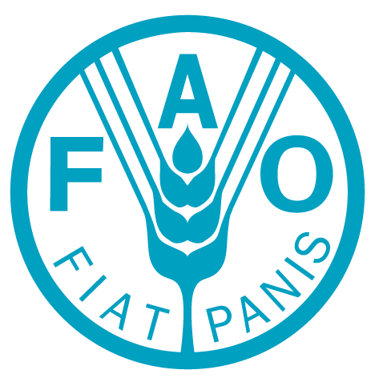
Food and Agriculture Organization of the United Nations
PSA Vacancy Announcement No:
VA –National Consultant on Communication Assistant -2017

Issued on: 24 March 2017

FOOD AND AGRICULTURE ORGANIZATION OF THE UNITED NATIONS
Professional Vacancy Announcement No: VA- National Consultant on Communication Assistant
Deadline For Application: | 7 April 2017
Position Title | National Consultant on Communication Assistant
Duty Station: | Beijing, China
Duration: | 8 months with possible extension
Type of Contract: | Personal Service Agreement
Organizational Unit:  Reports to: | FAO Representation Office in China  Vincent Martin, FAO Representative

General Description of task(s) and objectives to be achieved
FAO, is a dynamic and renewed organization, that is recognized as the lead UN technical organization in the fight to eradicate hunger, eliminate rural poverty, and in the promotion of sustainable agriculture, fisheries and livestock development while promoting sustainable management of the environment and natural resources for the benefit of communities and rural people in need.

One of the FAO’s corporate goals is to increase visibility of the organization’s good work being done at country, regional and international levels. While the Headquarters and Regional Offices have dedicated staff to help achieve this goal, dedicated specialists in media outreach at country-level (National Media and Communication Consultants) are required to increase visibility in national vernacular media (and beyond).
The Communication Assistant will be under the overall supervision of the FAO Representative in China and DPR Korea, and will be under the technical guidance and supervision of the FAO Regional Communication Officer in Bangkok, Thailand. He or she, on daily basis, works in the communication team of FAO China and under the direct supervision of the National Media and Communication Consultant (MSC) at all times.
The Communication Assistant will support enhance the communication efforts of FAO China, ensuring visibility and dissemination of FAO message and initiatives in China, in collaboration with FAO Communication strategy. In addition, as a full-time member of the FAO China the incumbent will provide support to FAO Representative in China (FAOR)’s activities as needed.
The overall objective of the Communication Assistant is to support/assist the implementation of the FAO Representation’s Communication strategy and Resource Mobilization Strategy. In line with the corporate communication policies and plans, the consultant will be primarily responsible for:
- Support advocacy of FAO China
- Provide support to formulate and rollout nationwide FAO communications initiatives, including social media campaigns and internal activities promoting the Sustainable Development Goals, maintenance of FAO China website and internal calendar, development of regular e-newsletter and media ,monitoring reports, etc.;
- Maintain and strengthen media relations, update media/partnership/information database;
- Develop innovative and impactful visual experience for FAO campaigns, design concepts and solution based on creative briefs and campaign strategies;
- Pull together information and produce information products accurately and within deadline;
- Develop, write and produce a variety of communication material including brochures, attractive fact sheets, briefs, advocacy materials for both print and Web to showcase project work for donors, and various stakeholders, clients, always adhering to FAO brand guidelines;
- Liaise with external trams/agencies to coordinate multimedia materials (photos, videos, audio etc.) production, contribution creative ideas and implement quality control;
- Assist in implementing social media strategy and campaign, including content development, dialogue monitoring as well as feedback collection;
- Assist in rolling out media events such as press conferences/media briefings, interviews, and campaigns. etc.;
- Co-ordinate production of major FAO publications such newsletters and other outreach materials;
- Prepare draft communications and translation of documentations including letters, briefing materials, talking points;
- Interact with UN Communications Group on its activities;
- Join any ad hoc task forces that require his/her support as requested.
Administrative support:
- Facilitate information flow, coordination of schedule and other logistic arrangement;
- Assist the preparation and organization of meetings, workshops, seminars, PAC, outreach activities and etc.; participate in these events and taking notes/minutes; Provide daily administrative and logistical tasks related to communication work/team.

KEY PERFORMANCE INDICATORS
Expected Outputs:
- No. of communication materials drafted
- No. of posts updated on Weibo and WeChat
- No. of news releases/reports/success stories, etc.
- No. of campaigns/events

REQUIRED COMPETENCIES

KEY PERFORMANCE INDICATORS

Minimum Requirements:
- University degree in communication, journalism, translation, international relations or related field with at least 5 years of relevant experience in communication and partnerships at the national or international level, including in media relations; OR
Master degree in communication, journalism, translation, international relations or related field with at least 2 years of relevant experience as above
- High proficiency in English and Chinese-Oral and written
- Familiarity with graphic design software such as Adobe Photoshop, In design, Illustrator and Dreamweaver would be an advantage; advanced skills in formatting and programmes of graphics, visual and presentation, video production
- Experience of working with local and international media
Selection Criteria:
- Experience in social-media outreach, maintenance of website is a plus; Experience in communication strategies for team, function and events will be a plus;
- Strong organizational and management skills, time bound;
- Team player, facilitator and innovator, good networking skills;
- Creative thinking, good with design software and excellent in writing, both in Chinese and English

Please note that all candidates should be capable of working with people of different national and cultural backgrounds.
The post is open to Chinese Nationals only and only short-listed candidates will be contacted for interview.
Send your application with your CV and Personal History Form (PHF) to: |  | Food and Agriculture Organization of the United Nations in China  Jianguomenwai Diplomatic Compound, Chaoyang District, Beijing, China.100600  E-mail:FAO-CN@fao.org  Please quote our no: VA- National Consultant on Communication Assistant-2017
This vacancy is open to Chinese citizen, male and female candidates. Applications from qualified women candidates are encouraged.
FAO IS A NON-SMOKING ENVIRONMENT

