 | 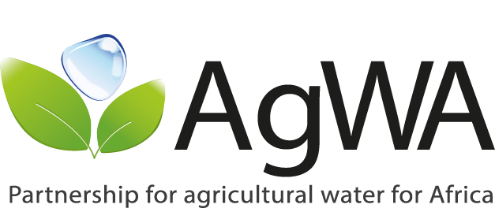 | 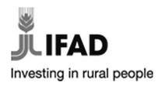

GCP/RAF/472/IFA
Building a Mature Partnership for Scaling up Agricultural Water Management in Africa

Promoting Investment in Agricultural Water Management in Nigeria and Tanzania
– Making Strong Connection with Country-Led Processes –
Dar es Salaam, TANZANIA
29 – 30 May 2014

WORKSHOP REPORT

1. Background and OBJECTIVES
Facilitated by the partnership for agricultural water for Africa (AgWA), this event brought together representatives from ministries related to water resources, agriculture and energy in Tanzania and Nigeria and other experts in order to share insights and discuss on agricultural water management (AWM) in both countries. In addition to this, current and planned trends of investment in AWM were reviewed and recommendations on how to promote more and better investment in AWM were made.
The workshop was one of the activities planned within the project GCP/RAF/472/IFA: Building a Mature Partnership for Scaling up Agricultural Water Management in Africa.
The main objectives of this 2-day workshop was to contribute to improved investment planning on Agriculture Water Management (AWM) in Nigeria and Tanzania in the context of the CAADP process and to explore investment possibilities in AWM in both countries. More specifically the workshop aimed to:
- Review current and expected investment trends in water management for agriculture and energy in Nigeria and Tanzania.
- Discuss on lessons learnt from the past and investment priorities for the future.
- Present results of the application of the Diagnostic Tools for Investment (DTI) in water for agriculture and energy in Nigeria and Tanzania.
- Train participants in the use of the Diagnostics Tools for Investment (DTI) in water for Agriculture and Energy.
- Provide recommendations and discuss on the scaling up of AWM investments in Nigeria and Tanzania, based on the results of DTI application in the countries.
- Provide recommendations and discuss on how to strengthen the AWM component in countries’ strategic planning within the CAADP framework.

2. Organization and venue
The AgWA Workshop took place in a well equipped room at the Double View Hotel in Dar es Salaam (Tanzania), from 29 to 30 May 2014. The training was organized by the following:
- The partnership AgWA and the Food and Agriculture Organisation (FAO) of the United Nations, which prepared the workshop materials and brought the facilitators;
- The Tanzanian NGO RATIIS that provided logistical support for the organization of the workshop.
- The national consultants, Ms Che Che from Tanzania and Mr. Busari from Nigeira, that selected the participants.

3. Participants
Twelve participants attended the workshop. Nine of them represented the ministries related to agriculture water management from Tanzania and Nigeria. For example, the Ministry of Agriculture and Natural Resources and Ministry of Water Resources from Nigeria and the Ministry of Agriculture, Food Security and Cooperatives and the Ministry of Energy and Minerals in Tanzania (see list below).
A group picture is provided below:
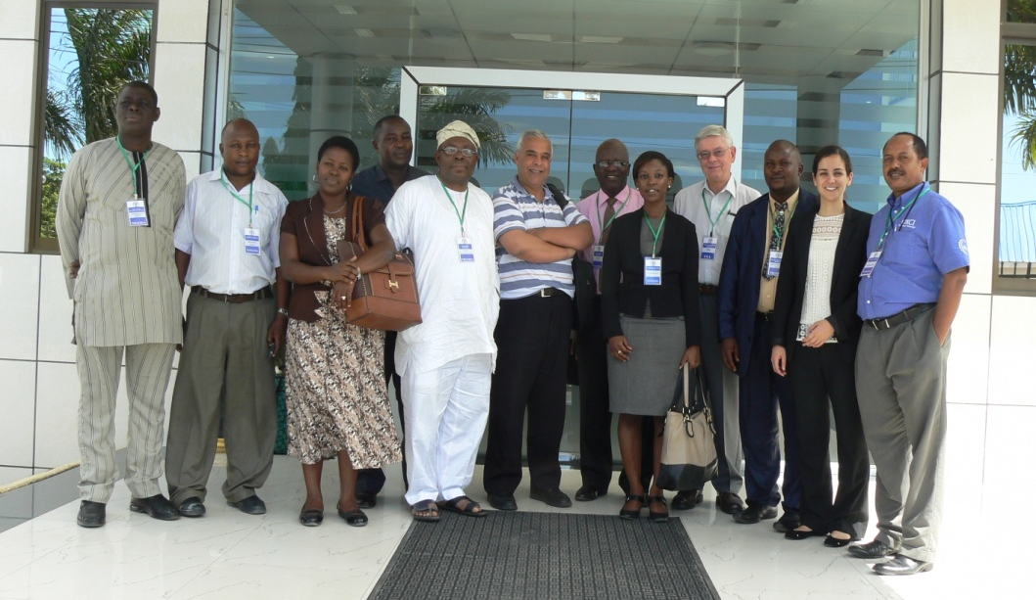

 | Name | Organization
1 | Fethi Lebdi | AgWA Coordinator
2 | Alba Martinez Salas | FAO-NRL, Project Officer
3 | Doug Merrey | International Consultant, AWM expert
4 | Engr. Busari Toyin Isiaka | Ministry of Agriculture and Natural Resources, Nigeria
5 | Engr. Akeju Olagbaju Mudasiru | CAADP Focal Point in Nigeria  Federal Ministry of Agriculture and Rural Development
6 | Engr. Hamza Muhammad Abubakar | Chief Irrigation Engineer, Federal Ministry of Water Resources
7 | Dr. Afolabi Bolaji A. | Director, Ministry of Agriculture and Natural Resources, Nigeria
8 | Gloria Che Che | The National Consultant in Tanzania
9 | Margaret Ndaba | CAADP Focal Point in Tanzania  Policy and Planning Department-Development Assistance and Coordination (DAC) Ministry of Agriculture, Food Security and Cooperatives (MAFC)
10 | Loyce Lubonera | Economist  Ministry of Agriculture, Food Security and Cooperatives
11 | Emilian Nyanda | Program Manager – Renewable Energies  Ministry of Energy and Minerals
12 | Anthony Nyarubamba | Head – Irrigation Technology Promotion, Irrigation and Technical Services Division  Ministry of Agriculture, Food Security and Cooperatives

4. AGENDA
[Note: the summary of the workshop Agenda is included in Annex 1]
Day 1
This two day workshop started with a short introduction given by Mr. Madubi from the NGO RATIIS and Mr. Fethi Lebdi, the AgWA coordinator. The first presented the workshop objectives and the second gave a short introduction on the partnership AgWA. After that, the rest of the participants introduced themselves.
The first session of the workshop included two presentations on the CAADP process in Tanzania and Nigeria, given by the respective CAADP focal points in each of the countries. Following the presentations there was some time for discussion.
The next session was dedicated to present the National Investment Profiles (NIP) of Nigeria and Tanzania. The task was undertaken by the national consultants. After the presentation there was also room for discussion.
As a second step, the Diagnostic Tools for Investment in Water for Agriculture and Energy (DTI), that have been developed by AgWA and its partners, were presented by Ms Martinez Salas, project officer at FAO headquarters. In addition to this, a short demonstration of the tools was also undertaken. After that, participants gave their inputs on how to improve the tool in order to make it more user friendly.
The afternoon session was dedicated to discuss around issues that are negatively affecting investment in AWM in Nigeria and Tanzania, in terms of levels of investment and outcomes of investment.
Each participant listed four of those issues and put them in common with the rest of the audience. Then solutions to overcome those issues were discussed. After almost two hours of discussion the meeting was closed for the day.
The results of discussions held during Day 1 are presented in section 5.
Day 2
The morning session began with a wrap up of Day 1 and an introduction to the day’s sessions. Afterwards, a presentation on the partnership AgWA was undertaken in order to inform participants about its mandate, goals, projects and activities, among others. A presentation of the possible role of AgWA in supporting countries to improve AWM was made by Dr. Doug Merrey, AWM expert and former Director for Africa at the International Water Management Institute (IWMI). This presentation was followed by a discussion where participants expressed the ways in which the partnership could support their respective countries in increasing and improving investment in AWM.
After the coffee break, a feedback session was held in order for participants to express their opinion on several aspects of the workshop. In addition to this, an evaluation form was distributed (see Annex 2). The results of the evaluation are presented in Section 6.

5. MAIN ISSUES RAISED, CONCLUSIONS AND FOLLOW UP ACTIONS
Day 1
Some interesting points were raised during the first day of the workshop, these are summarized below:
- The conflict between pastoralists and farmers on the use of water for cattle vs crops was highlighted by the Tanzanians. The creation of Water Users Associations was proposed as one possible solution to the problem.
- In Nigeria, the development of small scale irrigation remains a challenge in terms of bringing the water from storage infrastructures to the field.
- Representatives from both countries outlined the importance of involving the private sector in the development of irrigation systems. In Tanzania incentives are already given in terms of tax reliefs (between 3 to 5 years), by providing the equipment, etc.
- Operation and Maintenance expenses (O&M) of irrigation schemes were discussed extensively. O&M is of key importance in order to ensure the success of investments and to reduce costs in rehabilitation of schemes. Incentives should be given and capacity should be built in order for farmers to take care of this task.
- It was highlighted that in Nigeria one important obstacle to develop water resources for agriculture is that there is no specific budget attached to AWM and that they depend on what the ministry of agriculture decides to allocate to AWM every year. In this regard, the Tanzanians proposed a possible solution that is actually under implementation in the country, which is to create an autonomous National Irrigation Commission that would have its own budget.
In addition to this, and as explained in section 4, the afternoon was dedicated to a discussion session to talk about issues that are negatively affecting investment in AWM in Nigeria and Tanzania, in terms of levels and outcomes of investment. Solutions to problems highlighted were also tackled. Tables 1 and 2 present the results of those discussions.

Day 2
During the second day of the workshop, discussion focused on the possible role of AgWA in supporting Nigeria and Tanzania in improving and increasing investment in AWM. The following were proposed (structured according to AgWA’s priority areas):
Potential AgWA Roles in Nigeria
- Advocacy
  - Facilitate studies, dialogue on critical AWM role in agriculture development
  - Facilitate the analysis of potential value added for increasing AWM investments
  - Assist Nigeria to develop an AWM strategy
  - Help establish a monitoring and evaluation framework to present more ‘concrete’ results of AWM investments at national level
- Partner harmonization
  - Support government efforts to harmonize investors’ and own plans
  - Facilitate closer collaboration between AWM investors
  - Provide a platform for dialogue between country institutions and investors
- Resource mobilization
  - Host-facilitate through FAO, NEPAD Planning and Coordinating Agency, ECOWAS, etc. high-level dialogues on benefits higher AWM investments
- Generating and sharing knowledge
  - Lead a commissioned study to review AWM research, gaps, capacities, needs as basis for long-term AWM research and development program
  - Facilitate stronger links between regional and international research partners
  - Support the development of a strong knowledge management (KM) program
  - Strengthen national and regional AWM associations, networks, etc.
- Capacity building
  - Facilitate the development and implementation of training programs to fill identified gaps – strengthen in-country training capacities
  - Encourage and support the participation of Nigerian researchers, trainers, policy makers in international workshops and training programs

Potential AgWA Roles in Tanzania
- Advocacy
  - Consultations to ascertain the status AgWater Solutions plans;
  - Workshop with wide set of partners to encourage long-term investment approach
- Partner harmonization
  - Generate support for innovative investments such as AgWater Solutions
  - Possible dialogue platform
- Resource mobilization
  - Organize a special consultation to link potential Tanzanian and EAC private sector investors regarding irrigation supply and services
- Generating and sharing knowledge
  - Strengthen national and regional associations, networks especially for KM and communication
  - Support efforts to increase resources for research and KM
  - Help establish and strengthen an M&E framework to present more ‘concrete’ AWM results-linked to MKUKUTA II monitoring master plan
- Capacity building
  - Support identification critical capacity needs to scale up AWM investments & mobilization of resources
  - Help strengthen agricultural water curriculum in technical training institutes, universities, etc.

Table 1. Problems and solutions related to levels of investment
What is preventing the country to invest in AWM? |  | How can more investment in AWM be promoted?
Nigerian participants | Tanzanian participants | All
Availability of adequate funds/ Limited resources | Budget is not enough/ insufficient funds/low economic level | - Create awareness on the importance of AWM and on the outcomes of investments  - Seek support from development partners  - Making funding allocations more transparent  - Farmers to contribute to the O&M costs (already doing it)  - To establish an autonomous commission outside  - Encourage PPP Projects
Other competing needs | Priority setting/Difficulty of setting priorities/A large number of priorities | - Big results now (Tanzania) is a policy document that sets irrigation of high priority in the country.
Low investment recovery/ High capital outlaying investment | - | [Answers provided in table 2]
- | Lack of human resources (number and staff and capacity) | - Capacity building programmes in new technologies, software, etc
Lack of appropriate AWM policies |  | - Finnish the National Irrigation Policy (Nigeria)
Lack of political commitment | - | [time for discussion was not enough to deal with this issue]

Table 2. Problems and solutions related to outcomes of investment
Why investments fail to produce expected outcomes? |  | How can investments perform better?
Nigerian participants | Tanzanian participants | All
Top-bottom approach (local communities not consulted) at large scale | Low involvement of stakeholders in the planning and execution of investments | - To devote more resources to ensure farmers are involved in the process
Human resource capacity for the management of schemes | Capacity to manage schemes (farmers) | - Training and skill development to farmers
Weak links between research, pilot stations and farmers | Weak links between research, pilot stations and farmers
There are no mechanisms for the monitoring and evaluation and lessons learned of project implementation |  | - Building capacity on M&E  - Develop Key Performance Indicators in project design  - Documentation of lessons learned and sharing those lessons
 | Most schemes remain unfinished for a long time (i.e. delays in scheme construction due to funds not being in tandem with field operations and delays in disbursement of funds) | - Better coordination is required between field operations and fund disbursements  - An example on solving this problem is the forthcoming Tanzanian commission on irrigation, that will have full autonomy on distributing funds
 | Poorly planned investment with unrealistic targets

Follow up actions proposed
The follow up actions after the workshop that were proposed by participants are the following:
Nigeria
- To organize a national sensitization workshop on Agricultural Water Management in order to:
- Articulate knowledge gaps
- Highlight specific problems
- Develop a programme of actions to get support from donors
- Identify areas of research
Tanzania
- To undertake an assessment of training needs of government staff related to AWM.
- To launch an awareness raising campaign on AWM targeting political leaders, technical officers and farmers.
Nigeria & Tanzania
AgWA to connect Nigerian representatives with those from Tanzania in order to learn more about the Tanzanian National Irrigation Commission and use it as an example for a possible Nigerian National Irrigation Commission.

6. EVALUATION
On the last day of the workshop, the participants received an evaluation form (Annex 2) which they completed anonymously. In total, 10 filled evaluation forms were handed in.
1. General aspects of the AquaCrop Workshop
1.1. Overall appreciation of the workshop
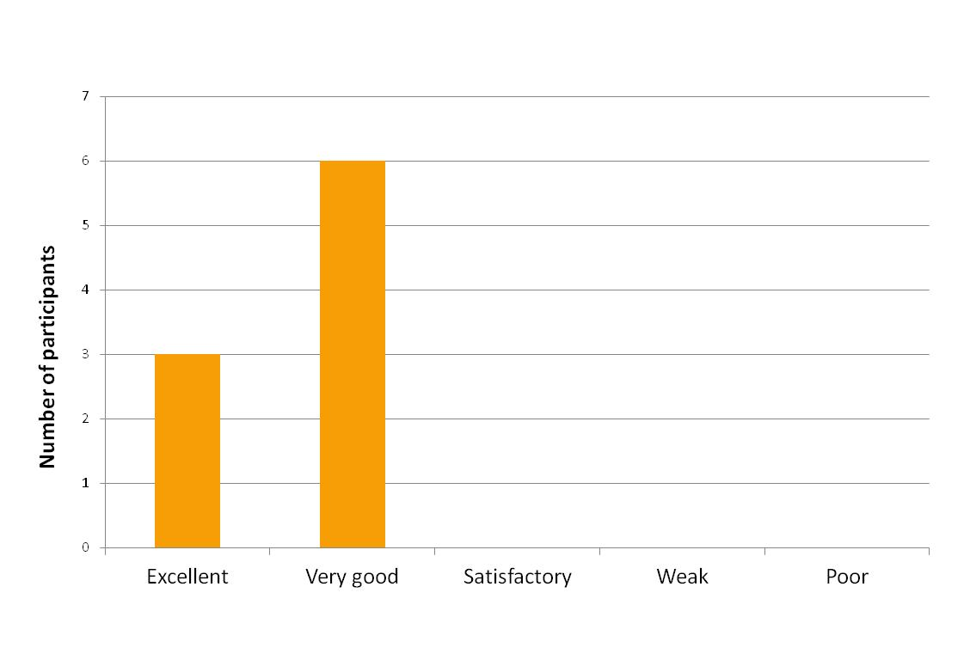
1.2. Relevance for your job (1: not relevant at all - 5: very relevant)
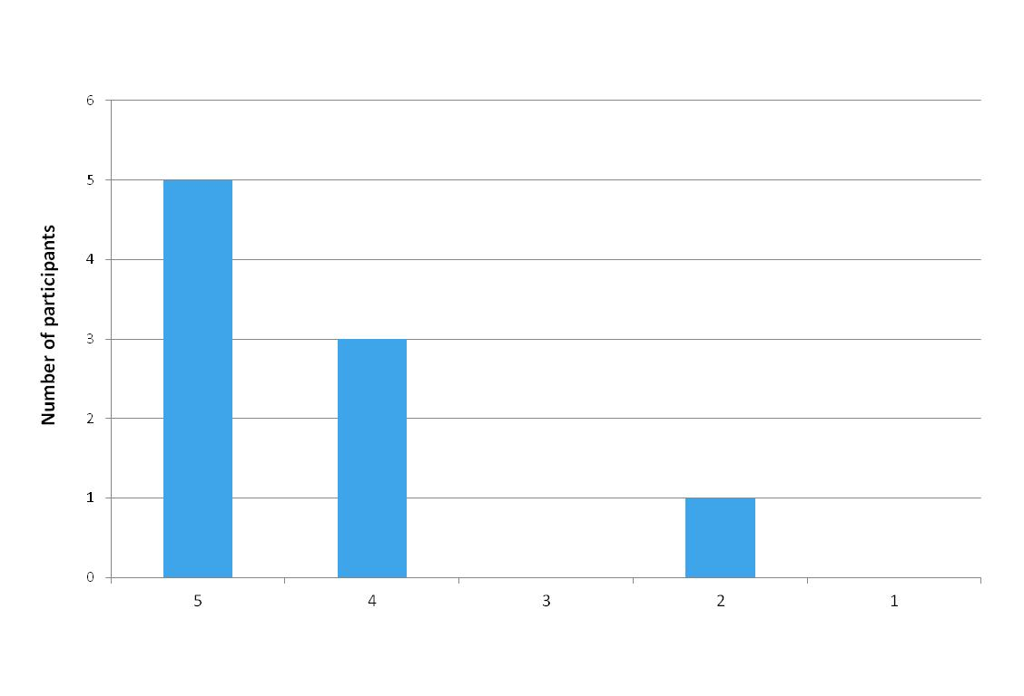

1.3. Length of the workshop (1: too long - 5: too short)
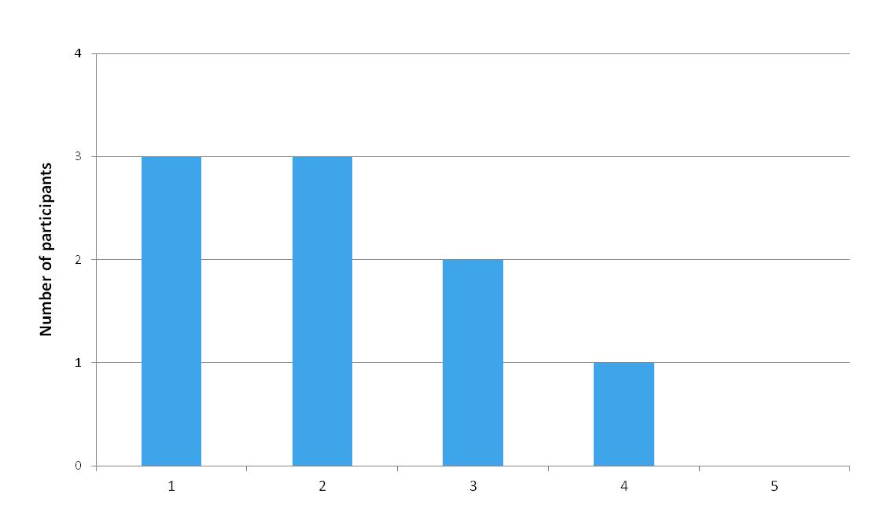

2. The DTI tool
2.1. Usefulness of the DTI tool in your everyday work (1: not useful – 5: very useful)
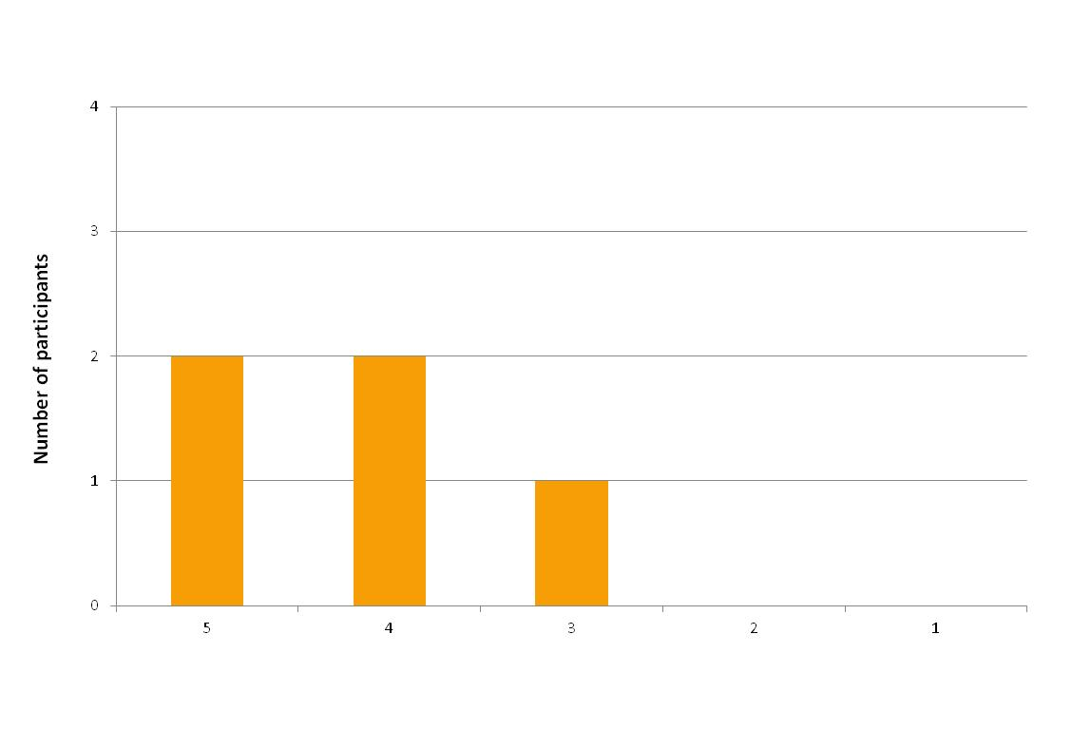

2.2. What were the easiest parts to understand of the DTI tool?
- The context tool
- The plugin of data

2.3. What were the most difficult parts to understand of the DTI tool?
- The institutional and policy tool
- Security of information

3. The AgWA partnership
3.1. Do you find AgWA useful? Why?
- Very useful, as it actually expresses the investment potential in AWM as well as fosters cooperation among the various water users in agriculture.
- AgWA could be a strong neutral facilitator and advocate for increased and appropriately target interventions in irrigation as well as help ease the tension with hydropower.
- Yes, it can contribute to improve the agriculture sector.
- Yes, the partnership enables countries to share knowledge between each other.
- Very, very useful. AgWA has to be institutionalized in Nigeria which will bring small projects to completion.
- It has a lot of potential and is no other organization playing the same roles.

3.2. Do you think you will get in contact with AgWA in the future for expert advice? Why?
- Yes, especially in fostering a partnership for rural pastoralists and crop farmers on the use of water.
- Yes, however its function in Tanzania needs to be clarified after this project intervention.
- Yes, the workshop has stimulated my interest in AgWA.
- Yes, to accelerate AWM investments.
- Absolutely yes, I strongly believe that AgWA could make things work in Nigeria.

4. Venue and organization
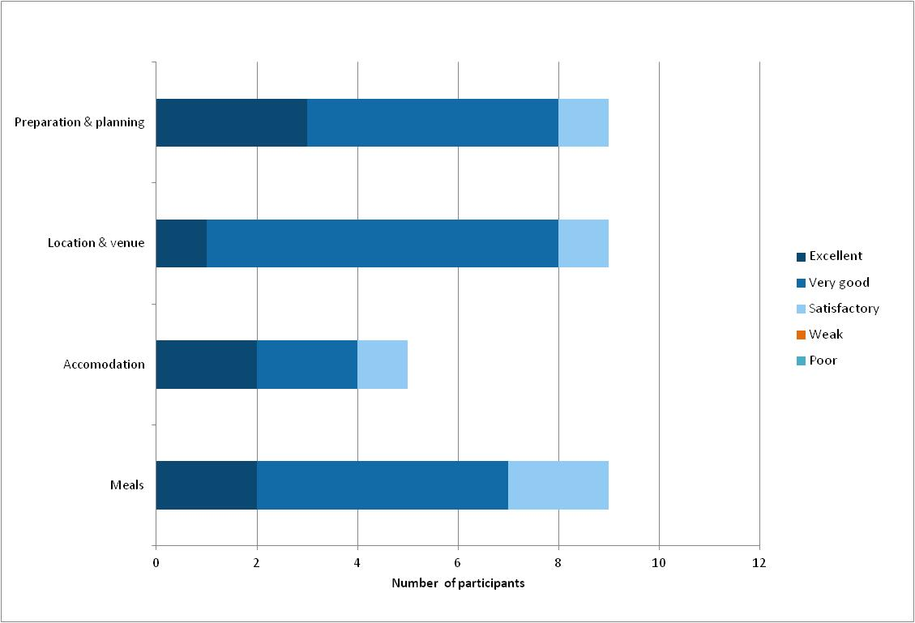

5. What were the best things about the workshop?
- The delivery of AgWA messages as well as the dialogue between participants, the organizers and the FAO officers.
- The variety of participants and the number of participants which allowed ideas to be thought and discussed.
- The presentation of the National Investment Profiles was very good.
- The interactive discussion and the knowledge sharing mechanisms.
- Learning from participants

6. What were the things you liked less about the workshop?
- The workshop might have been better with more participants representing a broader set of stakeholders from the two countries.
- There was lack of clarity regarding logistics.

ANNEX 1: Workshop Agenda

ANNEX 2: Evaluation form

