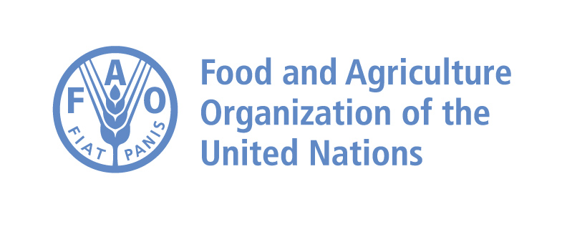
LOGO of the institution

FAO Reference Centre - Annual report
(Antimicrobial Resistance)

Title of FAO Reference Centre for Antimicrobial Resistance

Name of the Institution and contact details
Director of Institute
Head of the FAO Reference Centre
Name, title and function of
reporting officer (if different from
above)
Reporting period

Date of reporting

Please report activities as specified in the paragraph “areas of collaboration” in the designation letter – Where applicable, please always give details on beneficiary countries, project names, activities carried out, outcomes and recommendations

Additionally, please provide information on:
- Involvement in other non-FAO technical assistance projects or activity
- Participation in international, regional scientific collaborative studies or projects (please mention partners and/or organisation; country, objectives and activities)
- Organisation/participation in international/ regional scientific meetings
- Publication and dissemination of information relevant to the work of FAO including list of scientific publications, internet publishing activities, presentations at international, regional conferences
- Any major change in staff or institution, including governmental institution(s), during the reporting period
- Updates on accreditation or biosafety level (if applicable)
- Comments or remarks on any general or technical matter/finding/trend

Note:
For country names, please refer to the Names of Countries system (NOCS): http://termportal.fao.org/faonocs/appl/

