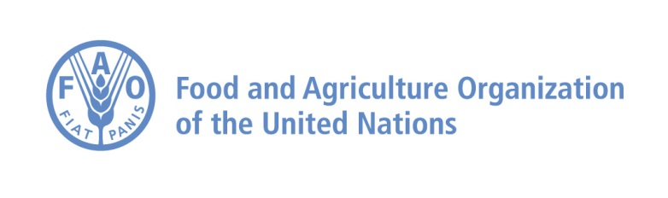

FAO TERM PORTAL
User’s Manual

October 2019
Table of contents

1. Introduction to the FAO Term Portal 4
2. Home Page description 5
3. How to search for a term 7
4. Results view 9
5. Entry Details view 11
6. Names of Countries (NOCS) 14
7. FAQ (Frequently Asked Questions) 15
8. Contact 16

- Introduction to the FAO Term Portal
As a multilingual organization, FAO owns a Term Portal that allows to create, store, manage and maintain concepts, terms and definitions in order to assure terminology standardization within a large number of subjects in all the FAO official languages – Arabic, English, Spanish, French, Russian and Chinese, as well as some Italian, Portuguese, German, Korean and also Scientific Names for plants and aquatic species. The idea behind the creation of the Term Portal is to offer a container and a one-stop-portal for searching in all glossaries.
FAO pays particular attention to enhancing language use and to standardizing technical terminology for its meetings, documentation and publications. It also promotes standard best practices for terminology management and storage, facilitating growth, interoperability and exchange. The FAO terminology as a whole is contained in the FAOTERM database and is managed by the Meeting Programming and Documentation Service (CPAM).
Upgraded in October 2014 to become more user-friendly and faster, the Term Portal has been conceived as a single search window for databases (FAOTERM, our historical database, and NOCS, the Names of countries database) and collections, in one or several languages, of different subjects (such as agricultural sciences, nutrition, biotechnology, fisheries, forestry, food safety, etc.).
In addition, the FAO technical Divisions often need to create glossaries, specific to their fields of activity, to ensure the harmonization of the linguistic information, its consistency and reliability, and to coordinate, maintain and share the existing linguistic resources while fostering the development of new ones. Therefore, several thematic glossaries have been developed, in close collaboration with the relevant technical Divisions, and present core concepts of common interest among technical experts and linguists. Glossaries are jointly maintained by the Language Support Group in CPAM and the concerned FAO technical Division.
The terminological development of the Term Portal involves various activities, among which the screening of FAO meeting documentation and major publications, for the retrieval of terminology concepts useful for all users. The process of developing terminology includes the following steps:
- identification of texts and corpora
- term extraction methodology
- comparative analysis of concepts
- collaborative terminology - inclusion of all stakeholders: linguists, terminologists, technical experts; proposals of terms from users’ feedback
- research of equivalents in all FAO languages
- terminography/terminology methodology - building the records
- validation of terminology in all languages (through a triple-validator system)
- developing term records in accordance with ISO standards and good practices.
- Home Page description
The FAO Term Portal home page provides you with a number of tools you may wish to use in order to look up for existing terminology, suggest new terminology, and be up-to-date with the latest news on the terminology portal and with new term additions.
This is how the Term Portal home page looks like:
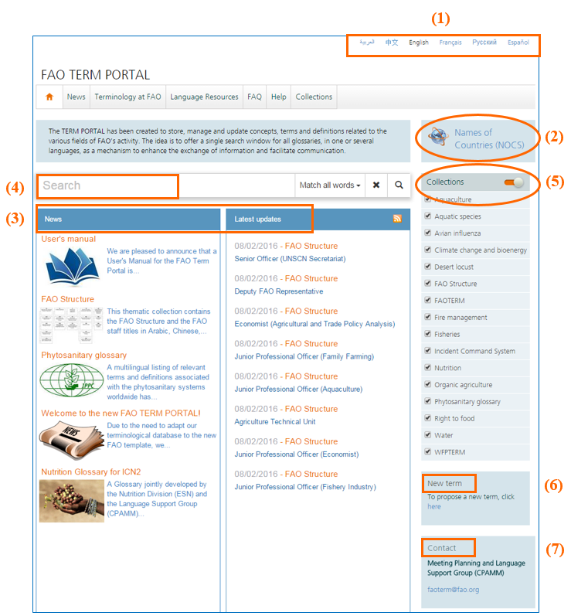
- Web site language: you may choose your preferred navigation language among Arabic, Chinese, English (default language), French, Russian and Spanish.
- Names of Countries (NOCS): by clicking on this link, you will be directed to the Names of Countries database, where you will be able to search for the official names of all FAO member countries in the six official languages of FAO, as well as Italian. In addition to some areas and territories, you will also be able to retrieve the names of the capital cities, nationality adjectives and currencies of each member country (see Section 6 of this Manual).
- News and Latest updates: these two panels show the news about FAO terminology activities and the latest terminological updates and additions.
- Search: this box allows for the terminology search and provides some advance tools to refine your research (see Section 3 of this Manual).
- Collections: this list shows all FAO collections within which you may perform a search. Each collection can be included in or excluded from your term search (please refer to Section 3 of this Manual).
- New term: we invite you to make new term proposals to the Language Support Group by clicking on this link and filling in the relevant form with the term details.
- Contact: should you need to contact our Language Support Group, please use the e-mail address: faoterm@fao.org

- How to search for a term
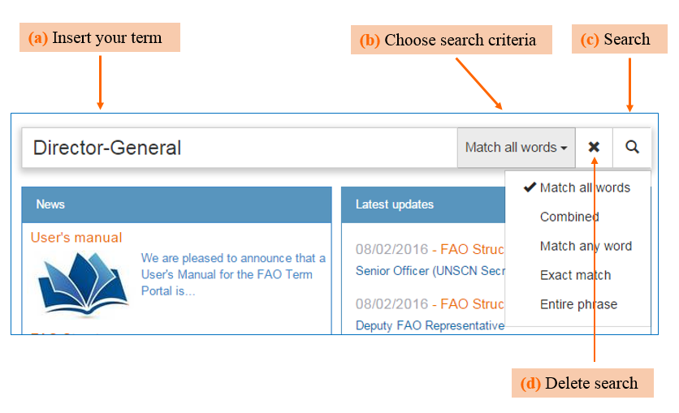
The FAO Term Portal allows for the search of terms contained in FAOTERM, the historical FAO database, and in 15 thematic collections for a total of nearly 100,000 entries.

In order to perform a search within the Term Portal you need to take the following steps:
- Enter your query in the Search window (this can be a word, expression, abbreviation, etc.).
- Choose the most suitable search option among:
  - Match any word: when you would like the results to show ANY of the words placed in the search window.
  - Combined: a combination of the Match all words and the Exact match search, with a priority given to the Exact match option.
  - Match all words: when you would like the results to show ALL the words inserted in the search window.
  - Exact match: looks for the word or expression exactly as you have entered it. This option is useful in order to limit the amount of results retrieved from a search. It should, however, be reminded that this option may sometimes limit too much the results obtained.
  - Entire phrase: if you wish to look for a chain of words, including prepositions and articles.
- Click on the Search icon.
- Delete the inserted term to perform another search, if necessary.

Search tips:

- Avoid searching for words in plural form.
- If you do not find a word that contains a hyphen, try without the hyphen, and vice-versa.
- Avoid leaving extra spaces at the end of the string.
- Once selected, a searching option stays for the next search. If you do not require this function, remember to revert to the default option, i.e. “Match all words”.
- Search in the Nominative case for those languages that have cases.

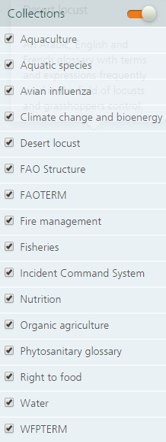
Collections
By default, the term search is performed within all FAO collections indicated on the right-hand side of the page. If you wish to restrict the search to some specific collections (for example, only FAOTERM and FAO Structure) and exclude others from the results, use the tick button near each collection title to select/deselect them. Alternatively, use the button located on top right of the list to select/deselect all collections.

- Results view
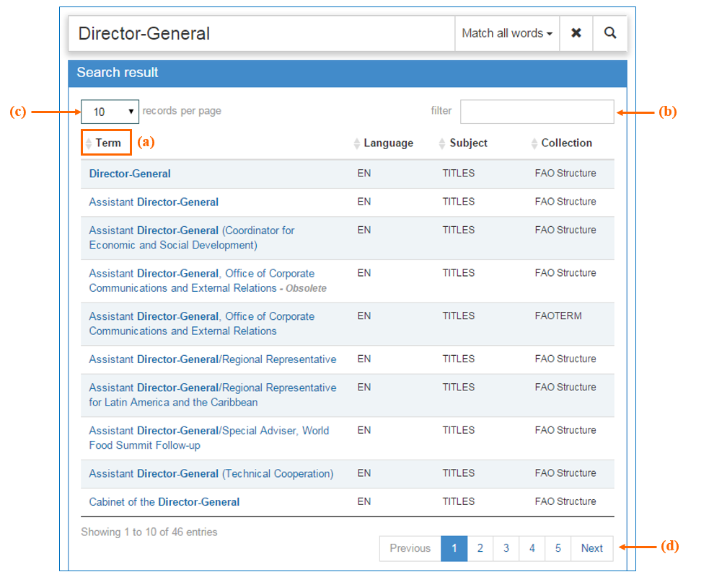
Once you press the Search button, the Portal will display the results in a list of matching terms together with some useful information on each result:

The first column shows the matching terms, the second column indicates the language of the term, the third column shows the subject assigned to that specific term and the last column illustrates the collection the term belongs to. Some of the terms may show an “Obsolete” status (see the fourth result on the above list), for details on this feature please see Section 5(a) of this Manual.
Should you wish to list the results by language, subject or collection, just click on the Title of the concerned column (see (a) in the previous image).
The search can be furtherly filtered by using the Filter box (see (b) in the previous image) or the Collection list on the right-hand side of the screen (see Section 3).

You may also increase the maximum number of records displayed on every page (from 10 as default value, to 100 per page) by choosing from the scroll-down menu on the top left corner of the table (see (c) in the previous image). In order to view previous/next results, click on the page numbers under the list (see (d) in the previous image).
If the search produced more than 50 results, the following message will appear at the bottom of the list and you will need to click on the blue link in order to load and view the rest of the results.
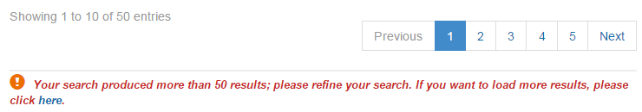

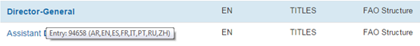
By hovering the mouse over each term of the list, you can also view the languages available in each entry. In the following example, the entry includes terms in Arabic (AR), English (EN), Spanish (ES), French (FR), Italian (IT), Portuguese (PT), Russian (RU) and Chinese (ZH). If the entry number is the same of another term, it means that the results proceed from the same record and are therefore synonyms.

- Entry Details view
From the results view, click on single entries to view their content. A separate window will open with the entry details:
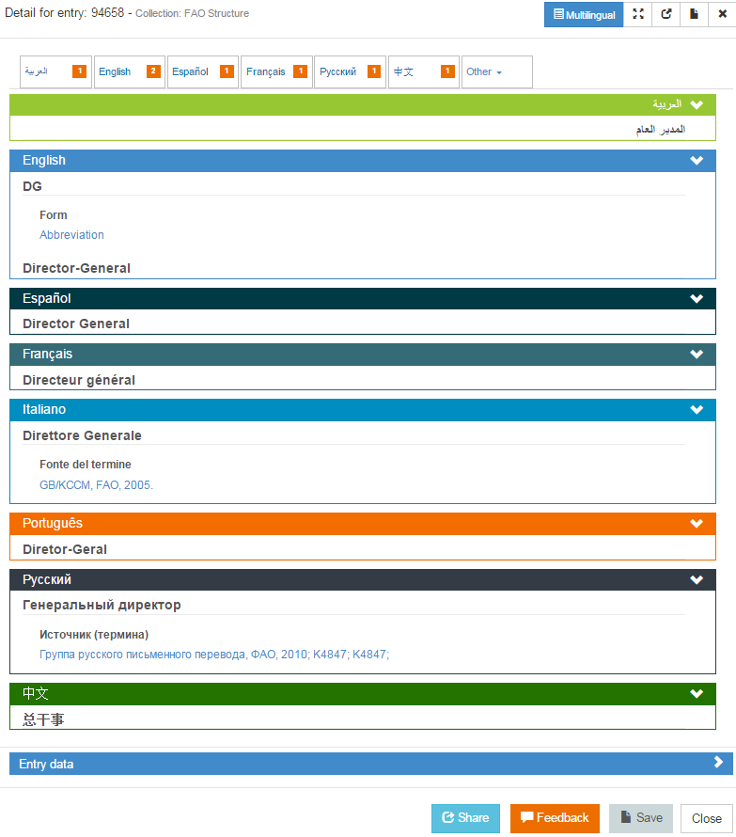
(f)
(b)
(a)
(c)
(d)
(e)
(g)
(h)
(i)

The Entry Details view is composed of the following elements:
- Entry number and Collection: on the top left corner of the window you will find the number of the entry within the FAO database, the name of the collection the entry belongs to and, if applicable, the “Obsolete” status of the entry. “Obsolete” entries are kept in the Portal for statistical and historical purposes, but the “Obsolete” status indicates that they are no longer in use.
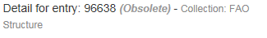
- View buttons: press “Multilingual” to return to this view from the bilingual view; press “View full screen” to expand the record; and press “View in a new window” to open the entry in a separate browser window for the sake of comparison with other records or any other use.
- Save: by pressing this button you may download a PDF file of the current entry and save it or print it, as needed.
- Close: in order to close the entry you can either press the “x” button close to the save button, you may press the “close” button at the bottom of the page, or you can press the “Esc” button of your keyboard.
- Bilingual view: by choosing one of these tabs, you can access the bilingual view (i.e. the selected language plus English). Under the tab “Other”, you may find the non-FAO languages.
- Terms and terms’ details: each entry includes the same term in different languages. You can decide to show or collapse each language panel by pressing the > or ∨ icons on the right-hand side.
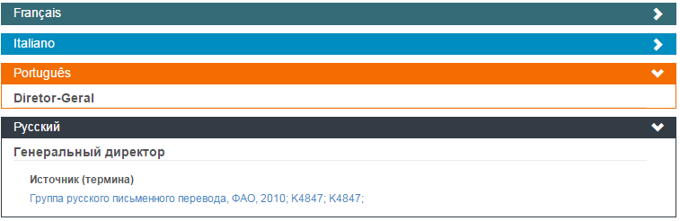
- Entry data: the last panel of the page shows the metadata belonging to the specific entry, such as entry number, subject, status, main source, etc.
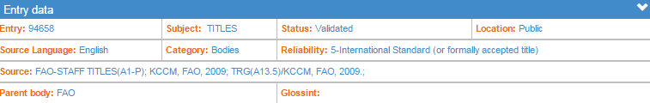

- Share: click on this icon if you wish to share the contents of an entry with other colleagues or send comments on a specific record to the site administrators. This function will automatically open a new e-mail message containing the link to the entry.
- Feedback: click on this orange icon in order to send your feedback on a particular entry; fill in the required information and press the “Send” button. . The feedback will be received by the Administrators of the Term Portal.

- Names of Countries (NOCS)
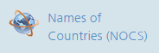
From the FAO Term Portal home page you can access the Names of Countries (NOCS) database, in which you may not only search for the official names of all FAO member countries, names of the capital cities, areas and territories, adjectives of nationality and currencies, but you are also provided with a tool to download all this information in Excel and/or PDF formats. In order to do that, take the following steps:
- Click on the Names of Countries link on the right-hand side of the FAO Term Portal home page.

- In the NOCS home page click on the tab “Services” (top menu), then click on “Download”:
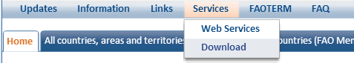
- Select the export format and choose among different criteria in order to customize the content of the list you wish to download. For instance, you can include/exclude non-FAO Members, areas and territories, you may add short/full name forms, ISO codes, capital cities, currencies, etc., and you can select only the required languages.
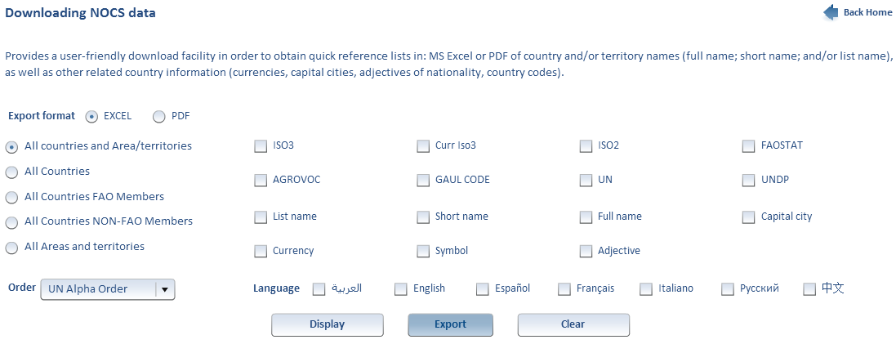

- FAQ (Frequently Asked Questions)
Where can I find the titles of the FAO staff?
The FAO staff titles and the FAO Structure are under the thematic collection denominated “FAO STRUCTURE”. However, please remember that the names of the officers are not included here and that titles such as “Chief, ...Service” have to be split for the search: 1) “Chief” and 2) the name of the Service.
How can I get a list of FAO names of countries?
Use the “Download” function under “Services” in the NOCS database. You can select as many combinations as you wish and export them in either Excel or pdf format (see Section 6 above).
I see many repeated records in the search results, why?
There might be repetitions if the term is searched in various thematic collections at the same time,. Also, the system retrieves as many occurrences of the term as are present in the database, in all languages; therefore, if the English abbreviation “SIPAM” is used also in French and Spanish, you will get 3 results for SIPAM: one for the English, one for the French and one for the Spanish.
Furthermore, the different technical areas in FAO may have different versions of the meaning of a given term and we store all of them.
In the case of FAO Structure, full titles might appear identical, but the acronyms are different. For example: CIOD, ESAD and AGAD are different organizational symbols, but they correspond to the same title: Office of Director.
Can I get an extraction of terms from the Portal?
It is possible to get extractions from the database on demand; to do this please send a written request to the following e-mail address: faoterm@fao.org.
Finally, we wish to remind users that a terminology database is a dynamic tool; this means that it changes frequently because of the evolving nature of languages themselves and also due to the changing nature of the different areas of FAO’s work. An online double-checking of terms is always recommended after some time.

- Contact
Should you need any further assistance on the use of the FAO Term Portal, or be in need of a terminological research, kindly contact the Meeting Planning and Language Support Group (CPAMM) at the following e-mail address: faoterm@fao.org.

