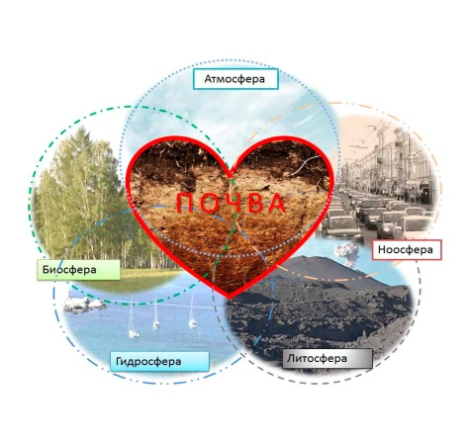 | 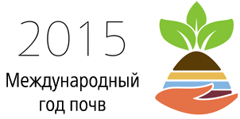

Dear colleagues!
Organizing committee invites all soil scientists and ecologists to join us
at the International Seminar
“Organization of soil and ecological monitoring using the collection of soil monoliths” / “Organizing methods of scientific and educational activity in the field of soil sciences” devoted to the International Year of Soils

August 5-10, 2015

Saint-Petersburg

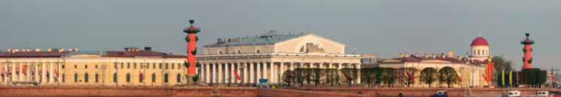

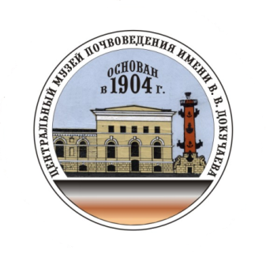
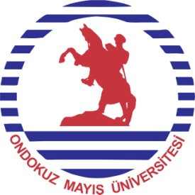

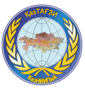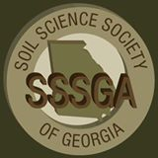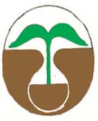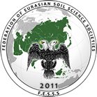

Organizators

Dokuchaev Central Soil Museum;
Federation of Eurasian Soil Science Societies;
Department of Agrarian Sciences of the Azerbaijan National Academy of Sciences;
Soil Scientist Society of Azerbaijan;
Soil Scientist Society of Georgia;
SU (Society Union) Soil, Agrochemical, Agroecological Science Society of Kazakhstan;
Ondokuz Mayis University, Turkey
Ordu University, Turkey

PROGRAMME

August 5, 2015 - Registration of participants
August 6-7, 2015 – Workshop “Organization of soil and ecological monitoring using the collection of soil monoliths”
August 8-9, 2015 – Workshop “Organizing methods of scientific and educational activity in the field of soil sciences”
Master classes “Modern information technologies of scientific and educational activities” will be carry out as part of the Seminar

Organizing committee

Aparin B.F., director of the Dokuchaev Central Soil Museum, vice-president of the Dokuchaev Soil Scientists Society, head of the Soil Science and Soil Ecology Department of the Saint-Petersburg State University
Dr., Prof.

Mammadov G. Sh, full member of the Azerbaijan National Academy of Sciences (ANAS), academician-secretary of the Department of Agrarian Sciences of the ANAS, president of the Soil Scientist Society of Azerbaijan

Kuliev A.G., director of the Institute of Soil Science and Agrochemistry of the ANAS, Dr., Prof.

Gasimzade T. E., scientific secretary of the Department of Agrarian Sciences of the ANAS, Ph.D, Assoc. Prof.

Urushadze T. F., Prof. member-corr. of the Georgian National Academy of Sciences (GNAN), president of the Dokuchaev Soil Scientists Society of Georgia

Saparov A. S. general director of the LLP “U.U. Uspanov Kazakh Research Institute of Soil Science and Agrochemistry”, Dr., Prof., full member of the Academy of Agricultural Sciences of Kazakhstan

Ridvan Kizilkaya, Prof. of the Ondokuz Mayis University, Samsun, Turkey

Tayfun Ashkin, Prof. of the Ordu University, Ordu, Turkey

Gashimov A. director of the Azerbaijan Research Institute of Hydraulic Engineering and Land Reclamation, Dr.

Sukhacheva E. U., deputy director of the Dokuchaev Central Soil Museum, Assoc. Prof. of the Soil Science and Soil Ecology Department of the Saint-Petersburg State University, International consultant – Coordinator of the International Year of Soils 2015 in Eurasia Food and Agriculture Organization of the United Nations

Secretaries

Mingareeva E.V., scientific secretary of the Dokuchaev Central Soil Museum

Lazareva M.A., researcher of the Dokuchaev Central Soil Museum

Contacts: (812)3285402, (812)3285602 (tel/fax)
E-mail: soilmuseum@bk.ru
Mob.tel.:
+7 921 388 9859 Sukhacheva Elena.
+ 7 911 097 7213 Lazareva Margarita.

Seminar place: Dokuchaev Central Soil Museum (Birzhevoy proezd, 6)

Seminar application form

The application form should include:
- First name and last name
- Paper title
- Country, city
- Organization, position, science degree
- E-mail, tel

Paper requirements

Papers should not be more than 2 pages. Format - MS Word 2003-2007. Type – Times New Roman. The size of type is 12 pt. (without tables and pictures). Interval between lines is single. Margins should be set at 2,0 cm all sides. Indent – 2,5 cm. Width alignment. References - square brackets. Literature – alphabetically. Pages without numbers

In Russian:
The first line is UDS (left aligned)
The second - title of paper
The third – authors
The fourth – organization, city, (country for foreigners), e-mail (centered)

Low lines – doubles in English (title of paper, authors, organization)

Paper example

УДК 631.44
ПОЧВЕННЫЕ РЕСУРСЫ РОССИИ
А.А, Иванов*б Б.Б. Петров**
*Институт экологического почвоведения МГУ, г. Москва, ivanov-aa@yandex.ru
**Факультет почвоведения МГУ, г. Москва, petrov-bb@mail.ru
SOIL RESOURCES OF RUSSIA
A.A. Ivanov*, B.B. Petrov**
*Institute of Ecological Soil Science MSU, Moscow, ivanov-aa@yandex.ru
**Faculty of Soil Science of MSU, Moscow, petrov-bb@mail.ru

Soil Resources of Russia - national treasure and a basis of food security…

Literature
- Dobrovolsky G.V.

Papers will be publish in electronic format

Papers and application forms should be sent to soilmuseum@bk.ru till August 1, 2015

Application forms and papers should be sent as attachments
File with a paper should be called by surname of the first author (in Roman alphabet)
File with an application form – surname of the first author_form

